European
judicial systems
Edition 2006 (2004 data)
European Commission for the Efficiency of Justice
(CEPEJ)

The opinions expressed in this work are the responsibility of the authors and do not necessarily reflect the official policy of the Council of Europe.

All requests concerning the reproduction or translation of all or part of the document should be addressed to the Public Information and Publications Division, Directorate of Communication (F-67075 Strasbourg Cedex or publishing@coe.int). All other correspondence concerning this publication should be addressed to the Directorate for Legal Co-operation, DG I CEPEJ.

© Council of Europe, 2006
Printed in Belgium

Table of contents

Foreword 5
Introduction 7
1. The evaluation process of the CEPEJ 9
1.1 The European Commission for the Efficiency of Justice 9
1.2 The revised Scheme for evaluating judicial systems 9
1.3 Data collection and processing 10
1.4 General methodological issues 11
1.5 General economic and demographic figures 13
1.6 Analysing the findings of the report 14
2. Public expenditures: courts and prosecution system 17
2.1 Introduction 17
2.2 Composition of the budget allocated to the courts 18
2.3 The budget allocated to the public prosecution system in 2004 24
2.4 Budget allocated to legal aid in 2004 27
2.5 Budget allocated to the courts and the prosecution system (without legal aid) in 2004 31
2.6 Budget allocated to the judicial system, including courts, the prosecution systems
and legal aid in 2004 36
2.7 Budget allocated to courts and legal aid 39
3. Legal aid 45
3.1 Introduction 45
3.2 The budget for legal aid 45
3.3 Conditions for granting or withdrawing legal aid 47
3.4 Court fees and reimbursements 49
4. The users of the courts (rights and public confidence) 53
4.1 Introduction 53
4.2 Provisions regarding the information of the users of the courts 53
4.3 The protection of vulnerable categories 53
4.4 Compensation procedures 56
4.5 Compensation of the users for judicial dysfunctions and complaints 57
4.6 The assessment of the satisfaction of users 58
5. The courts 61
5.1 Introduction 61
5.2 The court organisation 61
5.3 Small claims, employment dismissal cases and robbery cases 65
5.4 Budgetary powers at the level of the courts 67
5.5 IT equipment of the courts 67
5.6 Evaluation and monitoring 70
6. Judges, Rechtspfleger and court staff 77
6.1 Introduction 77
6.2 Judges 77
6.3 The Rechtspfleger 82
6.4 Non-judge staff (and Rechtspfleger if included) 83
7. Fair trial within a reasonable time 85
7.1 Introduction 85
7.2 Cases regarding Article 6 ECHR before the European Court of Human Rights 86
7.3 Simplified procedures and procedures for urgent matters 86
7.4 Other means to increase the efficiency of court proceedings: specific appeal
arrangements and stimulation of an early settlement of disputes 87
7.5 The treatment of civil (and administrative) cases 87
7.6 Timeframes of civil proceedings (divorces and dismissals) 93
7.7 The treatment of criminal cases by the public prosecutor 97
7.8 Criminal cases treated by the courts 100
7.9 Length of proceedings for robbery cases and intentional homicides 104
8. Public prosecutors 105
8.1 Introduction 105
8.2 Role and powers of the prosecutor 105
8.3 Prosecutors and staff of the prosecution service 105
9. The status of judges and prosecutors 109
9.1 Introduction 109
9.2 Recruitment and nomination 109
9.3 Training 112
9.4 Salaries 113
9.4.1 The salaries of judges 114
9.4.2 Salaries of prosecutors 117
9.4.3 Additional benefits 120
9.5 Possibility to combine work with other activities 120
9.6 Disciplinary proceedings and sanctions 121
10. Lawyers 127
10.1 Introduction 127
10.2 Number of lawyers 127
10.3 Monopoly in legal representation before the court 129
10.4 Organisation and training 130
10.5 Supervision on the practice of the profession 130
10.6 Disciplinary proceedings and sanctions 133
11. Enforcement of court decisions 136
11.1 Introduction 136
11.2 Enforcement of court decisions in civil, commercial and administrative law 136
11.2.1 Enforcement agents 136
11.2.2 Organisation and training of enforcement agents 139
11.2.3 Transparency of fees and quality standards 140
11.2.4 Supervision and control 141
11.2.5 Disciplinary proceedings and sanctions 142
11.2.6 The enforcement procedure: complaints 143
11.2.7 Enforcement timeframes 144
11.3 The enforcement in criminal matters 144
11.4 Measures to improve the enforcement procedure 145
12. The notaries 147
12.1 Introduction 147
12.2 The status and number of notaries 147
12.3 Supervision and control 148
13. ADR (alternative dispute resolution) 149
13.1 Introduction 149
13.2 Number of mediation procedures 149
14. Panoramic overview of judicial systems 151
15. Appendix 155
15.1 Methodological issues concerning the budget of the courts and the justice budget
(chapter 3) 155
15.2 Additional tables 158
15.3 Revised scheme for evaluating judicial systems 178
15.4 Explanatory note 196
15.5 National Correspondents entrusted with the coordination of the answers to
the Scheme for evaluating judicial systems 215

Foreword
by Mr. Eberhard Desch, President of the CEPEJ, and Mr. Guy De Vel, Director General Legal Affairs of the Council of Europe

In deciding "to develop the evaluation functions" of the European Commission for the Efficiency of Justice (CEPEJ) in the Action Plan adopted in Warsaw in May 2005, the Heads of State and government of the Council of Europe's member states have expressed their support to the process set up by the CEPEJ and wish to strengthen it.

This exercise aims to have a detailed knowledge of the functioning of the justice system in all European states and has become the corner stone of the action of our Commission. Drawing lessons from the pilot exercise implemented in 2004 and wishing to develop the proper know how to, according to its Statute, "examine the results achieved by the different judicial systems (…) by using (…) common statistical criteria and means of evaluation", the CEPEJ is delighted to offer this report to policy makers, judicial practitioners, researchers as well as all citizens who might be users of justice systems. These reports will be published regularly, thus enabling to assess the evolutions of the public services of justice for 800 million Europeans.

It is indeed a unique process, built according to a specific methodology, to present the most detailed picture possible for comparing judicial systems of 45 European states. But what for?

In setting up the CEPEJ, under the impulsion of the European ministers of justice, the Committee of Ministers of the Council of Europe wanted a structure with the capacity to propose concrete solutions to improve fairness, quality and efficiency of justice in Europe, to strengthen the confidence of the citizens in their domestic system and to limit cases filed before the Strasbourg Court because of dysfunctions within the justice systems, which are contrary to Article 6 of the European Convention of Human Rights.

The CEPEJ has achieved the first part of its mission in delivering this report, open to the analysis by administrations, universities and research institutes in the member states. Of course the CEPEJ strongly encourages policy makers and researchers to use this unique information to develop studies and feed the indispensable European debate and the reforms, the necessity of which is regularly reminded by the case-law of the Strasbourg Court and the events in our member states. But the CEPEJ also wishes that this report be for itself a source of in-depth reflections so as to be able to propose to the Committee of Ministers and to the relevant administrations within the member states concrete tools for developing their public policies of justice.

The 2006 edition of the report of the CEPEJ is therefore the starting point of a continuous process, where phases of knowledge will alternate with phases of analysis, both for the CEPEJ and the relevant bodies entrusted with justice throughout Europe.

Our Commission would not have been able to produce such results without the exceptional work, both in quality and quantity, of a fully dedicated group of experts. We would like to pay a tribute to the high expertise and scientific rigour of Ana-Maria FALCONI and the Working Group chaired by Jean-Paul JEAN and also composed of Pim ALBERS, Fausto DE SANTIS, Elsa GARCIA-MALTRAS DE BLAS, Hazel GENN, Beata GRUSZCZYŃSKA and Mikhail VINOGRADOV, as well as to the appreciated support of Julien LHUILLIER and Jean HUBER. We would also like to thank the Ministry of Justice of the Netherlands for its specific support in this process.

Introduction

In December 2004 the European Commission for the Efficiency of Justice (CEPEJ) adopted the Report: “European judicial systems: facts and figures”. It was the result of an experimental exercise, based on a Pilot Scheme (questionnaire) for evaluating judicial systems designed to obtain comparable, objective quantitative and qualitative figures concerning the organisation and functioning of judicial systems. 40 of the 46 member states of the Council of Europe were considered in the experimental process. This was a European first: no such exercise had ever been conducted in the justice field. In spite of limits and shortcomings because of its experimental character, the Pilot report showed that this kind of evaluation exercise was not merely possible, but, above all, worthwhile, providing for useful figures on key areas for understanding the functioning of the judicial systems in Europe. The report has been studied by policy-makers and judicial authorities in many member states, some of which drew on the information provided to identify gaps in their own systems and to find inspiration for reforms. Several states set up ad hoc working groups to study the report and make use of it. Therefore the Committee of Ministers of the Council of Europe urged the CEPEJ to continue its efforts in this direction.

In the Action Plan which they adopted at their Third Summit (Warsaw, May 2005), the Heads of State and Government of Council of Europe member states decided to develop the evaluation and assistance functions of the CEPEJ in order to help states deliver justice fairly and rapidly. Based on the lessons learnt from the pilot exercise, the CEPEJ launched in 2005 an initial regular evaluation exercise, using the in-depth methodological approach implemented in the pilot exercise and drawing on the Network of national correspondents set up to collect figures.

This report was adopted by the CEPEJ at its 7th plenary meeting (July 2006), under the Chairmanship of Mr Eberhard DESCH (Germany). It is the result of this new evaluation process. It is based on reports by the states, whose preparation was coordinated by national correspondents appointed within the states. It presents the results of a survey conducted in 45 European states. It is unique in the number of subjects and countries that are covered.

This process aims progressively to define a set of key quantitative and qualitative figures to be regularly collected and equally processed in all member states and to bring out shared indicators of the quality and efficiency of court activities in the states of the Council of Europe (key figures of European judicial systems), including assessment of the evolution of the situation from one period to another.

Comparing quantitative figures from different countries, with different geographical, economic, and judicial situations is a difficult task which must be addressed cautiously, both by the experts while drafting the report and by the readers while interpreting the information provided by the report. The figures must be addressed in their specific context, taking fully into account the relevant comments.

This report offers policy-makers, judicial practitioners, researchers or any citizens interested in judicial issues in the member states a description of the European judicial systems with qualitative and quantitative figures, presented in a comparative perspective together with the first elements for further analysis. The reader can find here comparative tables and relevant comments on key areas for understanding the functioning of the judicial systems, grasping the main developments, identifying problems and orientating public policies aimed at improving the quality, equity and efficiency of the services offered to the citizens by the justice systems.

This report is only the first step of a two-tier approach. Beyond the useful picture that is given, there is room for in-depth analysis to be further carried out by the CEPEJ itself as well as by the main stakeholders of this report, on the basis of this information.

This Edition 2006 of the report is based on the 2004 figures. The collection, processing and presentation of the figures reflected in the Report were done within a very tight timeframe, in order to stick as far as possible to the reality of judicial systems at the time of its publication (being understood that the 2004 figures were generally not available in the member states before the last quarter of 2005). Despite the time constraints, the CEPEJ has chosen to work so as to adopt the report in July 2006.

This work is a joint effort involving at least a hundred people, including the national correspondents in charge of answering the questionnaire, the scientific expert, the experts of the Working group, the CEPEJ members and the Secretariat of the Council of Europe. This could not have been possible without their full commitment.

1. The evaluation process of the CEPEJ

This first chapter describes the evaluation process carried out by the CEPEJ to prepare this report. It makes explicit the working principles and methodological choices which presided to this exercise. The chapter ends with a few notes to guide the reader through this report.

1.1 The European Commission for the Efficiency of Justice

The European Commission for the efficiency of justice (CEPEJ) was set up by the Committee of Ministers of the Council of Europe in September 2002, entrusted in particular with proposing concrete solutions, suitable for use by Council of Europe member states for:
- promoting the effective implementation of existing Council of Europe instruments relating to the organisation of justice (normative "after sale service"),
- ensuring that public policies concerning the courts take account of the needs of users of the justice system and
- helping to reduce congestion in the European Court of Human Rights by offering states effective solutions prior to application to the Court and preventing violations of Article 6 of the European Convention on Human Rights.

The CEPEJ is today a unique body for all European States, made up of qualified experts from the 46 Council of Europe member states, to assess the efficiency of judicial systems and propose practical tools and measures towards an increasingly efficient service to the citizens.

According to its Statute, the CEPEJ must " (a) examine the results achieved by the different judicial systems (...) by using, amongst other things, common statistical criteria and means of evaluation, (b) define problems and areas for possible improvements and exchange views on the functioning of the judicial systems, (c) identify concrete ways to improve the measuring and functioning of the judicial systems of the member states, having regard to their specific needs. These tasks shall be fulfilled by, among others, (a) identifying and developing indicators, collecting and analysing quantitative and qualitative figures, and defining measures and means of evaluation, and (b) drawing up reports, statistics, best practice surveys, guidelines, action plans, opinions and general comments".

The statute emphasizes in this way the comparison of judicial systems and the exchange of knowledge on their functioning. The scope of this comparison is broader than ‘just’ efficiency in a narrow sense: it emphasizes the quality and the effectiveness of justice as well.

In order to fulfil these tasks, the CEPEJ has namely undertaken a regular process for evaluating judicial systems of the Council of Europe's member states.

1.2 The revised Scheme for evaluating judicial systems

The CEPEJ set up in 2005 a Working Group on the evaluation of judicial systems (CEPEJ-GT-EVAL) to revise the evaluation Scheme (questionnaire) in the light of the conclusions of the pilot exercise, to ensure the collection and processing of new figures and to prepare the draft report.

The main purpose of revising the Scheme was to come up with a questionnaire that could be systematically used in future evaluation exercises.

To draft the revised scheme (123 questions) and its explanatory note, the experts kept the main principles which were used for the drafting of the pilot scheme. They particularly had in mind the principles identified in the Resolution Res (2002)12 which establishes the CEPEJ as well as the Council of Europe's Resolutions and Recommendations in the field of efficiency and fairness of justice.

They also took into account the proposals for amendments submitted by the CEPEJ members, observers, and national correspondents within the framework of the pilot process. Specific attention was paid to the explanatory note, aimed at helping national correspondents to answer the questions in a homogeneous way. In particular, more precise definitions have been introduced with a view to reducing interpretation difficulties, taking into account the comments of the experts and stakeholders of the pilot report.

Compared to the pilot scheme, the revised scheme, including both descriptive and quantitative figures, tries to improve questions to get more meaningful answers, improving the layout to make it easier to answer them, encouraging comments or explanations. It contains a number of new questions (mainly about the court budgets, the users of the courts, timeframes of proceedings, the execution of court decisions and notaries) and a section on fair trial has been expanded. The structure has been modified to enable national correspondents to divide the collection of figures between several relevant bodies.

The CEPEJ-GT-EVAL prepared the revised scheme adopted by the CEPEJ at its 5th plenary meeting (June 2005) and approved by the Ministers’ Deputies at their 936th meeting (September 2005). The revised scheme and the subsequent explanatory note were submitted to member states in September 2005, in order to receive new figures at the beginning of 2006.

1.3 Data collection and processing

This report is based on figures from 2004. As the majority of the countries were able to issue judicial figures for 2004 in the autumn 2005, the CEPEJ was not able to gather figures before the beginning of 2006, which left only three months for member states to collect and consolidate their individual replies to the evaluation scheme and less than five effective working months for the experts to process them and prepare the report.

Methodologically, the collection of figures is then based on reports by member states, who were invited to appoint national correspondents entrusted with the coordination of the replies to the scheme in their respective countries.

The CEPEJ instructed its Working Group, under the chairmanship of Jean-Paul JEAN (France), with the preparation of the report. The Secretariat of the Council of Europe appointed Ana-Maria FALCONI (France), as scientific expert in charge of processing the national figures submitted by member states and preparing the preliminary draft report, together with the Secretariat of the CEPEJ.

The national correspondents were considered as the main interlocutors of the Secretariat and of the experts when collecting new figures and as those primarily responsible for the quality of figures used in the survey. All individual replies of the member states were registered in a database by the scientific expert.

The scientific expert had many contacts with national correspondents to validate or clarify the figures and their adjustments continued until shortly before the final version of the report. However, the CEPEJ experts agreed that the figures would not been changed ex officio, unless the correspondents explicitly agreed to such changes. All changes to them were approved by the national correspondents.

The meeting between the scientific experts, the CEPEJ-GT-EVAL and the network of national correspondents (Strasbourg, May 2006) was an essential step of the process, aimed at validating figures, discussing decisions of the experts and improving the quality of the figures provided.

Responding states

By May 2006, 45 states had participated in the process: Albania, Andorra, Armenia, Austria, Azerbaijan, Belgium, Bosnia and Herzegovina, Bulgaria, Croatia, Cyprus, Czech Republic, Denmark, Estonia, Finland, France, Georgia, Germany, Greece, Hungary, Iceland, Ireland, Italia, Latvia, Liechtenstein, Lithuania, Luxembourg, Malta, Moldova, Monaco, the Netherlands, Norway, Poland, Portugal, Romania, the Russian Federation, San Marino, Serbia, Slovak Republic, Slovenia, Spain, Sweden, Turkey, Ukraine, United Kingdom and Montenegro.

The following countries did not reply to this report: Switzerland and “the former Yugoslav Republic of Macedonia”. Hopefully, they will be included in the next exercise.

In federal states or states with a decentralised system of justice administration, the data collection offers different characteristics, compared to those of centralised states. The situation is frequently more complex. In these states, data collection at central level is limited, while at the level of entities, both the type and the quantity of figures collected may vary. In practice, several federations have sent the questionnaire to each of its entities. Some states have extrapolated their answers for the whole country from the figures made available from the entities, taking into account the number of inhabitants of each entity.

All the figures provided for by individual member states have been made available on the CEPEJ Website: (www. coe.int/CEPEJ). National replies sometimes contain descriptions of legal systems and explanations that greatly contribute to the understanding of the figures provided. They are therefore a useful complement to the report: because of the need to be concise and consistent, it was indeed not possible to include all this information in this report.

1.4 General methodological issues

Objectives of the CEPEJ

This report does not pretend to have exploited exhaustively all the relevant information that has been forwarded by the member states. The CEPEJ tried to address the issues in this report, bearing in mind first of all the priorities and the fundamental principles of the Council of Europe. Beyond the figures, the interest of the CEPEJ report lies in the main trends, evolutions and common issues for European states.

This report is an important step for the regular evaluation process of European judicial systems, taking into account the valuable results of the pilot exercise and trying to improve it, in a dynamic perspective. When preparing the report, experts and national correspondents were encouraged to keep in mind the long term objective of the process: defining a set of key quantitative and qualitative data to be regularly collected and equally processed in all member states and bringing out shared indicators of the quality and efficiency of court activities in the member states of the Council of Europe.

The quality of figures

The quality of the figures in this report depends very much on the type of questions asked in the data collection instrument, the definitions used by the countries, the system of registration in the countries, on the efforts made by national correspondents, the national figures available to them and on the way the figures have been processed and analysed. In spite of the improvements resulting from the experience of the pilot process, it is reasonable to assume that some variations occurred when national respondents interpreted the questions for their country and tried to match the questions to the information available to them. The reader should bear this in mind and always interpret the statistical figures given in the light of their attached narrative comments.

The CEPEJ has chosen to process and present only the figures which presented a high level of quality and credibility. It decided to disregard the figures which were either too varied from one country to another or which did not present enough guarantees of reliability. More information than the one included into this report has been collected and is available on the CEPEJ Website (www.coe.int/CEPEJ).

The comparability of figures and concepts

The comparison of quantitative figures from different countries set against the varied geographical, economic and legal situations is a delicate job. It should be approached with great caution by the experts writing the report and by the readers consulting it, and above all, by those who are interpreting and analysing the information it contains.

In order to compare the various states and their various systems, those specificities of the systems which explain differences from one country to another one (different judicial structure, organisation of justice and the use of statistical tools to evaluate the systems, etc.) must be highlighted. Specific efforts have been made to define words and ensure that concepts had been addressed according to a common understanding. For instance, several questions have been included in the revised scheme, with clear definitions in the explanatory note, to address the number of courts (both through an institutional and a geographical perspective) or the number of judges (different categories have been specified). Particular attention has been paid to the definition of the budget allocated to courts, so that the figures provided by member states correspond to similar expenditures. However the diversity in the systems might prevent achieving shared concepts. In these cases, specific comments have been drafted together with the figures. Therefore only an active reading of this report can allow drawing analyses and conclusions; figures cannot be passively taken one after the others, but must be interpreted in the light of the subsequent comments.

In this context, as the aim of this report is to give an overview of the situation of the European judicial systems, the CEPEJ has generally decided to present the situation in member states following the alphabetical order. Comparing is not ranking. However, this report gives the reader tools for an in-depth study which would then have to be carried out by choosing relevant clusters of countries: according to the characteristics of the judicial systems (for instance civil law and common law countries; countries in transition or with old judicial traditions), geographical criteria (size, population) or economic criteria (for instance within or outside the Euro zone). The CEPEJ itself will carry out its own analytical phase on the basis of this report in a second stage.

The CEPEJ scheme was filled in by small states. Andorra, Monaco, Liechtenstein or San Marino are territories which are, due to their scale, not comparable with other countries. Consequently the figures compared according to a scale "per 100.000 inhabitants" must be interpreted cautiously for these countries.

Financial values are reported in Euros. Because of this, some problems have occurred while using exchange rates for countries outside the euro zone. Exchange rates vary from year to year. Since the report focuses mainly on 2004, the exchange rates of 1 January 2005 were used. For countries with high inflation rates, the figures presented may seem strange at times; their interpretation should therefore be viewed within their specific context.

Chronological comparisons of figures

Although this report relies mainly on the work developed in the framework of the experimental phase and the report adopted in 2004, it would not be relevant to compare the figures presented in this report with the information of the previous report. Indeed, the last report was an experimental project. The definitions and variables used might have changed from one exercise to another. Therefore, though highlighting the quality and usefulness of the pilot exercise and the subsequent report, the CEPEJ considers this current exercise as the starting point of a regular process and envisages to proceed to chronological comparisons in next evaluation exercises. It considers the current report as a standard on which it will be possible to make useful analysis to assess the evolution of judicial systems in groups of countries or within individual states.

The evolution of judicial systems

Since 2004, some member states of the Council of Europe have implemented essential institutional and legislative reforms of their legal systems. For these states, the situation described in this report may be completely different from today’s situation.

1.5 General economic and demographic figures

These figures, which almost every state was able to provide, give comprehensive information on the general context in which this study was made. They enable in particular, as was the case in the report resulting from the pilot exercise, to relativize and to put the other figures in context, particularly budgetary figures and figures relating to court activity.

The figures also enable the reader to measure the enormous variables in the population and the size of the countries concerned, from San Marino, with less than 30.000 inhabitants, to the Russian Federation with more than 143 millions. This variable in the demographic definition must always be borne in mind. The population concerned by this study is roughly 796 millions.

The figures also demonstrate the huge differences as regards wealth and living standards in the various countries, through per capita GDP (new figures vis-à-vis the pilot survey), and partially reflected in the amount of the global public expenditure. The average annual gross salary gives an interesting overview of the wealth and living standards as it involves economic, social (welfare system) and demographic figures. Though this indicator is not perfect, it nevertheless highlights, again, substantial disparities between the citizens of the member states.

Finally, the influence of the monetary exchange rate between the "Euro zone" countries and the "others" must be taken into account, as it strongly modifies what salaries represent vis-à-vis the quality of life for the inhabitants of each country.

Therefore comparisons must always be limited to what can be compared. The results that each member state would want to measure against other states that appear comparable to it must be balanced, taking into account the specific context. There are obviously threshold effects according to the level of population or level of living standards which are measured through ratios regarding the number of inhabitant, the per capita GDP and the average gross salary.

The data regarding public expenditures (question 2) seem to be too tied to various techniques of public accounting, both as regards defined perimeters and, for instance, the presentation of deficits. The problem of national and regional budgets on public competences as a whole also gives rise to further methodological problems. Therefore these figures are only given as information in the table of general economic and demographic figures.

Some reservations were expressed as regards the figures relating to the average gross salary provided by all the countries, except Denmark and Monaco. These figures will only be used in tables and not in graphs in order to compare the salary of judges and prosecutors.

It was thus decided to mainly use two ratios usually used in such surveys for comparisons, in particular budgetary comparisons through graphs: the number of inhabitants and the per capita GDP, which will be included in the relevant graphs.
The figures on population were provided by all member states. They will be used in all ratios which measure an impact per inhabitant. Only the states with similar sizes will then be compared.

Figures related to per inhabitant GDP were provided by almost all the countries. Only Bulgaria, Denmark and Monaco were not able to provide them, and will therefore be excluded from the comparative tables and graphs prepared on the basis of such variable. Here again, huge disparities in the per capita GDP can be noted and must always be kept in mind when considering the subsequent results. For instance, two extremes can be noted: on the one hand the countries with a per capita GDP below 2.000 € (Albania, Armenia, Azerbaijan, Bosnia and Herzegovina, Georgia, Moldova and Ukraine), and on the other hand, Liechtenstein with a declared per capita GDP fifty times higher.

Table 1. General information on responding countries in 2004 (questions 1 - 4)

Country | Q1 Number of inhabitants | Q2 Total of annual State public expenditure at State level | Q2 Total of annual State public expenditure at regional / entity level | Q3 Per capita GDP | Q4 Average gross annual salary
Albania | 3 069 275 | n.r. |  | 1 920 € | 2 440 €
Andorra | 76 875 | 275 500 000 € |  | 22 347 € | 14 846 €
Armenia | 3 210 000 | 454 210 840 € |  | 850 € | 756 €
Austria | 8 206 500 | 65 000 000 000 € |  | 29 000 € | 38 640 €
Azerbaijan | 8 347 000 | 1 305 570 000 € |  | 852 € | 994 €
Belgium | 10 446 000 | 142 577 800 000 € | 59 925 000 000 € | 27 579 € | 31 992 €
Bosnia and Herzegovina | 3 832 000 | 2 662 255 000 € |  | 1 732 € | 4 634 €
Bulgaria | 7 761 049 | n.r. |  | n.r. | 2 417 €
Croatia | 4 443 900 | 11 279 647 220 € | 1 863 093 620 € | 6 200 € | 9 582 €
Cyprus | 689 565 | 3 313 706 975 € |  | 7 216 € | 11 700 €
Czech Republic | 10 220 577 | 32 450 758 526 € |  | 8 446 € | 6 783 €
Denmark | 5 397 640 | 3 894 612 799 € |  | n.a. | n.a.
Estonia | 1 351 069 | 3 000 000 000 € |  | 6 644 € | 5 588 €
Finland | 5 236 611 | 36 320 000 000 € |  | 28 646 € | 33 000 €
France | 62 177 400 | 374 597 000 000 € | 161 600 000 000 € | 26 511 € | 38 921 €
Georgia | 4 535 200 | n.a. | n.a. | 923 € | 992 €
Germany | 82 500 000 | 273 600 000 000 € | 255 900 000 000 € | 26 754 € | 39 815 €
Greece | 11 056 800 | 63 500 000 000 € |  | 15 119 € | 16 776 €
Hungary | 10 097 549 | 24 950 400 000 € |  | 8 025 € | 6 984 €
Iceland | 293 577 | 3 700 000 000 € | 1 400 000 000 € | 34 700 € | 38 700 €
Ireland | 4 040 000 | 41 230 000 000 € |  | 36 737 € | 27 780 €
Italy | 58 462 375 | 452 826 000 001 € | n.a. | 23 115 € | 22 254 €
Latvia | 2 319 200 | 3 167 516 484 € |  | 4 777 € | 3 600 €
Liechtenstein | 34 600 | 524 133 333 € |  | 106 000 € | 74 592 €
Lithuania | 3 425 300 | 3 664 414 301 € |  | 5 264 € | 4 024 €
Luxembourg | 455 000 | 6 476 725 546 € |  | 56 488 € | 39 587 €
Malta | 402 668 | 1 519 354 800 € |  | 9 647 € | 11 644 €
Moldova | 3 386 000 | 4 286 300 000 € | 1 885 600 000 € | 572 € | 853 €
Monaco | 30 020 | 694 840 032 € |  | n.a. | n.a.
Montenegro | 620 533 | 450 738 779 € |  | 2 113 € | 3 636 €
Netherlands | 16 292 000 | 227 500 000 000 € |  | 29 993 € | 30 642 €
Norway | 4 606 363 | 72 992 239 200 € | 22 109 122 400 € | 43 818 € | 41 219 €
Poland | 38 174 000 | 44 660 633 484 € |  | 5 246 € | 6 218 €
Portugal | 10 529 255 | 64 175 000 000 € |  | 13 550 € | 13 492 €
Romania | 21 673 328 | 7 494 168 708 € | 3 422 276 068 € | 2 718 € | 2 423 €
Russian Federation | 143 474 143 | 125 591 176 470 € |  | 3 478 € | 2 379 €
San Marino | 29 673 | 715 834 955 € |  | 26 350 € | 23 609 €
Serbia | 7 498 001 | n.r. |  | 2 255 € | 3 420 €
Slovakia | 5 400 000 | 8 388 155 026 € | 572 550 000 € | 6 200 € | 4 997 €
Slovenia | 1 997 590 | 7 006 900 000 € |  | 13 103 € | 13 565 €
Spain | 42 935 001 | 102 665 000 000 € | 324 972 000 000 € | 19 502 € | 25 060 €
Sweden | 9 034 837 | 87 913 178 770 € | 65 806 087 566 € | 28 832 € | 31 906 €
Turkey | 71 152 000 | 79 312 575 000 € |  | 3 359 € | 7 783 €
Ukraine | 47 280 800 | 11 283 701 187 € |  | 1 141 € | 1 105 €
UK England & Wales | 53 046 300 | 201 000 000 000 € |  | 24 579 € | 36 900 €
UK Northern Ireland | 1 710 300 | 12 400 000 000 € |  | 25 343 € | 31 061 €
UK Scotland | 5 078 400 | 65 241 060 000 € |  | 24 600 € | 33 500 €

1.6 Analysing the findings of the report

The ultimate aim of the regular evaluation exercise is to develop recommendations and set up concrete tools to improve the quality, equity and efficiency of judicial systems. Therefore a second phase of the process would consist in the CEPEJ "letting the figures speak". The CEPEJ will then turn its attention to the analysis of the results, where specific topics would be addressed more in depth on the basis of the facts and figures available.

***

Keys
In the report – especially in the tables presented – a number of abbreviations have been used:
- (Question x) refers to the (number of the) question in the scheme which appears in appendix, by which the information has been collected.
- If a certain country left a question open, this is shown as “n.r.” (no reply) or a blank (“ “).
- If there was a reply, saying no (valid) information was available, this is shown as “n.a.” (Not available).
- In some cases, a question could not be replied to, for it referred to a situation that does not exist in the responding country. These cases, and cases in which an answer was given that clearly did not match the question, are shown as “nap” (not applicable).
- When a "-" appears in the tables it means that, due to the fact that the main data is not available, no calculation (of a ratio) could be made.
- fte = full time equivalent; number of staff (judges, prosecutors, etc.) are given in full time equivalent so as to enable comparisons.
- "UK–England and Wales" / "UK–Scotland" /" UK–Northern Ireland" corresponds to the territories of the United Kingdom concerned by the figures reported.

Figure 0 Responding countries

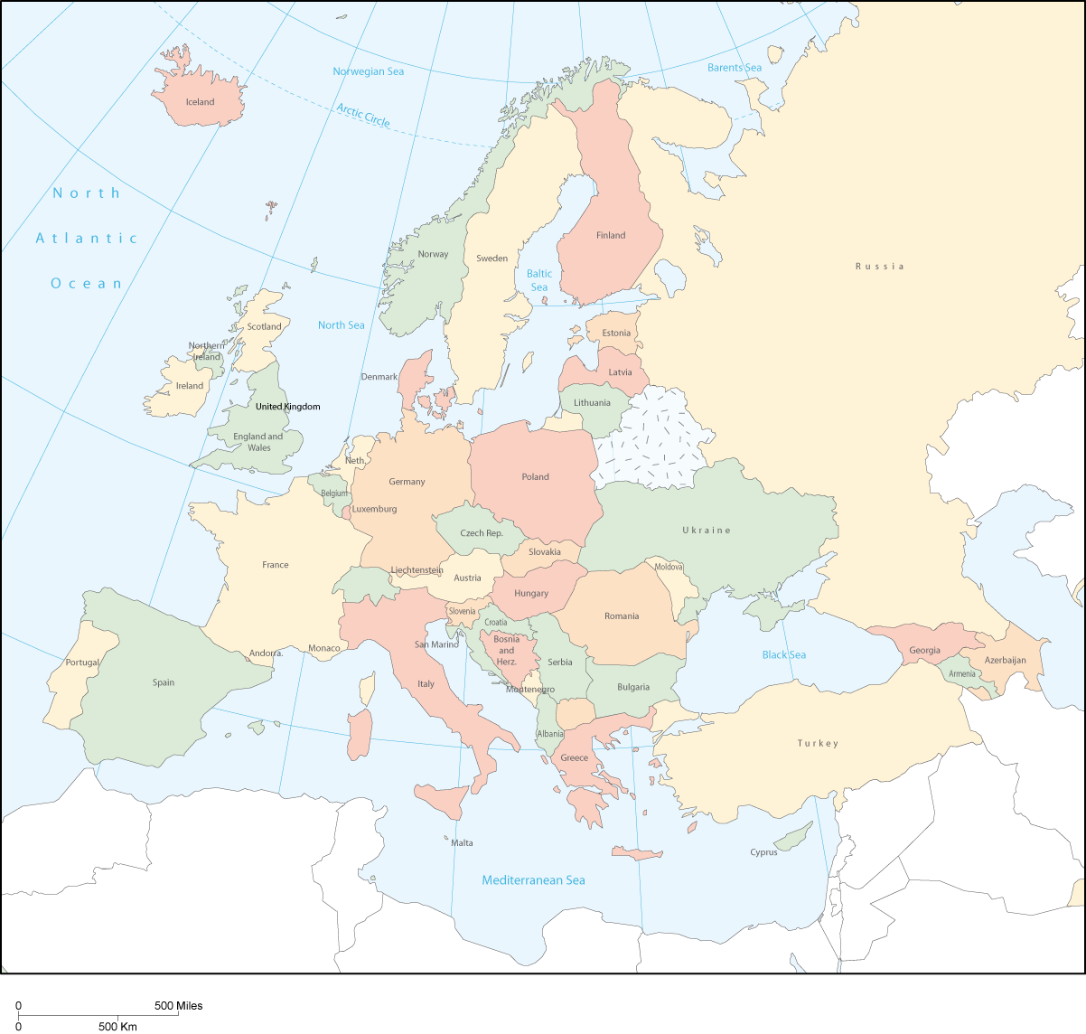

Public expenditures: courts and prosecution system

2.1 Introduction

This chapter focuses on the means of the judicial systems, and especially on the courts, legal aid and the prosecution system. In the first section, the financing of the courts is described. A reference to methodological matters is also made in the appendix.

With this in mind and regarding the complexity of these questions, the CEPEJ has chosen to break up as much as possible the various elements of the budgets to allow a progressive approach. Three entities were taken into account:

- the budget allocated to the courts (answer to question 5), which will be put in relation to the part of the report devoted to the activities of the courts,
- the budget allocated to the public prosecution (answer to question 9), which will be put in relation to the part of the report devoted to the activities of the public prosecutor,
- the budget devoted to legal aid (answer to question 7) which constitutes an indicator of the efforts devoted by a country to making their legal systems accessible.

The tables presented one after the other make it possible to provide all the comparisons on each one of these three entities, the courts (C), the public prosecution (PP) and the system of legal aid (LA).

Table 2: Budget devoted to the courts in 2004 (excluding legal aid)
Table 3: Budget devoted to the public prosecution in 2004 (real or estimated)
Table 4: Budget devoted to legal aid in 2004

Furthermore, totals showing the evaluation of budgets devoted to the following are also presented:

- to the whole of the bodies dealing with prosecution and judgment (C + PP)- Table no. 5: budget allocated to the judicial system, including courts and public prosecution in 2004 (without legal aid),
- to the whole of three entities (C + LA +PP) - Table no. 6: budget allocated to the judicial system, including courts, legal aid and public prosecution in 2004,
- to the access to justice and the courts (C + LA) - Table no. 7: budget allocated to the jurisdictions and legal aid in 2004.

As a result, any state will be able to compare itself to other countries deemed as similar. It will then, in the same way, be able to check the activity results.

In order to contribute to these reasoned comparisons, all the figures transmitted and used (summary table 75 in appendix) was made available. At the end of each table, ratios have been highlighted, to allow comparisons with comparable categories, by connecting the budgetary figures to the number of inhabitant and the GDP per capita, in the form of graphs.

Following each table, charts are presented with the ratio of the budget per inhabitant and the ratio as a percentage of the GDP per head of the population. This makes it possible to compare comparable categories.

The necessary data for these calculations are, in addition to the budget or «regrouped» budget: the number of inhabitants, the GDP per head and the average annual gross salary.

Each point studied successively distinguishes a part "figures and methodology" and a part "comments".

2.2 Composition of the budget allocated to the courts

Figures and methodology

This section measures the efforts that each state makes to the proper functioning of its court system. The efforts are set against the number of inhabitants and the GDP.

Among the 47 states or specific entities (the three entities of the United Kingdom), 37 have been included in this table.

The budget allocated to courts does not include here the amounts allocated to the public prosecution system nor to legal aid.

Albania and Bulgaria appear in the table although they have submitted the amount of legal aid (question 7) without specifying whether it was included or not in the budget of the courts (question 5). In order to include them into future analyses, the decision was taken to privilege the answers favourable to these countries, that legal aid is not included in the budget. However it must be specified in any case that the amounts of legal aid given do not represent a significant part of the budget of these two countries (see table 76 in appendix).

Cyprus and Slovenia have indicated that they have included the figures for legal aid, but they were not able to specify the amount. After exchanges having shown that these amounts were insignificant, the decision was taken to include these two countries in the table.

Hungary specified that only one part of the legal aid budget (100.000 € on 851.333 €) was included in the budget allocated to all courts. The calculations take this into account.

4 countries did not specify whether the budget of the public prosecution (question 9) was included or not into the budget of courts: Albania, Bulgaria, Denmark and Ireland. But it is believed that these countries have indeed followed the provisions of the explanatory note (which appears under section 15.4 in appendix), i.e. the budget of the public prosecution shall not be included in the budget of courts. All these countries have declared the amount allocated to the public prosecution.

11 countries have included the public prosecution system (question 9) into the budget of courts (question 5): Andorra, Austria, Armenia, Belgium, Germany, Greece, Luxembourg, Monaco, Portugal, Spain and Turkey. Among them, 3 (Andorra, Monaco and Spain) were able to give an estimate and were therefore included with an amount re-calculated according to the information provided.

UK-Northern Ireland, has not been able to submit the amount of the budget allocated to the courts (question 5), but has been able to provide the amounts allocated to the public prosecution system (question 9) and to legal aid (question 7).

The states which do not appear in the list are:
- San Marino and UK-Northern Ireland which could not provide the figure of the budget allocated to the courts,
- Ukraine which has not specified if legal aid was included or not in the budget of the courts, nor has it given an estimate; therefore it will be excluded from the analysis requesting these figures,
- Armenia, Austria, Belgium, Germany, Greece, Luxembourg, Portugal and Turkey, which could not dissociate or measure the budget allocated to the prosecution system from the total figure given.

The case of Germany was difficult to address. The understandable difficulty to get figures from some Länder had led the country to firstly give a figure which identified only one part of the budget of the public prosecution system within the budget of the courts; some immovable investments, which were included, could not be measured. Germany was unable to isolate precisely the budget of public prosecution in the Länder included into the budget of the courts. Therefore Germany, as the 8 other countries in a similar situation, cannot be compared here. However, its figures related to legal aid, which have been reconstituted from a national survey by the federal government involving all the Länder, are fully established and will allow the inclusion of some results of this country into other calculations.

Two other parameters were investigated in depth: the increase - impossible, because far too high - in the budgetary allocations of some countries over two years, as well as the inclusion, for some of these countries, of the amounts dedicated to immovable investments (examined above).

More precisely, it appeared that, of the 45 countries or entities concerned by the study, among which 33 replied to the two successive questionnaires, 8 had greatly increased the figure related to the 2004 budget vis-à-vis the same figures for 2002, with such proportions that it can only be explained by the inclusion of new budgetary lines. By increasing order: Slovenia (+ 9,99%), Poland (+ 13,84%), Slovakia (+ 16,99%), Latvia (+ 23,19%), Turkey (+24,60%), France (+ 42,78%) and Andorra (+ 45,02%).

These abnormalities could not all be resolved during the process of setting up the report. However it appears, for instance, that the increase in Slovakia can be almost fully explained (+ 13%) by immovable investments in courts. The increase unexplained by this element is only of 0,92% for Andorra and 7,14% for Poland. More important for Turkey, it is due to a considerable increase in the whole of the budget allocated to the ministry of justice (808.141.000.000 000 Turkish Liras in 2002 and 1.368.435 000.000.000 Turkish Liras in 2004); the courts profited from it too. As regards Slovenia, it concerns only small investments and not building programmes.

As regards Andorra, the very high increase comes probably from a communication error, as the amount indicated of 4.474.162 € also includes the figures for the ministry of justice (see the answer of the previous study), whereas in 2002, the distinction was made. The real amount which could have been taken into account must be around 3,4 million €, but, as this country had not specified it, the given figure which was included in the table as an indication, while emitting severe reservations as regards its credibility.

As regards France, the high increase between 2002 and 2004 stems, to a very small extent, from the inclusion, which was not done in 2002, of the budget of administrative courts, but also, for the main part, from the inclusion of budgetary lines that this country has followed, indicating that it is due to its way of posting the salaries paid, e.g. "payments made by the Ministry of Finance to the fund for the pensions of public officials in proportion to the wage bill before the courts" as well as "the expenditures directly linked to court activity such as, for instance, judicial transfers, building guardianship and the security of persons".

The table showing the answers to question 6 (see table 77 in appendix), relating in particular to the part on salaries in the budget of courts, is an indicator which enables to assess the scale of these "exogenous" amounts in the figures given by the states. The higher the scale of these salaries is, the less the "exogenous" elements have had an influence. The scale of salaries in the budget of courts is the following: Andorra 83,9%, Turkey 72,7%, Slovenia 69,1%, Poland 60%, France 54%, Latvia 53,5%, Slovakia 49%.

It has not been possible to specify the figure of UK-Scotland from the initial answer to the questionnaire. Indeed, disparities can be noted between the two entities of the United Kingdom which provided data, on which the experts would have wanted further information.

For these countries, the interpretation of the results presented for the court budget as well as those concerning the total budget allocated to the judicial system must therefore include each of these parameters, in order to relativize its impact.

Table 2. Budget allocated to courts in 2004 (question 5)

Country | Total annual budget allocated to all courts without prosecution nor legal aid | Annual budget allocated to all courts without prosecution and legal aid per inhabitant | Annual budget allocated to all courts without prosecution and legal aid per inhabitant as percentage of per capita GDP | Annual budget allocated to all courts without prosecution and legal aid per inhabitant as percentage of annual gross average salary
Albania | 10 486 065 € | 3,4 € | 0,18% | 0,14%
Andorra * | 4 447 193 € | 57,8 € | 0,26% | 0,39%
Azerbaijan | 6 915 057 € | 0,8 € | 0,10% | 0,08%
Bosnia and Herzegovina | 59 262 904 € | 15,5 € | 0,89% | 0,33%
Bulgaria | 48 900 313 € | 6,3 € | - | 0,26%
Croatia | 159 988 552 € | 36,0 € | 0,58% | 0,38%
Cyprus | 17 997 698 € | 26,1 € | 0,36% | 0,22%
Czech Republic | 241 292 690 € | 23,6 € | 0,28% | 0,35%
Denmark | 155 000 000 € | 28,7 € | - | -
Estonia | 20 700 000 € | 15,3 € | 0,23% | 0,27%
Finland | 211 636 000 € | 40,4 € | 0,14% | 0,12%
France | 2 257 981 000 € | 36,3 € | 0,14% | 0,09%
Georgia | 7 206 338 € | 1,6 € | 0,17% | 0,16%
Hungary | 276 563 900 € | 27,4 € | 0,34% | 0,39%
Iceland | 9 400 000 € | 32,0 € | 0,09% | 0,08%
Ireland | 97 991 000 € | 24,3 € | 0,07% | 0,09%
Italy | 2 749 944 000 € | 47,0 € | 0,20% | 0,21%
Latvia | 21 074 355 € | 9,1 € | 0,19% | 0,25%
Liechtenstein | 8 611 142 € | 248,9 € | 0,23% | 0,33%
Lithuania | 38 045 065 € | 11,1 € | 0,21% | 0,28%
Malta | 8 679 000 € | 21,6 € | 0,22% | 0,19%
Moldova | 26 015 100 € | 7,7 € | 1,34% | 0,90%
Monaco * | 3 020 010 € | 100,6 € | - | -
Montenegro | 6 791 731 € | 10,9 € | 0,52% | 0,30%
Netherlands | 762 607 000 € | 46,8 € | 0,16% | 0,15%
Norway | 164 000 000 € | 35,6 € | 0,08% | 0,09%
Poland | 813 729 185 € | 21,3 € | 0,41% | 0,34%
Romania | 117 961 263 € | 5,4 € | 0,20% | 0,22%
Russian Federation | 1 545 651 802 € | 10,8 € | 0,31% | 0,45%
Serbia | 70 207 781 € | 9,4 € | 0,42% | 0,27%
Slovakia | 79 339 027 € | 14,7 € | 0,24% | 0,29%
Slovenia | 111 500 000 € | 55,8 € | 0,43% | 0,41%
Spain * | 2 231 531 310 € | 52,0 € | 0,27% | 0,21%
Sweden | 463 687 163 € | 51,3 € | 0,18% | 0,16%
UK England & Wales | 429 000 000 € | 8,1 € | 0,03% | 0,02%
UK Scotland | 93 301 917 € | 18,4 € | 0,07% | 0,05%
* estimated budget

Comments

Armenia, Austria, Belgium, Germany, Greece, Luxembourg, San Marino, Portugal, Ukraine, Turkey, and UK-Northern Ireland are not presented in the table for the reasons explained earlier in this chapter.

The gross results must be balanced by several ratios to make sense.

Where Liechtenstein clearly stands out from other states for the budget allocated to courts per inhabitant, this is mainly due to the standard of living declared. The ratio related to GDP per inhabitant places immediately this country in the European average . (See graph 2).

The ratio in Euro per inhabitant enables to note the percentage of possible overestimation of some budgets. The high increase of budgets can also be explained in new entering countries in, and candidate countries to the European Union, or countries which benefit from specific programmes with the Union, because of specific investments in their judicial system.

This 2002-2004 increase mainly concerns, for the above mentioned reasons and in variable proportions (by increasing order): Slovenia, Poland, Slovakia, Latvia, France and Andorra. To check this point, it is easy to compare the results of these countries with the results corresponding to the 2002 figures.

Euros per inhabitant allocated only to court budget (excluding legal aid)
(according to the declarations of the states, when a significant disparity was noted):

2002 2004
Andorra 49, 58 57,8
France 28,35 36,3
Latvia 6,70 9,1
Poland 17,33 21,3
Slovakia 11,24 14,7
Slovenia 51,42 55,8
See above the explanations given for each of these states.

It must also be noted that obvious specificities can fully explain some results. For instance, the small number of professional judges and the use of magistrates, citizen volunteers, for the large majority of litigations in the two entities of the United Kingdom which provided data mainly accounts for the weakness of the budget allocated to courts. This is also the case in some countries of Northern Europe which use citizen commissions to solve litigations and which experience lower rates of litigations.

When the ratio Euro/inhabitant (graph 1) favours the richest countries, the ratio of expenditure per inhabitant vis-à-vis GDP (the calculation was possible for 34 countries or entities) highlights more favourably less rich countries which make a real effort towards their courts (graph 2).

In the same direction, the budget of the courts represents a very small share of the average annual gross salary in the two parts of the United Kingdom which have given this data, Iceland, Azerbaijan and Norway, while in Andorra, Hungary, Slovenia, Russian Federation and Moldova, this share is definitely more important (possible calculation for 34 countries or entities).

The financial impact of European aid for improving judicial systems in some of these states seems positive.

Graph 1 Annual budget allocated to all courts without prosecution and legal aid in 2004 per inhabitant

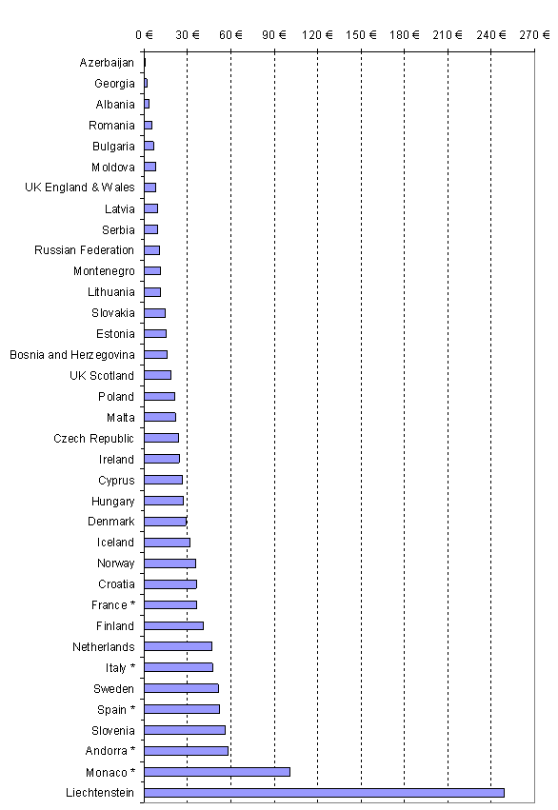

* estimated or calculated budget
Graph 2 Annual budget allocated to all courts without prosecution and legal aid in 2004 per inhabitant as percentage of per capita GDP
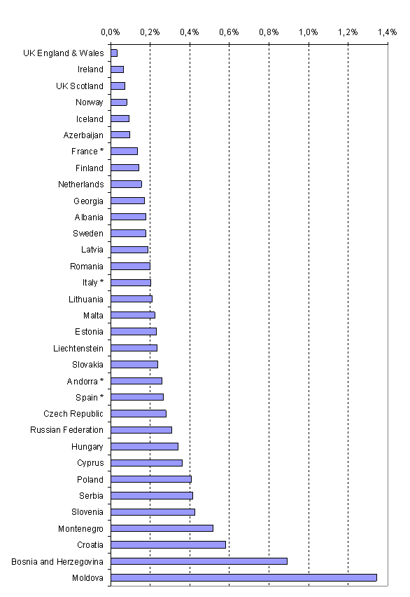

* estimated or calculated budget

2.3 The budget allocated to the public prosecution system in 2004

Figures and methodology

Among the 47 states or entities considered, 36 were taken into account in this table.

In the large majority of the countries or entities (32), public prosecution systems are fully separate from courts and have their own budget.

In 13 countries, courts and prosecution systems are managed together or come under a single budget. Five of them (Andorra, France, Italy, Monaco and Spain) have been able to estimate the respective parts of the budget allocated to courts and to the prosecution system. Therefore, they appear in the table. On the contrary, 8 other states (Armenia, Austria, Belgium, Germany, Greece, Luxembourg, Portugal, Turkey) were unable to estimate these respective parts and therefore do not appear in the table, such as Cyprus, Denmark and San Marino which were not able to provide answers on this part.

Table 3. Budget allocated to the prosecution system in 2004 (question 9)

Country | Q9 Annual public budget spent on the prosecution system | Annual public budget spent on the prosecution system per inhabitant | Annual public budget spent on the prosecution system per inhabitant as percentage of per capita GDP | Annual public budget spent on the prosecution system per inhabitant as percentage of annual gross average salary
Albania | 8 498 900 € | 2,8 € | 0,14% | 0,11%
Andorra * | 426 969 € | 5,6 € | 0,02% | 0,04%
Azerbaijan | 10 916 740 € | 1,3 € | 0,15% | 0,13%
Bosnia and Herzegovina | 16 591 370 € | 4,3 € | 0,25% | 0,09%
Bulgaria | 22 826 626 € | 2,9 € | - | 0,12%
Croatia | 28 967 501 € | 6,5 € | 0,11% | 0,07%
Czech Republic | 55 924 241 € | 5,5 € | 0,06% | 0,08%
Estonia | 3 500 000 € | 2,6 € | 0,04% | 0,05%
Finland | 33 022 000 € | 6,3 € | 0,02% | 0,02%
France | 646 771 000 € | 10,4 € | 0,04% | 0,03%
Georgia | 7 498 585 € | 1,7 € | 0,18% | 0,17%
Hungary | 108 000 000 € | 10,7 € | 0,13% | 0,15%
Iceland | 3 100 000 € | 10,6 € | 0,03% | 0,03%
Ireland | 28 661 000 € | 7,1 € | 0,02% | 0,03%
Italy | 1 167 510 000 € | 20,0 € | 0,09% | 0,09%
Latvia | 12 018 365 € | 5,2 € | 0,11% | 0,14%
Liechtenstein | 1 302 339 € | 37,6 € | 0,04% | 0,05%
Lithuania | 24 375 087 € | 7,1 € | 0,14% | 0,18%
Malta | 1 023 260 € | 2,5 € | 0,03% | 0,02%
Moldova | 18 623 700 € | 5,5 € | 0,96% | 0,64%
Monaco * | 780 740 € | 26,0 € | - | -
Montenegro | 1 197 047 € | 1,9 € | 0,09% | 0,05%
Netherlands | 335 300 000 € | 20,6 € | 0,07% | 0,07%
Norway | 10 737 € | 0,0 € | 0,00001% | 0,00001%
Poland | 226 591 855 € | 5,9 € | 0,11% | 0,10%
Romania | 70 989 086 € | 3,3 € | 0,12% | 0,14%
Russian Federation | 926 827 355 € | 6,5 € | 0,19% | 0,27%
Serbia | 12 108 235 € | 1,6 € | 0,07% | 0,05%
Slovakia | 26 289 474 € | 4,9 € | 0,08% | 0,10%
Slovenia | 15 600 000 € | 7,8 € | 0,06% | 0,06%
Spain * | 153 158 726 € | 3,6 € | 0,02% | 0,01%
Sweden | 89 000 000 € | 9,9 € | 0,03% | 0,03%
Ukraine | 41 307 900 € | 0,9 € | 0,08% | 0,08%
UK England & Wales | 770 000 000 € | 14,5 € | 0,06% | 0,04%
UK Northern Ireland | 35 370 000 € | 20,7 € | 0,08% | 0,07%
UK Scotland | 131 300 000 € | 25,9 € | 0,11% | 0,08%
* estimated budget

Comments

The very strong differences between the competences and the organisational structure of the public prosecution must be taken into account when examining the amounts devoted to the public prosecution. This information appears later in the report, such as other important and relevant data, in particular the number of staff and their jurisdiction.

Some countries indicated a small amount of financial resources assigned to the public prosecution. It is in particular the case for Norway, which would have declared a much higher amount if it had integrated in the budget of its prosecution system the members of the police force who are attached to the public prosecution. The figure must therefore be interpreted cautiously. In another example, in Malta, the legal aid (16.720 €) is included in the budget of the public prosecution.

In 6 countries or entities (Italy, Liechtenstein, Netherlands, Monaco, UK-Northern Ireland and UK-Scotland), the amount that is devoted to the functions of the public prosecution is equal or exceeds the 20 Euros per capita. But it is in Bosnia-Herzegovina, Moldova, Russian Federation and Georgia that this amount is the highest compared to the GDP per capita.
Graph 3. Annual budget spend on the public prosecution system in 2004
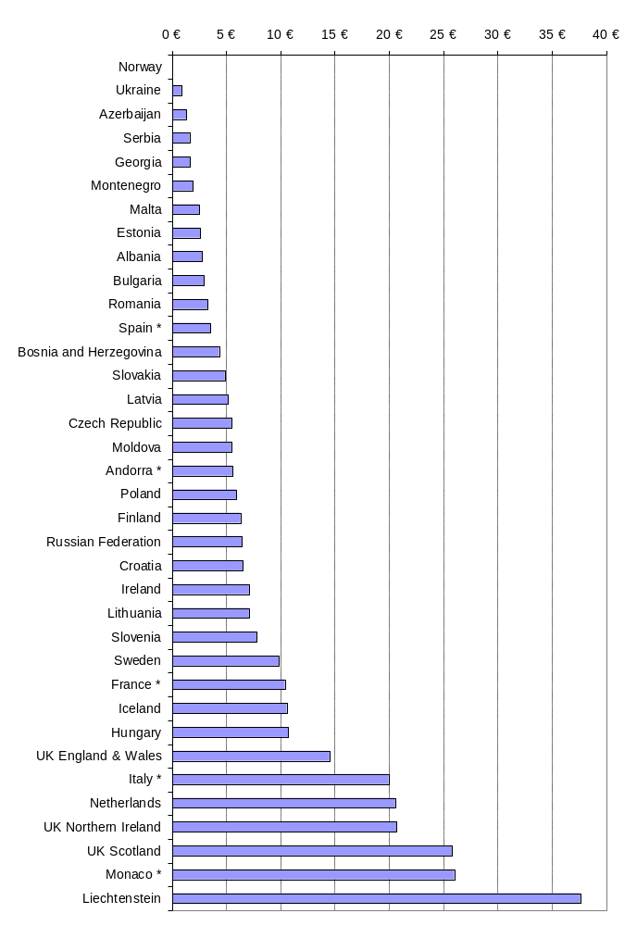
* estimated budget

Graph 4. Public budget spend on the prosecution system per inhabitant as percentage of the per capita GDP in 2004
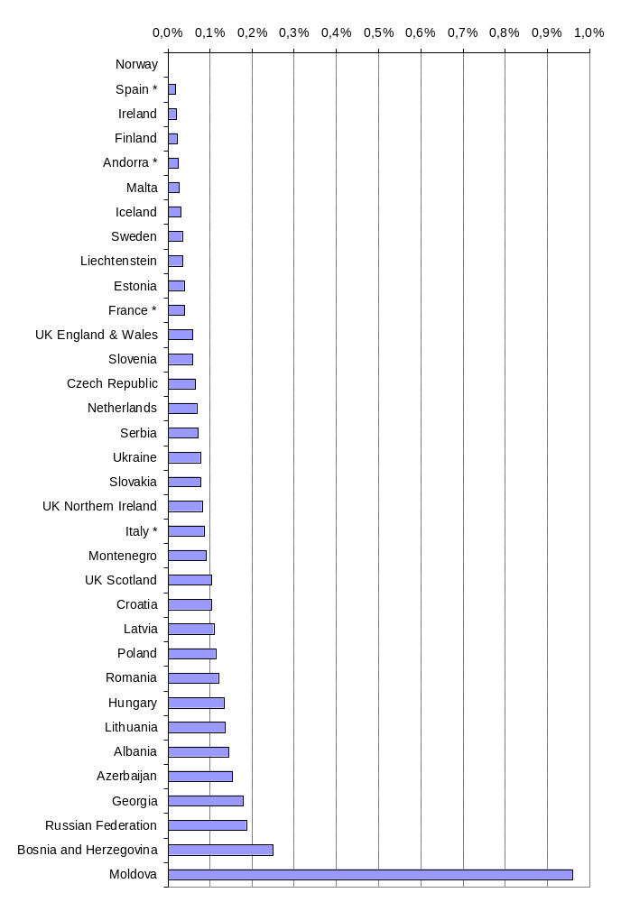
* estimated budget

2.4 Budget allocated to legal aid in 2004

Figures and methodology

38 countries or entities were able to provide the data on the total budget allocated to the legal aid. For two of them, Austria and Germany, it concerns estimated data.

For Bosnia-Herzegovina, the amount quoted in the table is a calculated average. The inadequacy of the accounting systems and the fact that only 54% of the courts could provide information concerning the budget for legal aid make that the amount of the legal aid cannot be quantified with exactitude. It is estimated, for the year 2004 between 1 million and 2,5 million Euros.

In the case of Hungary the situation is a little different: the budget of 2004 envisages an amount of 2.554.000 Euros, but this sum is intended to meet the needs for legal aid over a three year period, until 2006 (included). It has thus been proceeded, in agreement with this country, with a division by three of the declared sum.

The following countries, which could not quantify the total amount of the legal aid, do not appear in the list: Croatia, Cyprus, Montenegro, Russian Federation, San Marino, Serbia, Slovenia and Ukraine. For Slovenia only the amount of legal aid in civil matters, with the exclusion of that granted for the penal criminal cases, is presented in the table. These data will be analyzed in chapter 3 of this report.

In addition, the data declared by two countries must be taken with precaution because they do not represent exactly the total amount devoted to the legal aid during the year 2004. Indeed, the budget of the legal aid of 2004 of Portugal includes amounts due for the legal aid granted at the time of the preceding years (but only regulated in 2004). Lastly, the amount declared by Spain corresponds to the adopted budget instead of the supplementary sums granted during the exercise of 2004. Thus, the envisaged budget for legal aid (as presented for the Parliament) concerning legal aid was 18.304.834 Euros, while the real expenditure for legal aid in 2004 was 29.054.112 Euros. It must also be noted that the expenditure for legal aid of all the all autonomous Communities during the year under review are not known.

Table 4. Annual public budget allocated to legal aid in 2004

Country | Q7 Annual public budget spent on legal aid | Annual budget allocated to legal aid per inhabitant | Annual budget allocated to legal aid per inhabitant as percentage of per capita GDP | Annual budget allocated to legal aid per inhabitant as percentage of annual gross average salary
Albania | 130 550 € | 0,043 € | 0,002% | 0,002%
Andorra | 230 668 € | 3,001 € | 0,013% | 0,020%
Armenia | 14 500 € | 0,005 € | 0,001% | 0,001%
Austria * | 24 100 000 € | 2,937 € | 0,010% | 0,008%
Azerbaijan | 28 500 € | 0,003 € | 0,000% | 0,000%
Belgium | 30 750 000 € | 2,944 € | 0,011% | 0,009%
Bosnia and Herzegovina * | 1 777 399 € | 0,464 € | 0,027% | 0,010%
Bulgaria | 1 571 358 € | 0,202 € | - | 0,008%
Czech Republic | 12 273 022 € | 1,201 € | 0,014% | 0,018%
Denmark | 3 200 000 € | 0,593 € | - | -
Estonia | 1 700 000 € | 1,258 € | 0,019% | 0,023%
Finland | 52 129 000 € | 9,955 € | 0,035% | 0,030%
France | 291 200 000 € | 4,683 € | 0,018% | 0,012%
Georgia | 69 760 € | 0,015 € | 0,002% | 0,002%
Germany * | 468 400 000 € | 5,678 € | 0,021% | 0,014%
Greece | 724 187 € | 0,065 € | 0,0004% | 0,0004%
Hungary * | 851 333 € | 0,084 € | 0,001% | 0,001%
Iceland | 1 200 000 € | 4,088 € | 0,012% | 0,011%
Ireland | 47 649 000 € | 11,794 € | 0,032% | 0,042%
Italy | 66 030 256 € | 1,129 € | 0,005% | 0,005%
Latvia | 653 490 € | 0,282 € | 0,006% | 0,008%
Liechtenstein | 1 292 008 € | 37,341 € | 0,035% | 0,050%
Lithuania | 1 636 208 € | 0,478 € | 0,009% | 0,012%
Luxembourg | 2 574 828 € | 5,659 € | 0,010% | 0,014%
Malta | 16 720 € | 0,042 € | 0,0004% | 0,0004%
Moldova | 124 100 € | 0,037 € | 0,006% | 0,004%
Monaco | 102 950 € | 3,429 € | - | -
Netherlands | 378 358 000 € | 23,224 € | 0,077% | 0,076%
Norway | 137 528 000 € | 29,856 € | 0,068% | 0,072%
Poland | 16 775 566 € | 0,439 € | 0,008% | 0,007%
Portugal | 27 632 424 € | 2,624 € | 0,019% | 0,019%
Romania | 1 810 732 € | 0,084 € | 0,003% | 0,003%
Slovakia | 1 967 026 € | 0,364 € | 0,006% | 0,007%
Spain | 119 055 984 € | 2,773 € | 0,014% | 0,011%
Sweden | 95 455 900 € | 10,565 € | 0,037% | 0,033%
Turkey | 13 626 853 € | 0,192 € | 0,006% | 0,002%
UK England & Wales | 3 070 000 000 € | 57,874 € | 0,235% | 0,157%
UK Northern Ireland | 93 630 000 € | 54,745 € | 0,216% | 0,176%
UK Scotland | 216 000 000 € | 42,533 € | 0,173% | 0,127%
* estimated budget or calculated budget

Comments

In UK-England and Wales, the budget devoted to the legal aid was in 2004, definitely higher than all the other countries. It is followed by far by Germany, the Netherlands and France.

The reports referring to the number of inhabitants, the GDP per head and the annual gross salary shows that the three entities of the United Kingdom allocate a high budget for legal aid. After that, in variable orders, the countries of Northern Europe (in particular Norway), Liechtenstein, and the Netherlands are following.

More precise elements regarding legal aid appear in chapter 3 of this report.

Graph 5. Annual public budget spend on legal aid per inhabitant in 2004

0 €
5 €
10 €
15 €
20 €
25 €
30 €
35 €
40 €
45 €
50 €
55 €
60 €
Azerbaijan
Armenia
Georgia
Moldova
Malta
Albania
Greece
Romania
Hungary *
Turkey
Bulgaria
Latvia
Slovakia
Poland
Bosnia and Herzegovina *
Lithuania
Denmark
Italy
Czech Republic
Estonia
Portugal
Spain
Austria *
Belgium
Andorra
Monaco
Iceland
France
Luxembourg
Germany *
Finland
Sweden
Ireland
Netherlands
Norway
Liechtenstein
UK Scotland
UK Northern Ireland
UK England & Wales

* estimated or calculated budget

Graph 6. Annual public budget spent on legal aid per inhabitant as percentage of per capita GDP in 2004
0,00%
0,02%
0,04%
0,06%
0,08%
0,10%
0,12%
0,14%
0,16%
0,18%
0,20%
0,22%
0,24%
0,26%
Azerbaijan
Malta
Greece
Armenia
Hungary *
Georgia
Albania
Romania
Italy
Turkey
Slovakia
Latvia
Moldova
Poland
Lithuania
Luxembourg
Austria *
Belgium
Iceland
Andorra
Czech Republic
Spain
France
Estonia
Portugal
Germany *
Bosnia and Herzegovina *
Ireland
Finland
Liechtenstein
Sweden
Norway
Netherlands
UK Scotland
UK Northern Ireland
UK England & Wales

* estimated or calculated budget

2.5 Budget allocated to the courts and the prosecution system (without legal aid) in 2004

Figures and methodology

The figures available allowed the inclusion in the comparison of 45 countries or entities, out of the 47 having answered.

The countries which were not included in tables 2 and 3 because they could not specify or evaluate the budget allocated to the prosecution system can appear in this table: Armenia, Austria, Belgium, Germany, Greece, Luxembourg, Monaco, Portugal and Turkey.

Cyprus and San Marino are excluded from this table, because they could not quantify the amount devoted to the public prosecution while at the same time this amount is excluded from the budget allocated to the courts. This is also the case for UK-Northern Ireland, which has not been able to provide for the amount of the budget allocated to courts.

Slovenia, which was not able to quantify the amount of the legal aid included in the budget, is present in the table because, as one mentioned above; this amount is not significant there.

This addition allows the comparison of the means allocated to the functions of prosecuting and judging, in spite of the differences in the organisation of the system, between those countries where the prosecution system is fully separate from courts and those where both institutions are joined.

Table 5. Budget allocated to the judicial system, including courts and public prosecution (without legal aid) in 2004

Country | Total annual budget allocated to all courts and prosecution (without legal aid) | Annual budget allocated to all courts and prosecution (without legal aid) in 2004 per inhabitant | Annual budget allocated to all courts and prosecution (without legal aid) in 2004 per inhabitant as percentage of per capita GDP | Annual budget allocated to all courts and prosecution (without legal aid) in 2004 per inhabitant as percentage of annual gross average salary
Albania | 18 984 965 € | 6 € | 0,3% | 0,3%
Andorra * | 4 874 162 € | 63 € | 0,3% | 0,4%
Armenia | 2 109 239 € | 1 € | 0,1% | 0,1%
Austria | 512 165 392 € | 62 € | 0,2% | 0,2%
Azerbaijan | 17 831 797 € | 2 € | 0,3% | 0,2%
Belgium | 661 850 000 € | 63 € | 0,2% | 0,2%
Bosnia and Herzegovina | 75 854 274 € | 20 € | 1,1% | 0,4%
Bulgaria | 71 726 939 € | 9 € | - | 0,4%
Croatia | 188 956 053 € | 43 € | 0,7% | 0,4%
Czech Republic | 297 216 931 € | 29 € | 0,3% | 0,4%
Denmark | 155 000 000 € | 29 € | - | -
Estonia | 24 200 000 € | 18 € | 0,3% | 0,3%
Finland | 244 658 000 € | 47 € | 0,2% | 0,1%
France | 2 904 752 000 € | 47 € | 0,2% | 0,1%
Georgia | 14 704 923 € | 3 € | 0,4% | 0,3%
Germany | 7 948 600 000 € | 96 € | 0,4% | 0,2%
Greece | 309 975 813 € | 28 € | 0,2% | 0,2%
Hungary | 384 464 000 € | 38 € | 0,5% | 0,5%
Iceland | 12 500 000 € | 43 € | 0,1% | 0,1%
Ireland | 126 652 000 € | 31 € | 0,1% | 0,1%
Italy | 3 917 454 000 € | 67 € | 0,3% | 0,3%
Latvia | 33 092 720 € | 14 € | 0,3% | 0,4%
Liechtenstein | 9 913 481 € | 287 € | 0,3% | 0,4%
Lithuania | 62 420 152 € | 18 € | 0,3% | 0,5%
Luxembourg | 46 019 167 € | 101 € | 0,2% | 0,3%
Malta | 9 702 260 € | 24 € | 0,2% | 0,2%
Moldova | 44 638 800 € | 13 € | 2,3% | 1,5%
Monaco * | 3 800 750 € | 127 € | - | -
Montenegro | 7 988 778 € | 13 € | 0,6% | 0,4%
Netherlands | 1 097 907 000 € | 67 € | 0,2% | 0,2%
Norway | 164 010 737 € | 36 € | 0,1% | 0,1%
Poland | 1 040 321 040 € | 27 € | 0,5% | 0,4%
Portugal | 524 830 177 € | 50 € | 0,4% | 0,4%
Romania | 188 950 349 € | 9 € | 0,3% | 0,4%
Russian Federation | 2 472 479 157 € | 17 € | 0,5% | 0,7%
Serbia | 82 316 016 € | 11 € | 0,5% | 0,3%
Slovakia | 105 628 501 € | 20 € | 0,3% | 0,4%
Slovenia | 127 100 000 € | 64 € | 0,5% | 0,5%
Spain * | 2 384 690 036 € | 56 € | 0,3% | 0,2%
Sweden | 552 687 163 € | 61 € | 0,2% | 0,2%
Turkey | 319 590 907 € | 4 € | 0,1% | 0,1%
Ukraine | 149 004 200 € | 3 € | 0,3% | 0,3%
UK England & Wales | 1 199 000 000 € | 23 € | 0,1% | 0,1%
UK Scotland | 224 601 917 € | 44 € | 0,2% | 0,1%
* estimated budget

Comments

The ratio per capita enables to compare 44 countries or entities. The main figures which arise correspond obviously to the level of wealth within the Council of Europe, but substantial differences exist between countries with similar levels of development.

The calculated figures taking the GDP per inhabitant as a basis, can be applied in 41 countries, makes it possible to create another hierarchy. It is then in Montenegro, Croatia, Bosnia-Herzegovina and Moldova that the amount devoted to the functions of prosecution and courts are the highest.

The share of this amount in the average gross annual salary, which could be calculated for 42 countries, is most important in Lithuania, Slovenia, Hungary, Russian Federation and Moldova.

Graph 7. Total annual budget allocated to all courts and prosecution (without legal aid) per inhabitant in 2004
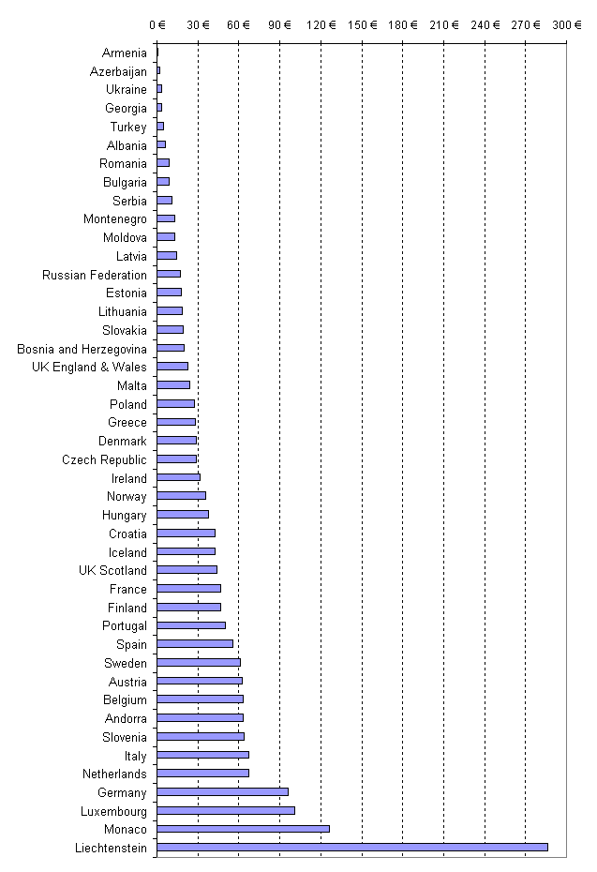

Graph 8. Total annual budget allocated to all courts and prosecution (without legal aid) per inhabitant in 2004 as percentage of per capita GDP
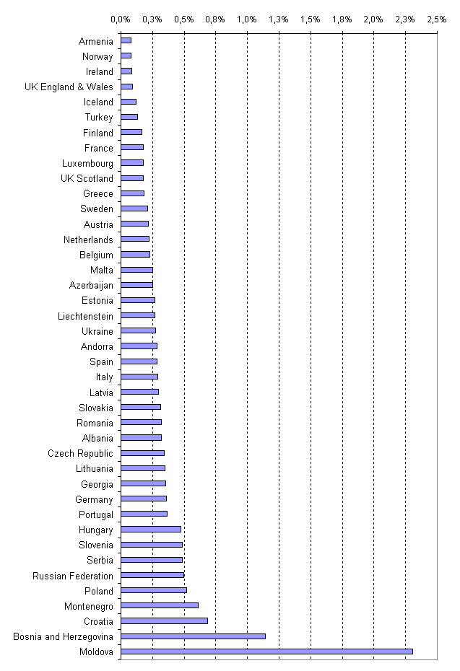

2.6 Budget allocated to the judicial system, including courts, the prosecution systems and legal aid in 2004

Figures and methodology

The figures available enabled to include in the comparison 38 countries or entities, out of the 47 responding ones.

Similarly to table 5, the countries which are not included in tables 2 and 3 because they could not specify or evaluate the budget allocated to the prosecution system can appear in this table: Austria, Belgium, Germany, Greece, Luxembourg, Monaco, Portugal and Turkey.

Excluded from the table are the countries which were not able to indicate, overall or separately, on the one hand the budget of the courts and the prosecution services and, on the other hand, the budget for the legal aid when this last item is excluded from the preceding budgets (Croatia, Cyprus, Denmark, Montenegro, Russia Federation, San Marino, Serbia, Ukraine and UK-Northern Ireland).

This addition enables not only to compare the means allocated to the functions of prosecuting and judging, in spite of the differences in the organisation of the systems, but also to add the amounts allocated to the access to justice. These data enable thus to have a global overview on the budgets for almost all the member states of the Council of Europe.

Table 6. Budget allocated to the judicial system, including the courts, the prosecution system and legal aid in 2004

Country | Total budget allocated to the judiciary system (courts, public prosecution and legal aid) | Annual budget allocated to the judiciary system (courts, prosecution and legal aid) in 2004 per inhabitant | Annual budget allocated to the judiciary system (courts, prosecution and legal aid) in 2004 per inhabitant as percentage of per capita GDP | Annual budget allocated to the judiciary system (courts, prosecution and legal aid) in 2004 per inhabitant as percentage of annual gross average salary
Albania | 19 115 515 € | 6,2 € | 0,3% | 0,3%
Andorra * | 5 104 829 € | 66,4 € | 0,3% | 0,4%
Armenia | 2 123 739 € | 0,7 € | 0,1% | 0,1%
Austria * | 536 265 392 € | 65,3 € | 0,2% | 0,2%
Azerbaijan | 17 860 297 € | 2,1 € | 0,3% | 0,2%
Belgium | 692 600 000 € | 66,3 € | 0,2% | 0,2%
Bosnia and Herzegovina * | 77 631 673 € | 20,3 € | 1,2% | 0,4%
Bulgaria | 73 298 297 € | 9,4 € | - | 0,4%
Czech Republic | 309 489 953 € | 30,3 € | 0,4% | 0,4%
Estonia | 25 900 000 € | 19,2 € | 0,3% | 0,3%
Finland | 296 787 000 € | 56,7 € | 0,2% | 0,2%
France | 3 195 952 000 € | 51,4 € | 0,2% | 0,1%
Georgia | 14 774 683 € | 3,3 € | 0,4% | 0,3%
Germany | 8 417 000 000 € | 102,0 € | 0,4% | 0,3%
Greece | 310 700 000 € | 28,1 € | 0,2% | 0,2%
Hungary * | 385 315 333 € | 38,2 € | 0,5% | 0,5%
Iceland | 13 700 000 € | 46,7 € | 0,1% | 0,1%
Ireland | 174 301 000 € | 43,1 € | 0,1% | 0,2%
Italy | 3 983 484 256 € | 68,1 € | 0,3% | 0,3%
Latvia | 33 746 210 € | 14,6 € | 0,3% | 0,4%
Liechtenstein | 11 205 489 € | 323,9 € | 0,3% | 0,4%
Lithuania | 64 056 360 € | 18,7 € | 0,4% | 0,5%
Luxembourg | 48 593 995 € | 106,8 € | 0,2% | 0,3%
Malta | 9 718 980 € | 24,1 € | 0,3% | 0,2%
Moldova | 44 762 900 € | 13,2 € | 2,3% | 1,5%
Monaco * | 3 903 700 € | 130,0 € | - | -
Netherlands | 1 476 265 000 € | 90,6 € | 0,3% | 0,3%
Norway | 301 538 737 € | 65,5 € | 0,1% | 0,2%
Poland | 1 057 096 606 € | 27,7 € | 0,5% | 0,4%
Portugal | 552 462 601 € | 52,5 € | 0,4% | 0,4%
Romania | 190 761 081 € | 8,8 € | 0,3% | 0,4%
Slovakia | 107 595 527 € | 19,9 € | 0,3% | 0,4%
Slovenia | 127 100 000 € | 63,6 € | 0,5% | 0,5%
Spain * | 2 503 746 020 € | 58,3 € | 0,3% | 0,2%
Sweden | 648 143 063 € | 71,7 € | 0,2% | 0,2%
Turkey | 333 217 760 € | 4,7 € | 0,1% | 0,1%
UK England & Wales | 4 269 000 000 € | 80,5 € | 0,3% | 0,2%
UK Scotland | 440 601 917 € | 86,8 € | 0,4% | 0,3%
* estimated budget or calculated budget

Comments

The ratio per inhabitant makes it possible to compare 38 countries or entities. The table above makes it possible to evaluate the direct impact of the budget of legal aid on the total amount of the budget devoted to the functioning of justice.

As in the preceding "regrouping" of countries, the size of these budgets corresponds obviously to the level of wealth of the member states of the Council of Europe.

Other hierarchies appear when the total budget is balanced with the GDP per inhabitant (calculated for 36 countries or entites). Moldova and Bosnia-Herzegovina appear always at the head and are followed, in the descending order by: Poland, Slovenia and Hungary. Lastly, the share of the total budget in the average annual gross salary, which could be calculated for 37 countries, is most important in Moldova, Slovenia, Hungary and Lithuania.
Graph 9. Total budget allocated to the judicial system per inhabitant in 2004
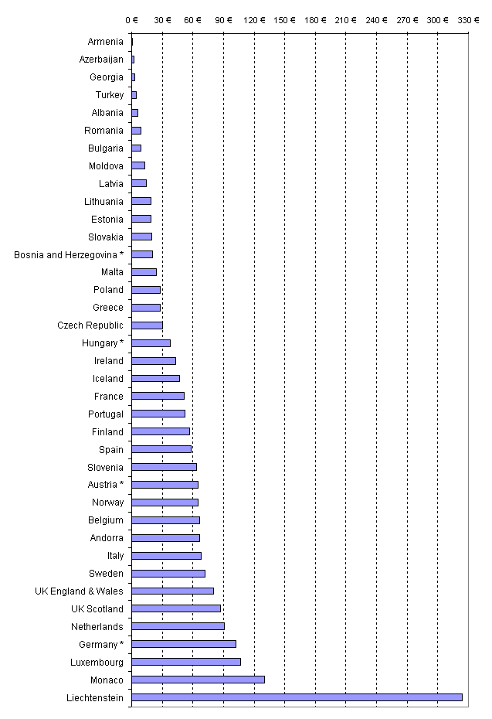
* estimated or calculated budget

Graph 10. Total budget allocated to the judicial system per inhabitant in 2004 as percentage of per capita GDP
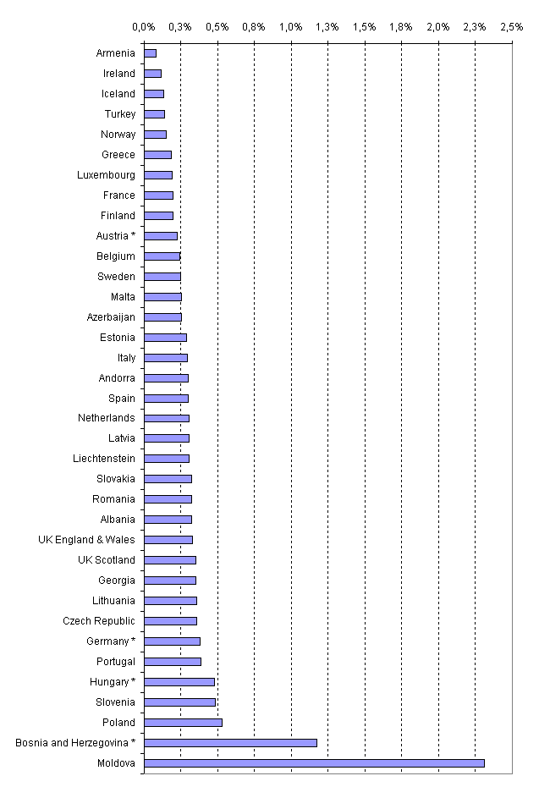
* estimated or calculated budget

2.7 Budget allocated to courts and legal aid

Figures and methodology

These figures enable to compare only 32 countries or entities.

Indeed, this table excludes the budget of the prosecution system. Therefore the countries which have not been able to provide or estimate the respective parts of the budget allocated to the courts and to the prosecution system cannot be included: Armenia, Austria, Belgium, Germany, Greece, Luxembourg, Portugal and Turkey.

It also excludes 6 countries which have not been able to indicate the amount of the legal aid budget: Croatia, Montenegro, the Russian Federation, San Marino, Serbia and Ukraine.

It includes Albania and Bulgaria for which it has been considered that the legal aid budget was not included in the budget of courts (see chapter 1).

Cyprus and Slovenia indicate that the figures given as regards the budget of courts include legal aid, but they cannot specify the amount. Subsequently, some exchanges showed that this amount does not seem to be significant, it deemed preferable to include these two countries in the table of the court budget (table 2). This also appears here, even though this approach, which was slightly favourable for these two countries in table 6, is here slightly unfavourable.

Table 7. Budget allocated to courts and legal aid (without public prosecution) in 2004

Country | Total annual budget allocated to all courts and legal aid (without prosecution) | Annual budget allocated to all courts and legal aid (without prosecution) per inhabitant | Annual budget allocated to all courts and legal aid (without prosecution) per inhabitant as percentage of per capita GDP | Annual budget allocated to all courts and legal aid (without prosecution) per inhabitant as percentage of annual gross average salary
Albania | 10 616 615 € | 3,5 € | 0,18% | 0,14%
Andorra | 4 677 861 € | 60,9 € | 0,27% | 0,41%
Azerbaijan | 6 943 557 € | 0,8 € | 0,10% | 0,08%
Bosnia and Herzegovina | 61 040 303 € | 15,9 € | 0,92% | 0,34%
Bulgaria | 50 471 671 € | 6,5 € | - | 0,27%
Cyprus | 17 997 698 € | 26,1 € | 0,36% | 0,22%
Czech Republic | 253 565 712 € | 24,8 € | 0,29% | 0,37%
Denmark | 158 200 000 € | 29,3 € | - | -
Estonia | 22 400 000 € | 16,6 € | 0,25% | 0,30%
Finland | 263 765 000 € | 50,4 € | 0,18% | 0,15%
France | 2 549 181 000 € | 41,0 € | 0,15% | 0,11%
Georgia | 7 276 098 € | 1,6 € | 0,17% | 0,16%
Hungary | 277 315 333 € | 27,5 € | 0,34% | 0,39%
Iceland | 10 600 000 € | 36,1 € | 0,10% | 0,09%
Ireland | 145 640 000 € | 36,0 € | 0,10% | 0,13%
Italy | 2 815 974 256 € | 48,2 € | 0,21% | 0,22%
Latvia | 21 727 845 € | 9,4 € | 0,20% | 0,26%
Liechtenstein | 9 903 150 € | 286,2 € | 0,27% | 0,38%
Lithuania | 39 681 273 € | 11,6 € | 0,22% | 0,29%
Malta | 8 695 720 € | 21,6 € | 0,22% | 0,19%
Moldova | 26 139 200 € | 7,7 € | 1,35% | 0,90%
Monaco | 3 122 960 € | 104,0 € | - | -
Netherlands | 1 140 965 000 € | 70,0 € | 0,23% | 0,23%
Norway | 301 528 000 € | 65,5 € | 0,15% | 0,16%
Poland | 830 504 751 € | 21,8 € | 0,41% | 0,35%
Romania | 119 771 995 € | 5,5 € | 0,20% | 0,23%
Slovakia | 81 306 053 € | 15,1 € | 0,24% | 0,30%
Slovenia | 111 500 000 € | 55,8 € | 0,43% | 0,41%
Spain | 2 350 587 294 € | 54,7 € | 0,28% | 0,22%
Sweden | 559 143 063 € | 61,9 € | 0,21% | 0,19%
UK England & Wales | 3 499 000 000 € | 66,0 € | 0,27% | 0,18%
UK Scotland | 309 301 917 € | 60,9 € | 0,25% | 0,18%

Comments

The regrouping makes it possible to compare 32 countries or entities and to measure the direct impact of the budgets of the legal aid compared to the budget of the courts strictly speaking. Balanced with the number of inhabitants, this impact is very important for UK-England and Wales, Netherlands, Liechtenstein and Monaco.

This ratio per inhabitant, reported as GDP per inhabitant and the average annual gross salary, reveals another hierarchy. In the first case appear Moldova, Bosnia and Herzegovina, Slovenia and Poland and in the second Moldova, Slovenia, Andorra and Hungary.

Graph 11. Total annual budget allocated to all courts and legal aid (without prosecution) per inhabitant in 2004
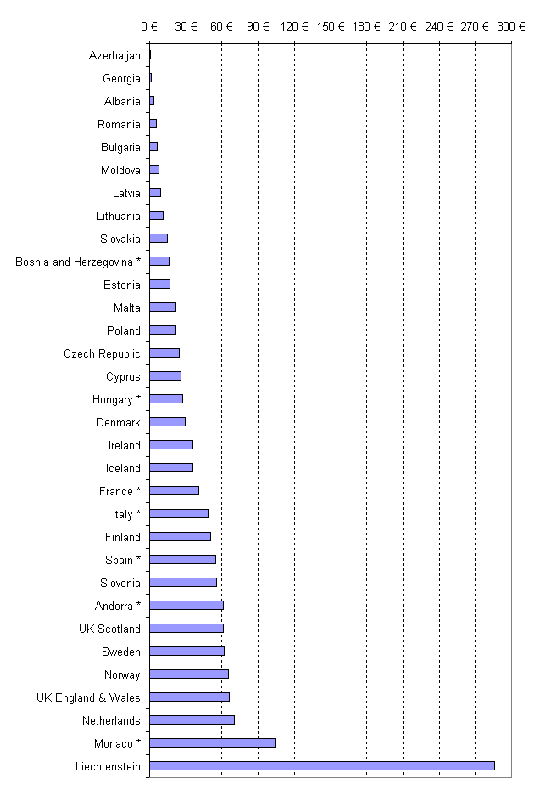
* estimated or calculated budget

Graph 12. Total annual budget allocated to all courts and legal aid (without prosecution) per inhabitant in 2004 as percentage of per capita GDP
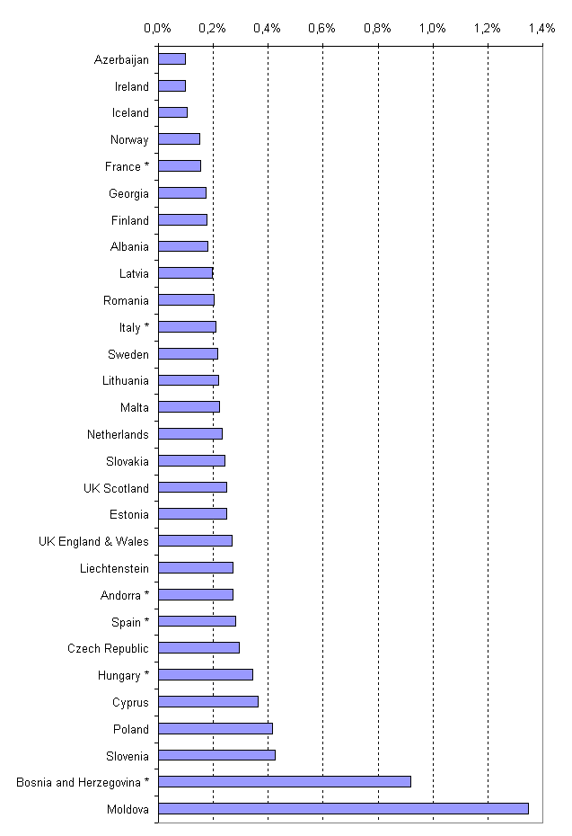
* estimated or calculated budget

3. Legal aid

3.1 Introduction

Legal aid is one of the fundamental elements to guarantee equal access to justice for all individuals, as provided for by Article 6.3 of the European Convention of Human Rights as regards criminal law cases. This aid should in particular allow citizens who do not have sufficient financial means, to be assisted free of charge or for limited costs by professionals or to be granted financial support within the framework of judicial proceedings.

Beyond the European Convention of Human Rights and the case law of the Court of Strasbourg, the Council of Europe encourages its member states to develop legal aid systems and has adopted several legal instruments in this field: Resolution 76 (5) on legal aid in civil, commercial and administrative matters; Resolution 78 (8) on legal aid and advice; Recommendation 93 (1) on effective access to the law and justice for the very poor and Recommendation 2005 (12) containing an application form for legal aid abroad for use under the European Agreement on the transmission of applications for legal aid and its additional protocol.

Legal aid is defined here as: aid given by the State to persons who do not have sufficient financial means to defend themselves before a court (or to start a court proceeding). In this definition legal aid mainly concerns legal representation before the court. However, legal aid might also consist in legal advice. In fact, not all citizens facing legal problems start a judicial proceeding before a court. In some cases legal advice can be sufficient to solve the question.

In the evaluation scheme, countries were asked to provide information regarding the use of legal aid in terms of legal representation and legal advice. 44 countries or entities offer legal aid to finance the cost of representation in criminal proceedings. In non-criminal cases, 38 countries provide for legal aid to be represented in courts. The financing of legal advice is foreseen for criminal cases in 37 countries and for non-criminal cases in 34 countries. Legal aid in criminal matters is not always provided in Denmark and Iceland. In Iceland, the State only pays the cost of an ex officio defence lawyer if the defendant is acquitted. In the case of a conviction, the convicted has to bear the legal cost. Only when a citizen is not able to pay the legal cost, the defence lawyer may be paid out of the state budget.

No legal aid in non-criminal matters is provided in Albania (legal aid is not provided by the state but by NGO's), Armenia (only legal advice concerning maintenance obligations), Bosnia and Herzegovina, Georgia, Latvia (only preparation of legal documents), Moldova, Montenegro (when an individual does not have sufficient financial means to cover the expenses of the court proceedings, he/she can request the court to relief him/her from the legal expenses) and Slovak Republic (only legal advice).

In the Czech Republic legal aid is provided through the budget of the Bar Association, which seems to be the only responding country to experience a system where officially recognized legal aid is funded by a professional organisation.

Table 8. Matters covered by legal aid and type of legal aid (question 11)

Matter | Type of aid | Number of positive answers
Criminal cases | Representation in court | 44
Criminal cases | Legal advice | 37
Criminal cases | Other | 15
Other than criminal cases | Representation in court | 38
Other than criminal cases | Legal advice | 34
Other than criminal cases | Other | 17

3.2 The budget for legal aid

In chapter 2 of this report was examined the total budget of legal aid under the angle of its amount reported to the population and the GDP per inhabitants. To supplement this first approach, the following table declines the average amount spent on legal aid in criminal matters, civil matters and on the whole, as well as the number of (granted) legal aid cases per 10.000 inhabitants in 2004. Only in this table the countries which have been able to provide at least one of detailed information appear. Bosnia and Herzegovina, for example, does not appear there because the number of cases is not known, whereas the granted total amount of legal aid was examined in chapter 2.

As in the chapter on budget, all the raw data have been given in appendix (see table 79 in appendix), namely the number of legal aid cases in criminal matters, civil matters and the total number of cases, as well as the corresponding amounts. The average amounts were calculated only for the countries having provided at the same time the number of cases concerned and the corresponding amount. Lastly, the precise details of the countries on the total amount of the legal aid (question 7) appear in chapter 2 of this report. Below in the table, the precise details concerning the number of cases (penal or civil) concerned by legal aid in 2004 is presented.

In table 9 appears the number of legal aid cases. By comparing the distribution of the budget for legal aid between the criminal matter cases and other than criminal matter cases, it can be noted that there are countries where the majority of the budget is allocated to criminal cases (Ireland, Italy, Turkey, UK-England and Wales and UK-Scotland). In Finland, France, Germany, Luxembourg, Monaco, the Netherlands and UK-Northern Ireland, a relatively significant part of the budget of legal aid is intended for the other than criminal cases.

In the Czech Republic, legal aid is funded through the budget of the bar association; it seems that it is the only responding country where official legal aid is funded by a professional organisation.

Table 9. Number of legal aid cases per 10 000 inhabitants and average amount per case spent in 2004 (questions 1, 7, 8 and 12)

Country | Total number of legal aid cases per 10 000 inhabitants | Average amount granted per case | Number of legal aid criminal cases per 10 000 inhabitants | average amount granted per case in criminal matters | Number of legal aid other than criminal cases per 10 000 inhabitants | average amount granted per case in other than criminal matters
Andorra | 57 | 528 € | - | - | - | -
Austria | 30 | 978 € | - | - | - | -
Belgium | 95 | 309 € | - | - | - | -
Croatia | 1 | - | - | - | - | -
Cyprus | 17 | - | 12 | - | 5 | -
Denmark | 32 | 185 € | - | - | 32 | 185 €
Finland | 152 | 656 € | 52 | - | 99 | -
France | 134 | 350 € | 57 | 350 € | 77 | 350 €
Georgia | 0,3 | 612 € | 0,3 | 612 € | - | -
Germany * | - | - | - | - | 70 | 657 €
Hungary | 52 | 16 € | 15 | - | 38 | -
Iceland | 13 | 3 061 € | - | - | - | -
Ireland | 99 | 1 192 € | 79 | 1 073 € | 20 | 1 659 €
Italy | 17 | 675 € | 12 | 859 € | 4 | 137 €
Luxembourg | 79 | 715 € | 20 | - | 59 | -
Monaco | 219 | 157 € | 32 | - | 187 | -
Netherlands | 211 | 1 102 € | 79 | 1 118 € | 131 | 1 092 €
Norway | - | - | - | - | 12 | 13 461 €
Portugal | 124 | 212 € | - | - | - | -
Romania | 133 | 6 € | - | - | - | -
Slovenia * | - | - | - | - | 93 | 48 €
Turkey | 15 | 127 € | 14 | 110 € | 1 | 531 €
Ukraine | 46 | - | 1 | - | 45 | -
UK England & Wales | 459 | 1 260 € | 298 | 1 108 € | 161 | 1 542 €
UK Northern Ireland | 562 | 975 € | 153 | 1 410 € | 408 | 797 €
UK Scotland | 802 | 531 € | 486 | 612 € | 315 | 404 €

Notes:
Germany: * As there is no federal statistics in this area the figures for Germany are estimates created on the occasion of proposals for acts amending legal aid rules. They are inter alia based on research work carried out by courts of auditors of the Länder. Number of cases > (more than) 578 835. It takes into account civil cases including family matters, general administrative courts and administrative courts for social matters. It is not yet possible to specify the number of legal aid cases in employment matters as well as in criminal cases.
Slovenia: There are two “systems” of providing legal aid in Slovenia: a) system governed by Free Legal Aid Act (FLAA), which covers all legal fields and b) system governed by Criminal Procedure Code (CPC), which covers criminal procedures only. While the numbers on legal aid under FLAA are available, numbers on legal aid under CPC are not.

In Croatia legal aid is included in the court budget. No separate figures concerning legal aid could be provided.

The following graph takes into account only the countries which have submitted data on the total amount of legal aid (question 7) and on the total number of cases concerned by legal aid (question 12). In this graph the amount of legal aid granted per case is presented. For methodological reasons the graph is presented by using a logarithmic scale. Using this scale (instead of a linear scale) makes it possible to present all the figures (very small amount until a large financial contribution) in a more easy readable form. Using a linear scale of the graph would have lead to a ‘disappearance’ from the graph of countries with a small financial contribution.

Graph 13. Average amount of legal aid granted per case in 2004 (in €) (log scale)
3 061 €
1 260 €
1 192 €
1 102 €
978 €
975 €
715 €
675 €
656 €
612 €
531 €
528 €
350 €
309 €
212 €
185 €
157 €
127 €
16 €
6 €
1 €
10 €
100 €
1 000 €
10 000 €
Romania
Hungary *
Turkey
Monaco
Denmark
Portugal
Belgium
France
Andorra
UK Scotland
Georgia
Finland
Italy
Luxembourg
UK Northern Ireland
Austria *
Netherlands
Ireland
UK England & Wales
Iceland
* estimated or calculated budget

In Iceland a substantial amount of legal aid per case is available (3.061 €). Countries that provide legal aid between 900 € and 1.300 € per case are: UK-Northern Ireland, Austria, the Netherlands, Ireland and UK-England and Wales. Legal aid that is granted at the amount between 500 € and 800 € per case can be found in: Andorra, UK-Scotland, Georgia, Finland, Italy and Luxembourg. Romania, Hungary, Turkey, Monaco, Denmark, Portugal, Belgium and France grant less than 351 € of legal aid per case.

3.3 Conditions for granting or withdrawing legal aid

In almost all countries a person who does not have sufficient financial means can be assisted by a free of charge lawyer in criminal cases. However there can be restrictions for granting legal aid, according to the type of cases concerned. For example, for certain cases (small criminal offences, civil cases with a small financial impact or cases where legal representation is not mandatory) it is not always possible for citizens to be granted legal aid. This is the case in Germany, where legal aid is only allowed for criminal cases with the mandatory representation of a lawyer before the court. In other situations (small criminal offences), legal aid is not granted.

In most cases it is necessary to verify the financial situation of a citizen who requires legal aid. As it can be seen in table 10, the majority of the countries use an income and asset test, to verify if legal aid can be granted.

Table 10. Income an asset test for granting legal aid (question 14)

Country | Income and asset test for granting legal aid for criminal cases and  level of monthly income considered |  | Income and asset test for granting legal aid for other than criminal cases and level of monthly income considered
Albania
Andorra | yes |  | yes
Armenia | no
Austria | yes | no fixed amount | yes | no fixed amount
Azerbaijan
Belgium | yes | 750€ for single person, 965€ for a household | yes | 750€ for single person, 965€ for a household
Bosnia and Herzegovina | no |  | no
Bulgaria | yes |  | yes
Croatia | yes |  | yes
Cyprus | yes |  | yes
Czech Republic | no |  | no
Denmark |  |  | yes | 231 000 DKK single persons, 291 000 DKK cohabitant couples
Estonia | yes | no fixed amount | no
Finland | yes | 1400 € | yes | 1400 €
France | yes | income < 1244 € | yes | income < 1244 €
Georgia | yes |  | yes
Germany | no |  | yes
Greece | yes | < 5600 € p.a. | yes | civil-commercial
Hungary | yes |  | yes
Iceland | no |  | yes
Ireland | yes | no fixed amount | yes | 13 000€ p.a. disposable income, 320 000€ p.a. disposable capital
Italy | yes | 9 296,22€ p.a. accompanied person, increased by 1 031,91€ for each person of household | yes | 9 296,22€ p.a. accompanied person, increased by 1 031,91€ for each person of household
Latvia | yes | individual | no | individual
Liechtenstein | yes | individual and costs of the case | yes | individual and costs of the case
Lithuania | yes |  | yes
Luxembourg | yes | 15 979,44€ p.a. | yes | 15 979,44€ p.a.
Malta | yes | 13 950€ | yes | 13 950€
Moldova | no
Monaco | yes | insufficient resources | yes
Montenegro | yes
Netherlands | yes | ~1 500€ monthly income., asset ~7 500€ | yes | ~1 500€ monthly income, asset ~7 500€
Norway | no |  | yes | <27 381€, asset <11 905€
Poland | yes | no fixed income or property limits | yes | No fixed income or property limits
Portugal | yes | no fixed income | yes | no fixed income
Romania | no |  | yes
Russian Federation | no |  | no
San Marino | no |  | yes
Slovakia | no |  | no
Slovenia | yes |  | yes | property < 20 minimum monthly wages (9 420€ p.a. in 2004)
Serbia | no |  | no
Spain | yes | ≤ 460,50€ p.m. x 2 | yes | ≤ 460,50€ p.m. x 2
Sweden | no |  | yes | 27 368€
Turkey | no |  | yes
Ukraine | no |  | no
UK England & Wales | yes | income <134€, advocacy assistance <284€ | no
UK Northern Ireland | no | no fixed amount | yes | varies following disposable income, capital, contributions and in case of personal injury
UK Scotland | yes | subjective test | yes | disposable income of 14 276€ p.a., disposable capital 15 754€ with variations

There are also situations in which legal aid is not granted, for example in the case of an abusive request. Most of the countries (35) refuse legal aid on the merit of a request (if this merit is ill-funded).

The decision of granting or refusing legal aid can be taken by the court (20 countries or entities), a body external to the court (for example in the Netherlands exist regional councils for Legal Aid responsible for the verification and granting legal aid) or a mixed decision making body. (See table 11).

Table 11. Possibility to refuse a request for legal aid in other than criminal cases and the organ responsible for granting or refusing legal aid (questions 15 and 16)

Country | In other than criminal cases, possibility to refuse legal aid for lack of merit of the case | If yes, the decision is taken by
Country |  | the court | a body external to the court | a mixed decision-making body
Albania
Andorra | no
Armenia | yes | Yes
Austria | yes | Yes
Azerbaijan
Belgium | no
Bosnia and Herzegovina | no
Bulgaria | yes | Yes
Croatia | yes |  |  | yes
Cyprus | yes | yes
Czech Republic | yes | yes | no | no
Denmark | yes |  | yes
Estonia | yes | yes
Finland | yes | yes | yes
France | no
Georgia | no
Germany | yes | yes
Greece | yes | yes
Hungary | yes | yes
Iceland | yes |  | yes
Ireland | yes |  | yes
Italy | yes |  |  | yes
Latvia | yes | yes | yes | yes
Liechtenstein | yes | yes | no | no
Lithuania | no
Luxembourg | yes | no | yes | no
Malta | yes |  | yes
Moldova
Monaco | yes | no | no | yes
Montenegro
Netherlands | yes |  | yes
Norway | yes | yes | yes
Poland | yes | yes
Portugal | yes |  | yes
Romania | yes | yes
Russian Federation
San Marino | yes |  | yes
Slovakia | yes | yes
Slovenia | yes | yes
Serbia
Spain | yes |  | yes
Sweden | yes | yes | yes
Turkey | yes | yes | no | no
Ukraine | yes | yes | yes | no
UK England & Wales | yes |  | yes
UK Northern Ireland | yes |  | yes
UK Scotland | yes | no | yes

3.4 Court fees and reimbursements

In almost any country court fees must be paid to start a civil or an administrative law court proceeding (44 countries or entities). In a very few countries (10) it is also the case in criminal proceedings. Only in France, Luxembourg and Spain do parties not have to pay court fees to start a civil or an administrative law court proceeding.

Mostly, a party must pay court fees in criminal proceedings when he/she (as a victim) claims for (financial) compensation from a criminal offender. This procedure can be found for example in Monaco. In Germany a court fee must be paid as part of a procedure where a victim seeks condemnation of the offender in less severe criminal cases where the public prosecution service is of the opinion that it is not justified to take over prosecution («Privatklageverfahren»).

From table 12 it can be seen that there are many exceptions to situations where it is not necessary to pay court fees. These exceptions can be linked to the financial situation of the party, the type of cases or the organisations which starts the proceeding. For example in Bosnia and Herzegovina, Hungary, Montenegro, Serbia and Slovenia, litigants who do not have sufficient financial means are exempted from the payment of court fees.

In Italy parties do not have to pay court fees for cases concerning employment, agricultural and family matters. In Croatia and Hungary too, no court fees have to be paid for employment cases, child accommodation cases and child custody cases. Parties do not have to pay court fees for administrative law cases for example in Bosnia and Herzegovina and in the Russian Federation.

In other countries, regulations for the exemption of the payment of court fees are related to the type of persons or institutions. For example in Bosnia and Herzegovina, humanitarian organisations and the state are exempted.

Table 12. The requirement to pay a court fee to start a judicial procedure (question 17)

Country | Litigants are required to pay a court tax or fee to start a proceeding at a court of general jurisdiction
Country | for criminal cases | for other than criminal cases | If yes, are there any exceptions
Albania | no | yes
Andorra | yes | yes | yes
Armenia | no | yes | yes
Austria | no | yes
Azerbaijan | no | yes | yes
Belgium | yes | yes
Bosnia and Herzegovina | no | yes | yes
Bulgaria | no | yes | yes
Croatia | no | yes | yes
Cyprus | yes | yes
Czech Republic | no | yes | yes
Denmark | no | yes | yes
Estonia | no | yes | yes
Finland | no | yes
France | no | no
Georgia | no | yes | yes
Germany | yes | yes | yes
Greece | no | yes | yes
Hungary | no | yes | yes
Iceland | no | yes | no
Ireland | no | yes | yes
Italy | no | yes | yes
Latvia | no | yes | yes
Liechtenstein | no | yes | yes
Lithuania | no | yes | yes
Luxembourg | no | no
Malta | no | yes | yes
Moldova | no | yes | yes
Monaco | yes | yes | yes
Montenegro | yes | yes | yes
Netherlands | no | yes
Norway | no | yes | yes
Poland | no | yes | yes
Portugal | yes | yes | yes
Romania | no | yes | yes
Russian Federation | no | yes | yes
San Marino | yes | yes | yes
Slovakia | no | yes | yes
Slovenia | no | yes | yes
Serbia | yes | yes | no
Spain | no | no
Sweden | yes | yes | yes
Turkey | no | yes | yes
Ukraine | no | yes | yes
UK England & Wales | no | yes | yes
UK Northern Ireland | no | yes
UK Scotland | no | yes | yes

Legal aid is mostly used in situations where parties cannot normally afford to start a court proceeding, due to a lack of financial means. In practice this means that the individuals belonging to the middle and high ‘income-groups’ have to pay court proceedings themselves. In certain countries, to overcome too high costs related to court proceedings, it is possible for citizens to be insured for legal expenses. These insurances make it possible for the parties to hire a lawyer and start a proceeding, without the full payment of the legal costs. In 25 countries, insurance companies provide legal expense insurances.

The costs of a judicial proceeding are not only related to the costs for hiring a lawyer or the payment of court fees, but there can also be costs in a situation where a party is losing his/her case before the court. In most countries, a judicial decision in criminal cases does have an impact on who bears the legal cost of a court proceeding (court fees, legal advice, legal representation, travel expenses, etc). In Georgia, Greece, Ireland, Lithuania, Moldova, Monaco, the Netherlands, Norway and Slovak Republic this is not (always) the case. In Greece and Latvia, the decision of the judge does not affect the outcome, i.e. who has to pay the legal cost in other cases than criminal ones. (See table 13).

Table 13. Legal expense insurances and cost bearing of judicial proceedings (questions 18 and 19)

Country | There is a private system of legal expense insurance for individuals | Judicial decisions do impact the bearing of legal costs paid by the parties
Country |  | in criminal cases | in other than criminal cases
Albania | no | yes
Andorra | no | yes | yes
Armenia | no | yes | yes
Austria | yes | yes | yes
Azerbaijan | yes | yes | yes
Belgium | yes | yes | yes
Bosnia and Herzegovina | no | yes | yes
Bulgaria | no | yes | yes
Croatia | no | yes | yes
Cyprus | no | yes | yes
Czech Republic | no | yes | yes
Denmark | yes | yes | yes
Estonia | yes | yes | yes
Finland | yes | yes | yes
France | yes | yes | yes
Georgia | no | no | yes
Germany | yes | yes | yes
Greece | no | no | no
Hungary | yes | yes | yes
Iceland | yes | yes | yes
Ireland | yes | no | yes
Italy | yes | yes | yes
Latvia | no | yes | no
Liechtenstein | yes | yes | yes
Lithuania | yes | no | yes
Luxembourg | yes | yes | yes
Malta | no | yes | yes
Moldova | no | no | yes
Monaco | no | no | yes
Country | There is a private system of legal expense insurance for individuals | Judicial decisions do impact the bearing of legal costs paid by the parties
Montenegro | no | yes | yes
Netherlands | yes | no | yes
Norway | yes | no | yes
Poland | no | yes | yes
Portugal | yes | yes | yes
Romania | no | yes | yes
Russian Federation | no | yes | yes
San Marino | yes | yes | yes
Slovakia | no | no | yes
Slovenia | yes | yes | yes
Serbia | no | yes | yes
Spain | yes | yes | yes
Sweden | yes | yes | yes
Turkey | no | yes | yes
Ukraine | yes | yes | yes
UK England & Wales | yes | yes | yes
UK Northern Ireland | yes | yes | yes
UK Scotland | yes | yes | yes

4. The users of the courts (rights and public confidence)

4.1 Introduction

This 2006 Edition has paid specific attention to the issue of the rights of the courts' users, the protection of vulnerable categories of persons and the confidence of the citizens in their judicial system. The public service of justice must operate in an efficient way, considering both the need to guarantee individual rights and freedoms and the necessity to deliver quality service for the sake of the community. The aim is to assess the judicial system respectful both of the rights of individuals and the quality provided to the users of a public service.

The first part of this chapter looks at specific means of information to the parties. The second part addresses the arrangements for vulnerable persons or groups of persons, and the last part relates to the confidence of individuals.

4.2 Provisions regarding the information of the users of the courts

One of the instruments to provide citizens free of charge information on legal texts, case-law of higher courts and other (practical) documents is the creation of special websites or webportals. In the majority of the responding countries citizens can receive information on all the three above-mentioned categories of information via the Internet. Only Greece and Monaco have quoted that they do not have such facilities for citizens.

Another important issue for the parties who have already started court proceedings concerns the provision of information regarding the foreseeable timeframe of the proceedings. In certain countries, it is prescribed by law that parties must be informed with respect to the duration of a proceeding. Finland, France, Georgia, Greece, Latvia, Moldova mentioned that they do have such a provision. In France, for example, the parties must be informed by the investigating judge with respect to the foreseeable duration of (criminal) proceedings (see Article 89-1 and 116 of the French Criminal Code).

Victims of crimes, as one of the specific categories of parties, should also be able to receive information concerning their legal rights. In 27 countries or entities a public and free of charge information system exists to help and inform them.

4.3 The protection of vulnerable categories

The figures presented in this paragraph enable to see how states protect those groups of population which are in a particular vulnerable position in the framework of judicial proceedings. The countries have indicated which modalities are used for vulnerable persons. It does not concern the police investigation phase of the procedure.

Various modalities can be used to protect these categories. For example:

- Specific information mechanism: for instance, a public, free of charge and personalised information mechanism, operated by the police or the justice system, which enables the victims of criminal offences to get information on the follow up to the complaints they have launched
- Specific hearing modalities: for instance, the possibility for a child to have his/her first declaration recorded so that he/she does not have to repeat it in further steps of the proceedings.
- Specific procedural rights: for instance, in camera hearing for the victims of rape or the obligation to inform beforehand the victim of rape, in case of the release of the offender.

The categories of persons that are identified in the questionnaire are: victims of rape, victims of terrorism, child witness/victim, and victims of domestic violence, people from ethnic minorities, disabled persons, juvenile offenders and other.

Trends

The collected figures show that geographical disparities exist concerning protection measures of vulnerable people in Europe. Initially, table 14 makes it possible to highlight certain trends of the member states concerning the field of application of such provisions (see also the tables in appendix).

Table 14. Number of positive answers on special arrangements to be applied during judicial proceedings to categories of vulnerable persons (question 23)

Categories of vulnerable  persons | Information mechanism | Hearing modalities | Procedural rights | Other right/device
Victims of rape | 21 | 33 | 27 | 8
Victims of terrorism | 15 | 21 | 18 | 6
Child/Witness/Victim | 26 | 41 | 36 | 12
Victims of domestic violence | 22 | 25 | 27 | 11
Ethnic minorities | 16 | 17 | 15 | 4
Disabled persons | 18 | 30 | 22 | 8
Juvenile offenders | 22 | 34 | 37 | 8
Other categories | 3 | 6 | 7 | 4

A consensus seems to emerge concerning children who are witnesses/victims of offences and juvenile offenders: for these categories of vulnerable persons, from half to three quarters of the countries agree on one of the particular provisions suggested (specific device of information; particular methods of hearing; particular procedural laws). The protection of the other factors of vulnerability of the users seems less assured.

A second group of vulnerable categories can be identified: indeed it can be noted that positive answers relating to specific provisions favourable to the victims of rape, domestic violence as well as disabled persons are fewer.

Lastly, the victims of terrorism and mainly persons from ethnic minorities form the groups of proposed categories of vulnerable users for whom the positive answers are fewer. None of the proposed specific provisions meet the requirements of at least half of the member states, and the specific methods presented by the states themselves can almost never compensate the proposals of the CEPEJ.

Furthermore, the revised scheme makes it possible to notice that the scope of specific modalities is extended to "other categories" of vulnerable persons. The answers of the states (see table 86 in appendix) refer in particular to witnesses for whom objective reasons make it possible to consider various procedural characteristics: Bosnia and Herzegovina foresees the appointment of experts entrusted with the collections of remote depositions, which is also possible for Turkey; in Romania there is the obligation to inform the user on the conditions and the procedures necessary to benefit from personal data protection measures. Several answers also refer to offenders undergoing either personally, or by the means of their close relations, threats or violence. Austria has thus set up psychosocial and legal assistances; many countries have a protection system for witnesses.

Table 15. Main trends in member states as regards the scope of the proposed
specific modalities

Categories of vulnerable persons concerned | Criteria of distinction
Group 1  - children witnesses or victims of offences  - minor offender | At least ¾ of the countries (35 or +) have answered "yes" as regards hearing modalities and procedural rights  and  More than half (24 or +) have answered "yes" to information devices
Group 2  - victims of rape  - victims of domestic violence  - disabled persons | Between half and less than ¾ of the countries (from 24 to 34) have answered "yes" to hearing modalities and procedural rights
Group 3  - victims of terrorism  - ethnic minorities | Less than half of the countries (24 or less) have answered "yes" to hearing modalities and procedural rights

It is also interesting to analyse the positive answers of the individual countries.

To face juvenile delinquency, all the countries seem to supplement traditional justice by particular guarantees (see table 86 in appendix). The methods of listening are often recordings of hearings. The specificities provided for by the procedural law of the countries are diversified: in addition to the erasing of the criminal record (France), the children’s judge has sometimes the freedom to determine a temporary placement of the minor in an institution (Bosnia and Herzegovina). Some countries envisage already procedures of "restorative justice" (Ireland) whereas others carry out pilot projects (Iceland).

The individual replies of the countries concerning the provisions for victims of rape and the category children who are witnesses/victims of offences (see tables 80 and 82 in appendix) give the following picture: the majority of them indeed govern the whole of the particular methods suggested or have set up at least specific hearing modalities and procedural rights. Videoconferences (Ireland, Malta), in camera procedures (Azerbaijan, France, Russian Federation, etc) are frequently foreseen. Concerning the victims of rape, several countries have also provided special urgent services within the hospitals for victims (Iceland, Poland, etc), and even medical examinations imposed on the author on request of the victim to determine the existence of sexually transmissible diseases (France).

In comparison, when it is proposed in the majority of the countries to the victims of domestic violence (see table 83 in appendix) to benefit at the same level from procedural rights and specific hearing procedures, it is remarkable that contrary to the victims of rape or the children witnesses/victims, specific legal arrangements are less common. However certain states propose for these categories of victims "information mechanisms", hearing modalities and procedural rights. Particularly interesting examples are: ad hoc telephone lines; psychological help and assistance of the victims; in Bosnia and Herzegovina the victim can be placed temporarily in a “safe house”; in France, the exercise of the rights of the civil party can be recognized, due to the fact that a husband responsible for domestic violence can be temporarily prohibited from entering the family house. In Spain special attention is also given to the victims of domestic violence.

Perhaps in a similar way, the answers relating to the legal provisions offered to disabled persons (see table 85 in appendix) lead to awareness raising. Only half of the countries have particular provisions for disabled persons, mostly related to information mechanisms.

Regarding the special arrangement for the victims of terrorist acts (see table 81 in appendix), countries that have been hit by terrorism in the past already provide for a full set of specific arrangements for the victims of terrorist acts (in particular the Russian Federation, Spain, UK-England and Wales and UK-Northern Ireland although in some of them further modalities could still be introduced (for example France and Italy). Other countries historically less exposed to terrorist acts also seem to contemplate such modalities (Austria, Cyprus and the Netherlands).

There are few positive answers concerning arrangements for persons from ethnic minorities (see table 84 in appendix). Certain countries having shared until recently a common history, in which various ethnic groups lived side by side, do not give common answers as regards the specific arrangements for ethnic minorities (Bosnia and Herzegovina, Croatia, Montenegro, Serbia, Slovenia). It can also be noted that a distinction has not always been made between a user coming from an ethnic minority – and citizen of the country – and a foreigner involved in a court proceeding. The CEPEJ scheme could further investigate this in the future. Logically, the number of foreigners involved in court proceedings – as victims, offenders, witnesses or third parties – will increase within the Council of Europe's territory (professional mobility, holidays, migrations, etc.). Ireland has for instance set up an assistance service for foreigner victims (interpretation, psychological assistance, housing, transport, medical assistance, etc.).

4.4 Compensation procedures

As a part of the criminal proceedings (or even outside the criminal sphere) financial compensation of victims of crimes can be included. Mostly the convicted criminal offender has to pay a sum to compensate for the material or non-material damage caused by his/her acts. Sometimes a victim has to start a civil court procedure for requesting compensation (and has to pay court fees: see chapter 3). However, in other situations, it is part of the criminal proceedings or an element of specific legal rights for victims to ask for financial compensation through a public fund.

40 countries or entities confirmed that they have a compensation procedure for victims of crimes. In 6 countries (Andorra, Bulgaria, Liechtenstein, Lithuania, Moldova and Poland) there is no such provision foreseen. In Lithuania and Poland a compensation provision is planned: in Lithuania, a new Law on the compensation of victims has entered into force in 2005 (civil procedure) and in Poland, a compensation procedure for victims was also introduced in 2005 (criminal law).

Table 16. Compensation procedure for victims of crime (questions 24 – 25)

Country | Compensation procedure for victims of crimes | If yes, this procedure consist in
Country | Compensation procedure for victims of crimes | a public fund | a court order
Albania | yes | yes
Andorra
Armenia | yes |  | yes
Austria | yes | yes | yes
Azerbaijan | yes | yes
Belgium | yes | yes
Bosnia and Herzegovina | yes |  | yes
Bulgaria
Croatia | yes | yes | yes
Cyprus | yes | yes | yes
Czech Republic | yes | yes
Denmark | yes | yes | yes
Estonia | yes | yes
Finland | yes | yes
France | yes | yes | yes
Georgia | yes |  | yes
Germany | yes | yes
Greece | yes |  | yes
Hungary | yes | yes
Iceland | yes | yes
Ireland | yes | yes
Italy | yes | yes
Latvia | yes |  | yes
Liechtenstein
Lithuania
Luxembourg | yes | yes | yes
Malta | yes |  | yes
Moldova
Monaco | yes | yes | yes
Montenegro | yes |  | yes
Netherlands | yes | yes | yes
Norway | yes | yes | yes
Poland
Portugal | yes | yes
Romania | yes | yes | yes
Russian Federation | yes |  | yes
San Marino | yes |  | yes
Slovakia | yes | yes
Slovenia | yes |  | yes
Serbia
Spain | yes | yes | yes
Sweden | yes | yes | yes
Turkey | yes | yes
Ukraine | yes | yes
UK England & Wales | yes | yes
UK Northern Ireland | yes | yes
UK Scotland | yes | yes

In most of the cases a public fund was set up to make it possible for victims to receive financial compensation. In none of the countries is the fund for financial compensation privatised (question 25). To receive financial compensation in 22 countries, it is necessary to have a court order.

When the financial compensation of a victim is an element of the criminal proceeding, judges may have the freedom to grant a financial compensation or to refuse a request for financial compensation. Also the amount of compensation to be granted can be one of the competences of a judge. In certain countries, specific studies on the recovery rate of the compensation are conducted. France, Luxembourg, Malta, Norway, the Russian Federation and UK-England and Wales replied that evaluation studies are carried out in this field. For example in France a telephone survey has been conducted to receive an overview of the level of financial compensation of victims. In Norway the Norwegian National Collection Agency (NCA) provides regular information of statistics of the compensation of the victims of crimes - on a general basis the recovery rate in Norway is 90 percent.

4.5 Compensation of the users for judicial dysfunctions and complaints

The CEPEJ has initiated and plans to further address a reflection regarding the dysfunctions within court systems. Specific questions already raised within the framework of the activity programme of the CEPEJ have been included in the revised scheme, where three examples of dysfunctions are highlighted: the excessive length of proceedings, unjustified arrest and unjustified condemnation of persons.

44 countries or entities have a system for granting compensation to persons in the case of a wrongful arrest and 43 countries or entities as regards a wrongful condemnation. In most of the cases the amount of financial compensation for a wrongful condemnation (or also arrest) is based on the number of days/months that a person has been in custody. To a smaller extent, compensation procedures are provided for excessive lengths of proceedings. Less than half of the countries (22 countries or entities: Andorra, Austria, Azerbaijan, Bulgaria, Croatia, Denmark, France, Greece, Hungary, Iceland, Italy, Luxembourg, Norway, Poland, Portugal, Slovak Republic, Slovenia, Spain, Sweden, UK-England and Wales, UK-Northern Ireland and UK-Scotland) indicate that they have such a system. Concrete examples can be found in Italy (the so-called "Pinto Law") or Slovenia, where a fund is raised for compensating persons who face excessive length of proceedings and Poland where parties can claim a financial compensation to a higher court (to the maximum amount of 2.262 Euros).

Table 17. Compensation procedures for judicial dysfunctions (question 28)

Country | System for compensating users in case of
Country | excessive length of proceedings | wrongful arrest | wrongful condemnation
Albania |  | yes | yes
Andorra | yes
Armenia |  | yes | yes
Austria | yes | yes | yes
Azerbaijan | yes | yes | yes
Belgium |  | yes | yes
Bosnia and Herzegovina |  | yes | yes
Bulgaria | yes | yes | yes
Croatia | yes | yes | yes
Cyprus |  | yes | yes
Czech Republic |  | yes | yes
Denmark | yes | yes | yes
Estonia |  | yes | yes
Finland |  | yes | yes
France | yes | yes | yes
Georgia |  | yes | yes
Germany |  | yes | yes
Greece | yes | yes | yes
Hungary | yes | yes | yes
Iceland | yes | yes | yes
Ireland |  | yes | yes
Italy | yes | yes | yes
Latvia |  | yes | yes
Liechtenstein |  | yes | yes
Lithuania |  | yes | yes
Luxembourg | yes | yes | yes
Malta
Moldova |  | yes | yes
Monaco |  | yes | yes
Montenegro |  | yes | yes
Netherlands |  | yes | yes
Norway | yes | yes | yes
Poland | yes | yes | yes
Portugal | yes | yes | yes
Romania |  | yes | yes
Russian Federation |  | yes | yes
San Marino
Slovakia | yes | yes | yes
Slovenia | yes | yes | yes
Serbia |  | yes | yes
Spain | yes | yes | yes
Sweden | yes | yes | yes
Turkey |  | yes | yes
Ukraine |  | yes
UK England & Wales | yes | yes | yes
UK Northern Ireland | yes | yes | yes
UK Scotland | yes | yes | yes

One part of the compensation procedure for judicial dysfunctions can give rise to the filing of a complaint procedure. In the majority of the responding countries, it is possible for citizens to file a complaint against a court or a judge if they are not satisfied. Only in Armenia, Greece and Hungary there is no possibility to lodge a complaint.

The complaints for the dysfunctions of the judicial system can be addressed to different organs, varying from: courts, higher courts, High Councils for the Judiciary, the Ministry of Justice or external organisations. The countries which have replied positively use, in the majority of cases, specific time limits to respond to a complaint and to deal with such complaints. (See table 18).

Table 18. Number of positive answers regarding deadlines to respond and to deal with the complaints (question 32)

Body concerned | Time limit to respond | Time limit for dealing with the complaint
Court | 20 | 16
Higher court | 23 | 20
Ministry of Justice | 19 | 14
High Council of Justice | 11 | 11
Other external organisations | 10 | 8

4.6 The assessment of the satisfaction of users

In some countries a periodic review is carried out to measure the public satisfaction of the users of the courts, which opens a new trend for European countries, likely to be further developed in the coming years. These measurements can be a part of a quality programme of the judiciary or the courts. In a quality programme, various elements related to the functioning of courts are systematically evaluated. Subjects for evaluation are not only the internal procedures, working methods, financial procedures, use of information and communication technology, but also the treatment of parties during court proceedings and their level of satisfaction.
The assessment of the satisfaction of the users of the courts can be measured at various levels. At national level, surveys can be conducted to measure the "public trust" in the justice area (using opinion polls for example). At a more local geographical level or at the level of the individual courts, assessment of the satisfaction of the users can take place too. For example, in the Netherlands, "client satisfaction surveys" are used on a regular basis to measure the level of satisfaction of the users of the courts (citizens, lawyers, public prosecutors, ‘repeat players’, etc). Users are invited to fill in a questionnaire after a court session (or after receiving the final decision of a judge). Another method for measuring the quality of the services delivered by the courts can be a survey carried out by private legal professionals (lawyers).

In table 19 the results on the answers to the question on measuring the public satisfaction are presented.

It can be noticed from this table that many countries have a (general) survey to measure public trust and satisfaction. In most of the situations, the surveys are carried out on a systematic basis or on an ad hoc basis at national level. It is less common that surveys (systematic or ad hoc) are conducted at the level of a court.

Table 19. Measuring public satisfaction (questions 29 and 30)

Country | Surveys to measure public trust and satisfaction | If yes, through systematic surveys at |  | If yes, through ad hoc surveys at
Country | Surveys to measure public trust and satisfaction | national level | court level | national level | court level
Albania | yes |  |  |  | yes
Andorra
Armenia | yes |  |  |  | yes
Austria | yes | yes | yes | yes | yes
Azerbaijan | yes |  |  | yes
Belgium | yes | yes | yes | yes | yes
Bosnia and Herzegovina
Bulgaria | yes
Croatia
Cyprus
Czech Republic
Denmark | yes
Estonia
Finland | yes | yes |  |  | yes
France | yes | yes
Georgia | yes |  |  | yes
Germany
Greece
Hungary | yes | yes
Iceland | yes | yes
Ireland
Italy | yes
Latvia
Liechtenstein
Lithuania | yes
Luxembourg
Malta
Moldova
Monaco
Montenegro
Netherlands | yes | yes | yes
Norway
Poland
Portugal | yes |  |  | yes
Romania | yes |  |  | yes | yes
Russian Federation | yes | yes |  | yes
San Marino
Slovakia
Slovenia | yes | yes |  |  | yes
Serbia | yes |  | yes |  | yes
Spain | yes | yes | yes
Sweden | yes |  |  |  | yes
Turkey
Ukraine
UK England & Wales | yes |  | yes |  | yes
UK Northern Ireland | yes |  |  |  | yes
UK Scotland | yes |  |  | yes | yes

5. The courts

Introduction

In this chapter the composition of the courts in the various states is described. Information is also provided with respect to the use of information and communication technology. A separate part of this chapter focuses on the exploitation of evaluation and monitoring tools, for internal management purposes or to present necessary information to the general public, i.e. supervisory bodies.

5.2 The court organisation

Several questions were addressed to the number of first instance courts of general jurisdiction, the number of specialised courts and the number of geographic court locations. From the lessons learnt from the pilot evaluation exercise, it is necessary to make a clear distinction between the figures presented for the total numbers of courts of first instance (general jurisdiction) and the number of geographic court locations.

In some states the number of courts is not "one to one" relating to the number of court buildings or the main seats of a court, but to the number of (panels of) judges during a court session (for example this is the case for Spain) because each judge is a jurisdiction. However, in other countries, the number of courts presented in the figures relates to the number of court buildings. To give an indication of the geographical spread of the courts it would be necessary to present figures with respect to the number of geographic court locations as well.

In spite of further specifications of the revised evaluation scheme, the interpretation of figures must be handled carefully due to the diversity of legal systems and the different meanings of the word "court". Another element that has to be taken into account when interpreting figures and comparing countries is the fact that in some countries, courts are not financed by the ministry of justice (or another judicial authority), but are financed by other ministries (and may be not included in the total number). For example in Germany, labour courts and tax courts are financed respectively by the ministry of social affairs and the ministry of finances.

To compare countries, it is also necessary to take into account the tasks and competencies of the courts. In some countries, courts are not only responsible for solving disputes in civil and administrative matters and for deciding criminal cases, but they may have also a task in the area of business registers or land registers. For example in Albania, Belgium, Croatia, Czech Republic, France, Germany, Poland, Slovenia (but also in other countries) the care of the business registers lies in the hands of the courts, whilst in other countries this may be the duty of the chamber of commerce (Greece, Italy, the Netherlands, Turkey) or an administrative office (Denmark, Finland, Norway, the Russian Federation, Portugal, Spain, Sweden or United Kingdom, for example). Land registers as part of the courts can be found for example in Austria, Croatia and Germany. In other countries this task may be the competency of another public (or private) authority.

In graphs 14 and 15 the differences between the number of court and court locations per 100.000 inhabitants is presented

Graph 14. Number of courts per 100.000 inhabitants in 2004

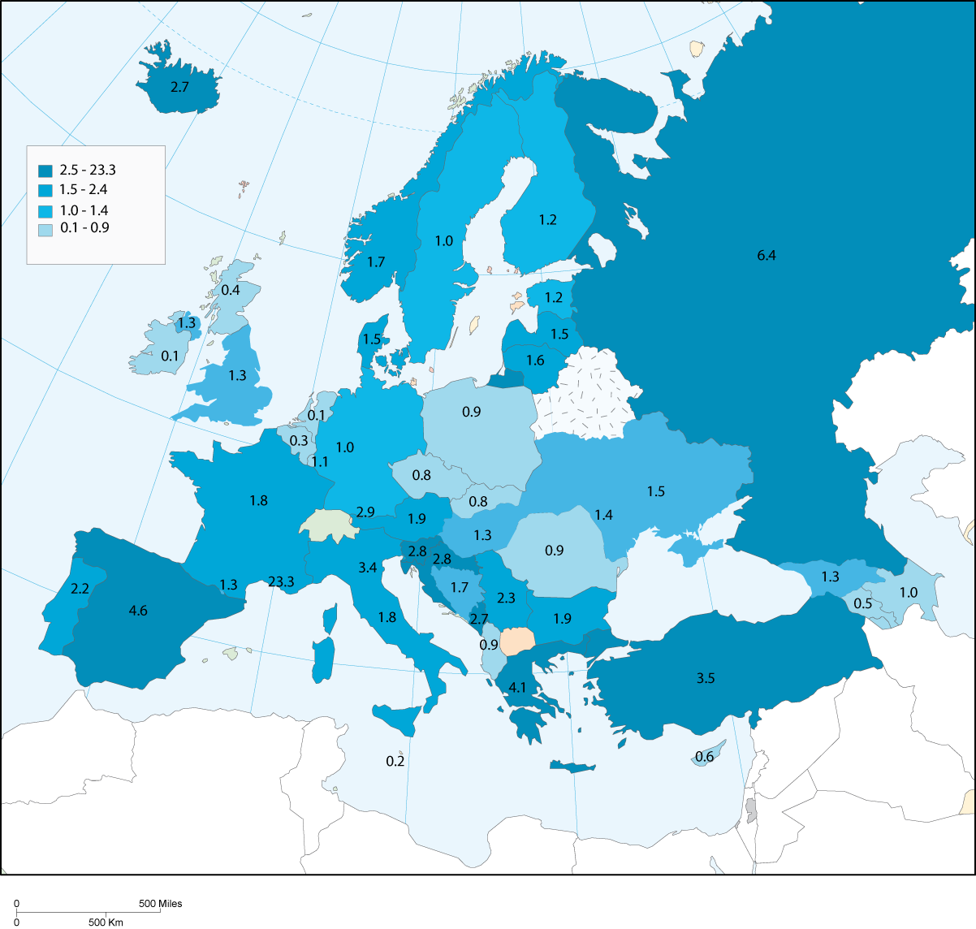

In different colours of blue the number of first instances courts per 100.000 inhabitants is presented. As can be seen from the graph, the countries with the highest number of first instance courts of general jurisdiction are: Croatia, Greece, Iceland, Montenegro, the Russian Federation, Slovenia, Spain and Turkey.

However, as it has already been stated before in this chapter, countries may define "courts" differently. This may change the picture when considering the geographical locations of courts. Belgium, Croatia, Finland, Greece, Iceland, Ireland, Montenegro, Portugal and Slovenia have many court locations per 100.000 inhabitants. Spain and the Russian Federation have many courts (see graph 14), but this is not the case with respect to the court locations (per 100.000 inhabitants). This has to do with the legal definition of what a court is within the countries concerned.

Graph 15. Court locations per 100.000 inhabitants in 2004

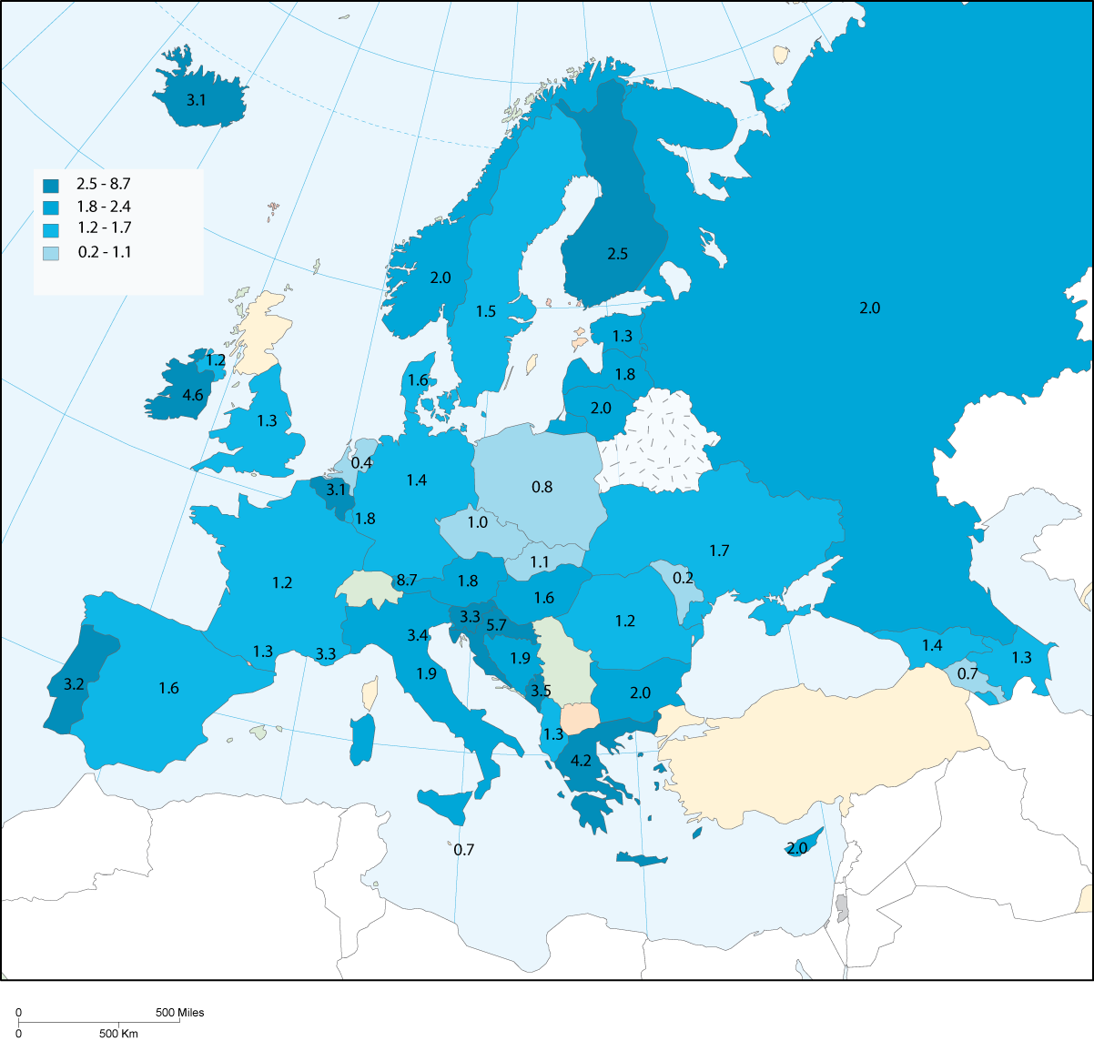

Some countries have designed a judicial map around the principle of a high number of first instance courts of general jurisdiction, competent for dispute resolution and the treatment of cases in the criminal, civil law and or administrative law area combined with very few specialised courts (for instance the Netherlands), whilst in other countries there can be a judicial organisation with many specialised courts.

A high number of specialised first instance courts can be found in: Belgium (the majority of the courts a related to judges of the peace (187), police tribunals (31), Labour tribunals (21), Commercial Tribunals (23)), Croatia (misdemeanour courts responsible for the treatment of small criminal offences (110)), France (the largest number of specialised courts are related to conseils des prud’hommes (labour cases: 271+6 tribunaux de travail), tribunaux de commerce (commercial cases: 184), tribunaux pour enfants (courts for minors: 154), tribunaux des affaires de securité sociale (social security cases: 116) and tribunaux paritaires des baux ruraux: 450), Germany (specialised courts at the level of (independent) regions (Länder): 815 tribunals at the Länder (general jurisdiction), 67 administrative law courts at the Länder, 19 tax courts at the Länder, 140 Labour Courts at the Länder and 84 Social courts at the Länder), Italy (mainly provincial tax commissions (103 courts), regional administrative tribunals (29) and regional audit commissions (21)), Portugal (mainly: family and juvenile courts (18), labour courts (47), administrative and tax courts (16) and also specialised civil and criminal courts (21)), Spain (176 administrative courts, 300 labour courts, 72 juvenile justice courts and 24 commercial courts) and Turkey (assise courts (17), juvenile assise courts (19), intellectual property criminal courts (5), enforcement courts (10), intellectual property civil courts (3), commercial courts (52), labour courts (80), consumer courts (11), family courts (131), specialised court of maritime
law (1)).

By looking at the countries which are using a system of specialised courts, these courts are mostly related to: administrative law (including social security cases and fiscal cases), family law, labour law, commercial cases and specific criminal cases (small criminal offences or juvenile offenders).

In table 20 the results in terms of the numbers of courts and geographical locations are summarised.

Table 20. Number of courts and geographic locations in 2004 (questions 33 and 34)

Country | Q33 Number of first instance courts of general jurisdiction | 1st instance courts of general jurisdiction per 100 000 inhabitants | Q33 Number of specialised first instance courts | Specialised 1st instance courts per 100 000 inhabitants | Q34 Total number of courts (geographic locations) | Number of geographic locations per 100 000 inhabitants
Albania | 29 | 0,9 | 1 | 0,03 | 39 | 1,3
Andorra | 1 | 1,3 | - | - | 1 | 1,3
Armenia | 17 | 0,5 | 1 | 0,03 | 21 | 0,7
Austria | 153 | 1,9 | 7 | 0,09 | 149 | 1,8
Azerbaijan | 85 | 1,0 | 16 | 0,19 | 106 | 1,3
Belgium | 27 | 0,3 | 262 | 2,51 | 320 | 3,1
Bosnia and Herzegovina | 66 | 1,7 | - | - | 72 | 1,9
Bulgaria | 145 | 1,9 | - | - | 153 | 2,0
Croatia | 126 | 2,8 | 123 | 2,77 | 252 | 5,7
Cyprus | 4 | 0,6 | 10 | 1,45 | 14 | 2,0
Czech Republic | 86 | 0,8 | - | - | 98 | 1,0
Denmark | 82 | 1,5 | 1 | 0,02 | 86 | 1,6
Estonia | 16 | 1,2 | 4 | 0,30 | 17 | 1,3
Finland | 63 | 1,2 | 11 | 0,21 | 130 | 2,5
France | 1143 | 1,8 | 1207 | 1,94 | 773 | 1,2
Georgia | 60 | 1,3 | - | - | 65 | 1,4
Germany | 791 | 1,0 | 262 | 0,32 | 1147 | 1,4
Greece | 455 | 4,1 | 4 | 0,04 | 460 | 4,2
Hungary | 131 | 1,3 | 20 | 0,20 | 157 | 1,6
Iceland | 8 | 2,7 | 2 | 0,68 | 9 | 3,1
Ireland | 4 | 0,1 | 3 | 0,07 | 187 | 4,6
Italy | 1072 | 1,8 | 153 | 0,26 | 1101 | 1,9
Latvia | 34 | 1,5 | 1 | 0,04 | 41 | 1,8
Liechtenstein | 1 | 2,9 | 1 | 2,89 | 3 | 8,7
Lithuania | 54 | 1,6 | 5 | 0,15 | 67 | 2,0
Luxembourg | 5 | 1,1 | 5 | 1,10 | 8 | 1,8
Malta | 1 | 0,2 | 1 | 0,25 | 3 | 0,7
Moldova | 46 | 1,4 | 2 | 0,06 | 6 | 0,2
Monaco | 7 | 23,3 | 6 | 19,99 | 1 | 3,3
Montenegro | 17 | 2,7 | 3 | 0,48 | 22 | 3,5
Netherlands | 19 | 0,1 | 2 | 0,01 | 61 | 0,4
Norway | 79 | 1,7 | 7 | 0,15 | 93 | 2,0
Poland | 353 | 0,9 | 29 | 0,08 | 301 | 0,8
Portugal | 229 | 2,2 | 116 | 1,10 | 333 | 3,2
Romania | 188 | 0,9 | 4 | 0,02 | 250 | 1,2
Russian Federation | 9170 | 6,4 | 82 | 0,06 | 2812 | 2,0
San Marino | 1 | 3,4 | - | - | 1 | 3,4
Serbia | 169 | 2,3 | 18 | 0,24 | n.a. | -
Slovakia | 45 | 0,8 | 3 | 0,06 | 58 | 1,1
Slovenia | 55 | 2,8 | 5 | 0,25 | 66 | 3,3
Spain | 1976 | 4,6 | 572 | 1,33 | 683 | 1,6
Sweden | 91 | 1,0 | 15 | 0,17 | 132 | 1,5
Turkey | 2502 | 3,5 | 1135 | 1,60 | n.a. | -
Ukraine | 722 | 1,5 | 54 | 0,11 | 790 | 1,7
UK England & Wales | 710 | 1,3 | 18 | 0,03 | 711 | 1,3
UK Northern Ireland | 22 | 1,3 | 2 | 0,12 | 21 | 1,2
UK Scotland | 22 | 0,4 | 22 | 0,43 | n.r. | -

Note:
Bosnia and Herzegovina: 48 municipal courts, 15 county courts (first instance only for some cases), 2 Supreme Courts (first instance courts in some cases, 1 State court (first instance for some cases).
Cyprus: 1 Supreme Court and 4 district courts.
France: 181 Tribune de Grande Instance, 5 TPI and 476 Tribunaux de Instance. There exist also 476 juridictions de proximité (addition = 1143 courts).
Poland: 353 courts of general jurisdiction; 310 district courts and 43 circuit courts of first instance.
Romania: 188 Courts of first instance (present 177 are operating), 41 Tribunals, 15 courts of appeal (in some cases courts of first instance). Besides this, Romania has 5 specialised Tribunals (1 family and 1 juvenile tribunal and 3 commercial tribunals).
Russian Federation: 2479 district courts, 133 garnison military courts and 6558 justices of the peace (addition = 9170).
Serbia: Municipal courts, district court and Supreme Court of Serbia.
UK-England and Wales: 710 courts (220 County courts, 90 Crown Court Centres, 400 Magistrates courts).

5.3 Small claims, employment dismissal cases and robbery cases

For certain types of disputes many countries have introduced proceedings to handle the cases within a short period. In a majority of countries such provisions are created for employment dismissal cases and robbery cases. For the latter category it is essential that a criminal offender is sanctioned as soon as possible after his/her criminal act (to prevent new criminal offences). In labour law, it is important for the employers and the employees for a quick decision to be taken concerning a dismissal and the subsequent level of financial compensation. However, recently, in many countries, specific proceedings (with a short duration) have been introduced in the area of small financial claims too. Sometimes the proceedings are simplified and the intervention of the judge is limited. In other situations new information technology has been introduced to handle small cases quickly and efficiently. To underline the importance of this trend a specific question was included in the scheme regarding the definition of a small claim and the numbers of courts which are responsible for the treatment of these cases (question 35).

The treatment of the small claims cases can be done by specialised courts (for instance municipal courts), specialised judges (like peace judges) or a unit within a first instance court of general jurisdiction. In table 21, information is presented regarding the number of first instance courts of general jurisdiction and courts competent for small claims procedures.

It is important to note that certain countries use different financial amounts for civil and commercial cases. In other situations, a small claim is connected with the level of income of a citizen, the family situation (married or single) or the nature of the claim.

In some countries the courts presented in column 2 (courts competent for small claims) are a specialised unit of a court of general jurisdiction (for example in the Netherlands), whilst in other states this competency is attributed to a special judge (mostly a judge of the peace: Belgium, Italy and Luxembourg) or a court (where there is a differentiation between civil courts or commercial courts: for example Croatia, Montenegro). Countries with a relatively large number of courts competent for small claims are: Austria, Belgium, France, Germany, Italy, Poland, Portugal, the Russian Federation, Spain, Turkey and UK-England and Wales.

Table 21. Courts competent for small claims, employment dismissal and robberies in 2004 (question 35)

Country | Q35 Number of first instance courts competent for a debt collection for small claims | per 100 000 inhabitants | Q35 Number of first instance courts competent for a dismissal | per 100 000 inhabitants | Q35 Number of first instance courts competent for a robbery | per  100 000 inhabitants
Albania | 29 | 0,9 | 29 | 0,94 | 29 | 0,94
Andorra | 1 | 1,3 | 1 | 1,30 | 1 | 1,30
Armenia | 18 | 0,6 | 17 | 0,53 | 17 | 0,53
Austria | 140 | 1,7 | 16 | 0,19 | 16 | 0,19
Azerbaijan | 90 | 1,1 | 85 | 1,02 | 3 | 0,04
Belgium | 187 | 1,8 | 21 | 0,20 | 27 | 0,26
Bosnia and Herzegovina | 48 | 1,3 | 48 | 1,25 | 48 | 1,25
Bulgaria | 112 | 1,4 | 112 | 1,44 | 145 | 1,87
Croatia | 117 | 2,6 | n.r. | - | n.r. | -
Cyprus | 4 | 0,6 | 5 | 0,73 | 5 | 0,73
Czech Republic | 86 | 0,8 | 86 | 0,84 | 86 | 0,84
Denmark | 82 | 1,5 | 82 | 1,52 | 82 | 1,52
Estonia | 16 | 1,2 | 16 | 1,18 | 16 | 1,18
Finland | 63 | 1,2 | 63 | 1,20 | 63 | 1,20
France | 476 | 0,8 | 277 | 0,45 | 186 | 0,30
Georgia | n.a. | - | n.r. | - | n.r. | -
Germany | 675 | 0,8 | 121 | 0,15 | 116 | 0,14
Greece | n.r. | - | 1 | 0,01 | 3 | 0,03
Hungary | 111 | 1,1 | 20 | 0,20 | 131 | 1,30
Iceland | 8 | 2,7 | 8 | 2,73 | 8 | 2,73
Ireland | 44 | 1,1 | n.a. | - | 187 | 4,63
Italy | 848 | 1,5 | 165 | 0,28 | 165 | 0,28
Latvia | 34 | 1,5 | 34 | 1,47 | 41 | 1,77
Liechtenstein | 1 | 2,9 | 1 | 2,89 | 1 | 2,89
Lithuania | 54 | 1,6 | 59 | 1,72 | 59 | 1,72
Luxembourg | 3 | 0,7 | 3 | 0,66 | 2 | 0,44
Malta | 9 | 2,2 | n.r. | - | n.r. | -
Moldova | 46 | 1,4 | 46 | 1,36 | 46 | 1,36
Monaco | 2 | 6,7 | 1 | 3,33 | 1 | 3,33
Montenegro | 15 | 2,4 | 15 | 2,42 | 15 | 2,42
Netherlands | 61 | 0,4 | 19 | 0,12 | 19 | 0,12
Norway | 79 | 1,7 | 24 | 0,52 | 79 | 1,72
Poland | 310 | 0,8 | 269 | 0,70 | 353 | 0,92
Portugal | 233 | 2,2 | 59 | 0,56 | 233 | 2,21
Romania | n.a.p | - | 41 | 0,19 | 229 | 1,06
Russian Federation | 6558 | 4,6 | 2479 | 1,73 | 2479 | 1,73
San Marino | n.a. | - | n.r. | - | n.r. | -
Serbia | n.a. | - | n.a. | - | n.a. | -
Slovakia | 45 | 0,8 | 45 | 0,83 | 45 | 0,83
Slovenia | 44 | 2,2 | 4 | 0,20 | 11 | 0,55
Spain | 1513 | 3,5 | 303 | 0,71 | 1480 | 3,45
Sweden | 68 | 0,8 | 68 | 0,75 | 68 | 0,75
Turkey | 479 | 0,7 | n.r. | - | n.r. | -
Ukraine | n.r. | - | n.r. | - | n.r. | -
UK England & Wales | 220 | 0,4 | 34 | 0,06 | 500 | 0,94
UK Northern Ireland | n.r. | - | n.r. | - | n.r. | -
UK Scotland | n.r. | - | n.r. | - | n.r. | -

In table 21 too, the numbers of first instances courts competent for employment dismissal cases and robbery cases are presented. Due to the fact that no separation is made between specialised courts for dismissal and robbery cases and/or special units/departments within a first instance court of general jurisdiction, no detailed explanation for this topic can be provided.

With respect to what a small claim in the different countries exactly means, countries have been required to provide a definition or give an indication of the financial amount related to a small claim. As can be seen from table 22 there is a large variety in the financial amount of what constitutes a small claim. An explanation of the definitions of small claims used by countries can be found in table 89 of the appendix.

Table 22. Precisions of the definition (monetary value) of a small claim (question 35)

Country | Q35 Definition of a small claim | Country | Q35 Definition of a small claim
Albania | no definition | Liechtenstein | ≤ 645 €
Andorra | ≤ 1 200 € | Lithuania | ≤ 290 €
Armenia | no definition | Luxembourg | ≤ 10 000 €
Austria | ≤ 10 000 € | Malta | ≤ 3 488 €
Azerbaijan | - | Moldova
Belgium | ≤ 1 860 € | Monaco | ≤ 1 800 €
Bosnia and Herzegovina | ≤ 1500 € | Montenegro | ≤ 500 €
Bulgaria | - | Netherlands | < 5 000 €
Croatia | ≤ 672 € | Norway | ≤ 2 500 €
Cyprus | ≤ 50 000 £ | Poland | ≤ 2 262 €
Czech Republic | ≤ 63 € | Portugal | < 3 740,98 €
Denmark | ≤ 50 000 DKK | Romania | n.a.p
Estonia | no definition | Russian Federation | ≤ 1 470 €
Finland | no definition | San Marino
France | ≤ 4 000 € | Serbia
Georgia | - | Slovakia | no definition
Germany | < 600 € | Slovenia | ≤ 845 €
Greece | ≤ 800 € | Spain | < 3000 €
Hungary | < 800 € | Sweden | < 2 074 €
Iceland | no definition | Turkey | < 2828€
Ireland | ≤ 1 270 € | Ukraine
Italy | ≤ 15 494 € | UK England & Wales | < 7 297 €
Latvia | - | UK Northern Ireland
 |  | UK Scotland | ≤ 750 £

5.4 Budgetary powers at the level of the courts

The powers for the court and justice budget are not only determined at national level (mostly addressed to the ministry of justice, council for the judiciary or other competent bodies), but also at the level of the individual courts. There exists variations between countries, with respect to the persons who are entrusted with the individual court budget. In most situations it is the court president who is responsible for the preparation of the general court budget and the allocation of (parts of) the budget to the individual departments within a court. He/she is in the majority of countries the person who is responsible for the day to day management and the evaluation of the performance of the court (examples of indicators for measuring the performance of courts are: labour productivity, length of proceedings in relation to the influx of cases, the number of pending cases, judicial decisions and personnel and material resources, the quality of the court services delivered, etc). To a lesser extent a court administrative director (in the Netherlands this is the director of conduct of business for example) or head of the court clerk office is entrusted with these tasks. In table 23 the results are summarised.

Table 23. Persons entrusted with the individual court budget (question 47)

Person entrusted | Preparation | Arbitration and allocation | Day to day management | Evaluation
Management board | 5 | 5 | 4 | 6
Court president | 30 | 25 | 22 | 26
Court administrative director | 15 | 15 | 17 | 15
Head of the court clerk office | 12 | 7 | 12 | 10
Other | 16 | 14 | 14 | 18

The detailed information regarding this topic is available on the website of the CEPEJ: www.coe.int/CEPEJ.

5.5 IT equipment of the courts

One of the instruments to increase the efficiency of justice, to improve the communication between the courts and the legal professionals or the society is the use of information and communication technology (ICT). On court websites, practical information can be presented regarding the opening hours of courts, the court location, important decisions made by the court, notification of execution court orders, etc. A more advanced use of the possibilities of the courts is the use of court websites, which makes it possible for legal professionals or clients to follow a case, to get access to an electronic file or to exchange figures.

The use of ICT is not only relevant for external communication, but also for the work of the judges, the court staff and court management. Judges can benefit from the possibility of IT for retrieving information regarding jurisprudence, drafting emails or preparing judgements by using word processing facilities. The management of a court may use case-management information systems for the registration of cases and the monitoring of the length of proceedings.

All the countries have reported that courts have computer facilities. However to indicate the level of automatisation in the revised scheme, countries were required to provide information with respect to the use of specific kinds of computer facilities in the work of a judge, the administration and the management of a court and the (external) communication.

With respect to computer facilities for the direct assistance of a judge or a court clerk (word processing, jurisprudence, electronic files, e-mail and internet connection), the majority of the countries reported that all courts are using word processing facilities. More than 50 percent (but less than 100 percent) of the courts in Armenia, Bosnia and Herzegovina, Croatia, Greece and Montenegro are using word processing facilities. 33 of the 45 reported countries or entities replied that all the courts can make use of a database with jurisprudence. In Armenia, Belgium, Croatia, Cyprus and Georgia, more than 50 percent (but less than 100 percent) of the courts have such facilities as well.

To a lesser extent, electronic files are available in the following countries: Bosnia and Herzegovina, Croatia, Cyprus, Czech Republic, Georgia, Germany, Montenegro, the Netherlands, Poland, Portugal, Romania, Slovakia, Slovenia and Sweden (lower than 10 percent). The countries that have installed email facilities in court (higher than 50 percent, lower than 100 percent are: Azerbaijan, Croatia, Cyprus, Germany, Greece, Italy and the Russian Federation. In Bosnia and Herzegovina (< 50 percent), Georgia (< 10 percent), Montenegro (< 10 percent), Poland (< 50 percent) and Romania (<50 percent), the use of email facilities is less than 50 percent of all the courts.

Case-registration systems, management information systems and financial systems in the courts are, compared to the first group of computer facilities, less common. In the following countries: Bosnia and Herzegovina, Croatia, Cyprus, Poland, Romania and Serbia, 10 percent or less of the courts have computer facilities to register cases. In all other situations, cases are registered manually. Countries which are advanced users of court management information systems (100 percent of all the courts) are: Austria, Denmark, Estonia, Finland, Georgia, France, Latvia, Liechtenstein, Lithuania, Luxembourg, Malta, Monaco, Norway, The Netherlands, Portugal, Spain, Sweden, Ukraine and United Kingdom (England and Wales, Northern Ireland and Scotland). 22 of the 41 responding countries have reported that all their courts have special financial information systems. In 7 countries, this is the case for at least 50 percent of the courts (but not 100 percent).

17 countries use electronic forms on a low level (<9 percent of all the courts). In 4 countries the percentage of coverage lies between 9 and 49 percent of all the courts. In 13 of the responding countries, all the courts use electronic forms: Austria, Czech Republic, Denmark, Estonia, Finland, Latvia, Luxembourg, Malta, Norway, Ukraine and the United Kingdom (England and Wales, Northern Ireland, Scotland).

In Austria, Czech Republic, Denmark, Finland, Iceland, Ireland, Latvia, Malta, Monaco, Portugal, Romania, Slovenia, Spain, Sweden, Ukraine and the United Kingdom (England and Wales, Northern Ireland and Scotland), all the courts have a special website.

In table 24 all the results are summarized.

Table 24. Computer facilities in the court (question 49)

Functions | Facilities | 100% of courts | + 50% of courts | - 50% of courts | - 10% of courts | missing answers
Direct  assistance  to the judge /  court clerk | Word processing | 40 | 5 | 1 | - | 1
Direct  assistance  to the judge /  court clerk | Electronic data base of jurisprudence | 33 | 5 | 1 | 3 | 5
Direct  assistance  to the judge /  court clerk | Electronic files | 20 | 6 | 1 | 14 | 6
Direct  assistance  to the judge /  court clerk | E-mail | 31 | 7 | 4 | 3 | 2
Direct  assistance  to the judge /  court clerk | Internet connection | 33 | 5 | 5 | 2 | 2
Administration  and  management | Case registration system | 25 | 9 | 4 | 6 | 3
Administration  and  management | Court management information system | 17 | 12 | 4 | 8 | 6
Administration  and  management | Financial information system | 23 | 7 | 3 | 8 | 6
Communication  between the court  and the parties | Electronic forms | 13 | 1 | 4 | 21 | 8
Communication  between the court  and the parties | Special Website | 18 | 5 | 7 | 13 | 4
Communication  between the court  and the parties | Other electronic communication facilities | 12 | 4 | 1 | 14 | 16

In the following graph the level of implementation of ICT in the courts, used for direct assistance to the judge and/or the court clerk is represented (word processing, electronic database of jurisprudence, electronic files, e-mail and internet connection). In dark bleu the very high level of equipment is displayed, in light bleu the low level of equipment. The classification of the countries is based on a ‘recoding’ of the replies. A reply with 100 percent is scored with a 4, >50 percent is scored with a 3, < 50 percent is scored with a 2 and < 10 percent is scored with a 1. The total sum of the scores was used for the categorization of countries. For example in Austria all the facilities for direct assistance to the judge or a court clerk are available in the courts (100 percent). This means a total score of 20 (the maximum). An example of countries with a high level of ICT equipment is the Czech Republic (total score of 17), a medium level: Croatia (total score of 14) and a limited level: Serbia (total score of 6).

The graph shows that for example in Bulgaria, Estonia, Finland, Iceland, Ireland, Italy, Latvia, Lithuania, Norway, Spain, United Kingdom, and Ukraine there are computer facilities in all courts to directly assist a judge or a court clerk. Examples of countries with computer facilities for direct assistance in almost (high level of implementation) all the courts are: Czech Republic, Germany, the Netherlands, Portugal and Sweden. To a lesser extent this is the case for example in Armenia, Azerbaijan, Croatia, Greece, Poland and Romania. Countries with hardly any computer facilities for direct assistance of a judge or a court clerk in the courts are: Bosnia and Herzegovina, Georgia, Montenegro, Moldova, Russian Federation and the Serbia.

Graph 16. ICT in the courts in 2004 (level of implementation of computer facilities for direct assistance of a judge or a court clerk)

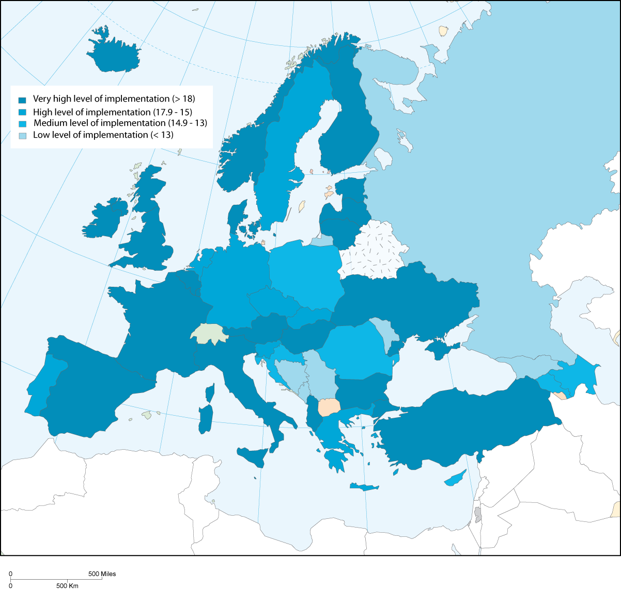

5.6 Evaluation and monitoring

To improve the efficiency of justice or the quality of the work delivered by the courts, a system of monitoring and/or evaluation should be implemented. Monitoring must be seen as the collection of court performance figures, used for supervision and control of the courts or the individual units/departments of the courts (for example: the number of incoming cases, length of proceedings, backlogs, decisions, etc), whilst evaluation concerns the collection and analysis of information in relation to specific norms. Evaluation can have a quantitative or a qualitative orientation. Examples of evaluation studies of qualitative nature are ‘best practice reports’ and studies of pilot projects (for example pilot projects aiming at reducing the length of proceedings).

Annual reports can be useful to present important performance results of the courts and the quality of their work to the public or to a supervisory body (parliament, ministry of justice, council for the judiciary, other ministries). In the CEPEJ scheme, states were required to present information with respect to the use of annual report, monitoring and evaluation systems.

However it must be noted that many countries were facing interpretation problems with the words «monitoring» and «evaluation». They might have been understood as synonyms.

Monitoring

In 43 countries or entities annual reports are presented. In Estonia this task is addressed to the ministry of Justice. Germany and Greece do not present annual reports of the courts. However, they use different forms for reporting on court performance.

The system of monitoring differs from country to country. These differences are related to: differences in the frequency of reporting the information, the authority responsible and also the type of information to be monitored. In Cyprus, for example, the annual reports need to be presented to the Supreme court, whilst in Iceland the annual report must be presented to the Supreme court and the Administrative council of district courts, in co-operation with the ministry of justice. In France, the ministry of justice requires on regular basis information from the courts (three-monthly reports and annual reports). In Italy, the president of the court prepares annual reports based on figures received from the statistical office of the ministry of justice.

In table 25 the total results are presented.

Table 25. Existence of regular monitoring systems (question 52)

Regular monitoring system of courts activities concerning: | Number of countries
incoming cases | 46
Decisions | 46
postponed cases | 43
length of procedures | 35
Other | 23

In table 26 specifications are given for the subjects where the countries are monitoring the courts.

Table 26. Content of the regular monitoring systems (question 52)

Country | Regular monitoring system of court activities concerning
Country | the number of incoming cases | the number of decisions | the number of postponed cases | the length of procedures | concerning other
Albania | yes | yes |  | yes
Andorra | yes | yes | yes
Armenia | yes | yes | yes | yes
Austria | yes | yes | yes | yes | yes
Azerbaijan | yes | yes | yes | yes | yes
Belgium | yes | yes | yes
Bosnia and Herzegovina | yes | yes | yes
Bulgaria | yes | yes | yes | yes | yes
Croatia | yes | yes | yes | yes | yes
Cyprus | yes | yes | yes | yes | yes
Czech Republic | yes | yes | yes | yes
Country | Regular monitoring system of court activities concerning
Country | the number of incoming cases | the number of decisions | the number of postponed cases | the length of procedures | concerning other
Denmark | yes | yes | yes | yes | yes
Estonia | yes | yes | yes | yes
Finland | yes | yes | yes | yes
France | yes | yes | yes | yes | yes
Georgia
Germany | yes | yes | yes | yes | yes
Greece | yes | yes | yes
Hungary | yes | yes | yes | yes | yes
Iceland | yes | yes |  | yes
Ireland | yes | yes | yes | yes
Italy | yes | yes | yes | yes
Latvia | yes | yes | yes |  | yes
Liechtenstein | yes | yes | yes
Lithuania | yes | yes | yes |  | yes
Luxembourg | yes | yes | yes |  | yes
Malta | yes | yes | yes | yes
Moldova | yes | yes | yes | yes | yes
Monaco | yes | yes | yes
Montenegro | yes | yes | yes |  | yes
Netherlands | yes | yes | yes | yes
Norway | yes | yes | yes | yes | yes
Poland | yes | yes | yes | yes | yes
Portugal | yes | yes | yes | yes | yes
Romania | yes | yes | yes | yes
Russian Federation | yes | yes | yes | yes | yes
San Marino | yes | yes | yes | yes
Slovakia | yes | yes | yes | yes
Slovenia | yes | yes | yes | yes | yes
Serbia | yes | yes |  |  | yes
Spain | yes | yes | yes | yes | yes
Sweden | yes | yes | yes | yes | yes
Turkey | yes | yes | yes | yes | yes
Ukraine | yes | yes | yes | yes
UK England & Wales | yes | yes | yes | yes
UK Northern Ireland | yes | yes | yes | yes
UK Scotland | yes | yes | yes | yes

Countries which have reported that they use a regular system of monitoring may have specified the type of performance indicators they are using. Generally speaking, it is a mixture between indicators focused on "quantity" and "quality". Below, the most used or mentioned indicators are presented (question 54):

- Number of incoming cases (weighted)
- Length of proceedings (in first instance, second instance and/or in total)
- Number of postponed cases
- Number of pending cases (including the number of cases which outrun a certain duration)
- Number of decisions
- Caseload of judges and courts.
- The budgetary means of a court and the spending of the budget
- Quality indicators (independence and impartiality of judges, fair trial, reasoned judgement, number of corrected errors made by a judge, the quality of the preparation of legal proceedings, the quality of the work of court departments and offices and court files, the dignity of the conduct of judges/court officials/other court employees, effectiveness of the complaint handling).

Evaluation

The table below presents the answers to the question on the existence of a mechanism for regular evaluation (question 53) as well as the questions on the authority entrusted with the evaluation (question 55). Some inconsistencies appear, as some countries which had initially indicated that had no system of evaluation, had then indicated that they have an authority entrusted with the evaluation and vice-versa.

Table 27. Regular evaluation systems of court activities and the organs responsible for evaluation (question 53)

Country | Regular evaluation system of performance of courts | Authority responsible for the evaluation of the performances of the courts
Country | Regular evaluation system of performance of courts | High Council of the judiciary | Ministry of Justice | Inspection body | Supreme Court | External audit body | Other
Albania | yes | yes
Andorra |  | yes
Armenia |  |  |  |  |  |  | yes
Austria | yes |  | yes | yes
Azerbaijan | yes | yes
Belgium |  | yes | yes
Bosnia & Herzegovina |  | yes |  |  |  |  | yes
Bulgaria | yes |  | yes
Croatia | yes |  | yes |  | yes
Cyprus | yes |  |  |  | yes
Czech Republic |  |  | yes |  |  |  | yes
Denmark | yes |  |  |  |  |  | yes
Estonia | yes |  | yes
Finland | yes |  | yes |  |  |  | yes
France | yes |  | yes | yes |  |  | yes
Georgia
Germany | yes |  | yes |  |  |  | yes
Greece | yes |  |  | yes
Hungary | yes | yes
Iceland |  | yes | yes |  | yes | yes
Ireland |  |  |  |  |  |  | yes
Italy | yes | yes | yes
Latvia | yes |  |  |  |  |  | yes
Liechtenstein |  |  |  |  |  |  | yes
Lithuania | yes
Luxembourg
Malta | yes |  | yes
Moldova | yes | yes
Monaco | yes |  |  |  |  |  | yes
Montenegro | yes | yes |  |  | yes
Netherlands | yes | yes
Norway | yes |  | yes |  |  |  | yes
Poland | yes |  | yes |  |  |  | yes
Portugal | yes | yes
Romania | yes | yes | yes
Russian Federation | yes |  |  |  | yes
San Marino |  | yes
Slovakia | yes |  | yes
Slovenia | yes | yes | yes |  | yes |  | yes
Serbia | yes |  | yes |  | yes
Spain | yes | yes
Sweden | yes |  | yes
Turkey | yes | yes | yes |  | yes
Ukraine |  |  |  |  |  |  | yes
UK England & Wales | yes |  | yes |  | yes |  | yes
UK Northern Ireland | yes |  | yes |  | yes |  | yes
UK Scotland | yes |  | yes |  | yes |  | yes

The responsibility for the evaluation of the performance of the courts may be the competence of a council for the judiciary, the ministry of justice, an inspection body, the Supreme court, an external audit organisation or another instance. 17 countries or entities reported that a (High) Council for the judiciary plays a central role in the evaluation of the performances of courts. For 22 countries or entities, this is the responsibility of the ministry of justice. Austria, France and Greece have a special inspection organisation for the evaluation of the performances of courts. In Cyprus, Croatia, Iceland, Montenegro, the Russian Federation, Slovenia, Serbia, Turkey, UK-England and Wales (the responsibility lies in the hands of the Department for Constitutional Affairs/Her Majesty’s Court Service), UK-Northern Ireland, UK-Scotland, the evaluation of the performances of the courts lies in the hands of the Supreme court.

With respect to target setting, 22 countries or entities replied that they use a system of target-setting. However, many countries were not able to present concrete examples of targets (25 countries or entities replied that they do not have specific targets).

Combinations are possible when it comes to the authority responsible for setting the targets. The executive power (mostly the ministry of justice), the legislative power or the judiciary appear as the key responsible authority, but there are countries where they share the responsibility. Like the budget issue, target setting may be seen at different levels. At the level of the court, it can be the court president or even a head of department within the court who is responsible for the targets. At a second level, more general, this responsibility lies with the ministry of justice, the parliament or the council for the judiciary. Exceptionally, targets may be set by other than judicial institutions (like the parliament) for the individual courts because of the link between these targets and the amount of the annual budget they have received. In other words, it is the level of achievement of the targets which is evaluated.

Details given by the countries as regards quality standards show that the point at stake is the balance between efficiency and quality. An oscillation between the need for a rapid and less expensive justice and the safeguard of the independence of judges in their decisions, as well as the possibility for an effective remedy to a higher instance when the first instance decision is not satisfactory (examples of quality indicators are listed under table 26). This question might appear a little bit vague but remains delicate, as it can be seen from the cautiousness of some answers.

The importance of measuring quality is expressed in Opinion (2004) No. 6 of the Consultative Council of European Judges (CCJE). The CCJE recommends that it is necessary to assess the quality of judicial activity, with reference to social and economic efficiency too, through criteria that are sometimes similar to those employed by other public services (CCJE Opinion (2004) No. 6: 32).

19 countries or entities have defined standards of quality (question 56). According to the explanatory note, the question is if there are standards relating for example to the formulation to be used in a court order (wording, motivation) or the time between the deposit and the delivery of the decision by the judge. The details given by certain countries make it possible to confirm that the respect of the procedural standards indeed constitutes the heart of what is understood by the term "quality". In Armenia, it is about the adequate implementation of the material standards and decisions by the judge, as well as relevance of the judicial documents. In Portugal, it is the High council for the judiciary which takes care of the legality of the procedures in general, and more precisely concerning the deadlines to be respected for general penal matters and for juvenile offender cases. One thus sees the combination of two dimensions of quality, the legality and the effectiveness (in terms of the deadlines) of the procedures. In Montenegro, where the decisions of courts must be returned within precise timeframes, the concept of quality takes also into account the number of procedural acts. Several countries indeed evoke the role of the systems of follow-up and/or the statistics in the application of the standards of quality. In Bosnia and Herzegovina, the courts collect statistical figures on the number of cancelled, closed cases and having been modified at the time of recourse, and this information is used in the evaluation of the work of the judges. It is also the case in Latvia, Poland, Russian Federation, Spain, Turkey and Ukraine. This type of follow-up is related to internal information of the courts, whilst there are other evaluation projects on quality that take into account the level of satisfaction of the clients of the courts. Thus, in the Netherlands, the evaluation of the quality, developed by the National Council of the Judiciary, is carried out starting from investigations and surveys among the users and the legal personnel.

See table for the replies of countries.

Table 28. Performance indicators, target-setting and responsible authorities (questions 53 and 56)

Country | Concerning court activities, have you defined |  | Authority responsible for setting the targets
Country | performance indicators? | targets? | Executive power | Legislative power | Judicial power | other
Albania
Andorra | no | no
Armenia | yes | yes |  |  | yes
Austria | yes | no
Azerbaijan |  | yes |  | yes
Belgium | no | no
Bosnia and Herzegovina | no | no |  |  | yes | yes
Bulgaria | yes | yes |  |  | yes
Croatia | no | no
Cyprus | yes | yes |  |  | yes
Czech Republic | no | no
Denmark | yes | no | yes
Estonia | yes | no
Finland | yes | yes | yes
France | yes | yes |  | yes
Georgia | no
Germany | no | yes | yes
Greece | no | no
Hungary | yes |  |  |  | yes
Iceland | no | yes | yes
Ireland | no | no
Italy | yes | no | yes |  | yes
Latvia | no | no
Liechtenstein | no
Lithuania | yes | no
Luxembourg | no | no
Malta | no | no
Moldova | no
Monaco | no | yes | no | no | yes | yes
Montenegro | yes | yes |  |  | yes
Netherlands | yes | yes |  |  | yes
Norway | yes | yes |  | yes |  | yes
Poland | yes | yes |  |  |  | yes
Portugal | no
Romania | no | yes |  |  | yes
Russian Federation | yes | yes | no | yes | yes | no
San Marino
Slovakia | yes | yes | yes
Slovenia | yes | yes | yes |  | yes | yes
Serbia | no | no
Spain | yes |  |  |  | yes
Sweden | yes | yes | yes
Turkey | yes | yes | yes | yes | yes | yes
Ukraine
UK England & Wales | yes | yes | yes | yes
UK Northern Ireland | yes | yes | yes | yes
UK Scotland | yes | yes | yes | yes

One of the important aspects to indicate the performance of courts (in terms of productivity, length of proceedings, backlog of cases related to the influx of cases and the personnel and material resources) is related to the backlog of cases. A high backlog of cases in the courts could be one of the causes for the excessive length of court proceedings. The measurement of backlog of cases is one of the tools to evaluate and monitor the functioning of courts. The majority of the countries have replied that they measure the backlog of cases (question 57). However, only 18 countries replied that they have a method to analyse the queuing time during court proceedings. The analysis of queuing time is especially relevant when it is combined with information regarding the length of proceedings. Some causes for long duration of court proceedings can lie for example in the fact that court files need to be registered or that files are shelved waiting for preparation and decision making by the judge.

Table 29. Countries that have a way to analyse queuing time during court proceedings (question 58)

Countries
Albania  Andorra  Armenia  Bulgaria  Cyprus  Finland  Hungary  Ireland  Latvia  Lithuania | Luxembourg  Monaco  The Netherlands  Russian Federation  Slovenia  Spain  Turkey  Scotland (United Kingdom)

The questions to measure the stock of cases (number of pending cases) and the idle periods (questions 57 and 58) make it possible to note in a precise way the overlap between, on the one hand, the technical tools and the activities of evaluation, on the other. A disclaimer is nevertheless essential about the tools for the follow-up and measurement of stocks (databases for example). In general, these tools make it possible to enter the number of cases at a given date in a given structure (a court) or in a legal system as a whole and/or the duration of the procedures regarding them. The use of the term «followed» in the revised scheme does not correspond to the measurement technique concept of flows, but is much more open: the procedure of follow-up of the activities aims at controlling the daily activity of the courts and in particular the production of the courts. On the other hand, the concept of “stock” corresponds well to its technical meaning: the stock of cases in progress is composed of the cases which are waiting to be judged. In UK-England and Wales, systems of follow-up at the local level make it possible to identify the cases which exceed the allowed duration. It is also the case in Latvia, where the National Courts Administration collects and summarizes information on the number cases with duration of more than 6 months, as well as reasons of this duration; the conclusions of this follow-up are addressed to the National council of the magistrature. The High National Council of the Magistrature of Portugal takes note of the cases in stock through inspections on the activity of the judges and the courts, i.e. through the complaints deposited by the users.

In all these countries, the follow-up directly feeds the evaluation. Without saying that it is not the case elsewhere, they are rather the design features of the measurement of stocks which are proposed. In Austria, for example, each case is recorded in electronic form in a database; the important stages of the procedure are registered and the status of each case can known by periodic requests. In Bosnia and Herzegovina, there is no centralized national system, but in fact the courts deal with the follow-up of each new case for one year period; the pending cases of the preceding years can also be identified.

A comparable system exists in the courts for the civil cases and administrative cases. The precision of Romania highlights well the central problem of the systems of follow-up of several other countries replied. The statistical system allowing the measurement of stocks in Romania is due to be replaced in 2006. Indeed, the current system allows the identification, for fixed reference periods (quarterly, semi-annual, annual) of stock and new cases. The number of cases whose procedure was accomplished is also measured but over different reference periods (0-6 month, 6-12 month, 1-2 years, 2-3 years, more than 3 years). However, the figures relate only to the cases registered at different levels of jurisdiction (courts of first instance, second instance, Court of Appeal). The system thus does not reflect the exact duration since the date of entry of a case in the system until the end of the procedure. The new system will make it possible to follow a case all along the stages of the process and to thus constitute reliable statistics over the real length of the procedures.

6. Judges, Rechtspfleger and court staff

6.1 Introduction

In this chapter the main topic is the judge and non-judge staff working in courts. In the first part of the chapter, the competencies and variety of types of judges are described. A specific category of court officials (mostly to be found in countries with an Austrian-German judicial system) are the Rechtspfleger. Information of this category is presented in paragraph 6.3 of this chapter. At the end of the chapter, figures regarding the court staff in the various countries are described.

6.2 Judges

In the CEPEJ scheme three types of judges are specified. In general a judge is defined as a person entrusted with the task of delivering or participating in a judicial decision. This definition must be placed in the context of the European Convention of Human Rights and the case-law of the European Court of Human Rights (ECHR). In particular: “the judge decides, according to the law and following an organised proceeding, or any issue within his/her jurisdiction”.

Professional judges are described in the explanatory note of the evaluation scheme as “those who have been trained and who are paid as such (and where their main function is to work as a judge)”. Next to the professional judges in the scheme, two other categories of judges are mentioned, namely the professional judges who are sitting in a court on an occasional basis (and who are paid as such) and the non-professional judges.

In some countries, professional judges who are sitting on an occasional basis are defined as "deputy-judges". For example, in certain countries, it is possible for a lawyer to handle cases as a judge on a case-by-case basis. Mostly, this category of judges has a law degree and has received special training. This is not always the case with the category of ‘non-professional’ judges. These may be "lay-judges", i.e. judges who do not have a legal background. Lay-judges can be hired (mostly also on a case-by-case basis) for reasons of specific expertise. Another possibility for recruiting lay-judges is the involvement of citizens in the work of justice. Mostly, lay-judges sit on a panel with other judges (where one of them is a professional judge). For example in the United Kingdom in the "Magistrates’ courts" a panel of lay-judges is responsible for the treatment of criminal cases. However there are also situations in which a lay-judge is a single-sitting judge. Another type of (non-)professional judges are the "judges of the peace". These judges are mostly responsible for the treatment of small civil claims (or also criminal offences). In some countries «judges of the peace» are defined as professional judges paid on an occasional basis, whilst in other countries they are identified as non-professional judges. To compare the judicial capacity between courts, it is necessary to take this note into account.

Lay judges are mostly involved in the treatment of criminal cases. Other areas where they are active are the labour courts and commercial courts. In some countries (France, for instance) lay-judges are working in various specialised courts.

The diversity of the types of judges is expressed in table 30.

Table 30. Type and number of judges in 2004 (questions 36 - 38)

Country | Q36 Professional judges on a full-time basis (fte) |  | Q37 Professional judges on occasional basis |  | Q38 Non-professional judges (lay-judges) |  | Number of non professional (lay) judges per professional judge sitting in courts
Country | number | per 100 000 inhabitants | number | per 100 000 inhabitants | number | per 100 000 inhabitants
Albania | 383 | 12,5 | n.a.p. | - | n.a.p. | - | -
Andorra | 22 | 28,6 | 2 | 2,6 | n.a.p. | - | -
Armenia | 179 | 5,6 | n.a.p. | - | n.a.p. | - | -
Austria | 1696,5 | 20,7 | n.a.p. | - | n.r. | - | -
Azerbaijan | 338 | 4,0 | n.r. | - | n.r. | - | -
Belgium | 2500 | 23,9 | n.a.p. | - | 3749 | 35,9 | 1,50
Bosnia and Herzegovina | 690 | 18,0 | 12 | 0,3 | 362 | 9,4 | 0,52
Bulgaria | n.r. | - | 1751 | 22,6 | n.r. | - | -
Croatia | 1907 | 42,9 | n.a.p. | - | 6272 | 141,1 | 3,29
Cyprus | 96 | 13,9 | n.r. | - | n.r. | - | -
Czech Republic | 2878 | 28,2 | n.a.p. | - | 7872 | 77,0 | 2,74
Denmark | 368 | 6,8 | n.a.p. | - | n.a. | - | -
Estonia | 245 | 18,1 | n.r. | - | 1955 | 144,7 | 7,98
Finland | 875 | 16,7 | n.r. | - | 3700 | 70,7 | 4,23
France | 6278 | 10,1 | 213 | 0,3 | 3299 | 5,3 | 0,53
Georgia | 406 | 9,0 | n.r. | - | n.r. | - | -
Germany | 20395 | 24,7 | n.r. | - | 100000 | 121,2 | 4,90
Greece | 2200 | 19,9 | n.a.p. | - | n.a.p. | - | -
Hungary | 2757 | 27,3 | n.a.p. | - | 2921 | 28,9 | 1,06
Iceland | 47 | 16,0 | n.a.p. | - | n.r. | - | -
Ireland | 130 | 3,2 | n.a.p. | - | n.a.p. | - | -
Italy | 6105 | 10,4 | n.r. | - | 8077 | 13,8 | 1,32
Latvia | 384 | 16,6 | n.r. | - | 4058 | 175,0 | 10,57
Liechtenstein | 17 | 49,1 | 1 | 2,9 | 16 | 46,2 | 0,94
Lithuania | 693 | 20,2 | n.a.p. | - | n.a.p. | - | -
Luxembourg | 162 | 35,6 | n.r. | - | 127 | 27,9 | 0,78
Malta | 35 | 8,7 | n.a.p. | - | n.a.p. | - | -
Moldova | 415 | 12,3 | n.r. | - | n.r. | - | -
Monaco | 18 | 60,0 | 14 | 46,6 | 118 | 393,1 | 6,56
Montenegro | 242 | 39,0 | n.a.p. | - | 544 | 87,7 | 2,25
Netherlands | 2004 | 12,3 | 900 | 5,5 | n.a. | - | -
Norway | 501 | 10,9 | n.r. | - | n.a. | - | -
Poland | 9766 | 25,6 | n.a.p. | - | 43613 | 114,2 | 4,47
Portugal | 1754 | 16,7 | n.a.p. | - | 676 | 6,4 | 0,39
Romania | 4030 | 18,6 | n.a.p. | - | 170 | 0,8 | 0,04
Russian Federation | 29685 | 20,7 | n.a.p. | - | n.a.p. | - | -
San Marino | 16 | 53,9 | 4 | 13,5 | n.a.p. | - | -
Serbia | 2418 | 32,2 | n.r. | - | n.a. | - | -
Slovakia | 1208 | 22,4 | n.a.p. | - | 2747 | 50,9 | 2,27
Slovenia | 780 | 39,0 | n.a.p. | - | 4065 | 203,5 | 5,21
Spain | 4201 | 9,8 | 1181 | 2,8 | 7681 | 17,9 | 1,83
Sweden | 1618 | 17,9 | n.a. | - | 7556 | 83,6 | 4,67
Turkey | 5304 | 7,5 | n.a.p. | - | n.r. | - | -
Ukraine | 6999 | 14,8 | n.r. | - | n.r. | - | -
UK England & Wales | 1305 | 2,5 | 2370 | 4,5 | 28029 | 52,8 | 21,48
UK Northern Ireland | 62 | 3,6 | n.r. | - | n.a.p. | - | -
UK Scotland | 227 | 4,5 | 57 | 1,1 | 749 | 14,7 | 3,30

Notes:

Professional judges:
Germany: There is no absolute figure for the number of full-time or part-time judges available. Instead the figure is reflecting full-time equivalents. Thus, it may not directly be comparable with other participating states.
Norway; the first instance courts also have deputy judges who are appointed by the court president for a maximum of 3 years.
Poland: the number includes 1.704 assessors (associate judges).
Russian Federation: federal courts (23.127 judges), justice of the peace (6.558). In total: 29.685 judges. Retired federal judges: 196 and 16 judges of the peace.
Serbia: 2.418 professional judges

Professional judges (on occasional basis):
Estonia: 1955 judges (unpaid, but who receive compensation). No legal qualifications.
France: 213 juges de proximité are installed in 2004. They work a maximum of 4 days a month.
Iceland: substitute judges are only used in the absence of regular supreme court judges.
Monaco: 12 judges and 2 deputy judges.
the Netherlands: 900 substitute judges.
Spain: replacement or substitute judges.
UK-England and Wales: 1.396 persons sit a minimum of 15 days and maximum of 30 days (fee paid basis): recorders. Deputy district judges: 801 judges (between 15-30 days per year) at the magistrate's courts.

Lay judges:
Belgium: there are "conseillers suppléants" at appeal courts (160), "juges suppléants" (2.554) and "juges consulaires" (1.035).
Croatia: there are 4.058 non-professional judges operating in municipal courts, 1.508 non-professional judges working at the county courts, 81 non-professional judges at the High Commercial Court and 625 non-professional judges at commercial courts.
Czech Republic: lay judges are engaged in district courts and regional courts. They are elected by local councils of their community or region. A panel consists of one professional judge and two lay judges (individual lay judges serves 20 calendar days per year).
Denmark: no figures available (only at a decentralised level). It is a public duty to assist in a court case if one is appointed for this duty.
Estonia has lay-judges, but they participate seldom in the judicial process.
Finland: there are 3.689 lay members in the district courts and some expert and interest’ members in administrative courts or specialised courts.
Finland: there are 3689 lay-judges in the District Courts and some experts and qualified members in administrative or specialised courts.
France: 14.610 conseillers prud’homaux, 1.800 (real, on the budget : 2.412) assesseurs des tribunaux pour enfants, 3.800 assesseurs des Tribunaux des affaires de sécurité sociale, 2.800 assesseurs des tribunaux du contentieux de l’incapacité and assesseurs des Tribunaux paritaires des baux ruraux (unknown figures).
Germany: the figure must be interpreted as the number of citizens who act as a judge along with professional judges at various courts. In criminal cases 36.029 citizens were involved, as far as the other types of proceedings are concerned the figure is an estimate.
Italy: 3.686 judges of the peace, 440 non-professional judges in the courts and 2.233 honorary judges in the courts with non-permanent posts.
Latvia: 4058 lay-judges positions.
Luxembourg: 12 judges of the peace (suppléants), 13 judges (suppléants) at arrondissement courts, in labour Tribunals (18 assesseurs patronaux, 12 assesseurs private employers, 12 assesseurs ‘ ouvriers’, in social security courts (30 asssseurs assures and 30 assesseurs employers).
Monaco: non-professional judges are working for ‘commission arbitrale des loyers commerciaux, commission arbitrale des loyers, labour courts, and the ‘commission administrative contentieuse de la Caisse autonome des retraites’.
Norway: lay judges participate in district courts and courts of appeal in criminal cases. As a rule in major criminal cases a bench of 10 jury members decides on the guilt of the accused. Lay judges may also participate in civil cases.
Poland: lay-judges are non-professional members of the court panel presided by a professional judge (they are appointed for each case and are obliged to sit in a court till a maximum of 12 days).
Portugal: This number refers to the people designated as social judges, as published in the Official Journal. Being on those lists does not mean actually participating in the judicial decision-making but only the possibility of being called to participate in very specific proceedings, namely towards those cases foreseen both in the Law n. 166/99 of 14th September (article 30, n. 2 -Tutorial Educational Law) and in the Law n. 147/99 of 1st September (article 115- Protection of Minors and Juvenile in Danger Law) and they decide together with a presiding professional judge. It is impossible to determine the number of non-professional judges who have actually participated in judgments in 2004.
Romania: in labour courts lay-judges operate next to professional judges.
Slovak Republic: non-professional judges may perform their judicial function not more then 12 days per year.
Slovenia: lay-judges operate on a panel of judges (next to professional judges).
Spain: the judges of the peace are concerned with petty criminal offences in municipalities.
UK-England and Wales: there are 28.029 lay magistrates (they have to apply for the function and must go through a rigorous selection process. They must sit a minimum of 26 sittings (that is 13 days) and a maximum of 70 sittings (35 days). Magistrate judges deal with summary cases, i.e. criminal cases where a prison sentence is less than 6 months or a fine under £5.000. 95 percent of the criminal cases begin and end in the Magistrates courts.
UK-Northern Ireland: there are 78 deputy judges, 879 justices of peace and 143 lay panel members to provide judicial assistance.

Countries that have many professional judges per 100.000 inhabitants are: Croatia, Czech Republic, Montenegro, Poland, Serbia and Slovenia. Other countries that have a large number of professional judges are: Belgium, Germany, Hungary, Luxembourg and Romania. In Bulgaria, The Netherlands and UK-England and Wales there are also many professional judges (absolute numbers) operating on an occasional basis. They should be taking into account of the whole judicial personnel capacity.

As regards part time professional judges, they do not exist in Armenia, Croatia, Greece, Hungary, Montenegro, Poland, Portugal, the Russian Federation, Slovak Republic, Slovenia and Turkey.

In Graph 17 the geographical map of professional judges per 100.000 inhabitants is presented.

Graph 17. Map of professional judges in 2004 (per 100.000 inhabitants)

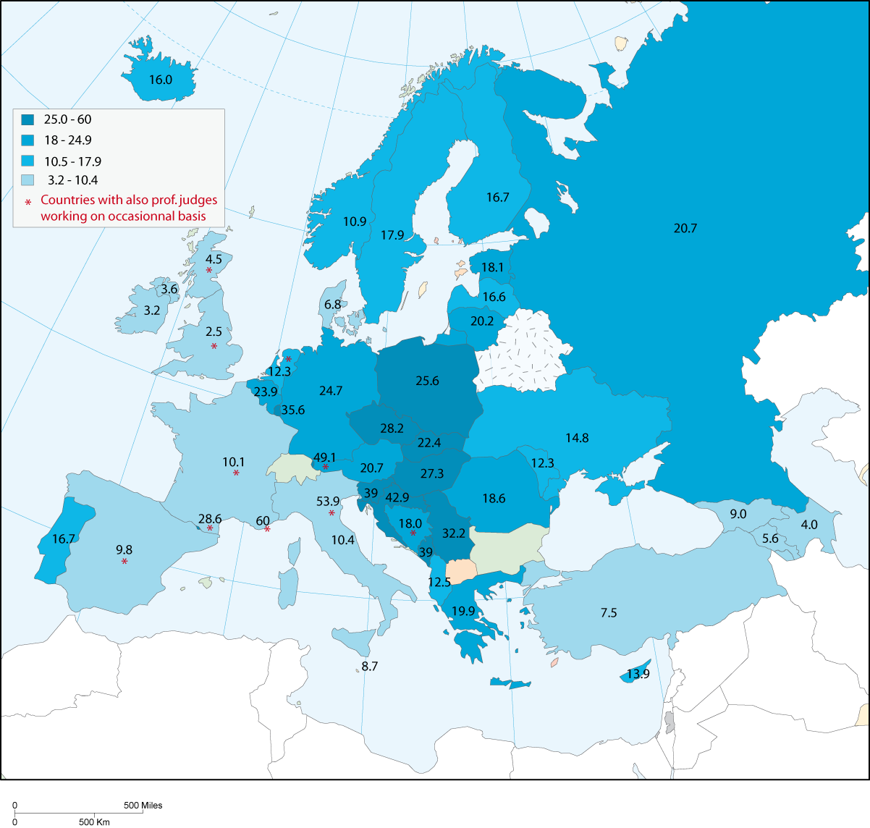

There are no non professional and non remunerated judges (including “lay judges”) in Armenia or in the Russian Federation.

In addition to the use of professional judges, there are states where the functioning of their judicial system is dependent on the use of non-professional judges (including lay-judges and "juges consulaires"). Especially in Croatia, Estonia, Latvia and Slovenia many non-professional judges are active. To a lesser extent, this is also the case for: Belgium, Czech Republic, Germany, Finland, France, Poland and UK-England and Wales.

On the following map, the number of non-professional judges per 100.000 inhabitants is shown.

Graph 18. Map of non-professional judges in 2004 (per 100.000 inhabitants)

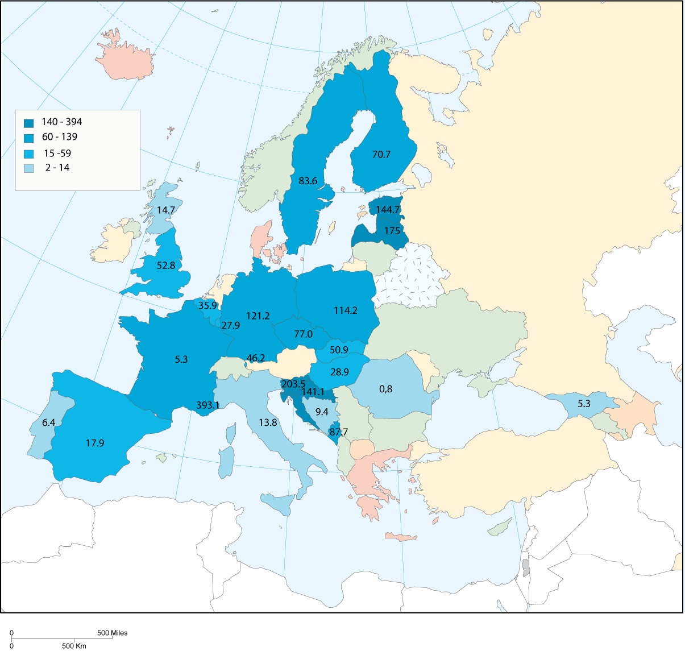

As it already has been stressed, the introduction of non-professional judges in the system can be justified with the wish to stimulate the participation of the society in justice. However other options are also possible, i.e. trial by jury.

21 countries or entities answered positively that they have a system of trial by jury with the participation of citizens. Only 6 of them could provide numbers of citizens who where involved in 2004 in a trial by jury (Germany, Ireland, Liechtenstein, Malta, Monaco and UK-England and Wales). The strongest participation of citizens in courts compared to the population can be found in Malta, followed by UK-England and Wales. (See table 31).

Table 31. Citizen participation as juries in 2004 (question 39)

Country | Q39 Trial by jury with the participation of citizens | Q39 Number of citizens who were involved in such juries in 2004 | per 100 000 inhabitants
Austria | yes
Azerbaijan | yes
Belgium | yes
Bulgaria | yes
Denmark | yes
France | yes
Germany | yes | 36 029 | 44
Greece | yes
Ireland | yes | 5 184 | 128
Italy | yes
Liechtenstein | yes | 23 | 66
Malta | yes | 2 180 | 541
Monaco | yes | 12 | 40
Montenegro | yes
Norway | yes
Portugal | yes
Russian Federation | yes
Spain | yes
Sweden | yes
Ukraine | yes
UK England & Wales | yes | 200 000 | 377

The table of figures regarding the participation of citizens and trial by jury must be handled with care, because some states have included in their figures the lay-judges too (Germany for example those sitting in criminal cases) or non-professional judges sitting in a panel (Greece, Montenegro, Portugal, Slovenia). Countries which explicitly mentioned the use of trials by jury are: Belgium (at the criminal courts: "cours d’assisses"), Denmark, France (for severe criminal cases), Italy, Norway (severe criminal cases where the penalty exceeds an imprisonment of 6 years), Portugal (crimes against cultural identity and personal integrity, crimes against the state security or crimes in which the sanction is more then 8 years of imprisonment), the Russian Federation (first instance courts composed of one federal judge and a bench of 12 jurors to consider criminal cases), Spain (regarding offences: against persons, public officials in the exercise of their duties, against honour and against liberty and security), Sweden (cases concerning the press and freedom of speech) and UK-England and Wales (in criminal cases).

6.3 The Rechtspfleger

A specific category of non-judge staff are the "Rechtspfleger", inspired by the German system. In the model statute of the European Union of Rechtspfleger, a Rechtspfleger is defined as follows: “Independent organ of jurisdiction according to the tasks that were delegated to him by law. As organ of jurisdiction the Rechtspfleger is anchored in the constitutional orders/constitution of the countries." However it must be noted that, in some member states, professions similar to the Rechtspfleger may not be anchored in the constitutional order (Germany, for instance).

Rechtspfleger may carry out various tasks. For example: in the area of family and guardianship law, law of succession, law of land register, commercial registers, decisions about granting nationality, penal cases, execution of penal cases (with issue of warrant or wanted circular), order to execute prison sentences as replacement or replacement of this punishment by making a welfare job, prosecution at district courts, decisions concerning legal aid, etc.

In 16 countries Rechtspfleger (or officials with similar duties) are operating: Armenia, Austria, Croatia, Czech Republic, Denmark, Estonia, Germany, Hungary, Ireland, Liechtenstein, Malta, Norway, Poland, Slovak Republic, Slovenia and Spain. Only Denmark, Norway and Slovenia were not able to indicate the number of persons concerned by these functions. (See table 32).

Table 32. Non-judge staff entrusted with judicial or quasi-judicial tasks in 2004 (Rechtspfleger) (question 42)

Country | Q42 In courts, do you have non-judge staff entrusted with judicial or quasi-judicial tasks and whose decisions could be subject to appeal (Rechtspfleger)? | Q42 Number of non-judge staff (Rechtspfleger) | per 100 000 inhabitants
Armenia | yes | 327 | 10
Austria | yes | 574 | 7
Croatia | yes | 220 | 5
Czech Republic | yes | 1 840 | 18
Denmark | yes | n.a. | -
Estonia | yes | 78 | 6
Germany | yes | 11 906 | 14
Hungary | yes | 430 | 4
Ireland | yes | 27 | 1
Liechtenstein | yes | 2 | 4
Malta | yes | 7 | 2
Norway | yes | n.a. | -
Poland | yes | 1 175 | -
Slovakia | yes | 582 | -
Slovenia | yes | n.a. | -
Spain | yes | 3 536 | 8

Compared to the population of the country, the Rechtspfleger are most numerous in Armenia, Czech Republic and Germany.

6.4 Non-judge staff (and Rechtspfleger if included)

In table 33, an overview is presented of the number of non-judge staff that is working in the courts. In this table, a differentiation is presented for the three types of non-judge staff. Firstly, non-judges whose task is to assist judges directly. These officials can be defined as judicial advisors and registrars. Mostly they play a role in court sessions to assist a judge or a panel of judges; they provide assistance in the drafting of judicial decisions or collect information on jurisprudence.

The second category of non-judge staff is the non-judge staff responsible for different administrative matters, as well as court management. For example: heads of the administrative units of the courts, financial departments or information-technology department. In this category is also included the administrative staff responsible for the registration of cases or the filing of cases.

The third category concerns the technical staff of the courts. For example personnel responsible for IT-equipment, security and cleaning. Approximately half of the countries was able to provide detailed figures for the non-judge staff in these three categories, while 5 of them (Austria, Estonia, Germany, Liechtenstein and Poland) included among their personnel the Rechtspfleger too (question 42). They thus constitute a fourth category in the table.

Some precise details concerning the quality of the data are necessary.
• The figures of Greece relate to the year 2006, but this country specifies that the increase compared to 2004 is negligible.
• The figure of Bosnia-Herzegovina is an estimate at December 2005. The three sub-categories of functions do not exist as such, due to the fact that the categories of functions have not been standardized yet through the country.
• Lastly, Denmark cannot provide detailed figures for the three sub-categories of functions, because this form of specialization does not exist.

The table gives a summary of the level of specialisation of the courts. It must be interpreted with care, because countries have included (or excluded) different groups of functions in the three categories of non-judge staff. France has excluded for example the non-judge staff working for the administrative courts (but they have been added). Turkey and Spain has included the number of non-prosecution staff in the figures, due to the fact that these court officials are also working for the courts and no separation can be made between non-judge staff working for the courts and staff working for the public prosecution agencies. Estonia provided figures which include staff entrusted with other quasi judicial tasks, like probation officers, while Austria explicitly excluded them. In UK-England and Wales, the number concerns all the personnel working in the courts, including the magistrates.

Table 33. Non-judge staff in 2004 (questions 40, 41 and 42 partially)
Country | Q40 Total number of non-judge staff working in courts (fte) | Q41 Non-judge staff whose task is to assist the judges (i.e. registrars) |  | Q41 Staff in charge of different administrative tasks as well as of the management of the courts |  | Q41 Technical staff |  | Q42 Rechtspfleger only if included in the total of non-judge staff and if figure provided
 |  | number | % | number | % | number | % | number | %
Albania | 808 | 388 | 48,0 | 276 | 34,2 | 144 | 17,8 | - | -
Andorra | 68 | 18 | 26,5 | 14 | 20,6 | 2 | 2,9 | - | -
Armenia | 966 | 179 | 18,5 | 451 | 46,7 | 336 | 34,8 | - | -
Austria | 4 320 | n.a. | - | n.a. | - | n.a. | - | 574 | 13,3
Azerbaijan | 1 524 | 267 | 17,5 | 495 | 32,5 | 762 | 50,0 | - | -
Belgium | 5 618 | 4 566 | 81,3 | n.r. | - | 1 052 | 18,7 | - | -
Bosnia and Herzegovina | 1 998 | 1 025 | 51,3 | 758 | 37,9 | 215 | 10,8 | - | -
Bulgaria | n.r. | n.r. | - | n.r. | - | n.r. | - | - | -
Croatia | 6 473 | 451 | 7,0 | 6 022 | 93,0 | n.a. | - | - | -
Cyprus | 425 | 137 | 32,2 | 46 | 10,8 | 125 | 29,4 | - | -
Czech Republic | 9 093 | 1 919 | 21,1 | 6 145 | 67,6 | 1 029 | 11,3 | - | -
Denmark | 1 422 | n.a.p. | - | n.a.p. | - | n.a.p. | - | - | -
Estonia | 1 016 | 646 | 63,6 | 74 | 7,3 | 213 | 21,0 | 78 | 7,7
Finland | 2 586 | n.a. | - | n.a. | - | n.a. | - | - | -
France | 16 646 | 6 658 | 40,0 | 1 931 | 11,6 | 8 057 | 48,4 | - | -
Georgia | 1 155 | 359 | 31,1 | 413 | 35,8 | 64 | 5,5 | - | -
Germany | 58 922 | 38 143 | 64,7 | 12 048 | 20,4 | n.a. | - | 11 906 | 20,2
Greece | 6 827 | 5 712 | 83,7 | 1 105 | 16,2 | 10 | 0,1 | - | -
Hungary | 6 770 | 2 700 | 39,9 | 2 800 | 41,4 | 1 270 | 18,8 | - | -
Iceland | 57 | 29 | 51,1 | 28 | 48,9 | 0 | 0,0 | - | -
Ireland | 1 084 | 200 | 18,5 | 865 | 79,8 | 19 | 1,8 | - | -
Italy | 24 952 | n.a. | - | n.a. | - | n.a. | - | - | -
Latvia | 1 371 | 746 | 54,4 | 425 | 31,0 | 200 | 14,6 | - | -
Liechtenstein | 39 | n.r. | - | n.r. | - | n.r. | - | 2 | 3,8
Lithuania | 2 350 | n.a. | - | n.a. | - | n.a. | - | - | -
Luxembourg | 240 | 120 | 50,0 | 109 | 45,4 | 10 | 4,2 | - | -
Malta | 346 | 136 | 39,3 | 160 | 46,2 | 50 | 14,5 | - | -
Moldova | n.r. | n.a. | - | n.a. | - | n.a. | - | - | -
Monaco | 41 | 13 | 31,7 | 4 | 9,8 | 6 | 14,6 | - | -
Montenegro | 830 | 77 | 9,3 | n.a. | - | n.a. | - | - | -
Netherlands | 5 217 | n.r. | - | n.r. | - | n.r. | - | - | -
Norway | 961 | n.a. | - | n.a. | - | n.a. | - | - | -
Poland | 33 878 | 19 189 | 56,6 | 8 790 | 25,9 | 3 691 | 10,9 | 1 175 | 3,5
Portugal | 7 506 | 6 670 | 88,9 | 425 | 5,7 | 343 | 4,6 | - | -
Romania | 8 975 | n.r. | - | n.r. | - | n.r. | - | - | -
Russian Federation | 65 237 | 35 819 | 54,9 | 6 019 | 9,2 | 2 480 | 3,8 | - | -
San Marino | 45 | n.a. | - | n.a. | - | n.a. | - | - | -
Serbia | 18171 | n.r. | - | n.r. | - | n.r. | - | - | -
Slovakia | 4 070 | 2 775 | 68,2 | 857 | 21,1 | 438 | 10,8 | - | -
Slovenia | 2 257 | n.a. | - | n.a. | - | n.a. | - | - | -
Spain | 37 744 | n.a. | - | n.a. | - | n.a. | - | - | -
Sweden | 1 337 | n.r. | - | n.r. | - | n.r. | - | - | -
Turkey | 18 276 | 12 674 | 69,3 | 5 419 | 29,7 | 183 | 1,0 | - | -
Ukraine | 23304 | n.r. | - | n.r. | - | n.r. | - | - | -
UK England & Wales | 23 000 | n.a. | - | n.a. | - | n.a. | - | - | -
UK Northern Ireland | 537 | n.r. | - | n.r. | - | n.r. | - | - | -
UK Scotland | 1 231 | n.r. | - | n.r. | - | n.r. | - | - | -

7. Fair trial within a reasonable time

7.1 Introduction

One of the most important aspects related to a proper functioning of courts is related to the adoption of the principles of a fair trial within a reasonable time and especially the principles laid down in article 6 of the European Convention on Human Rights. Fair trial within a reasonable time must be brought into relation with the workload of a court, the duration of the proceedings, specific measures to reduce their length and improve their efficiency and effectiveness. As part of the scheme countries were ask to provide information concerning the cases brought to the European Court of Human Rights on the basis of article 6, case information and measures to increase effective court proceedings.

Article 6 of the European Convention on Human Rights reads as follows:

“6.1 In the determination of his civil rights and obligations or of any criminal charge against him, everyone is entitled to a fair and public hearing within a reasonable time by an independent and impartial tribunal established by law. Judgment shall be pronounced publicly but the press and public may be excluded from all or part of the trial in the interests of morals, public order or national security in a democratic society, where the interests of juveniles or the protection of the private life of the parties so require, or to the extent strictly necessary in the opinion of the court in special circumstances where publicity would prejudice the interests of justice.

6.2 Everyone charged with a criminal offence shall be presumed innocent until proved guilty according to law.

6.3 Everyone charged with a criminal offence has the following minimum rights:
a. to be informed promptly, in a language which he understands and in detail, of the nature and cause of the accusation against him;
b. to have adequate time and facilities for the preparation of his defence;
c. to defend himself in person or through legal assistance of his own choosing or, if he has not sufficient means to pay for legal assistance, to be given it free when the interests of justice so require;
d. to examine or have examined witnesses against him and to obtain the attendance and examination of witnesses on his behalf under the same conditions as witnesses against him;
e. to have the free assistance of an interpreter if he cannot understand or speak the language used in court.”

In the scheme countries were required to verify if they have incorporated in their system all the elements of article 6. With respect to the right for an interpreter (article 6.3a), but also to the right for clear reasons (a proper motivation) for prison sentences and an effective remedy to a superior jurisdiction, almost all the countries confirmed positively that they have integrated these principles into their legal system. The right to the effective remedy to a superior jurisdiction is not completely ensured in two countries: Armenia (answer empty) and Turkey (negative answer). For certain civil cases (related to financial thresholds of a case) in Portugal there can be a situation where there is no effective remedy for a superior jurisdiction available.

For the majority of the countries or entities (33) the figure on the percentage of judgements where the suspect is not presented or represented is not available. In Armenia and Lithuania the law does not envisage a judgement in the absence of the suspect, which is also the case in Bosnia and Herzegovina since the adoption, in 2003, of the new Code of penal procedure.

On the other hand, in each country, there is the possibility to challenge a judge. Due to the small number of replies to this question a quantitative exploitation of the figures is not possible.

7.2 Cases regarding Article 6 ECHR before the European Court of Human Rights

A majority of member states was not been able to give detailed statistical information regarding the situation of their own country of the cases related to the various rights protected by Article 6 (question 6). However this information appears as an essential assessment and management tool of the judgements of the European Court of Human Rights at national level, in particular in view of remedying to the situations violating the Convention. Those few states which had recorded such figures, or which had done it for this evaluation process, now have in their hands a valuable aid as regards their obligations vis-à-vis the Convention. Therefore the CEPEJ can only encourage the relevant bodies in the member states to develop their statistical tools so as to be in a position to answer this question in the future, for the sake of the proper compliance with the Court's judgements.

Because of the lack of figures provided by the countries, the CEPEJ has chosen to show below official statistics from the European Court of Human Rights regarding Article 6. The answers received from member states appear in the appendix (table 91), for information. However they are not representative of the volume of cases addressed by the Court on this issue.

In table 34, information on the number of applications, the treatment of cases by the European Court of Human Rights and the number of violations decided are presented. It shows that a large majority of the applications examined by the Court in 2004 (concerning article 6) are related to the length of court proceedings (most of these cases are criminal proceedings, but to a lesser extent civil cases too).

Table 34. Number of applications/cases regarding article 6 ECHR (6.1 – 6.3) (information provided by the European Court of Human Rights)

 |  | Cases declared inadmissible by the Court | Friendly settlements | Judgements establishing a violation | Judgements establishing a non violation
 |  | 2004 | 2004 | 2004 | 2004
Criminal proceedings | Article 6§1 (equity) | 1 | 6 | 105 | 10
Criminal proceedings | Article 6§1 (duration) | 3 | 3 | 49 | 7
Criminal proceedings | Article 6§2 | 1 | 2 | 2 | 1
Criminal proceedings | Article 6§3a | 0 | 0 | 2 | 0
Criminal proceedings | Article 6§3b | 0 | 0 | 0 | 0
Criminal proceedings | Article 6§3c | 1 | 1 | 6 | 1
Criminal proceedings | Article 6§3d | 1 | 0 | 3 | 2
Criminal proceedings | Article 6§3e | 0 | 0 | 0 | 0
Civil proceedings | Article 6§1 (equity) | 28 | 32 | 79 | 19
Civil proceedings | Article 6§1 (duration) | 9 | 5 | 211 | 6

7.3 Simplified procedures and procedures for urgent matters

The efficiency of judicial proceedings can be improved by using at least two measures. The first measure concerns the treatment of urgent matters, i.e. the possibility for a judge to make provisional decisions (for example as regards child custody), to preserve elements of proof or to avoid an imminent or not easily reparable damage (question 64). The second measure is related to the use of a simplified procedure (and thus less expensive and more rapid) for certain types of cases: small and simple civil cases and petty offences (for example traffic offences or shoplifting). In some countries, minor traffic offences (for example ignoring the speed limits or illegal car parking) are not treated via criminal procedures, but through the use of simplified administrative procedures (the «offender» receives his/her fine via the postal services sent by a government enforcement agency and must be paid within a defined period).

In civil cases, 40 countries or entities use simplified procedures. One of the examples of a simplified procedure is the enforcement procedures for the enforcement of uncontested monetary claims. In certain countries the role of the judge in such a procedure is very limited and short proceedings can be achieved (for example the Mahnverfahren procedure in Germany and Money claim online in the United Kingdom). Simplified procedures in criminal matters exist in 35 countries or entities. To a lesser extent, it is common to use simplified procedures in administrative matters (21 countries or entities). But for the latter, it is necessary to take into account the fact that, in some countries, administrative law is part of civil law.

The same pattern can be found for urgent procedures, for instance in a situation where a (temporary) decision of the judge is necessary, due to an urgent situation. Many countries have urgent procedures for civil, criminal and administrative law cases. A concrete example of an urgent procedure concerns the procedure of ‘réferé’ (kort geding in Dutch). In such a civil procedure a judge is able to decide on any question after hearing the parties on the basis of (limited) evidence that they are able to put before the court within a very short time period. A decision is rendered immediately after the hearing or within a short time limit. The decision is directly enforceable but the judgement does not have the force of the authority of a final decision (res judicata). (See table 35).

Table 35. Simplified procedures and procedures for urgent matters (question 64 and 65)

 | In civil cases | In criminal cases | In administrative cases
Specific procedures for urgent matters | 41 | 37 | 31
Simplified procedures | 40 | 35 | 21

7.4 Other means to increase the efficiency of court proceedings: specific appeal arrangements and stimulation of an early settlement of disputes

Another possibility to increase the efficiency and to reduce length of proceedings would be the use of early settlements/agreements arranged between lawyers and the court. The agreements can especially facilitate the dialogue between the principal actors of the procedure, especially to realise fixed deadlines within court procedures. Such agreements can be related to the presentation of the files by the parties, the setting of deadlines to conclude the case, dates of audience, etc. (question 67). Only half the countries envisage this possibility (21 countries or entities). Concrete examples of the use of agreements between courts and parties are: a situation where the court can conclude agreements with the parties during the preliminary hearing concerning the further processing of a case (Denmark) and/or decide on the dates of hearings in co-operation with the parties (Albania, Estonia, Finland, for example).

The last option that was mentioned in the scheme concerns the possibility for a court of second instance to return the case to a lower instance court for a new examination of the case (question 66). This possibility is especially important to prevent a blockage of case at the level of higher jurisdictions and a misuse of the possibilities for appeal.

This possibility exists in the vast majority of countries (40 countries or entities). For Bosnia and Herzegovina and Germany, this possibility exists only for civil cases (and for Germany in administrative matters too). The criminal cases are excluded from this possibility

7.5 The treatment of civil (and administrative) cases

39 countries or entities could provide the total number of litigious and non-litigious civil cases (question 68). Lithuania, provided only the number of litigious cases; the non-litigious cases could not be identified for 2004. Among the others, Greece explained why it could not present all the information due to time restrictions. Romania and Northern Ireland (U.K.) did not provide figures, but they were able to present information on the types of cases concerned. Montenegro did not answer the question.

All the countries have answered, in all or partly, the following questions about litigious civil, administrative, divorce and dismissal cases (question 69). The only exception was San Marino, which provided the number of litigious and non-litigious civil cases, but indicated figures on the detail of the cases (question 68) as being non available (n.a.). Only 3 countries or entities were not able to provide figures: Bosnia and Herzegovina declared that very recently a new information system was introduced, making it possible to know stocks and the durations of cases. However they could not provide figures for 2004. Georgia specified that they did not have any means of monitoring cases. UK-Scotland could not provide information because the figures were not published by Scottish court services.

The following table gives a general outline by counting the answers to the sub-questions concerning civil, administrative, divorce and dismissal cases in particular.

Table 36. Number of answers concerning civil cases (questions 68 and 69)

 | Q69 Civil cases | Q69 Administrative cases | Q69 Divorce cases | Q69 Employment dismissal cases
1st instance incoming cases | 43 | 31 | 35 | 22

The majority of the countries have included in the figures the litigious and not-litigious civil cases (question 68), the family affairs, dismissal cases and litigations with a financial claim. Nevertheless, there are more complex exceptions and combinations, of which a tentative list appears here:

- The countries which have included commercial cases: Albania, Austria, France, Hungary, Poland.
- On the contrary, Slovenia has excluded commercial cases from the total number of civil cases.
- The countries or entities which have included the administrative law cases: Armenia, Bulgaria, Finland, France, UK-Northern Ireland and Poland (social security cases).
- The countries which have included cases concerning the land and buildings (land registers), the litigations between companies like the dissolution of enterprises or, the registration of facts of legal importance: Austria, Lithuania, the Russian Federation, Turkey (commercial registers).
- The countries which have included certain criminal cases: Monaco.
- The countries which have included enforcement procedures: Austria, Czech Republic, Lithuania.
- Those which have excluded them explicitly: Slovenia.

The total number of civil cases quoted in question 68 is obviously dependent on these definitions, according to whether one includes or not land litigations, commercial litigations, etc. It thus does not seem relevant to proceed here to some re-handling of figures. The definition of what is a civil case is dependent on the legal reasoning and history of each country, and one cannot touch that without altering the answers. In other words, this diversity implies that the answers of the countries to question 69 concerning only litigious cases must be handled with care, because they are not strictly comparable. The tables and graphs have only an indicative value of the volume of litigious cases to be addressed by the courts in each country. In the future, an analysis of these figures will give results in the comparison, in each country, of the numbers and lengths of each type of cases.

Bosnia and Herzegovina, Georgia and UK-Scotland are not included in the table. To facilitate the reading, the answers "n.a." do not appear in the table.

In table 37 the total number of civil cases received by the courts, as well as the decisions, pending cases, duration and appeals are presented. However, the figures in the tables are not easily comparable, because certain countries have varying definitions for the term “civil case”.

Table 37. Cases in civil and administrative proceedings in 2004 (questions 68 and 69)

Country | Q68 Total number of civil cases in courts (litigious and not litigious) | Q69-1  Civil and administrative litigious incoming cases (1st instance) | per 100 000 inhabitants | Q 69-2  Decisions on the merits | Q 69-3  % of decisions subject to appeal in a higher court | Q 69-4  Cases pending by 1 January 2005 | Q 69-5  % of pending cases of more than 3 years
Albania | 41 755 | 24 960 | 813 |  | 9,0 | 3 386 | 0
Andorra | 3 765 | 3 070 | 3 993 | 1 100 | 1,9 | 1 426 | 1,3
Armenia | 101 703 | 101 703 | 3 168 | 84 851 | 4,6 | 5 927
Austria | 4 807 881 | 818 213 | 9 970 | 44 169 | 32,2 | 177 106 | 1,5
Azerbaijan | 53 249 | 53 249 | 638 | 38 252 | 21,9 | 4 616
Belgium | 700 709 | 694 986 | 6 653 | 733 890 | 5,1
Bulgaria | 680 742 | 573 399 | 7 388 | 542 417 |  | 68 852
Croatia | 417 223 | 160 790 | 3 618 |  |  | 237 749
Cyprus | 338 159 | 29 043 | 4 212 | 31 220 | 1,0 | 32 679 | 20,0
Czech Republic | 1 209 659 | 285 469 | 2 793 | 316 367 |  | 171 454 | 5,9
Denmark | 141 486 | 126 696 | 2 347 |  | 2,0 | 35 308
Estonia | 37 781 | 25 301 | 1 873 | 25 682 | 9,3 | 11 826 | 7,6
Finland | 176 171 | 9 460 | 181 | 9 715 | 24,6 | 5 682 | 4,0
France | 3 390 413 | 1 779 344 | 2 862 | 1 368 181 | 12,8 | 1 490 000 | 12,0
Germany | 13 755 061 | 3 083 980 | 3 738 | 1 375 938 | 23,4 | 1 510 916
Greece | n.r. | 168 651 | 1 525 | 113 748 | 100,0 | 34 087
Hungary | 635 000 | 165 027 | 1 634 | 86 965 | 25,2 | 76 203 | 1,4
Iceland | 25 664 | 1 296 | 441 |  | 0,9 | 728 | 0
Ireland | 135 510 | 130 391 | 3 228 | 7 716 | 19,0
Italy | 3 944 961 | 3 600 526 | 6 159 | 1 156 045 | 21,8 | 4 087 311
Latvia | 116 808 | 59 156 | 2 551 | 44 491 | 6,6 | 20 720 | 1,4
Liechtenstein | 831 | 416 | 1 202 | 89 |  | 154
Lithuania | 152 132 | 152 132 | 4 441 | 149 646 | 5,0 | 1 779
Luxembourg | 12 079 | 4 315 | 948 | 8 931 | n.a. | n.a. | n.a.
Malta | 5 858 | 5 858 | 1 455 |  |  | 14 277 | 33,0
Moldova | 56 401 | 52 414 | 1 548 | 42 124 | 15,7 | 6 692 | n.a.
Monaco | 950 | 748 | 2 492 | 860 | 20,0 | 1 091
Montenegro | n.r. | 15 462 | 2 492 | 11 996 | 21,7 | 3 466 | 8,4
Netherlands | 1 131 810 | 902 980 | 5 542 | 896 700
Norway | 13 450 | 13 450 | 292 | 13 944 | 12,0 | 7 751 | 0
Poland | 7 602 495 | 1 162 480 | 3 045 | 1 201 149 | 17,8 | 498 955
Portugal | 628 170 | 628 170 | 5 966 | 524 684 |  | 1 325 662
Romania | 1 353 749 | 1 153 187 | 5 321 | 933 854 |  | 247 337
Russian Federation | 6 334 000 | 5 852 000 | 4 079 | 5 019 000 | 5,9 | 485 000 | 0,8
Serbia | 756 758 | 687431 | 9 168 | 461589 | 23,7 | 225 555 | n.a.
Slovakia | 228 755 | 238 662 | 4 420 |  | 12,0 | 226 462 | 15,2
Slovenia | 550 470 | 25 335 | 1 268 | 18 971 | 21,2 | 44 418 | 31,8
Spain | 1 862 966 | 826 835 | 1 926 | 188 246 | 17,5 | 578 209
Sweden | 69 721 | 43 539 | 482 |  | 4,8 | 26 151 | 3,9
Turkey | 2 116 746 | 1 391 095 | 1 955 | 1 081 777 |  | 671 915
Ukraine | 1 873 438 | 2031123 | 4 296 |  |  | 224 325
UK England & Wales | 1 770 056 | 1 597 123 | 3 011 | 61 824 |  |  | 0
UK Northern Ireland | n.r. | 28 062 | 1 641 | 24 407 | 2,0 | 9 364

- Azerbaijan: decisions in the following three columns (on the merits, on redressing a claim, on dismissing a claim) the figure concerns only on the merits of cases.
- Belgium: the figure does not include the (administrative law) cases before the State Council (Conseil d'Etat).
- Czech Republic: decisions on the merits are the closed cases.
- France :
- Q 69-1: are included civil and litigious cases of the tribunaux de grande instance, tribunaux d’instance, juges de proximité, conseils des prud’hommes, commercial courts and the social security tribunals; the orders on request and the summary procedures are not counted. For the minors are counted the minors in danger before the judge for minors and the families under social monitoring.
- Q 69-2: the decisions on the merit include all the decisions which close a case on the merit (except summary procedures and orders on request, removals, junctions, etc).
-Q 69-3: the average rate of appeal calculated for all jurisdictions has never been given and will mix different rates such as 4.6% for the tribunaux d’instance and 56.9% the conseils des prud’hommes.
- Q 69-5: no information on stocks of cases of more than 3 years could be provided except for the tribunaux des grande instance.
- Germany: the total number of cases includes ca. 9 100 000 accelerted procedures for the recovery of uncontested pecuniary claims which are mostly dealt with automatically by means of electronic data processing (“automatisiertes Mahnverfahren”).
- Greece: total number of incoming civil cases: 168.651; total number of decisions issued: 113.748; all the decisions were submitted for further appeal. For 34.087 incoming cases: their decisions were issued after the year 2004. There are no pending cases beyond the 3 years because the law does not permit it. Not possible to estimate the average length. Data of the number of civil, criminal and administrative cases concern the data given only by the Public Prosecutor's office of the Court of First Instance in Athens and the Administrative Court of First Instance in Athens.
- Italy: Q 69-3: estimated data
- Luxembourg:
-Q 69-3: the appeal court received 397 appeals (civil cases) against decisions of the two tribunals. The available statistics makes it not possible to differentiate between the new incoming cases received by the arrondissement tribunals and the appeal cases received by the judges of the peace.
- Q 69-4: the figures of the pending cases by 1 January 2005 are not available, due to the fact that the judicial year is starting from 16 September and is ending in the next year at 15 September.
- Moldova: Q 69-1, are included only the number of examined cases by the judicial body with a pronounced judgement.
- Monaco: civil litigious cases concern the civil cases + administrative cases + divorce cases on 1 October 2004.
- Romania:
-Q 69-1: sum of Court of First Instance cases (895.408) + cases received by the tribunals (3153.250) + cases of the Courts of Appeal (including the number of cases tried in first instance, in appeal and in second appeal before courts of appeal) (142.911) = 1.353.569.
-Q 69-2: refer only to cases tried in first instance by the Court of First Instance (746.532) + Tribunals (175.965) + Courts of Appeal (11.357) = 933.854 cases.
-Q 69-3: 10.54% of the decisions rendered by the courts of first instance were appealed against the tribunals; 27.45% of the decisions rendered by the tribunals in first instance were appealed against to courts of appeal.
-Q 69-4: sum of Court of First Instance cases (148.876) + Tribunal cases (64.526) + Courts of Appeal cases (33.935) = 247.337.
- Q 69-5: data not available.
- Slovenia: Q 69-1: 25335 (the definition of a civil case is even narrower, including only cases to which we refer in the original report as “ litigation affaires”, since otherwise we are not able to give data on the length of procedures).

Graph 19. Litigious civil and administrative law incoming cases in 2004 (per 100.000 inhabitants)

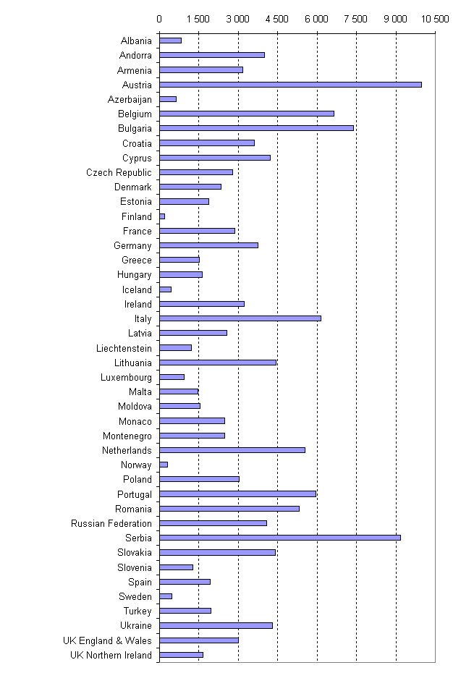
The next graph represents three specific types of civil law cases (and administrative law cases) received by the courts: divorce cases (excluding mutual consent), employment dismissal cases and administrative law cases.

Graph 20. Litigious administrative law cases, divorce cases and employment dismissal cases in 2004 (per 100.000 inhabitants)
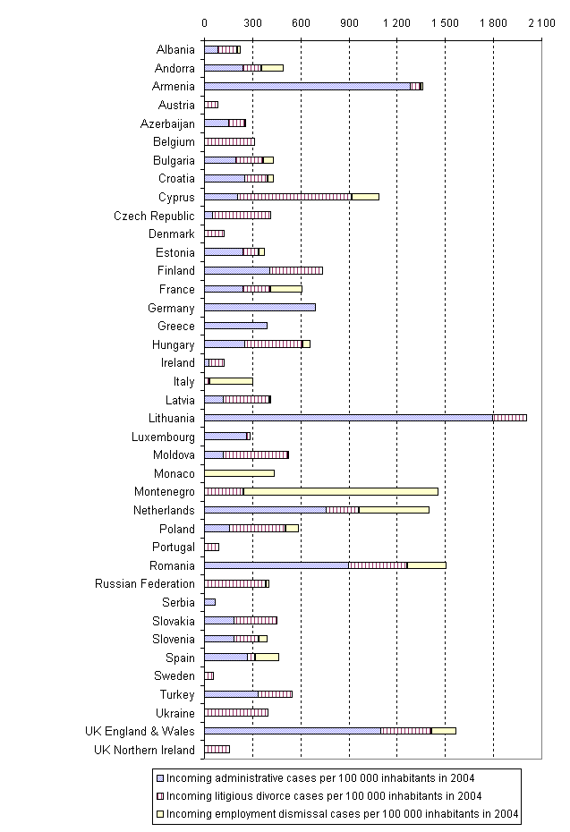

7.6 Timeframes of civil proceedings (divorces and dismissals)

Measuring the length of proceedings is one of the instruments gives an overview at court level or national level of one of the major indicators for the performances of courts. Short proceedings could indicate an efficient situation, when courts are using their personnel resources optimally and have effective court proceedings at their disposal. On the other hand lengthy proceedings can be an indication of problems in the operation of courts or inefficiencies.

At the moment only a few countries are able to provide (reliable) statistics regarding the length of proceedings (see table 36). This lack of concrete information on lengths of proceedings must be underlined, as a detailed knowledge of the duration of the proceedings is certainly an essential element for developing efficient policies towards foreseeable and optimal timeframes, as advocated by the CEPEJ in its Framework-Programme: "A new objective for judicial systems: the processing of each case within an optimal and foreseeable timeframe". Member states should therefore be encouraged to work specifically towards a concrete measure of their judicial timeframes, using in particular the specific tools designed by the CEPEJ, such as the "Checklist of indicators for the analysis of lengths of proceedings in the justice system".

As many countries have not provided detailed figures but only global figures, reasoned additions have been made to calculate the average length of proceedings according to the various levels of instances, when it was possible to do it.

All durations have been converted in days according to the following manner:
- 1 week = 7 days
- 1 month = 30 days
- 6 months = 182,5 days
- 1 year = 365 days

Because of the disparities in the definition of civil cases underlined above, the decision was taken to present here only the cases of litigious divorces and dismissals, rather than the figures on the length of the whole of civil cases.

The lengths of dismissal procedures are presented according to the level of instances concerned (1st and 2nd instance).
Graph 21. Average length of 1st and 2nd instance procedures of employment dismissal cases in 2004 (question 69)
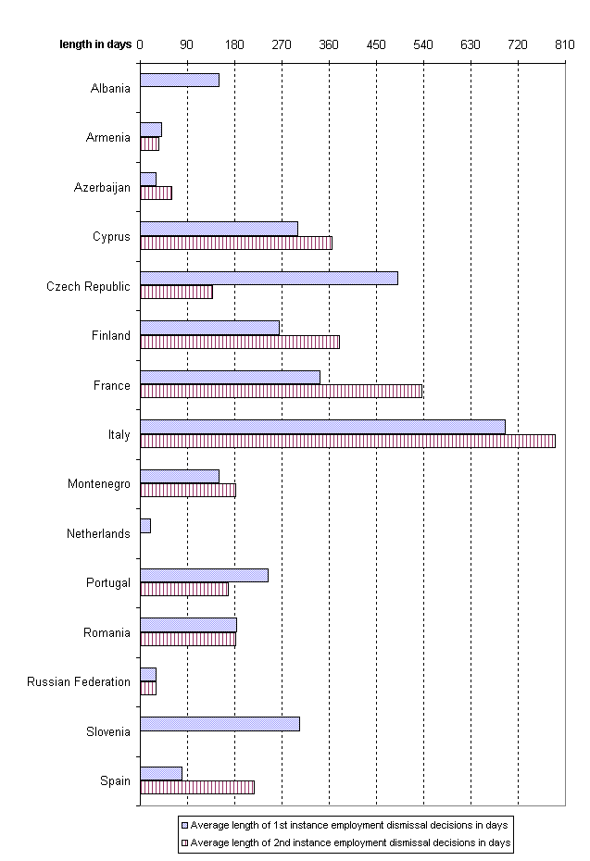

In certain countries, in divorce proceedings before the court, reconsideration periods of several months may be included. 15 countries gave details regarding divorce. In Andorra, a divorce procedure is comparable with a declaration procedure (“abreujat”), like the application of a request for a small claim (1.200 € to 12.000 €). As part of the procedure, it is possible to ask for emergency measures to manage the transitory situation before obtaining the final judgement of divorce. In Azerbaijan there is a consideration period of three months (but in a situation where one of the parties does not agree with the divorce, the judge can extend this period to six months). One month is provided for submitting an appeal and the consideration period at the level of appeal is two months. In Croatia divorce is not possible when the spouse is pregnant (during the period of pregnancy) and in a situation when a child is not older than one year. Mediation in divorce matters is mandatory in Croatia, when the spouses have infants or adopted infants or children over whom they perform parental custody. In Cyprus, divorce petitions are filed to the family court and appeals are lodged at the Supreme Court. In the Czech Republic, the following rules applies to divorces: if the marriage has existed for at least one year, the spouses have not lived together for more than six months and the petition for divorce by one spouse is joined by the other, the court does not establish the grounds for the breakdown of marriage and issues the judgment of divorce if the parties submit: a) written agreement with officially verified signatures of parties which regulates the settlement of property after divorce, the rights and duties of the parties with respect to their common housing and duty to financially maintain the other spouse, if relevant; and b) a final and conclusive decision of court approving the spouses´ agreement with respect to their infants after divorce. If there is an infant (babies) the court decides, before issuing the judgment of divorce, on the rights and duties of parents with respect to the child or children, in particular, which of them will be entrusted with custody of a child or children and what their duties to (financially) support and maintain children are. Marriage may not be divorced until the decision on the position of children after divorce becomes final and conclusive. The decision on parental responsibility may be replaced by an agreement by the parents which must be approved by the court to be valid. In Estonia it is possible to file for divorce at a Marital Status Office (in case of a divorce with mutual consent) or to start a divorce procedure before the courts (litigious divorce). A marriage may be dissolved in Finland by a court order too. A divorce will be granted after a reconsideration period of six months or after the spouses have lived separately for the past two years without interruption. The divorce procedure starts with a written application send to the district courts. The district court shall grant a divorce when the six month period of reconsideration has expired and the spouses (or one of the spouses) demands that the divorce should be realised. Spouses can start a divorce procedure immediately (without a reconsideration period of six months) when they have been living separately for the past two years. In Malta a divorce is not legal. In Montenegro, the only specificity in the procedure concerns with a compulsory hearing at which the parties attempt to reconcile. In Poland there are two options for the termination of a marriage: a divorce or a separation. A separation is decided by the court when there is a complete (but not irretrievable) disintegration of matrimonial life. The judicial decree of a separation has in principle the same effect as a divorce. However the most significant difference is that the separated spouses are not allowed to remarry. Procedures regarding the termination of a marriage are initiated by lodging a petition for divorce or separation by one of the spouses in a Circuit Court. A lawyer is not obligatory in dissolution proceedings. Each party may personally go to the competent court, undertake actions in connection with the legal proceedings, lodge motions, appoint an attorney or request the court to appoint an attorney (legal aid motion). Marriages will be dissolved when the judgment becomes final - when the judgment cannot be appealed because of the expiry of time-limit for filing an appeal or, of the exhaustion of the appeal process. In Portugal, litigious divorces can be required by any one of the spouses if one of them violates marriage rights. The amicable separation during a period of three years can also be invoked, the amicable separation for a year if the divorce has been demanded by one of the spouses without opposition from the other, the alteration of one of the spouse’s mental faculties if it has lasted more than three years and which endangers the preservation of the married life and the absence of one of the spouses for a period of no less than two years. The litigious divorce is required by one of the spouses against the other. In the divorce proceedings, there will always be a spouse’s attempt at conciliation

The lengths of procedures regarding litigious divorce cases are presented according to the level of instances (1st and 2nd instances).
Graph 22 Average length of 1st and 2nd instance procedures of litigious divorce cases in 2004 (question 69)
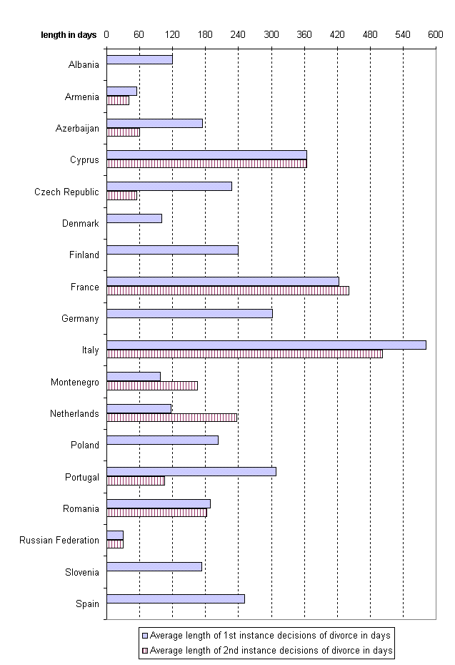

7.7 The treatment of criminal cases by the public prosecutor

As for the civil cases, several countries were facing difficulties to present the required detailed figures on criminal cases. The following table sums up the number of answers concerning the new cases treated by the prosecutors and the incoming cases treated by the courts in general, for robbery and intentional homicide.

Table 38. Number of answers concerning criminal cases (questions 72 and 73)

Criminal cases received by the public prosecutor |  | Criminal cases | Robbery cases | Intentional homicide cases
37 | 1st instance incoming cases | 38 | 21 | 19

In contrast with the civil law cases more (reliable) figures were received for criminal matters. 40 countries or entities provided valuable information regarding criminal activity on the basis of similar definitions, taking into account the European Sourcebook of crime and criminal justice statistics. The figures might be further analysed in the future.

In table 39 the total number of criminal cases received by the public prosecutor at the first instance level is presented.

In a majority of countries, after police investigation, criminal files are handed to the public prosecutor. Then the public prosecutor has three main modalities of treatment at his or her disposal: (1) the discontinuation of cases (in general, unknown offender, legal grounds such as a lack of evidence), (2) a penalty imposed or negotiated or (3) charging a case before the court. All three modalities are presented in the following table. It may be concluded from this table that there are countries where a numerous amount of cases received are discontinued (on a general basis or due to the fact that the criminal offender could not be identified). Only a relatively small portion of cases are treated before a court.

Table 39. Criminal cases dealt by the public prosecutor in 2004 (question 72)

Country | Q72 Total number of 1st instance criminal cases received by the public prosecutor | per 100 000 inhabitants | Discontinued by the public prosecutor |  |  | Concluded by a penalty imposed or negotiated by the public prosecutor | Charged by the public prosecutor before the courts
Country |  | per 100 000 inhabitants | in general | because the offender could not be identified | due to the lack of an established offence or a specific legal situation |  | Charged by the public prosecutor before the courts
Albania | 14 204 | 463 | 2 175 | - | - | - | 3 779
Andorra | 2 343 | 3 048 | 10 | - | - | - | 14
Armenia | 3 481 | 108 | 1 485 | 1 345 | 403 | - | -
Austria | 631 619 | 7 697 | 126 717 | - | 107 064 | 32 765 | 67 002
Azerbaijan | - | - | 145 | 75 | 39 | 443 | 11 452
Belgium | 821 392 | 7 863 | 624 880 | 294 386 | 133 751 | 8 390 | 19 331
Croatia | 96 915 | 2 181 | - | 41 679 | 15 075 | - | -
Czech Republic | 111 694 | 1 093 | 294 | 0 | 184 | 0 | 79 012
Denmark | 892 288 | 16 531 | - | - | - | - | 194 926
Estonia | 34 078 | 2 522 | 29 474 | 20 987 | 2 336 | 2 096 | -
Finland | 88 000 | 1 680 | 26 000 | - | - | 3 700 | 67 000
France | 5 004 678 | 8 049 | 366 382 | 3 147 897 | 401 184 | 414 693 | 674 522
Georgia | 43 071 | 950 | 7 016 | 792 | 6 224 | - | 7 291
Germany | 4 988 450 | 6 047 | 4 997 579 | - | 1 313 576 | 265 319 | 1 211 875
Greece | 148 556 | 1 344 | 2 257 | 50 700 | - | - | -
Hungary | 137 886 | 1 366 | 16 934 | - | - | 5 254 | 78 850
Iceland | 8 782 | 2 991 | 2 794 | - | 455 | - | 5 944
Italy | 3 188 511 | 5 454 | 2 223 721 | 1 339 369 | - | - | 568 515
Latvia | 15 511 | 669 | 1 639 | 54 | 213 | 1 282 | 13 322
Liechtenstein | 2 787 | 8 055 | 1 407 | 208 | 1 199 | 0 | 1 158
Country | Q72 Total number of 1st instance criminal cases received by the public prosecutor | per 100 000 inhabitants | Discontinued by the public prosecutor |  |  | Concluded by a penalty imposed or negotiated by the public prosecutor | Charged by the public prosecutor before the courts
Country |  | per 100 000 inhabitants | in general | because the offender could not be identified | due to the lack of an established offence or a specific legal situation |  | Charged by the public prosecutor before the courts
Lithuania | 17 358 | 507 | 61 696 | - | 20 401 | - | 18 827
Luxembourg | 48 365 | 10 630 | 9 749 | - | - | 618 | 11 477
Monaco | 2 714 | 9 041 | 1 680 | 240 | - | 0 | 617
Montenegro | 10 535 | 1 698 | - | 6 458 | 554 | - | 8 503
Netherlands | 273 974 | 1 682 | 36 743 | - | 36 743 | 78 613 | 160 000
Norway | 426 053 | 9 249 | 241 046 | 183 762 | - | 185 007 | 87 466
Poland | 1 816 335 | 4 758 | 1 040 125 | 681 860 | 294 198 | 0 | 425 048
Portugal | 498 935 | 4 739 | 406 151 | - | - | 2 116 | 85 563
Romania | 661 355 | 3 051 | 321 219 | - | - | 96 976 | 49 185
Russian Federation | 978 371 | 682 | 1 435 830 | 1 369 326 | 65 904 | - | 65 123
Serbia | 88 453 | 1 180 | - | - | - | - | 44881
Slovakia | 139 384 | 2 581 | 65 727 | 63 234 | - | - | 32 682
Slovenia | 91 956 | 4 603 | 15 472 | - | - | 3 007 | 14 721
Spain | 3 956 078 | 9 214 | - | 2 305 225 | 424 819 | 91 562 | 514 741
Sweden | 185 710 | 2 055 | 71 944 | - | - | 24 488 | 92 900
Turkey | 2 300 954 | 3 234 | 919 158 | - | - | - | 872 875
UK England & Wales | 1 570 000 | 2 960 | 172 848 | 72 195 | 32 832 | 1 060 619 | 1 330 767
UK Northern Ireland | 70 000 | 4 093 | - | - | - | - | -

Notes:
Regarding the figures provided by the Netherlands, it concerns only criminal cases, thus excluding the petty offences in general and almost all the traffic offence (traffic offences are treated via the administrative law procedure). In Belgium the numbers provided are related to the number of criminal cases of first instance, excluding the cases treated by the Federal court. In France and Iceland traffic offences are included in the total figures. In Norway they exclude the decisions from withdrawal of case (acquittals). Romania includes them in the total figure of the classifications without continuation, and counts the people having been the subject of an administrative sanction among the cases concluded by a negotiation. The Slovenian figures include minors.

However, this is not the only possible system, as the variety of national criminal procedures implies that the role and the power of the Public Prosecutors can greatly differ from one country to the other (see chapter 8 below). In this sense, for example, several empty answers are explained because the options suggested do not form part of attributions of the prosecutor examined previously, such as for example the fact of closing a case without court order itself. This remark is also true for countries which did not provide the number of cases discontinued by the public prosecutor in a situation where the offender could not be identified, because their system does not provide that these cases are treated by the prosecutor (Armenia, the Netherlands); sometimes these cases are managed by the police force until their elucidation (Croatia), which is not exactly the same as a discontinued case by the public prosecutor. It is also the case for the Czech Republic, where the police force has the power to discontinue and close a case. The specificity of Ireland must be underlined in this respect, whose accusatory system makes it difficult to transfer a case to the prosecutor when the offender is unknown and the chances to locate the offender are low. It can also be noted that sometimes a light shift between the categories suggested and the legal provisions of the countries. In the Netherlands, for example, the word «sanction» is not the exact equivalent of a case concluded by a penalty imposed or negotiated by the public prosecutor.

The differences in sizes make it necessary to use a logarithmic scale in the following graph: the number of cases received by the public prosecutor per 100.000 inhabitants is in Armenia (108) 150 times lower compared with the number of cases received per 100.000 inhabitants by the public prosecutor in Denmark (16.531).

Graph 23 First instance criminal cases received by the public prosecutor in 2004 (per 100.000 inhabitants) (question 72)
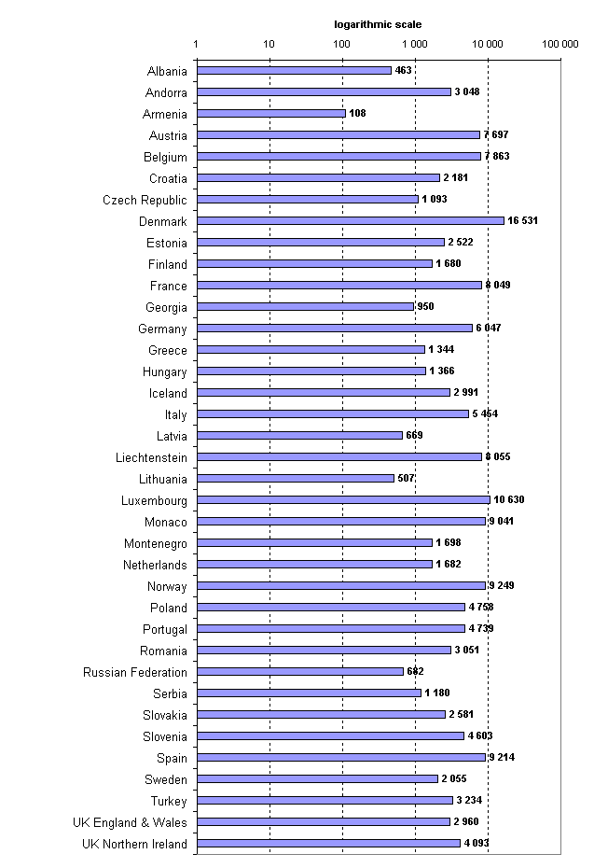

7.8 Criminal cases treated by the courts

As it has already been identified in the previous paragraph, only a relatively small portion of criminal cases are charged by the public prosecutor before a court. In table 40 general figures are presented for the number of criminal cases received by courts, appeal rates, decisions taken and length of proceedings. All these figures should be handled with care and should only be used for illustrative purposes, to show the caseload of courts.

It must be noted that the general length of proceedings has been included as an indication, but cannot be used for a comparative analysis, due to disparities in the periods of the proceeding taken into account.

Table 40. Criminal cases in courts in 2004 (question 73)

Country | Q73-1 Criminal incoming cases | per 100 000 inhabitants | Q 73-2  judicial decisions | Q73-3  convicted persons | Q 73-4  acquitted persons | Q 73-5  % of decisions subject to appeal in a higher court | Q73-6 pending cases by 1 January 2005 | Q 73-7  % of pending cases of more than 3 years
Albania | 9 181 | 299 | 7068 | 6379 | 303 | 38,0 | 2113 | -
Andorra | 2 319 | 3 017 | 911 | 1656 | 420 | - | - | -
Armenia | 4 651 | 145 | 3780 | 4881 | 6 | 33,3 | 547 | -
Austria | 91 152 | 1 111 | 50 723 | - | - | 8,8 | 15695 | 2,4
Azerbaijan | 13 838 | 166 | 10 775 | 13 353 | 6 | 18,6 | 1305 | -
Belgium | 32 437 | 311 | - | - | - | - | - | -
Bulgaria | 67 537 | 870 | 58377 | 57383 | 2953 | - | 28117 | -
Croatia | 33 931 | 764 | - | - | - | - | - | -
Cyprus | 81 948 | 11 884 | 80608 | 68536 | 13412 | 0,3 | 32058 | 0
Czech Republic | 79 012 | 773 | 94024 | 68443 | 7456 | - | 5403 | 10,86
Denmark | 134 647 | 2 495 | 131298 | 131298 | - | 3,0 | 42780 | -
Estonia | 8 622 | 638 | 8412 | 10060 | 248 | 21,0 | 2181 | 3,8
Finland | 67 298 | 1 285 | 66 533 | 54 018 | 3 486 | 12,4 | 17 380 | 6
France | 962 917 | 1 549 | 1086651 | 1115823 | 47800 | - | 368818 | -
Germany | 910 548 | 1 104 | 433 406 | 442 356 | 37 243 | 14,0 | 313989 | 0,63
Greece | 205 534 | 1 859 | - | - | - | - | - | -
Hungary | 138 433 | 1 371 | 103041 | 98976 | 4490 | 10,6 | 51761 | 1,61
Iceland | 8 563 | 2 917 | 8 105 | 2 612 | 81 | 2,0 | 761 | 0
Ireland | 360 334 | 8 919 | - | - | - | - | - | -
Italy | 1 433 260 | 2 452 | 1 311 549 | - | - | - | 1 254 003 | -
Latvia | 12 167 | 525 | 12 295 | 13 222 | 209 | 17,2 | 4 475 | 1,9
Liechtenstein | 1 429 | 4 130 | 1 293 | - | - | - | 321 | -
Lithuania | 17 592 | 514 | 17 364 | 17 882 | 458 | 26,0 | 3 493 | -
Luxembourg | - | - | 11477 | - | - | - | 2956 | -
Moldova | 12 774 | 377 | 13046 | 12751 | 338 | 4,6 | 2799 | -
Monaco | 617 | 2 055 | 700 | 796 | 30 | 10,0 | 40 | -
Montenegro | 5 190 | 836 | 3 459 | 3 000 | 585 | 32,3 | 1 731 | 5,1
Netherlands | - | - | 133218 | 126174 | 6353 | - | - | -
Norway | 16 896 | 367 | 16 343 | - | - | 8,0 | 5 264 | -
Poland | 548 136 | 1 436 | 564 196 | 500 799 | 13 070 | 18,4 | 213 277 | 2,8
Portugal | 116 344 | 1 105 | 99 747 | 69 798 | 35 105 | - | 170 008 | -
Romania | 416 581 | 1 922 | 353 945 | 76 198 | 27 816 | - | 60 633 | -
Russian Federation | 1 059 000 | 738 | 677 000 | 816 000 | 9 000 | 19,8 | 155 000 | -
Serbia | 105389 | 1 406 | 56824 | - | - | 25,0 | 48565 | -
Slovakia | 26 939 | 499 | 26 446 | 26 804 | 1 223 | 17,0 | 17 330 | 9
Slovenia | 14 529 | 727 | 16 008 | 7 974 | 1 713 | - | 20 904 | 26,5
Spain | 5 184 126 | 12 074 | 415 313 | - | - | 7,0 | 751 472 | -
Sweden | 68 555 | 759 | - | - | - | 12,9 | 25 827 | 2,6
Turkey | 1 778 875 | 2 500 | 2 337 748 | 1 091 358 | 485 253 | - | 1 056 754 | -
UK England & Wales | 2 022 604 | 3 813 | 1 599 448 | 1 548 500 | 50 948 | 12,7 | 28 198 | 0

Comments

- Albania:
- Q73-3: for 772 persons the case is dismissed.
- Q73-5: decisions subject to appeal: the figures that are included concerns only the appeals to the appeal court (second instance court).
- Czech Republic:
- Q73-2: closed cases.
- Q73-7: percentage of pending cases of more than 2 years.
- Denmark:
- Q 73-1,2,3,6: City Courts.
- Q 73-5: approximation.
- Estonia: Q 73-3,4: number of persons concerned (not cases).
- France :
- Q 73-1: 517 245 criminal acts and offences, 445 672 infringements including 119 622 of the 5th category.
- Q 73-2: judicial decisions (judgements and terminations of a case) 1.086.651 including 518 699 criminal acts and offences, 567 952 infringements including 149 789 of the 5th category.
- Q 73-3: 566 919 criminal acts and offences, 548 904 infringements including 143 953 of the 5th category.
- Q 73-4; including 31 110 criminal acts and offences, 16 690 infringements including 4 403 of the 5th category.
- Q 73-5: pending cases on 1 January 2005 (excepted courts for minors) 368 818, police tribunals and juridictions de proximité 221 917 (except courts for minors).
- Greece: data are those given only by the Public Prosecutor's office of the Court of First Instance in Athens.
- Iceland: Q73-5: 170 cases
- Italy:
- Q 73-1: 1.343.481 court cases, 89.779 justice of the peace court cases (total 1,433,260).
- Q 73-2: 1.231.499 court cases, 80.010 justice of the peace court cases (total 1,311,549).
- Q 73-6: 1.196.156 court cases, 57.847 justice of the peace court cases (total 1,254,003).
- Luxembourg: 73a1: the provided statistics are compared to the number of returned decisions. It should however be noted that out of criminal matters, the number of new submitted cases to the court dealing with the substance of a case is appreciably equal to the number of given judgements. 73a3,4: The statistics are drawn up on the basis of the figures of the given judgements, without taking into account of the number of the persons concerned with the decision.
- Monaco: Q 73-5: around + 10%
- Montenegro: basic courts
- Romania:
- - Q 73-1: sum of Court of first instance cases (280.313) + Tribunal cases (includes cases tried in first instance, in appeal and in second appeal before tribunals) (102.088) + Courts of Appeal cases (includes cases tried in first instance, in appeal and in second appeal before courts of appeal) (34.180) = 416.581.
- Q 73-2: sum of Court of first instance cases (231.056) + Tribunal cases (includes decisions rendered by tribunals in first instance, appeal and second appeal) (90.712) + Courts of Appeal cases (includes decisions rendered by courts of appeal in first instance, appeal and second appeal) (32.177) = 353.945.
- Q 73-3: sum of Court of first instance cases (includes defendants convicted by the courts of first instance - not by final decisions) (68.101) + Tribunal cases (first instance 7.327; appeal cases 287; second appeal cases 281) + Courts of Appeal cases (first instance 43; appeal 47; second appeal 112) = 76.198.
- Q 73-4: sum of Court of first instance cases (includes defendants convicted by the courts of first instance (not by final decisions) (26.358) + Tribunal cases (first instance 222; appeal 271; second appeal 760) + Courts of Appeal cases (first instance 18; appeal 30; second appeal 157) = 27.816.
- Q 73-5: 23.78% of the cases decided by the courts of first instance were appealed to tribunals; 24.39% of the cases decided in first instance by the tribunals were appealed to courts of appeal. – Q 73-6: sum of Court of first instance cases (49.257) + Tribunal cases (includes cases tried in first instance, in appeal and in second appeal before tribunals) (11.376) + Courts of Appeal cases (2.003) = 60.633.
- Russian Federation:
- Q 73-5: with regard to the persons whose sentences were appealed.
- Q 73-7: 2.8 % of the total amount of completed cases. 8.3 % of the total amount of pending cases.
- UK England & Wales: Q 73-5: from Crown Ct. to Court of Appeal.

For illustrative purposes, in the following graphs, the criminal cases received by the courts per 100.000 inhabitants, the robbery and intentional homicide incoming cases are displayed.

Graph 24. Criminal incoming cases in 2004 (per 100.000 inhabitants) (question 73)
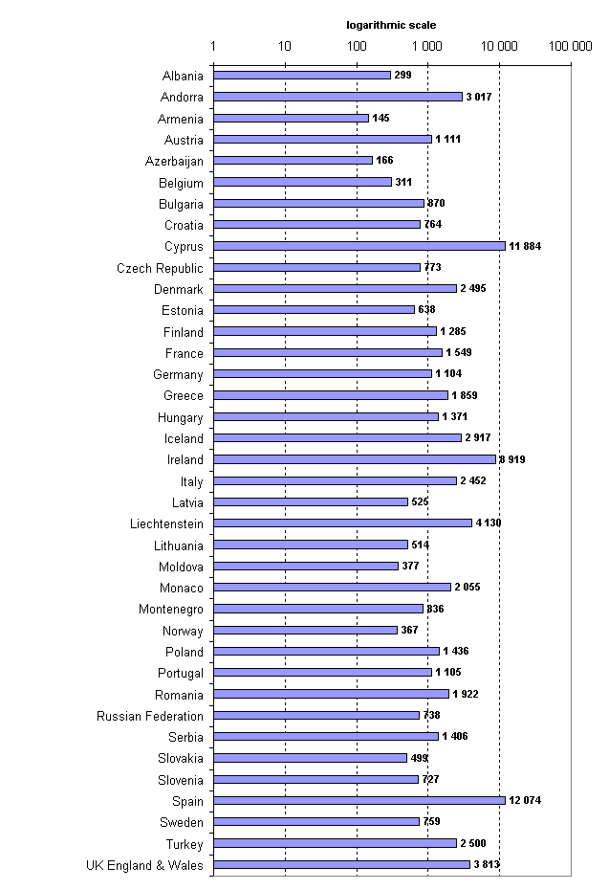

Graph 25. Incoming cases robbery and intentional homicide cases in 2004 (per 100.000 inhabitants) (question 73)
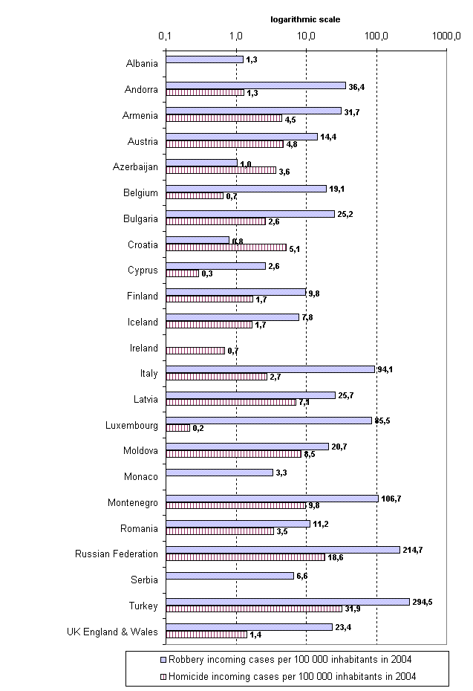

7.9 Length of proceedings for robbery cases and intentional homicides

As for the tables regarding civil cases, the general length of proceedings is given as an indication for each country, but cannot be used for comparisons. The CEPEJ have chosen to analyse more specifically two kinds of criminal cases: robbery and intentional homicide. Despite the importance of measuring the length of court proceedings, many countries are not able to provide quantitative information. Only 8 countries were able to present information regarding the length of proceedings of robbery cases; for intentional homicide cases, only 6 countries could provide the information.

Robbery cases
Albania, Czech Republic, Finland, France, Iceland, Montenegro, the Netherlands and Portugal were able to present figures regarding the length of treatment of a robbery before a court. Very short proceedings can be found in Albania (average duration of 60 days in first instance courts). For other countries, the average length is the same as a first instance court: Iceland (107 days), Finland (147 days), the Netherlands (150 days), Montenegro (158 days), France (240 days), Portugal (346 days) and Czech Republic (373 days).

The average length of cases at 2nd level instance courts: Albania (60 days), Czech Republic (52 days), Finland (215 days), France (552 days), Montenegro (163 days) and Portugal (102 days). Information regarding the total length of proceedings (from first instance to the highest court) was provided by: Czech Republic (409 days), Montenegro (315 days) and Slovak Republic (284 days).

Intentional homicide cases
To compare homogeneous and clearly identifiable severe criminal cases, countries were invited to provide information concerning the duration of proceedings with respect to intentional homicide cases (excluding tries). However only a few countries were able to send quantitative information.

At first level instance courts the average duration of the treatment of intentional homicide cases varied from 63 days (Iceland) to 1179 days (France). In the other countries, the figures were: 210 days (Czech Republic), 126 days (Finland), 536 days (Montenegro) and 293 days (Portugal).

In second level instance courts, the average duration was: 53 days (Czech Republic), 272 days (Finland), 205 days (Montenegro) and 115 days (Portugal). Information regarding the total length was provided by: Montenegro (715 days), Czech Republic (285 days) and Slovak Republic (150 days).

8. Public prosecutors

8.1 Introduction

In this chapter the main competences, tasks and performances of the public prosecutor are described. The public prosecutor is defined in Recommendation 2000 (19) on the role of public prosecutors in the criminal system: public prosecutors are “public authorities who, on behalf of society and in the public interest, ensure the application of the law where the breach of the law carries a criminal sanction, taking into account both the rights of the individual and the necessary effectiveness of the criminal justice system”.

8.2 Role and powers of the prosecutor

Common tasks and competences of public prosecutors are: to decide whether to initiate or continue prosecutions, to conduct prosecutions before the courts and appeal concerning some criminal court decisions. In certain instances, public prosecutors may have a role in the enforcement of civil proceedings, the supervision of criminal investigations, the assistance of victims, the decision on alternative sanctions, etc.

The roles and powers of the public prosecutor may vary from country to country. In all countries the public prosecutor has a role in charging a criminal offence and to present a case before the court (the only exception is Ukraine). To a lesser extent, many countries replied that there is a role for the public prosecutor in the appeal of a criminal case or to demand investigation measures from the judge. It should be noted that less than half of the countries make it possible for a prosecutor to close a case by imposing a penalty or a negotiated measure without a judicial decision. (See table 41).

Table 41. Number of positive answers regarding the role and powers of the prosecutor (questions 70 and 71)

Role and powers of Prosecutors | conduct or supervise police investigation | 39
Role and powers of Prosecutors | conduct investigation | 32
Role and powers of Prosecutors | demand investigation measures from the judge | 42
Role and powers of Prosecutors | Charge | 47
Role and powers of Prosecutors | present the case in the court | 46
Role and powers of Prosecutors | propose a sentence to the judge | 41
Role and powers of Prosecutors | Appeal | 44
Role and powers of Prosecutors | supervise enforcement procedure | 27
Role and powers of Prosecutors | end the case without the need for a judicial decision | 40
Role and powers of Prosecutors | impose or negotiate a penalty without a judicial decision | 15
Role and powers of Prosecutors | Have other significant powers | 16
 | The prosecutor has a role in civil and or administrative cases | 31

It should be noted that remarks concerning the category "other significant powers" were not exploited in detail.

In 31 countries the public prosecutor has a role in civil and or administrative law cases. Mostly, this role is related to the execution of court decisions. This task may be exercised in other countries by a bailiff.

Monitoring and evaluation

As for the monitoring and evaluation of the services of the public prosecution (question 59), only 6 countries on 47 do not have such a system: Armenia, Cyprus, Denmark, the Russian Federation, San Marino and Ukraine.

8.3 Prosecutors and staff of the prosecution service

In some countries, a specific group of tasks may be addressed to other officials than public prosecutors or may be exercised by lawyers on a contractual basis. For example in Austria, the agents of public prosecutor’s offices (“Bezirksanwälte”) are judicial officers with legal training, and are allowed to act for the public prosecutor’s offices under the supervision of a public prosecutor (quite similar to the “Rechtspfleger”, but with a lower range of competency and fewer qualifications). These 145 (fte) agents are not included in the total number of public prosecutors, as presented in table 41. In Ireland, public prosecution is ensured by 66 full time lawyers, plus 34 persons, also professional lawyers, who are entrusted with similar duties (State Solicitors) but on a contractual basis. In the table, an addition has been made either because duties are the same, or because, if this had not been done, these 34 prosecutors would have not appeared in the statistics.

It has to be noted that the issue of categorization is recurrent for some countries or entities whose judicial organisation does not correspond to the criteria of the evaluation scheme. Thus, in UK-Northern Ireland, there are 100 judges among the 300 prosecutors indicated. Norway stresses that the number indicated includes several authorities: “The officials of the prosecuting authority are: 1) the Director General of Public Prosecutions and the Assistant Director General of Public Prosecutions, 2) the public prosecutors, deputy public prosecutors, and assistant public prosecutors, 3) the chiefs of police, the deputy chiefs of police, the head of the security service, the assistant chiefs of police, police prosecutors, police intendants I, and police intendants II, in so far as they have a law degree and serve in an office or position that confers the authority to prosecute.” Finally Sweden includes in this number the 79 persons working at the Economic Crime Bureau.

Table 42. Number of public prosecutors in 2004 (questions 43 and 44)

Country | Q43 Number of public prosecutors (fte) | per 100 000 inhabitants | Q44 Are there persons who have similar duties as public prosecutors? | Q44 If yes, number | per 100 000 inhabitants
Albania | 267 | 8,7 | yes
Andorra | 4 | 5,2 | no
Armenia | 605 | 18,9 | no
Austria | 216 | 2,6 | yes | 145 | 1,8
Azerbaijan | 360 | 4,3 | n.a.
Belgium | 893 | 8,5 | no
Bosnia and Herzegovina | 274 | 7,2 | no
Bulgaria | n.r. |  | no
Croatia | 558 | 12,6 | no
Cyprus | 107 | 15,5 | no
Czech Republic | 1 066 | 10,4 | no
Denmark | 564 | 10,4 | yes
Estonia | 186 | 13,8 | no
Finland | 330 | 6,3 | yes
France | 1 848 | 3,0 | yes
Georgia | 532 | 11,7 | no
Germany | 5 106 | 6,2 | yes
Greece | 520 | 4,7 | no
Hungary | 1 453 | 14,4 | no
Iceland | 7 | 2,4 | yes | 26 | 8,9
Ireland | 100 | 2,5 | yes | 16 | 0,4
Italy | 2 146 | 3,7 | yes | 1 506 | 2,6
Latvia | 604 | 26,0 | no
Liechtenstein | 7 | 18,8 | no
Lithuania | 850 | 24,8 | no
Luxembourg | 39 | 8,6 | no
Malta | 6 | 1,5 | yes | 85 | 21,1
Moldova | 766 | 22,6 | no
Monaco | 4 | 13,3 | no
Montenegro | 83 | 13,4 | no
Netherlands | 598 | 3,7 | no
Norway | 705 | 15,3 | yes | 628 | 13,6
Poland | 5 393 | 14,1 | yes
Portugal | 1 217 | 11,6 | no
Romania | 2 784 | 12,8 | no
Russian Federation | 55 021 | 38,3 | no
San Marino | 1 | 3,4 | yes
Slovakia | 697 | 12,9 | no
Slovenia | 171 | 8,6 | yes | 22 | 1,1
Serbia | 800 | 10,7 | no
Spain | 1 740 | 4,1 | no
Sweden | 767 | 8,5 | no
Turkey | 3 006 | 4,2 | no
Ukraine | n.r. |  | no
UK England & Wales | 2 819 | 5,3 | yes
UK Northern Ireland | 300 | 17,5 | no
UK Scotland | 1 428 | 28,1 | n.r.

The number of prosecutors stricto sensu per inhabitant varies considerably. The average in all the responding countries is a little bit more than 11 prosecutors per 100.000 inhabitants (Bulgaria and Ukraine are excluded from this calculation, as they did not submit the information). The minimum is to be found in Malta, with almost 1.5 prosecutor per 100.000 inhabitants, and at the opposite the Russian Federation, where there are about 38 prosecutors per 100.000 inhabitants.

In graph 26 the differences between the numbers of public prosecutors per 100.000 inhabitants is presented in a geographical map. It shows that, especially in Eastern Europe, many prosecutors per 100.000 inhabitants are operating.

Graph 26 Geographical map of public prosecutors in 2004 (per 100.000 inhabitants)

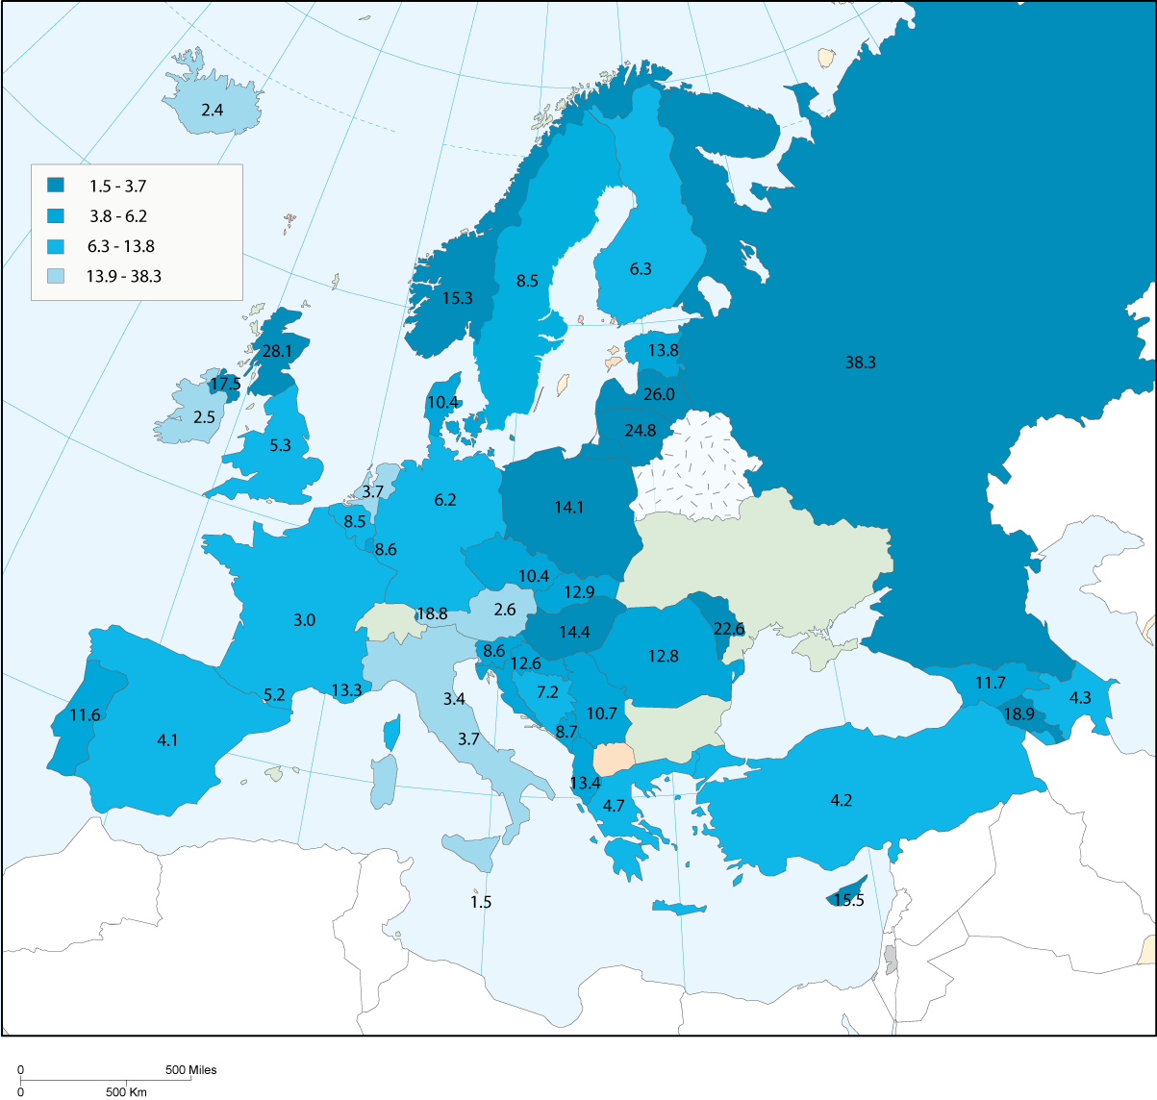

In the explanatory note it is stated that non-prosecution staff are defined as officials working for the public prosecution system. As a result of this, variations occur in what is included in the total number per country. For example Croatia includes assessors, trainees and experts. Norway has not included the staff working for the police, whereas Sweden, which has a similar system, has done so. Finally Turkey has already specified that non-judge and non-prosecutor staff were counted together (due to the fact that for assisting staff there is no separation between the courts and the public prosecution).

In table 43 the non-prosecution staff of all countries is represented. Also the ratio between the number of non-prosecutor staff per prosecutor as well as the number of judges per prosecutor is described.

Table 43. Number of non-prosecution staff in 2004 and ratios (questions 36, 40, 43 and 46)

Country | Q46 Number of staff (non prosecutors) attached to the public prosecution service (fte) | Q43 Number of public prosecutors (fte) | Non-prosecutor staff per prosecutor | Q40 Number of non-judge staff who are working in courts (fte) | Q36 Number of professional judges sitting in courts (fte) | Non-judge staff per judge
Albania | 497 | 267 | 1,9 | 808 | 383 | 2,1
Andorra | 4 | 4 | 1,0 | 68 | 22 | 3,1
Armenia | 273 | 605 | 0,5 | 966 | 179 | 5,4
Austria | 171,6 | 216 | 0,8 | 4 320 | 1 697 | 2,5
Azerbaijan | 700 | 360 | 1,9 | 1 524 | 338 | 4,5
Belgium | 2304 | 893 | 2,6 | 5 618 | 2 500 | 2,2
Bosnia & Herzegovina | 427 | 274 | 1,6 | 1 998 | 690 | 2,9
Bulgaria | n.r. | n.r. |  | n.r. | n.r.
Croatia | 885 | 558 | 1,6 | 6 473 | 1 907 | 3,4
Cyprus | 190 | 107 | 1,8 | 425 | 96 | 4,4
Czech Republic | 1580 | 1 066 | 1,5 | 9 093 | 2 878 | 3,2
Denmark | n/a | 564 |  | 1 422 | 368 | 3,9
Estonia | 74 | 186 | 0,4 | 1 016 | 245 | 4,1
Finland | 210 | 330 | 0,6 | 2 586 | 875 | 3,0
France | 4077,64 | 1 848 | 2,2 | 17 376 | 6 278 | 2,8
Georgia | 290 | 532 | 0,5 | 1 155 | 406 | 2,8
Germany | 12304,65 | 5 106 | 2,4 | 58 922 | 20 395 | 2,9
Greece | nap | 520 |  | 6 827 | 2 200 | 3,1
Hungary | 2295 | 1 453 | 1,6 | 6 770 | 2 757 | 2,5
Iceland | 57 | 7 | 8,1 | 57 | 47 | 1,2
Ireland | 102 | 100 | 1,0 | 1 084 | 130 | 8,3
Italy | 10852 | 2 146 | 5,1 | 24 952 | 6 105 | 4,1
Latvia | 372 | 604 | 0,6 | 1 371 | 384 | 3,6
Liechtenstein | 3,8 | 7 | 0,6 | 39 | 17 | 2,3
Lithuania | 585 | 850 | 0,7 | 2 350 | 693 | 3,4
Luxembourg | 36 | 39 | 0,9 | 240 | 162 | 1,5
Malta | 7 | 6 | 1,2 | 346 | 35 | 9,9
Moldova | 790 | 766 | 1,0 | n.a. | 415
Monaco | 5 | 4 | 1,3 | 41 | 18 | 2,3
Montenegro | 116 | 83 | 1,4 | 830 | 242 | 3,4
Netherlands | 3382 | 598 | 5,7 | 5 217 | 2 004 | 2,6
Norway | 51 | 705 | 0,1 | 961 | 501 | 1,9
Poland | 4213 | 5 393 | 0,8 | 33 878 | 9 766 | 3,5
Portugal | 1696 | 1 217 | 1,4 | 7 506 | 1 754 | 4,3
Romania | n.r. | 2 784 |  | 8 975 | 4 030 | 2,2
Russian Federation | 16902 | 55 021 | 0,3 | 65 237 | 29 685 | 2,2
San Marino | n.r. | 1 |  | 45 | 16 | 2,8
Slovakia | 756 | 697 | 1,1 | 4 070 | 1 208 | 3,4
Slovenia | 174 | 171 | 1,0 | 2 257 | 780 | 2,9
Serbia | n.r. | 800 |  | 18 171 | 2 418 | 7,5
Spain | 1751 | 1 740 | 1,0 | 37 744 | 4 201 | 9,0
Sweden | 620 | 767 | 0,8 | 1 337 | 1 618 | 0,8
Turkey | nap | 3 006 |  | 18 276 | 5 304 | 3,4
Ukraine | n.r. | n.r. |  | 23 304 | 6 999 | 3,3
UK England & Wales | 8011 | 2 819 | 2,8 | 23 000 | 1 305 | 17,6
UK Northern Ireland | 300 | 300 | 1,0 | 537 | 62 | 8,7
UK Scotland | 1428 | 1 428 | 1,0 | 1 231 | 227 | 5,4

Note: the total number of prosecutors in Iceland does not include 26 police commissioners who have also prosecution powers

When the ratio of non-prosecution staff per prosecutor is compared to non-judge staff per judge, the general result is that on the average judges have more staff at their disposal than public prosecutors (with the exception of: Iceland, Italy, the Netherlands and the United Kingdom (England and Wales, Northern Ireland and Scotland).

Differences between countries can also be clearly identified according to the number of judges per prosecutor. In a first group of countries, prosecutors are more numerous than judges, because this ratio is below 1 (in increasing order): two entities of the United Kingdom (Scotland and Northern Ireland), Armenia, the Russian Federation, Moldova, Latvia, Denmark, Norway, Georgia, UK-England and Wales, Lithuania, Cyprus and Azerbaijan. In a second group, judges are slightly more numerous than prosecutors (less than 2): Ireland, Estonia, Albania, Portugal, Poland, Slovak republic, Turkey and Hungary.

Finally, judges are much more numerous than prosecutors (more than 2) in the following countries : Sweden, Spain, Bosnia and Herzegovina, Liechtenstein, Finland, Czech Republic, Belgium, Italy, Montenegro, Malta, the Netherlands, Croatia, Germany, France, Luxembourg, Greece, Monaco, Slovenia, Andorra, Iceland, Austria and San-Marino.

9. The status of judges and prosecutors

9.1 Introduction

The practice of the profession of judges and prosecutors will be the focus of this chapter and divided into six topics. The recruitment and the nomination of judges and prosecutors will be presented in section 9.2. This includes also the duration of their mandate. In section 9.3, training will be discussed. In the two following sections the remuneration and additional benefits of judges and prosecutors will be shown, followed by a paragraph on the possibility to combine the work with other professions. The chapter ends with the facts and figures regarding the number of disciplinary proceedings and sanctions.

9.2 Recruitment and nomination

With respect to the recruitment and nomination of judges it is interesting to take note of Opinion (2001)1 of the Consultative Council of European Judges (CCJE). According to the CCJE, the nomination of judges should be based on objective criteria and taken by an independent authority. “The CCJE considered that every decision relating to a judge’s appointment or career should be based on objective criteria and be either taken by an independent authority or subject to guarantees to ensure that it is not taken other than on the basis of such criteria” (CCJE Opinion No. (2001) 1 § 37).

Regarding the authority responsible for the nomination, the CCJE also promotes a system whereby a substantial number of judges are represented on the nomination board. Opinion No. 1 recommends that the decisions for the nomination of judges are taken by “an independent authority with substantial judicial representation chosen democratically by other judges” (CCJE Opinion (2001) No. 1 §45).

As regards the nomination of public prosecutors, Recommendation Rec(2000) 19 on the role of public prosecution in the criminal justice system provides that "the recruitment (…) of public prosecutors are carried out according to fair and impartial procedures embodying safeguards against any approach which favours the interests of specific groups, and excluding discrimination on any ground (…)".

In practice, the recruitment of judges and prosecutors can be accomplished via three different authorities: (1) by a body composed of members of the judiciary, (2) by a body composed of member external to the judiciary or (3) by a body composed of members of the judiciary and external to the judiciary.

The following table shows the number of positive answers.

Table 44. Recruitment of judges and prosecutors (questions 74 and 75)

Recruitment of judges | by a body composed of members of the judiciary | 6
Recruitment of judges | by a body composed of members external to the judiciary | 7
Recruitment of judges | by a mixed body | 35
Recruitment of prosecutors | by a body composed of members of the prosecution services | 16
Recruitment of prosecutors | by a body composed of members external to the prosecution services | 10
Recruitment of prosecutors | by a mixed body | 22

In the majority of the member states the recruitment and nomination of judges and prosecutors is carried out by a body composed of members of the judiciary and external members (mixed body). In many member states a (High) Council for the Judiciary plays a central role in the nomination of judges: Azerbaijan (Judicial Legal Council), Bosnia and Herzegovina (High Judicial and Prosecutorial Council), Bulgaria (Supreme Judicial Council), France (Conseil Supérieur de la Magistrature), Georgia (Supreme Council of Justice), Lithuania (Judicial Council), Moldova (Conseil Supérieur de la Magistrature), Romania (Conseil Supérieur de la Magistrature), Slovenia (Judicial Council) and Turkey (Supreme Council of Judges and Public Prosecutors). In most of the councils for the judiciary, the Council is composed of members of the judiciary and external members (legal scientists, lawyers and incidentally representatives of the Ministry of Justice). In general the councils for the judiciary give an opinion (which might be mandatory or not) on the nomination of judges and prosecutors. The formal nomination itself is mostly done by the Head of State or government (for example: France, Lithuania, Moldova and Romania).

In other states there are judicial appointment commissions or advisory boards. This is the case for: Finland (Judicial Appointments Board), Ireland (Judicial Appointments Advisory Board), Latvia (Judicial Qualifications Board), Norway (Judicial Appointments board), Poland (National Council’s of Judiciary nomination), UK-England and Wales (Judicial Appointments Commission), UK - Northern Ireland (Judicial Appointments Commission), UK-Scotland (Judicial Appointments Board). The majority of these boards are composed of members of the judiciary and legal practitioners (lawyers). In most cases the board is responsible for making a proposal to the Minister of Justice or the Parliament. The Parliament then nominates the judges formally.

Germany specifies that the regulations for the recruitment of the judges vary from one Land to another.

It should be noted that, in certain countries, the appointment and the recruitment of prosecutors are often not ensured by the same bodies/organs exactly as in the case of the judges, even if it is a body with the same characteristics. In UK-Scotland for example, it is the Crown Office who deals with these services for the public prosecutor, a system that is similar to that of Croatia, where there is a mixed body (State Attorney’s Council). This body is composed of representatives of the public prosecution and members external to the judiciary. In Iceland, the recruitment and nomination come under the competencies of the Ministry for Justice.

Table 45. Recruitment of judges and prosecutors (questions 74 and 75)

Country | Q74 Recruitment of judges |  |  | Q75 Recruitment of prosecutors
Country | by a body composed of members of the judiciary | by a body composed of members external to the judiciary | by a mixed body | by a body composed of members of the prosecution service | by a body composed of members external to the prosecution service | by a mixed body
Albania |  |  | yes |  |  | yes
Andorra |  |  | yes |  | yes
Armenia |  |  | yes | yes
Austria |  |  | yes |  |  | yes
Azerbaijan |  |  | yes | yes | yes
Belgium |  |  | yes |  |  | yes
Bosnia and Herzegovina |  |  | yes |  |  | yes
Bulgaria |  | yes |  |  |  | yes
Croatia |  |  | yes |  |  | yes
Cyprus | yes |  |  |  | yes
Czech Republic | yes |  |  | yes
Denmark | yes |  | yes | yes
Estonia |  |  | yes |  |  | yes
Finland |  |  | yes | yes
France |  |  | yes |  |  | yes
Georgia |  | yes |  | yes
Germany |  | yes | yes |  | yes
Greece |  |  | yes |  |  | yes
Hungary |  |  | yes | yes
Iceland |  |  | yes |  | yes
Ireland |  |  | yes |  |  | yes
Italy |  |  | yes |  |  | yes
Latvia | yes |  |  | yes
Liechtenstein |  | yes |  |  | yes
Lithuania |  | yes |  | yes
Luxembourg |  |  | yes |  |  | yes
Malta |  |  | yes |  |  | yes
Moldova |  |  | yes |  |  | yes
Monaco |  | yes |  |  | yes
Montenegro |  |  | yes |  |  | yes
Netherlands |  |  | yes |  |  | yes
Norway |  |  | yes | yes
Poland | yes |  |  | yes
Portugal |  |  | yes |  |  | yes

Country | Q74 Recruitment of judges |  |  | Q75 Recruitment of prosecutors
Country | by a body composed of members of the judiciary | by a body composed of members external to the judiciary | by a mixed body | by a body composed of members of the prosecution service | by a body composed of members external to the prosecution service | by a mixed body
Romania |  |  | yes |  |  | yes
Russian Federation |  |  | yes | yes
San Marino |  |  | yes |  | yes
Slovakia |  |  | yes |  |  | yes
Slovenia |  | yes |  |  | yes
Serbia | no | no | yes |  |  | yes
Spain |  |  | yes |  |  | yes
Sweden | yes |  |  | yes
Turkey |  |  | yes |  |  | yes
Ukraine |  |  |  | yes
UK England & Wales |  |  | yes |  | yes
UK Northern Ireland |  |  | yes | yes
UK Scotland |  |  | yes | yes

Some explanations are necessary for the "terms of office" of the judges and prosecutors to consolidate the figures provided . Armenia did not answer the question. There are countries where the mandate given to a judge or a prosecutor is for a set period, which can be renewed. For example in Andorra judges and prosecutors are nominated for a set period, and the mandate can be renewed for a period of 6 years. In Georgia, the mandate for judges can be extended to 10 years and for prosecutors to 5 years. Bulgaria and Moldova also replied that there is a set mandate for judges, which can be renewed (however information regarding the length is not provided). Other countries, which are using set mandates for public prosecutors are (Bulgaria, renewable but no additional figures provided), Iceland (renewable length - 5 years), Liechtenstein, Malta (renewable length - 3 years), Montenegro (renewable length - 5 years), United Kingdom (renewable, but length is individually determined). (See table 46).

Table 46. Characteristics of the mandate given to judges and prosecutors (question 76)

Country | Q76 The mandate of judges |  |  | Q76 The mandate of prosecutors |  |  | Are there any exceptions?
Country | is given for an undetermined period | If NO, is it renewable? | If mandate renewable, length | is given for an undetermined period | If NO, is it renewable? | If mandate renewable, length | Are there any exceptions?
Albania | yes |  |  | yes
Andorra |  | yes | 6 years |  | yes | 6 years
Armenia
Austria | yes |  |  | yes
Azerbaijan | yes |  |  |  | yes | 5 years | yes
Belgium | yes |  |  | yes |  |  | yes
Bosnia & Herzegovina | yes |  |  | yes |  |  | yes
Bulgaria | yes | yes |  | yes | yes
Croatia | yes |  |  | yes
Cyprus | yes |  |  | yes
Czech Republic | yes |  |  | yes
Denmark | yes |  |  | yes
Estonia | yes |  |  | yes
Finland | yes |  |  | yes |  |  | yes
France | yes |  |  | yes |  |  | yes
Georgia |  | yes | 10 years |  | yes | 5 years
Germany | yes |  |  | yes |  |  | yes
Greece | yes |  |  | yes
Hungary | yes |  |  | yes
Iceland | yes |  |  |  | yes | 5 years | yes
Ireland | yes |  |  | yes
Italy | yes |  |  | yes
Latvia | yes |  |  | yes |  |  | yes
Liechtenstein | yes |  |  |  | yes
Lithuania | yes |  |  | yes |  |  | yes
Luxembourg | yes |  |  | yes |  |  | yes
Malta | yes |  |  |  | yes | 3 years | yes
Moldova |  | yes | 5 years | yes
Monaco | yes |  |  | yes |  |  | yes

Country | Q76 The mandate of judges |  |  | Q76 The mandate of prosecutors |  |  | Are there any exceptions?
Country | is given for an undetermined period | If NO, is it renewable? | If mandate renewable, length | is given for an undetermined period | If NO, is it renewable? | If mandate renewable, length | Are there any exceptions?
Montenegro | yes |  |  |  | yes | 5 years
Netherlands | yes
Norway | yes |  |  | yes |  |  | yes
Poland | yes |  |  | yes |  |  | yes
Portugal | yes |  |  | yes
Romania | yes |  |  | yes
Russian Federation |  |  |  |  |  |  | yes
San Marino | yes |  |  | yes
Slovakia | yes |  |  | yes
Slovenia | yes |  |  | yes |  |  | yes
Serbia | yes |  |  | yes |  |  | yes
Spain | yes |  |  | yes |  |  | yes
Sweden | yes |  |  | yes
Turkey | yes |  |  | yes
Ukraine |  |  |  | yes
UK England & Wales | yes |  |  |  | yes | individual
UK Northern Ireland | yes |  |  |  | yes | individual
UK Scotland | yes |  |  |  | yes | individual

9.3 Training

Many European countries have special institutes for the training of judges and prosecutors. With respect to judges, the Consultative Council of European Judges (CCJE) states that the authority responsible for the training and the quality of the training programme should be independent from the executive and the legislative power and that at least half of its members should be judges (CCJE Opinion (2003) No. 4: 3). The CCJE also recommends that for the training, an independent body should be established, with its own budget and which is able to devise training programmes.

Regarding initial training, the CCJE is of the opinion that mandatory initial training should be given to judges appropriate to the professional experience of the appointees. This means that an experienced lawyer needs less training than a judge trainee who has just finished law university (see CCJE Opinion (2003) No. 4: 4). For in-service training, the CCJE recommends that it should normally be based on the voluntary participation of judges and that mandatory in-service training should only be given in exceptional cases (CCJE Opinion (2003) No. 4: 6).

As regards the training of prosecutors, Recommendation Rec(2000) 19 on the role of public prosecution in the criminal justice system provides that "training is both a duty and a right for all public prosecutors, before their appointment as well as on a permanent basis. States should therefore take effective measures to ensure that public prosecutors have appropriate education and training, both before and after their appointment".

In the majority of countries, the initial training of judges (32 countries or entities answered positively) and prosecutors (37 countries or entities) is compulsory. In one country the initial training is optional (Iceland). The training of judges and prosecutors can be carried out by national training centres for the judiciary and prosecutors. Another possibility is the in-service training. For 17 countries or entities (judges) and 19 countries or entities (prosecutors) the in-service training is compulsory for judges and prosecutors. However, there are also numerous countries where this training facility is highly recommended (22 countries or entities replied that this is the case for judges and 19 countries or entities replied that in-service training is highly recommended for public prosecutors). With respect to the frequency that in-service training is given, most of the countries replied that this is done on a regular basis.

Generally speaking, in-service training for specialised functions (for example specialised judges or prosecutors) is in most countries highly recommended. 10 (judges) and 13 (prosecutors) countries or entities replied that it is compulsory. Just like the general in-service training, most countries provide training on a regular basis.

For court presidents, heads of departments of courts/public prosecution agencies, court directors etc., there may be a (specialised) in-service training too. Mostly for specific functions in the courts or the public prosecution agencies, the in-service training for this category of persons is highly recommended. In 6 countries it is compulsory for specific functions in the courts. In-service training is carried out regularly in the majority of the countries.
In table 47 and 48 the results are summarized for the judges and the public prosecutors.

Table 47. Nature and frequency of training of judges (question 77)

Training of judges | Compulsion (yes) |  | Frequency
Initial training | Compulsory | 32
Initial training | Highly recommended | 6
Initial training | Optional | 2
Initial training | empty or n/a or - | 7
General in-service training | Compulsory | 17 | Annual | 13
General in-service training | Highly recommended | 22 | Regular | 22
General in-service training | Optional | 5 | Occasional | 7
General in-service training | empty or n/a | 3 | empty or n/a | 5
In-service training for specialised functions | Compulsory | 10 | Annual | 6
In-service training for specialised functions | Highly recommended | 22 | Regular | 23
In-service training for specialised functions | Optional | 10 | Occasional | 12
In-service training for specialised functions | empty or n/a | 5 | empty or n/a | 6
In-service training for specific functions | Compulsory | 6 | Annual | 4
In-service training for specific functions | Highly recommended | 18 | Regular | 13
In-service training for specific functions | Optional | 13 | Occasional | 17
In-service training for specific functions | empty or n/a | 10 | empty or n/a | 13

Table 48. Nature and frequency of the training of prosecutors (question 78)

Training of prosecutors | Compulsion (yes) |  | Frequency
Initial training | Compulsory | 37
Initial training | Highly recommended | 4
Initial training | Optional | 2
Initial training | empty or n/a | 4
General in-service training | Compulsory | 19 | Annual | 12
General in-service training | Highly recommended | 19 | Regular | 22
General in-service training | Optional | 5 | Occasional | 6
General in-service training | empty or n/a | 4 | empty or n/a | 7
Specialised in-service training | Compulsory | 13 | Annual | 5
Specialised in-service training | Highly recommended | 16 | Regular | 20
Specialised in-service training | Optional | 12 | Occasional | 13
Specialised in-service training | empty or n/a | 6 | empty or n/a | 9

9.4 Salaries

Recommendation 94(12) on the independence, efficiency and role of judges states that the remuneration of judges should be guaranteed by law and “commensurate with the dignity of their profession and burden of responsibilities”. A comparable provision can be found in Recommendation 2000 (19) on the role of public prosecutors in the criminal system: “Public prosecutors have reasonable conditions of service such as remuneration, tenure and pension commensurate with their crucial role as well as an appropriate age of retirement and that these conditions are governed by law”. Opinion -2001) No.1 of the Consultative Council of European Judges confirmed the fact that an adequate level of remuneration is necessary to guarantee that a judge can operate freely, without the pressure aimed at influencing their decision and or their behaviour (CCJE, Opinion (2001) No. 1: 14).

The remuneration of judges and prosecutors (questions 79, 80, 81 and 82) must be addressed carefully. The CEPEJ has decided to provide all the figures, taking into account the large number and quality of the answers. It must indeed be repeated that it is difficult to compare countries.

The evaluation scheme requires, for judges and prosecutors, to indicate their annual gross salary at the beginning of their career and at the end of the career. This concept of gross annual salary is the only one, in spite of its inevitable defects, which makes it possible to identify the total amount of salary paid to a judge, including social security contributions and contributions to the retirement pension scheme fund, while avoiding, compared to the net salary, the question of deduction from their income tax. Thus this part is not about what judges receive, but about what the state pays for them. The level of the salaries indicates also the degree of the obligatory payments of pension premiums and social security premiums.

The experts could further require, for future evaluation exercises, at the same time, the gross salary, and the net salary, with an indication of the tax level, so as to know the amount that a judge indeed receives.

For judges, the salaries at the beginning of their career are related to the function of a judge of first instance court. The salaries at the end of their career are similar to a judge of the Supreme court or the highest appeal court and of a prosecutor attached to the Supreme court or the highest prosecution authority. For these four questions, the note formulates the same precision: "(...) working full-time. If the premiums given [to a judge or prosecutor] increase his/her wages significantly, please specify it and if possible, indicate the annual amount of these premiums or the percentage which represent these premiums in the wages of [the judge or prosecutor]. These premiums do not include those mentioned in question 85 (incentive wage). The gross annual salary means the salary before the tax and social welfare reduction."

Almost every country could provide the figures except Montenegro and Serbia. The reply from Monaco could not be used since it refers only to an index which has not been specified. Bulgaria, Greece and the Russian Federation transmitted amounts which cannot be other than monthly. In the absence of a detailed answer from these countries, the CEPEJ decided to convert the monthly figures into an annual salary, to include them in the comparative table.

9.4.1 The salaries of judges

Several countries provided not one but two figures for the salaries. The CEPEJ have therefore initially carried out a calculation of the average in all these cases.

Judges at the beginning of career

Particular ways of calculating ad regards certain countries:
• Bosnia and Herzegovina: the amount selected is an average of the wages of a first instance judge (with a work experience of 3 years) in the whole federation of Bosnia and Herzegovina (26 153€) and of that of a judge working in Republika Srpska (22 148€).
• Estonia: judges salary = national average annual salary multiplied by 4.
• France: the new transmission of the level of gross salary modifies considerably the initial figures which represented the net salary. As in the figure of the budget of the courts, the explanation lays in the integration of the payment at the pension funds of the civil servant.
• Ireland: the amount selected is an average between the wages of a judge of a district court (District Court, 114.147€) and of that of a judge of a Circuit Court 136.978€.
• Luxembourg: this amount corresponds to the annual gross salary of beginning of career of a judge (rank m2) at the District Court.
• Russian Federation: approximation.
• UK-England & Wales: provided the wages of a judge of Circuit Court (167 270€) and that of a High Court judge (133 000€). The first was retained.
• UK-Northern Ireland: took into account the wages of a district judge L 93,483 converted into euros (and not the salary of judge of County Court 125.803£, converted into euros is 181.181€).
• UK-Scotland: wages of a Circuit Court judge (167 270€), whereas there is undoubtedly another less remunerated category.

Countries specified certain aspects of these amounts

- Germany: first, similarly to public servants, judges and public prosecutors enjoy a special status concerning social security. They are exempt from mandatory contributions to unemployment insurance, legal pension funds and legal health insurance. Second, they benefit from salary supplements depending on the social situation (marital status, number of children) and type of court (supplement for judges at supreme courts). Third, they receive a Christmas bonus whose amount varies among the Länder. All these elements make it impossible to quantify the effective income that is available to judges and prosecutors.
- UK England & Wales : Judges pensions are non-contributory

Judges at the end of the career

• Belgium: judge of the highest appellate court: 93 657,9 for an adviser with 15 years of seniority in the judiciary (and quantifies adapted to the index), with has maximum of 103 287,05 €.
• Bosnia and Herzegovina: the amount selected applies to a judge of the highest jurisdiction and by supposing a 20 years experiment; it is an average of the salary applicable to the whole of the Federation of Bosnia and Herzegovina (47 617€) and that of Republika Srpska (33 605€).
• Estonia: national average salary multiplied by 5,5.
• France: Conseiller à la Cour de Cassation.
• Denmark: answered accurately: "Approx. € 91 000 if the case is appealed to a High Court for the lowest paid permanent judge".
• Ireland: the salaries of a judge of the High Court (187 529€) were isolated to retain only that of a judge of the Supreme Court (198 942€).
• Luxembourg: on the level of the supreme jurisdictions, the salaries of the magistrates are variable, on the one hand of the rank of the magistrate and, on the other hand, it is related to the number of indicial points (fork ranging between 410 and 700) which depend on the seniority of the magistrate. These figures are valid as well for the judges and the prosecutors.
• Russian Federation: the declared salaries are an approximation.
• U.K.-Northern Ireland: was converted into euros the wages of a Lord Justice of Appeal in Ordinary (£175,671 X 1,44020= 253 001,37 E).

No country had included premiums in the provided amounts. No country, except Greece, had included special pensions or no-claims bonuses in the wages of the judges.

Some countries remunerate their judges by allowances per case. These are small states where, taking into account the low number of important cases, the judges are generally posted in another country and receive allowances for this additional activity:
• Andorra: the fees are paid in a contractual way to these judges irrespective of the volume of treated cases.
• Liechtenstein: non-permanent judges. They are paid on a per case basis (lump sum plus fee per case). Total therefore varies on the workload.
• San Marino: the highest judges of Appeal receive a salary of 1,178 € for each proceeding decided by them.

All the monetary figures were round with the unit.

Table 49. The gross annual salary of judges in 2004 (questions 79 and 80)

Country | Q4 Average gross annual salary | Q79 Gross annual salary of a 1st instance professional judge at the beginning of his/her career | in regard of the average gross annual salary | Q80 Gross annual salary of a judge of the Supreme Court or of the highest appellate court | in regard of the average gross annual salary
Albania | 2 440 € | 7 750 € | 3,2 times | 18 600 € | 7,6 times
Andorra | 14 846 € | 63 425 € | 4,3 times | 34 189 € | 2,3 times
Armenia | 756 € | 4 884 € | 6,5 times | 5 868 € | 7,8 times
Austria | 38 640 € | 41 301 € | 1,1 times | 100 180 € | 2,6 times
Azerbaijan | 994 € | 6 860 € | 6,9 times | 11 440 € | 11,5 times
Belgium | 31 992 € | 51 187 € | 1,6 times | 93 658 € | 2,9 times
Bosnia and Herzegovina | 4 634 € | 24 151 € | 5,2 times | 40 611 € | 8,8 times
Bulgaria | 2 417 € | 4 140 € | 1,7 times | 10 644 € | 4,4 times
Croatia | 9 582 € | 22 837 € | 2,4 times | 51 845 € | 5,4 times
Cyprus | 11 700 € | 30 449 € | 2,6 times | 54 123 € | 4,6 times
Czech Republic | 6 783 € | 16 344 € | 2,4 times | 37 464 € | 5,5 times
Denmark | n.a. | 83 000 € | - | 118 000 € | -
Estonia | 5 588 € | 20 620 € | 3,7 times | 28 353 € | 5,1 times
Finland | 33 000 € | 50 000 € | 1,5 times | 105 000 € | 3,2 times
France | 38 921 € | 49 095 € | 1,3 times | 158 561 € | 4,1 times
Georgia | 992 € | 4 800 € | 4,8 times | 9 248 € | 9,3 times
Germany | 39 815 € | 38 829 € | 1, times | 86 478 € | 2,2 times
Greece | 16 776 € | n.r. | - | 56 400 € | 3,4 times
Hungary | 6 984 € | 20 729 € | 3, times | 34 426 € | 4,9 times
Iceland | 38 700 € | 100 500 € | 2,6 times | 125 000 € | 3,2 times
Ireland | 27 780 € | 125 563 € | 4,5 times | 198 942 € | 7,2 times
Italy | 22 254 € | 34 582 € | 1,6 times | 112 903 € | 5,1 times
Latvia | 3 600 € | 8 552 € | 2,4 times | 16 740 € | 4,7 times
Liechtenstein | 74 592 € | 100 000 € | 1,3 times | n.a. | -
Lithuania | 4 024 € | 14 316 € | 3,6 times | 32 449 € | 8,1 times
Luxembourg | 39 587 € | 68 880 € | 1,7 times | 113 285 € | 2,9 times
Malta | 11 644 € | 26 548 € | 2,3 times | 31 235 € | 2,7 times
Moldova | 853 € | 851 € | 1, times | 2 663 € | 3,1 times
Monaco | n.a. | 38 905 € | - | - | -
Montenegro | 3 636 € | - | - | - | -
Netherlands | 30 642 € | 65 000 € | 2,1 times | 110 000 € | 3,6 times
Norway | 41 219 € | 70 477 € | 1,7 times | 111 688 € | 2,7 times
Poland | 6 218 € | 11 633 € | 1,9 times | 37 217 € | 6, times
Portugal | 13 492 € | 32 272 € | 2,4 times | 77 583 € | 5,8 times
Romania | 2 423 € | 4 056 € | 1,7 times | 18 894 € | 7,8 times
Russian Federation | 2 379 € | 10 428 € | 4,4 times | 24 600 € | 10,3 times
San Marino | 23 609 € | 70 000 € | 3, times | - | -
Serbia | 3 420 € | - | - | - | -
Slovakia | 4 997 € | 17 632 € | 3,5 times | 24 132 € | 4,8 times
Slovenia | 13 565 € | 22 260 € | 1,6 times | 48 260 € | 3,6 times
Spain | 25 060 € | 46 412 € | 1,9 times | 108 549 € | 4,3 times
Sweden | 31 906 € | 23 364 € | ,7 times | 88 416 € | 2,8 times
Turkey | 7 783 € | 12 637 € | 1,6 times | 27 158 € | 3,5 times
Ukraine | 1 105 € | 7 679 € | 6,9 times | 19 705 € | 17,8 times
UK England & Wales | 36 900 € | 150 135 € | 4,1 times | 265 390 € | 7,2 times
UK Northern Ireland | 31 061 € | 181 181 € | 5,8 times | 253 001 € | 8,1 times
UK Scotland | 33 500 € | 167 275 € | 5, times | 253 559 € | 7,6 times

Comments

This table must be interpreted with a great caution and no comparison in the form of graph is presented. The elements given here are indicative and it is each time advisable to refer to the details given by the countries as stated before.

The figures presented in the table regarding the gross annual salaries of judges cannot exactly be compared between countries, due to differences in the social (security) system of the countries and the differences in the level of taxation and payment of social premiums. The table shows only how much a judge costs taking into account the welfare system of a country. Each country can thus only be compared with another in a situation of a comparable level of taxation and system of payment of social premiums.

In the future evaluation exercise an attempt will be made to collect additional information concerning the net salary.

It should be stressed that the figures relating to the salary of a judge of the Supreme court could be more easily compared than that of a beginner judge working at first level. Indeed, each country has a Supreme court and it was advisable to remove the obstacle of the highest salaries which can be reserved to the president of this court, while keeping the idea of the salaries of the oldest magistrates and highest in the hierarchy, whatever the legal system.

On the other hand, the difference between legal systems has a strong influence on the remuneration of judges beginning their career. There are two large systems clearly represented:
- the systems where the young judges are recruited, initially as trainees, through a general competition, by ensuring the training by means of a national school for the magistrates, such as exist in France, Italy, Portugal or Spain. Remuneration in these countries can then be compared, and be put perfectly in perspective with the average salaries or any other element to measure the standard of living;
- systems where one recruits judges at a higher level, namely after a career as a lawyer, as in the United Kingdom. Higher remunerations cannot, logically, be compared to the other legal system of recruitment of the judges.

In the comparable categories, the reference to the average salaries shows to some extent the place held by justice through the level of remuneration of its judges.

In the same way the very important variations in figures indicated by France and Poland must be noted, compared to the last exercise, even if a part of these variations can be explained. In contrast, the other comparable countries presented stable figures, for example, on the gross salary of a judge of a Supreme Court (Austria, Germany, Denmark, Hungary, Italy, Netherlands, Norway, Portugal, Spain and United Kingdom). These methodological problems will have to be regulated in the evaluation exercise.

The fact that Andorra appears to spend less for its high ranking judges than for its other younger judges can be certainly explained by the fact that the Andorran judges are remunerated by a set income independently of the volume of treated cases and that French and Spanish high ranking judges sit only occasionally for an indemnity remuneration.

Premiums related to the productivity of judges

Question 85 asked whether allowances were granted to judges according to the quantitative objectives of production of decision. The explanatory note gives an example of a production bonus according to the number of decisions given in a set time. All the countries answered this question negatively except 4.

Only two systems envisage increasing the wages of judges by a premium based on output:
- Bulgaria: additional material stimulation at the end of the budget year depending on the real participation in the jurisdiction according to the quality of the decisions.
- Spain: judges receive a variable remuneration if they reach a productivity level of 120% in respect of the required productivity. [But a decision by the Supreme Court has recently challenged this system of variable.]

Poland and the Ukraine answered positively, but their answers do not mention premiums, but rather like the majority of the countries, career advancement for those who work more effectively and efficiently:
- Poland: quantitative and quality performance are the criteria for the possible promotion of judge to the higher court.
- Ukraine: judges have bonuses for work with particular characteristics and intensiveness taking into account the bonuses for the judge’s rank and longevity as judge. He/she can also be given a bonus for the execution of particularly hard work taking into account the bonus for the rank of qualification of the judge.

On the contrary, France answered "no", but specified that a flexible premium is granted to the judges of the court and the prosecutors. Its rate varies from 0 to 15% of the indicial gross treatment (the average rate is fixed at 9% from 1 October 2005). It is paid monthly. The individual rate is set by the chiefs of court on suggestion of the chiefs of jurisdiction, according to the contribution of the judge to the proper functioning of the court in terms of quality and quantity of the work.

9.4.2 Salaries of prosecutors

The general remarks which were made and specified are generally the same as those made in connection with judges. Only new elements are thus specified in this paragraph.

Prosecutors at the beginning of career

• Bosnia and Herzegovina: as for judges, the amount presented is the average of the salary of a basic prosecutor with 3 years working experiment, in the whole of the Federation of Bosnia and Herzegovina (26 153€) and a prosecutor working in the Republika Srpska (22 148€).
• Denmark: figures (DK 300.000) converted into euros (X 0,133969=40 190,7€).
• Germany: same general remarks as for the judges.
• Iceland: estimated.
• Liechtenstein: estimated.
• Luxembourg: in theory, the annual gross salary of a prosecutor at the beginning of his/ her career (rank m2) is similar to that of a judge. However, the prosecutors may profit from a special allowance, during the time of their regular assignment to the service.
• Monaco: non assigned information.
• UK - England & Wales: between 38,320 € and 91,740 €, depending on rank and seniority. We have selected 38.320€. as the basic reference.
• UK-Northern Ireland: between 35,660 € and 74,852 € depending on rank and seniority. We have selected the first figure. And for the salary of the prosecutor working at the highest level we have used the same method.

Prosecutors at the end of their career

• Andorra repeats the precision given in connection with judges at the end of the career: the fees are paid are fixed similar to that of judges and independently of the volume of treated cases.
• Belgium specified that the amounts of the annual salary is fixed by the Legal Code and are automatically adapted each year to the cost of living (system of the index). For the year the 2004 amounts are multiplied by 1,3195. Thus, annual salary of has public prosecutor of highest appellate instance is: 95.476,36 euros for an attorney-general (advocate general) with 15 years of seniority in the magistrature (figure adapted to the index). The maximum salary of an attorney- general is 105.178,05 euros. One retains the first figure, which corresponds to the definition of the note.
• Bosnia and Herzegovina: average of the salary in FBiH (47 617€) and RS (33 605€), for a prosecutor with 20 years of experiment .
• Croatia: in Croatia there is separate and independent Public Prosecutor' s Office of the Republic of Croatia (State Attorney Office)> it is the highest prosecuting authority.
• Denmark: conversion of figures (DK 600.000 -1.100.000) into euros (850 000 X 0,133969=113 873,65)
• France: attorney-general of the Supreme Court.
• Greece: for the salary of a prosecutor at the end of the career one retained the monthly salary (multiplied by 12) of a judge of the Supreme Court (4.700€ allowances included).
• lceland: estimated.
• Ireland: there is no such position; the Director of Public Prosecution is independent. The figures provided
• Liechtenstein: no separate prosecutor at the higher courts. The maximum earning of a ‘regular’ prosecutor may rise as high as approx. 160.000 €.
• Lithuania: annual salary of prosecutors of the Public Charges Division of the Prosecutor General’s Office, who pursue charges in the Supreme Court of Lithuania: lowest - 16 503 €; average - 20 431 €; highest - 23 278 €. We used the last figure.
• Luxembourg: the gross annual salary annual of a first attorney-general (rank M 5) near the Prosecution General which is at the end of the career (625 indicial points)
• Netherlands: approximation.
• Montenegro: it is related to the Supreme State Prosecutor and his/her six deputies.
• UK-Northern Ireland: between 35,660 € and 74,852 € (depending one rank and seniority). The last figure is retained.

All the monetary figures were round with the unit.

Table 50. The gross annual salary of prosecutors in 2004 (questions 81 and 82)

Country | Q4 Average gross annual salary | Q81 Gross annual salary of a public prosecutor at the beginning of his/her career | in regard of the average gross annual salary | Q82 Gross annual salary of a public prosecutor of the Supreme Court or of the highest appellate court | in regard of the average gross annual salary
Albania | 2 440 € | 7 750 € | 3,2 times | 18 600 € | 7,6 times
Andorra | 14 846 € | 63 425 € | 4,3 times | 34 189 € | 2,3 times
Armenia | 756 € | 2 022 € | 2,7 times | 4 800 € | 6,3 times
Austria | 38 640 € | 43 854 € | 1,1 times | 100 180 € | 2,6 times
Azerbaijan | 994 € | 3 000 € | 3, times | 6 635 € | 6,7 times
Belgium | 31 992 € | 51 187 € | 1,6 times | 95 476 € | 3, times
Bosnia and Herzegovina | 4 634 € | 24 151 € | 5,2 times | 40 611 € | 8,8 times
Bulgaria | 2 417 € | 4 140 € | 1,7 times | 10 644 € | 4,4 times
Croatia | 9 582 € | 22 788 € | 2,4 times | 68 029 € | 7,1 times
Cyprus | 11 700 € | n.a. | - | n.a. | -
Czech Republic | 6 783 € | 11 904 € | 1,8 times | 28 776 € | 4,2 times
Denmark | n.a. | 40 191 € | - | 113 874 € | -
Estonia | 5 588 € | 11 505 € | 2,1 times | 21 450 € | 3,8 times
Finland | 33 000 € | 35 000 € | 1,1 times | 62 000 € | 1,9 times
France | 38 921 € | 50 923 € | 1,3 times | 158 561 € | 4,1 times
Georgia | 992 € | 3 576 € | 3,6 times | 6 816 € | 6,9 times
Germany | 39 815 € | 38 829 € | 1, times | 86 478 € | 2,2 times
Greece | 16 776 € | - | - | 64 800 € | 3,9 times
Hungary | 6 984 € | 17 285 € | 2,5 times | 32 191 € | 4,6 times
Iceland | 38 700 € | 97 000 € | 2,5 times | 130 000 € | 3,4 times
Ireland | 27 780 € | 57 630 € | 2,1 times | 177 637 € | 6,4 times
Italy | 22 254 € | 34 582 € | 1,6 times | 112 903 € | 5,1 times
Latvia | 3 600 € | 7 263 € | 2, times | 14 124 € | 3,9 times
Liechtenstein | 74 592 € | 100 000 € | 1,3 times | 160 000 € | 2,1 times
Lithuania | 4 024 € | 8 945 € | 2,2 times | 20 431 € | 5,1 times
Luxembourg | 39 587 € | 68 880 € | 1,7 times | 113 285 € | 2,9 times
Malta | 11 644 € | 22 735 € | 2, times | 22 735 € | 2, times
Moldova | 853 € | 700 € | ,8 times | 2 183 € | 2,6 times
Monaco | n.a. | 38 905 € | - | 125 581 € | -
Montenegro | 3 636 € | 6 842 € | 1,9 times | 64 289 € | 17,7 times
Netherlands | 30 642 € | 80 000 € | 2,6 times | 110 000 € | 3,6 times
Norway | 41 219 € | 60 622 € | 1,5 times | n.a. | -
Poland | 6 218 € | 11 633 € | 1,9 times | 37 217 € | 6, times
Portugal | 13 492 € | 32 272 € | 2,4 times | 75 329 € | 5,6 times
Romania | 2 423 € | 4 056 € | 1,7 times | - | -
Russian Federation | 2 379 € | 6 324 € | 2,7 times | 11 388 € | 4,8 times
San Marino | 23 609 € | 45 700 € | 1,9 times | - | -
Serbia | 3 420 € | - | - | - | -
Slovakia | 4 997 € | 12 750 € | 2,6 times | 19 263 € | 3,9 times
Slovenia | 13 565 € | 26 583 € | 2, times | 48 632 € | 3,6 times
Spain | 25 060 € | 49 413 € | 2, times | 111 449 € | 4,4 times
Sweden | 31 906 € | 38 000 € | 1,2 times | 70 000 € | 2,2 times
Turkey | 7 783 € | 12 637 € | 1,6 times | 27 158 € | 3,5 times
Ukraine | 1 105 € | 2 656 € | 2,4 times | - | -
UK England & Wales | 36 900 € | 65 030 € | 1,8 times | 91 740 € | 2,5 times
UK Northern Ireland | 31 061 € | 35 660 € | 1,1 times | 74 852 € | 2,4 times
UK Scotland | 33 500 € | - | - | - | -

The same methodological remarks than those made in connection with judges are applicable to prosecutors. This is more or less the case in Azerbaijan, Czech Republic, Georgia, Ireland, Lithuania, Malta, Moldova, the Russian Federation, Slovenia and Sweden.

Croatia and Iceland indicate the opposite tendency, but to a much lesser extent.

Judges and prosecutors compared

At the beginning of their career, the salaries of judges and prosecutors can be more or less compared, since in 17 countries the remuneration is the same for both professions. In 5 other countries the salary of judges is slightly lower. In 20 other countries, judges working at the fist level courts are remunerated better than their colleague prosecutors at the same level. Their wages are more than double that of the prosecutors in 7 countries. The significant difference in remuneration in favour of judges compared to the members of the prosecution is explained obviously by their different status in the United Kingdom. This difference can also be noted in particular in Armenia, Azerbaijan, Denmark, Ireland and Ukraine.

In 18 countries, the salaries at the end of the career of judges and prosecutors are identical. All in all, the tendency towards equalization is obvious. In only 3 responding countries or entities (Russian Federation, UK-England and Wales and UK-Northern Ireland) there are judges remunerated more than double than their counterpart prosecutors.

Table 51. Compared gross annual salaries of judges and prosecutors in 2004
Country | Q79 Gross annual salary of a 1st instance professional judge at the beginning of his/her career | Q81 Gross annual salary of a public prosecutor at the beginning of his/her career | the salary of a judge in regard of that of a public prosecutor at the beginning of their careers | 80a Gross annual salary of a judge of the Supreme Court or of the highest appellate court € | Q82 Gross annual salary of a public prosecutor of the Supreme Court or of the highest appellate court | the salary of a judge in regard of that of a public prosecutor at the end of their careers
Albania | 7 750 € | 7 750 € | 1,0 | 18 600 € | 18 600 € | 1,0
Andorra | 63 425 € | 63 425 € | 1,0 | 34 189 € | 34 189 € | 1,0
Armenia | 4 884 € | 2 022 € | 2,4 | 5 868 € | 4 800 € | 1,2
Austria | 41 301 € | 43 854 € | 0,9 | 100 180 € | 100 180 € | 1,0
Azerbaijan | 6 860 € | 3 000 € | 2,3 | 11 440 € | 6 635 € | 1,7
Belgium | 51 187 € | 51 187 € | 1,0 | 93 658 € | 95 476 € | 1,0
Bosnia and Herzegovina | 24 151 € | 24 151 € | 1,0 | 40 611 € | 40 611 € | 1,0
Bulgaria | 4 140 € | 4 140 € | 1,0 | 10 644 € | 10 644 € | 1,0
Croatia | 22 837 € | 22 788 € | 1,0 | 51 845 € | 68 029 € | 0,8
Cyprus | 30 449 € | n.a. | - | 54 123 € | n.a. | -
Czech Republic | 16 344 € | 11 904 € | 1,4 | 37 464 € | 28 776 € | 1,3
Denmark | 83 000 € | 40 191 € | 2,1 | 118 000 € | 113 874 € | 1,0
Estonia | 20 620 € | 11 505 € | 1,8 | 28 353 € | 21 450 € | 1,3
Finland | 50 000 € | 35 000 € | 1,4 | 105 000 € | 62 000 € | 1,7
France | 49 095 € | 50 923 € | 1,0 | 158 561 € | 158 561 € | 1,0
Georgia | 4 800 € | 3 576 € | 1,3 | 9 248 € | 6 816 € | 1,4
Germany | 38 829 € | 38 829 € | 1,0 | 86 478 € | 86 478 € | 1,0
Greece |  |  | - | 56 400 € | 64 800 € | 0,9
Hungary | 20 729 € | 17 285 € | 1,2 | 34 426 € | 32 191 € | 1,1
Iceland | 100 500 € | 97 000 € | 1,0 | 125 000 € | 130 000 € | 1,0
Ireland | 125 563 € | 57 630 € | 2,2 | 198 942 € | 177 637 € | 1,1
Italy | 34 582 € | 34 582 € | 1,0 | 112 903 € | 112 903 € | 1,0
Latvia | 8 552 € | 7 263 € | 1,2 | 16 740 € | 14 124 € | 1,2
Liechtenstein | 100 000 € | 100 000 € | 1,0 | n.a. | 160 000 € | -
Lithuania | 14 316 € | 8 945 € | 1,6 | 32 449 € | 20 431 € | 1,6
Luxembourg | 68 880 € | 68 880 € | 1,0 | 113 285 € | 113 285 € | 1,0
Malta | 26 548 € | 22 735 € | 1,2 | 31 235 € | 22 735 € | 1,4
Moldova | 851 € | 700 € | 1,2 | 2 663 € | 2 183 € | 1,2
Monaco | 38 905 € | 38 905 € | 1,0 |  | 125 581 € | -
Montenegro | - | 6 842 € | - |  | 64 289 € | -
Netherlands | 65 000 € | 80 000 € | 0,8 | 110 000 € | 110 000 € | 1,0
Norway | 70 477 € | 60 622 € | 1,2 | 111 688 € | n.a. | -
Poland | 11 633 € | 11 633 € | 1,0 | 37 217 € | 37 217 € | 1,0
Portugal | 32 272 € | 32 272 € | 1,0 | 77 583 € | 75 329 € | 1,0
Romania | 4 056 € | 4 056 € | 1,0 | 18 894 € | - | -
Russian Federation | 10 428 € | 6 324 € | 1,6 | 24 600 € | 11 388 € | 2,2
San Marino | 70 000 € | 45 700 € | 1,5 |  |  | -
Serbia |  |  | - |  |  | -
Slovakia | 17 632 € | 12 750 € | 1,4 | 24 132 € | 19 263 € | 1,3
Slovenia | 22 260 € | 26 583 € | 0,8 | 48 260 € | 48 632 € | 1,0
Spain | 46 412 € | 49 413 € | 0,9 | 108 549 € | 111 449 € | 1,0
Sweden | 23 364 € | 38 000 € | 0,6 | 88 416 € | 70 000 € | 1,3
Turkey | 12 637 € | 12 637 € | 1,0 | 27 158 € | 27 158 € | 1,0
Ukraine | 7 679 € | 2 656 € | 2,9 | 19 705 € |  | -
UK England & Wales | 150 135 € | 65 030 € | 2,3 | 265 390 € | 91 740 € | 2,9
UK Northern Ireland | 181 181 € | 35 660 € | 5,1 | 253 001 € | 74 852 € | 3,4
UK Scotland | 167 275 € |  | - | 253 559 € |  | -

9.4.3 Additional benefits

The salaries of judges and prosecutors of different countries are not easy to compare because of the different standards of living. Other factors make it difficult to compare the salaries from one country to another: in some countries judges and prosecutors receive additional benefits, such as a special pension, housing arrangements, reduced health care, the use of official cars, free transportation from home to work, etc.

It was reported that none of the member states have special arrangements in the area of a reduced taxation from the salary.

Table 52. Additional benefits for judges and prosecutors (question 83)

 | Judges | Prosecutors
Tax reduction | 0 | 0
Special pension schemes | 11 | 11
Housing arrangements | 10 | 10
Other financial benefits | 16 | 16

There are also other advantages than the specific retirement arrangements and housing facilities. These advantages can be, in general, holiday bonuses related to age and seniority, special life insurances, health insurances and/or transport facilities (car provided by the government) and sometimes allowances for representation costs. Certain countries envisage exceptions concerning the special housing facilities in a situation where a judge or prosecutor is nominated in another city than the usual residence, or for high ranking officials in courts or public prosecution agencies (court presidents for example in France). In Iceland, judges of the Supreme court benefit from a special pension scheme.

More precisely, in Azerbaijan, Cyprus, Czech Republic, Estonia, Georgia, Hungary, Latvia, Luxembourg, Malta, Montenegro, Norway, Poland, Portugal, Romania, Russian Federation, Slovakia, Spain, Turkey and Ukraine judges can receive additional benefits. This can vary from: special health insurances, reduced loan for housing, refund of clothes allowances, meal contributions, housing arrangements and use of official cars to salary bonuses.

9.5 Possibility to combine work with other activities

The possibility to combine the work as a judge or a prosecutor with other professions must be seen in the light of the protection of their independent position. In that respect, a balance should be struck between the degree to which judges and prosecutors may be involved in society and the need to be independent and impartial. Regarding judges, the Consultative Council of European Judges recommends that judges ”refrain from any professional activity that might divert them from their judicial responsibilities or cause them to exercise those responsibilities in a partial manner” (CCJE Opinion (2002) No. 3: 6). This does not mean that judges are not allowed to have another professional activity, as judges should not become isolated from the society in which they live.

The various functions considered here have been specified in the explanatory note:

- Teaching means for instance exercising as a university professor, participation in conferences, in pedagogical activities in schools, etc.;
- Research and publication means for instance publication of articles in newspapers, participation in the drafting of legal norms;
- Cultural function means for instance performances in concerts, theatre plays, selling of his/her own paintings, etc.

In almost every country, teaching or participating in legal and research work is considered as a normal activity. Nevertheless it should be noted that in 10 countries, the remuneration of such activities is not allowed. However having an activity of another nature can be problematic vis-à-vis ethics, in particular for those activities which are competing with the regular judicial activity such as functions of arbitration or consultant.

Table 53. Combinations of the work as a judge or prosecutor with other activities (question 84)

 | Q84 Judges |  |  | Q84 Prosecutors
Activity | Yes  remunerated | Yes, not remunerated | No | Yes remunerated | Yes, not remunerated | No
Teaching | 39 | 12 | 1 | 41 | 10 | 2
Research and publication | 40 | 12 | 1 | 41 | 10 | 2
Arbitrator | 10 | 4 | 32 | 8 | 3 | 35
Consultant | 7 | 4 | 33 | 7 | 3 | 34
Cultural function | 19 | 16 | 14 | 20 | 15 | 13
Other function | 11 | 3 | 13 | 6 | 3 | 14

The number of countries allowing the exercise of other activities without remuneration is higher than those allowing the same activity with remuneration.

In the majority of countries, judges are allowed to have an additional function as teacher (only in Cyprus is teaching not allowed). In Ireland, Malta, Portugal and UK-England and Wales, it is only allowed if it is a non-paid activity. In the area of research and publications judges are also, in most countries, allowed to exercise.

The activities of an arbitrator are prohibited in the majority of countries who have replied. It is only possible in Croatia, Denmark, Finland, Germany, Greece, Iceland, Norway, Slovenia, Sweden and UK-Scotland.

In most of the countries judges are not allowed to work as consultants. The only exceptions to this rule can be found in Austria, Czech Republic (only for the Ministry of Justice, government and parliament), Germany (unpaid), Denmark, Finland, Montenegro, Sweden and UK-Scotland.

Prosecutors

In most countries, public prosecutors are allowed to combine their work with teaching activities (paid or unpaid), except Cyprus.

The combination of work as public prosecutor and that of an arbitrator (except: Croatia, Denmark, Germany, Greece, Iceland, Ireland and Slovenia) or consultant (except: Austria, Czech Republic, Germany (unpaid), Denmark, Ireland, Lithuania and Montenegro) are forbidden in almost all responding countries. Working as a consultant is mostly only allowed when this task is connected with legal advice to the Ministry of Justice or for the drafting of legal texts for Parliament. The combination of cultural functions and the work as a public prosecutor is not allowed in Albania, Azerbaijan, Bosnia Herzegovina, Cyprus, Estonia, Finland, Moldova, Montenegro, Romania, Russian Federation, Serbia, Turkey and Ukraine.

9.6 Disciplinary proceedings and sanctions

The number of disciplinary proceedings is much higher against prosecutors than against judges. However, these numbers must be treated with caution, as only a few countries were able to provide quantitative information. The four tables below give just an illustration of the diversity in the number of registered disciplinary proceedings against judges and prosecutors, their reason and type of sanction. For judges there is an indication that the main cause for disciplinary proceedings is a breach of professional ethics or professional inadequacy. For public prosecutors professional inadequacy is the main reason to start a disciplinary proceeding. To a much lesser extent disciplinary proceedings against judges and prosecutors are related to a criminal offence.

When considering the individual replies, it can be seen that with respect to the disciplinary proceedings initiated against judges: Germany (50), Norway (107), Poland (111), the Russian Federation (417), and the Slovak Republic (54) reported that they registered for 2004 many proceedings. These figures must obviously be balanced against the number of judges on duty in the country. In 17 countries, the reason for starting a disciplinary proceeding can also be a criminal offence. (See table 54).

Table 54. Disciplinary proceedings initiated against professional judges in 2004 (question 86)

Country | Q86 Total number of disciplinary proceedings initiated | Breach of professional ethics |  | Professional inadequacy |  | Criminal offence |  | Other
Albania | 9 | yes | 1 |  | - |  | - | yes | 8
Andorra | 0 |  | - |  | - |  | - |  | -
Armenia | - | yes | - | yes | - |  | - |  | -
Austria | 37 | yes | 13 | yes | 21 | yes | 3 | no | -
Azerbaijan | 13 |  | - |  | - |  | - | yes | 13
Belgium | n/a |  | - |  | - |  | - |  | -
Bosnia and Herzegovina | 9 | yes | 5 | yes | 4 |  | 0 |  | 0
Bulgaria | - | yes | - | yes | - | yes | - |  | -
Croatia | 1 | no | - | no | - | yes | 1 | no | -
Cyprus | - | yes | - | yes | - | yes | - | yes | 4
Czech Republic | 24 | yes | 7 | yes | 15 | no | - | yes | 2
Denmark | 1 |  | - |  | - | yes | 1 |  | -
Estonia | 7 | yes | 1 | yes | 7 | no | - |  | -
Finland | 4 | no | - | no | - | no | - | yes | 4
France | 4 | yes | 4 | yes | 1 | yes | 3 | no | -
Georgia | - | yes | 1 | no | - | yes | 2 | yes | -
Germany | 50 | yes | 12 | yes | 25 | yes | 12 |  | -
Greece | - | yes | - | yes | - | yes | - |  | -
Hungary | 21 | yes | 17 |  | - | yes | 4 |  | -
Iceland | 0 |  | - |  | - |  | - |  | -
Ireland | - |  | - |  | - |  | - |  | -
Italy | - |  | - |  | - |  | - |  | -
Latvia | 11 |  | 0 |  | 0 |  | 0 | yes | 11
Liechtenstein | 0 |  | - |  | - |  | - |  | -
Lithuania | 3 | n/a | - | n/a | - | n/a | - | n/a | -
Luxembourg | 0 |  | - |  | - |  | - |  | -
Malta | 0 |  | - |  | - |  | - |  | -
Moldova | - | yes | 1 | yes | 8 | yes | 4 | no | -
Monaco | 0 |  | - |  | - |  | - |  | -
Montenegro | - |  | - |  | - |  | - |  | -
Netherlands | - |  | - |  | - |  | - |  | -
Norway | 107 | yes | 3 | yes | 9 | no | - | no | -
Poland | 111 | yes | 47 | yes | 48 | yes | 13 | yes | 3
Portugal | 18 | yes | 13 | yes | 1 |  | - | yes | 4
Romania | - |  | - |  | - |  | - |  | -
Russian Federation | 417 | yes | - | yes | - | yes | - | no | -
San Marino | 0 |  | - |  | - |  | - |  | -
Serbia | - |  | - |  | - |  | - |  | -
Slovakia | 54 | yes | 3 | yes | 14 | no | - | yes | 37
Slovenia | 1 | n/a | - | n/a | - | no | - |  | -
Spain | 39 | yes | 6 | yes | 33 | yes | - |  | -
Sweden | - |  | - |  | - |  | - |  | -
Turkey | - | yes | 60 | yes | 63 | yes | 4 | yes | 26
Ukraine | - | no | - | no | - | no | - | yes | -
UK England & Wales | - |  | - |  | - |  | - |  | -
UK Northern Ireland | 0 | no | - | no | - | no | - | no | -
UK Scotland | 0 | no | - | no | - | no | - | no | -

The type and the number of sanctions against judges are presented in the following table. In the majority of countries who have replied the most common sanction is reprimand. The figure of the proceedings initiated and that of sanctions imposed in 2004 do not correspond necessarily because some proceedings are not followed by a condemnation and because a proceeding initiated one year can be completed in the following year.

With respect to the number of disciplinary proceedings against public prosecutors, many cases have been reported by the Russian Federation. Here again, these figures must be balanced against the number of prosecutors on duty in the countries. To a much lesser extent in Azerbaijan (63), Georgia (74), Poland (52) and Portugal (47), disciplinary proceedings had been started against public prosecutors. Most of these procedures are related to professional inadequacy. A breach of professional ethics can also be a cause for starting a disciplinary proceeding. However, only Moldova and Turkey replied that they have had respectively 31 and 33 procedures related to this (Table 56).

Table 55. Number and type of sanctions imposed on judges in 2004 (question 86)

Country | Q86 Total number of sanctions | Reprimand |  | Suspension |  | Dismissal |  | Fine |  | Other sanctions
Albania | 9 | yes | 4 |  | - | yes | 5 |  | - |  | -
Andorra | 0 |  | - |  | - |  | - |  | - |  | -
Armenia | - |  | - |  | - |  | - |  | - |  | -
Austria | 16 | yes | 9 | yes | 2 | yes | 1 | yes | 4 | no | -
Azerbaijan | 13 | yes | 10 |  | - |  | - |  | - | yes | 3
Belgium | 5 | yes | 1 |  | - |  | - |  | 1 | yes | 3
Bosnia and Herzegovina | 13 | yes | 5 |  | 0 | yes | 2 | yes | 5 | yes | -
Bulgaria | - | yes | - | yes | - | yes | - | no | - |  | -
Croatia | 11 | yes | 1 | no | - | yes | 4 | yes | 6 | no | -
Cyprus | 0 | yes | - | yes | - | yes | - | no | - | no | -
Czech Republic | 12 | yes | 5 | no | - | yes | 1 | no | - | yes | 17
Denmark | - | yes | 1 |  | - |  | - |  | - |  | -
Estonia | 5 | yes | 3 | no | - | no | 0 | yes | 1 | yes | 1
Finland | 4 | yes | 4 | no | - | no | - | no | - | no | -
France | 5 | no | - | yes | 2 | no | - |  | - | yes | 3
Georgia | 116 | yes | 35 | yes | 0 | yes | 15 | no | - | yes | 35
Germany | 20 | yes | 10 | yes | 2 | no | - | yes | 4 | yes | 4
Greece | - | yes | - | yes | - | yes | - | yes | - |  | -
Hungary | 5 | yes | 5 |  | - |  | - |  | - | yes | 4
Iceland | 0 |  | - |  | - |  | - |  | - |  | -
Ireland | - |  | - |  | - |  | - |  | - |  | -
Italy | n/a |  | - |  | - |  | - |  | - |  | -
Latvia | 11 | yes | 4 |  | 0 | yes | 1 |  | 0 | yes | 6
Liechtenstein | 0 |  | - |  | - |  | - |  | - |  | -
Lithuania | 3 | yes | 3 | no | - | no | - | no | - | no | -
Luxembourg | 0 |  | - |  | - |  | - |  | - |  | -
Malta | 0 |  | - |  | - |  | - |  | - |  | -
Moldova | - | yes | 7 | no | - | yes | 3 | no | - | yes | 3
Monaco | 0 |  | - |  | - |  | - |  | - |  | -
Montenegro | - |  | - |  | - |  | - |  | - |  | -
Netherlands | - |  | - |  | - |  | - |  | - |  | -
Norway | 12 | yes | 12 | no | - | no | - | no | - | no | -
Poland | 50 | yes | 28 | yes | 11 | yes | 4 | no | - | yes | 7
Portugal | 15 | yes | 2 | yes | 7 |  | - | yes | 5 | yes | 1
Romania | - |  | - | yes | 3 |  | - |  | - |  | -
Russian Federation | 417 | no | - | no | - | yes | 94 | no | - | yes | 323
San Marino | 0 |  | - |  | - |  | - |  | - |  | -
Serbia | - |  | - |  | - |  | - |  | - |  | -
Slovakia | 17 | yes | 9 |  | - |  | - | yes | 8 |  | -
Slovenia | 1 | yes | 1 |  | - |  | - |  | - |  | -
Spain | 24 | yes | 14 | yes | - | yes | - | yes | 10 |  | -
Sweden | - | yes | 3 | no | - | yes | 1 | no | - | yes | 4
Turkey | - | yes | 34 | yes | 2 | yes | 4 | yes | 5 | yes | 52
Ukraine | - | yes | - | no | - | yes | - | no | - | yes | -
UK England & Wales | - |  | - |  | - |  | - |  | - |  | -
UK Northern Ireland | 0 | no | - | no | - | no | - | no | - | no | -
UK Scotland | 0 | no | - | no | - | no | - | no | - | no | -

The "other sanctions" seem sometimes to be specific sanctions corresponding to some categories of sanctions specified above; however they have been counted separately by the responding states. For instance, reprimands can be similar to blames (Azerbaijan), simple censures, warnings (Belgium, Russian Federation) or private recommendations (Georgia). Furthermore, those "other sanctions" can consist in a temporary reduction of the salary (Czech Republic) or not (Estonia), in an anticipated retirement ex officio (France, Portugal), in the deprivation of a grade or a function (France, Georgia, Latvia, Poland). It can be noted that, perhaps because they knew that they would be sanctioned, judges might have resigned before or during disciplinary proceedings (Bosnia and Herzegovina, Hungary).

Table 56. Number of disciplinary proceedings initiated against public prosecutors in 2004 (question 86)

Country | Q86 Total number of disciplinary proceedings | Breach of professional ethics |  | Professional inadequacy |  | Criminal offence |  | Other
Albania | 13 | yes | 0 | yes | 0 | yes | 0 | yes | 13
Andorra | 0 |  | - |  |  |  | - |  | -
Armenia | 7 |  | - | yes | 3 |  | - | yes | 4
Austria | 0 | no | - | no |  | no | - | no | -
Azerbaijan | 63 | yes | 2 | yes | 2 |  | - | yes | 59
Belgium | n/a |  | - |  |  |  | - |  | -
Bosnia and Herzegovina | 4 | yes | 3 | yes | 1 |  | 0 |  | 0
Bulgaria | - | yes | - | yes |  | yes | - |  | -
Croatia | 17 | no | - | yes |  | no | - | no | -
Cyprus | n/a |  | - |  | - |  | - |  | -
Czech Republic | 12 | yes | 7 | yes | 5 | no | - | no | -
Denmark | 0 |  | - |  | - |  | - |  | -
Estonia | 3 | yes | 2 | yes | 1 | no | - | no | -
Finland | 8 | no | - | no | - | no |  | yes | 8
France | 3 | yes | 3 | no | - | yes | 2 | no | -
Georgia | 74 | yes | 3 | yes | 71 | no | - |  | -
Germany | 12 | yes | 4 | yes | 4 | yes | 4 |  | -
Greece | - | yes |  | yes |  | yes | - |  | -
Hungary | 4 |  | - |  | - |  | - | yes | 1
Iceland | 0 |  | - |  | - |  | - |  | -
Ireland | - |  | - |  | - |  | - |  | -
Italy | n/a |  | - |  | - |  | - |  | -
Latvia | 27 | yes | 4 |  | 0 | yes | - | yes | 27
Liechtenstein | 1 |  | - | yes | 1 |  | - |  | -
Lithuania | 10 | yes | 1 | no |  | no |  | yes | 9
Luxembourg | 0 |  | - |  | - |  | - |  | -
Malta | 0 |  | - |  | - |  | - |  | -
Moldova | - | yes | 31 | no | - | no | - | no | -
Monaco | 0 |  | - |  | - |  | - |  | -
Montenegro | - |  | - |  | - |  | - |  | -
Netherlands | - |  | - |  | - |  | - |  | -
Norway | n/a | n/a |  | n/a |  | n/a |  | n/a | -
Poland | 52 | yes | 16 | yes | 19 | yes | 17 |  | -
Portugal | 47 |  | - | yes | 12 |  | - | yes | 35
Romania | - |  | - |  | - |  | - |  | -
Russian Federation | 4790 | yes | - | yes | - | yes | - | n/a | -
San Marino | 0 |  | - |  | - |  | - |  | -
Serbia | - |  | - |  | - |  | - |  | -
Slovakia | 9 |  | - | yes | 7 |  | - | yes | 2
Slovenia | 1 |  | - | yes | 1 |  | - |  | -
Spain | 32 | yes | - | yes | - | yes | - |  | -
Sweden | 4 | yes | - | yes | 1 | yes | 3 |  | -
Turkey | - | yes | 33 | yes | 38 | yes | 3 | yes | 19
Ukraine | - | yes | - | yes | - | yes | - | no | -
UK England & Wales | - |  | - |  | - | - | - |  | -
UK Northern Ireland | 0 | no | - | no | - | no | - | no | -
UK Scotland | 0 | no | - | no | - | no | - | no | -

In table 57 the type and number of sanctions against public prosecutors is presented. As is the case for judges, the most common sanction for a prosecutor is reprimand.

Table 57. The type and number of sanctions imposed on public prosecutors in 2004 (question 86)

Country | Q86 Total number of sanctions | Reprimand |  | Suspension |  | Dismissal |  | Fine |  | Other sanctions
Albania | 13 | yes | 6 | yes | 0 | yes | 4 | yes | 0 | yes | 3
Andorra | 0 |  | - |  | - |  | - |  | - |  | -
Armenia | 14 | yes | 7 |  | - | yes | 7 |  | - |  | -
Austria | 0 | no | - | no | - | no | - | no | - | no | -
Azerbaijan | 63 | yes | 36 |  | - | yes | 22 |  | - | yes | 5
Belgium | n.a. |  | - |  | - |  | - |  | - | yes | 1
Bosnia and Herzegovina | 6 | yes | 3 |  | 0 |  | 0 | yes | 2 | yes | -
Bulgaria | - | yes | - | yes | - | yes | - | no | - |  | -
Croatia | 15 | yes | 2 | no | - | yes | 4 | yes | 6 | yes | 3
Cyprus | n.a. |  | - |  | - |  | - |  | - |  | -
Czech Republic | 8 | yes | 1 | no | - | yes | 1 | no | - | yes | 12
Denmark | 0 |  | - |  | - |  | - |  | - |  | -
Estonia | - | yes | 1 | no | - | no | - | no | - | no | -
Finland | 8 | yes | 8 | no | - | no | - | no | - | no | -
France | 2 | yes | 1 | no | - | no | - |  | - | yes | 1
Georgia | 74 | yes | 70 | no | - | yes | 4 | no | - | no | -
Germany | 6 | yes | 2 | no | - | no | - | yes | 3 | yes | 1
Greece | - | yes | - | yes | - | yes | - | yes | - |  | -
Hungary | 2 | yes | 1 |  | - |  | - |  | - | yes | 1
Iceland | 0 |  | - |  | - |  | - |  | - |  | -
Ireland | - |  | - |  | - |  | - |  | - |  | -
Italy | n.a. |  | - |  | - |  | - |  | - |  | -
Latvia | 27 | yes | 10 | yes | 2 | yes | 2 | yes | 5 | yes | 8
Liechtenstein | 0 |  | - |  | - |  | - |  | - |  | -
Lithuania | 10 | yes | 6 | no | - | no | - | no | - | yes | 4
Luxembourg | 0 |  | - |  | - |  | - |  | - |  | -
Malta | 0 |  | - |  | - |  | - |  | - |  | -
Moldova | - |  | - |  | - |  | - |  | - |  | -
Monaco | 0 |  | - |  | - |  | - |  | - | yes | -
Montenegro | - |  | - |  | - |  | - |  | - |  | -
Netherlands | - |  | - |  | - |  | - |  | - |  | -
Norway | n.a. | n.a. | - | n.a. | - | n.a. | - | n.a. | - |  | -
Poland | 19 | yes | 15 |  | - | yes | 1 | no | - | yes | 3
Portugal | 13 | yes | 6 | yes | 2 | yes | 1 | yes | 4 |  | -
Romania | - | yes | 2 |  | - |  | - |  | - |  | -
Russian Federation | 4790 | yes | - | n/a | - | yes | - | no | - | yes | -
San Marino | 0 |  | - |  | - |  | - |  | - |  | -
Serbia | - |  | - |  | - |  | - |  | - |  | -
Slovakia | - | yes | 2 |  | - |  | - | yes | 2 | yes | 1
Slovenia | 1 |  | - |  | - |  | - |  | - | yes | 1
Spain | - | yes | - | yes | - | yes | - | yes | - |  | -
Sweden | - | yes | 1 |  | - |  | - |  | - |  | -
Turkey | - | yes | 16 | yes | - | yes | - | yes | 3 | yes | 27
Ukraine | - | yes | - | yes | - | yes | - | no | - | no | -
UK England & Wales | - |  | - |  | - |  | - |  | - |  | -
UK Northern Ireland | 0 | no | - | no | - | no | - | no | - | no | -
UK Scotland | 0 | no | - | no | - | no | - | no | - | no | -

As it was the case for judges, the "other sanctions" can be similar to some sanctions already specified and have been counted apart by the responding states. Their content is similar to the one applied to "other sanctions" as regards judges.

10. Lawyers

10.1 Introduction

In this chapter the role and the position of lawyers in the various countries are represented. Data are given as regards the number of lawyers, the organisation of the profession and training facilities. The supervision of the practice of professionals is one of the elements of this evaluation. The results will be shown at the end of the chapter.

In Recommendation 2000(21) on the freedom of exercise of a lawyer, a definition is given for the legal profession. A "lawyer" means "a person qualified and authorised according to the national law to plead and act on behalf of his or her clients, to engage in the practice of law, to appear before the courts or advise and represent his or her clients in legal matters”. As it can be derived from the definition, a lawyer may have the task of legal representation before a court, but also in providing legal assistance. The above mentioned definition is used as a reference point for the questionnaire.

In certain countries other definitions are used, such as solicitors (a person who gives legal advice and prepares legal documents) and barristers (a person who represents his/her clients in court). The word attorney is also used and is similar to the term “lawyer” as mentioned in this report (a person authorized to practice law, conducts lawsuits or gives legal advice).

For practical purposes in the report the main reference is made to the definition of a lawyer, as stated in Recommendation 2000(21). Where possible, a distinction will be made between the above-mentioned categories.

10.2 Number of lawyers

With respect to the number of lawyers, every country provided information regarding the number of persons practicing in their country. Among them, 8 included solicitors (legal advisers) in their total figures (Cyprus, Germany, Ireland, Malta, Norway, Poland, UK-England & Wales, UK-Scotland). Austria and Luxembourg also included trainee-lawyers. In order to obtain the correct number of lawyers entitled to plead before a court (within the meaning of Recommendation Rec (2000) 21), the CEPEJ subtracted wherever possible the number of trainees and solicitors (legal advisers) to the total figures. This operation was possible for the figures given by the 3 following countries: Austria, Luxembourg and Poland.

The figures appearing in table 58 must consequently be interpreted with precaution, taking into account these methodological comments.

The summary table presents the number of lawyers for the countries which have replied to this question. The table also provides information regarding the number of lawyers per 100.000 inhabitants and, finally, to give a broader image of the role of lawyers, the ratio between lawyers and judges is displayed.

Table 58. The number of lawyers with and without solicitors and trainees in 2004 (questions 87 and 88)

Country | Q87 Number of lawyers practising | Number of practicing lawyers without solicitors nor trainees (Q88) | Number of lawyers without solicitors nor trainees per  100 000 inhabitants | Number of professional judges sitting in courts | Number of lawyers per judge
Albania | 1 212 | 1 212 | 39,5 | 383 | 3,2
Andorra | 108 | 108 | 140,5 | 22 | 4,9
Armenia | 469 | 469 | 14,7 | 179 | 2,6
Austria | 6 622 | 2 792 | 34,0 | 1 697 | 1,6
Azerbaijan | 537 | 537 | 6,4 | 338 | 1,6
Belgium | 14 876 | 14 876 | 142,4 | 2 500 | 6,0
Bosnia & Herzegovina | 1 224 | 1 224 | 31,9 | 690 | 1,8
Bulgaria | 11 452 | 11 452 | 147,6 | n.r.
Croatia | 2 851 | 2 851 | 64,2 | 1 907 | 1,5
Cyprus | 2 200* | 2 200 | 319,0 | 96 | 22,9
Czech Republic | 8 235 | 8 235 | 80,6 | 2 878 | 2,9
Denmark | 4 635 | 4 635 | 85,9 | 368 | 12,6
Estonia | 520 | 520 | 38,5 | 245 | 2,1
Finland | 1 700 | 1 700 | 32,5 | 875 | 1,9
France | 43 977 | 43 977 | 70,7 | 6 278 | 7,0
Georgia | 1 000 | 1 000 | 22,0 | 406 | 2,5
Germany | 126 799* | 126 799 | 153,7 | 20 395 | 6,2
Greece | 34 000 | 34 000 | 307,5 | 2 200 | 15,5
Hungary | 9 500 | 9 500 | 94,1 | 2 757 | 3,4
Iceland | 695 | 695 | 236,7 | 47 | 14,8
Ireland | 9 273* | 9 273 | 229,5 | 130 | 71,3
Italy | 151 470 | 151 470 | 259,1 | 6 105 | 24,8
Latvia | 800 | 800 | 34,5 | 384 | 2,1
Liechtenstein | 113 | 113 | 326,6 | 17 | 6,6
Lithuania | 1 282 | 1 282 | 37,4 | 693 | 1,8
Luxembourg | 946 | 690 | 151,6 | 162 | 4,3
Malta | 657* | 657 | 163,2 | 35 | 18,8
Moldova | 1 140 | 1 140 | 33,7 | 415 | 2,7
Monaco | 27 | 27 | 89,9 | 18 | 1,5
Montenegro | 462 | 462 | 74,5 | 242 | 1,9
Netherlands | 13 111 | 13 111 | 80,5 | 2 004 | 6,5
Norway | 5 772* | 5 772 | 125,3 | 501 | 11,5
Poland | 22 516 | 5 485 | 14,4 | 9 766 | 0,6
Portugal | 22 418 | 22 418 | 212,9 | 1 754 | 12,8
Romania | 16 000 | 16 000 | 73,8 | 4 030 | 4,0
Russian Federation | 56 100 | 56 100 | 39,1 | 29 685 | 1,9
San Marino | 87 | 87 | 293,2 | 16 | 5,4
Slovakia | 4 100 | 4 100 | 75,9 | 1 208 | 3,4
Slovenia | 1 040 | 1 040 | 52,1 | 780 | 1,3
Serbia | n.r. | n.r. |  | 2 418
Spain | 111 313 | 111 313 | 259,3 | 4 201 | 26,5
Sweden | 4 354 | 4 354 | 48,2 | 1 618 | 2,7
Turkey | 52 195 | 52 195 | 73,4 | 5 304 | 9,8
Ukraine | n.r. | n.r. |  | 6 999
UK England & Wales | 106 486* | 106 486 | 200,7 | 1 305 | 81,6
UK Northern Ireland | 552 | 552 | 32,3 | 62 | 8,9
UK Scotland | 9 443* | 9 443 | 185,9 | 227 | 41,6

* = includes the numbers of legal advisors (i.e. solicitors). No distinction can be made between the first and the second column.

When considering the table, there are countries for which the total number of lawyers per 100.000 inhabitants is high (except those countries with * in the table above). This is the case for: Greece, Ireland, Iceland, Italy, Liechtenstein, Luxembourg, Portugal, Spain, UK-England and Wales.

In the graph below the number of lawyers per 100.000 inhabitants per country is highlighted.

Graph 27. Number of lawyers (as defined in (Recommendation Rec(2000) 21) in 2004 (per 100.000 inhabitants)

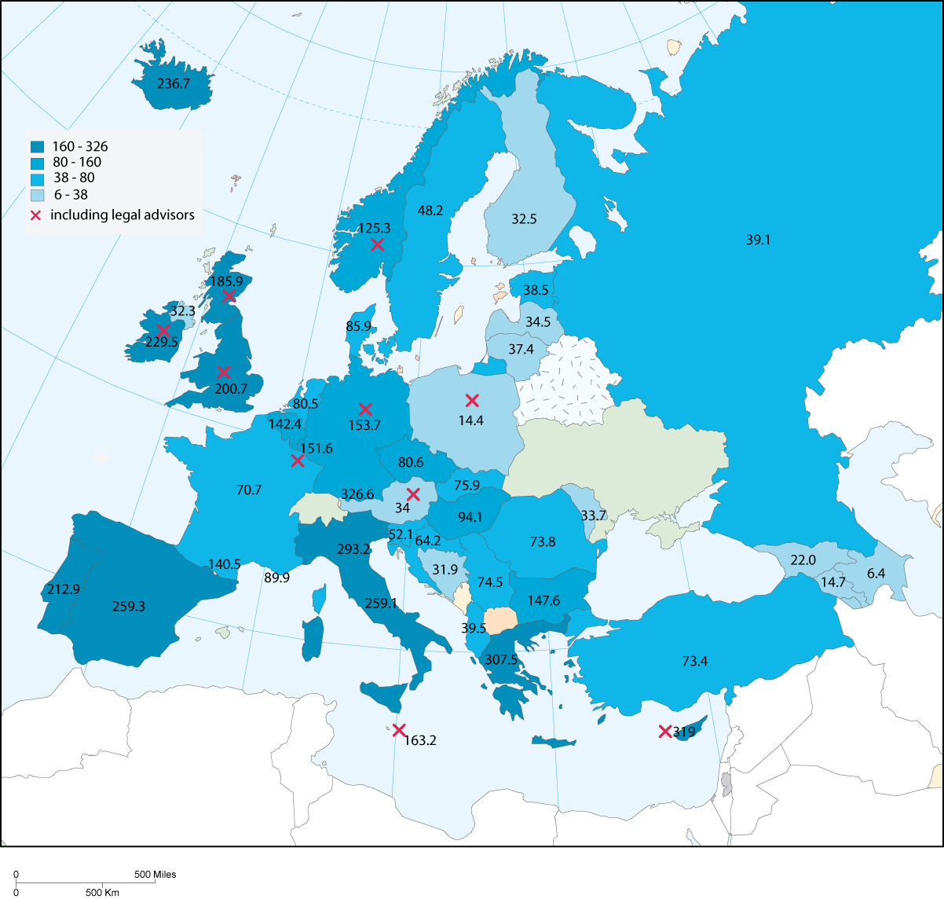

10.3 Monopoly in legal representation before the court

The information presented in the table is supplemented by the information on the monopoly of the representations by lawyers. The answers to this question comprises many exceptions, often concerning precisely the level of competence of a court (first instance court or appeal), but it can also be related to the specific type of case. In certain countries like Austria, for example, where the obligation to be represented by a lawyer concerns only certain types of cases (civil cases before the “Bezirksgerichte” and exceeding 4.000 €). It is also the case of the countries with federal systems, which present even more complicated systems and degrees of monopoly of lawyers. The following tables give a report on the positive answers about the monopoly for civil cases, criminal (the legal representation of victims and defendants) and administrative law cases.

In most countries, lawyers have the monopoly of legal representation of the defendant in criminal cases. In Bulgaria, Belgium (only for the Cours d'Assises), Estonia, Finland (representation by a person with a law degree), Germany (representation is generally possible by university professors; other persons can be approved by the court), Hungary, Iceland, Norway, Sweden, UK-England and Wales and Turkey, other persons may represent a defendant, mainly if she/he is a family member, but also by a trade union representative, a NGO or another person. As for victims, 21 countries or entities replied that legal representation by a lawyer is not mandatory. Family members, and also, to a lesser extent, members of a trade union, NGO’s or other persons can represent a victim.

In administrative law cases, a monopoly of lawyers is rare. Family members are accepted and also (in some cases) trade unions, NGO’s or other instances or organisations. (See Table 59).

Table 59. The scope of the ‘monopoly of representation of lawyers’ (question 89)

Q89 Do Lawyers have the monopoly of representation : | yes | no | variable | no reply
in civil matters | 8 | 27 | 7 | 5
in criminal matters as defendant | 27 | 8 | 5 | 6
in criminal matters as victim | 15 | 21 | 3 | 8
in administrative matters | 9 | 25 | 5 | 8

Note: in the third column ‘variable’ is included. It means that for some cases lawyers do have a monopoly in legal representation, whilst in other situations this is not the case.

10.4 Organisation and training

Lawyers can be organised through bar associations. They can operate at national, regional or local level. In the questionnaire countries were asked to provide information, with respect to the organisation of the lawyers (question 90).

In Belgium, Bosnia-Herzegovina, France, Greece and Luxembourg, there are only regional bar associations or bar associations at local level (no national bar association) with direct jurisdiction on the exercise of the profession (registration, discipline). Member states with a combination of a national bar association and regional and/or local bar associations are: Azerbaijan, Bulgaria, Cyprus, Germany, Hungary, Ireland, Italy, Norway, Poland, Russian Federation, Spain and Sweden.

Regarding the training of lawyers and examinations to enter the profession, in almost every country specific initial training is mandatory, as well as an examination. The exceptions are Andorra (no mandatory training or examination, but supervision of the profession is arranged to control the quality of the work delivered by the lawyers), Spain and Slovenia.

One of the instruments to protect the quality of the work delivered by lawyers is the use of a mandatory system for lawyers requiring continuing professional development. In general, it means that lawyers need to undergo frequently mandatory training courses (or attend law conferences for example). In 22 countries such a system exists. However this is not the case for: Albania, Andorra, Austria, Azerbaijan, Croatia, Cyprus, Czech Republic, Denmark, Finland, Greece, Hungary, Iceland, Italy, Latvia, Liechtenstein, Malta, Montenegro, Poland, San Marino, Slovak Republic, Slovenia, Serbia, Spain, Turkey and Ukraine.

In 12 countries or entities there is a need for certain specialised lawyers to require specific training, qualifications or diploma: Croatia, France, Georgia, Germany, Hungary, Liechtenstein, Luxembourg, Portugal, Slovenia, Turkey, UK-Northern Ireland and UK-Scotland. All the other countries replied that they do not have such a system.

10.5 Supervision on the practice of the profession

A first level of supervision of the practice of the profession of lawyers relates to their remunerations. Generally lawyers are paid fees either fixed by law, the bar association, or even freely negotiated. Nevertheless in some countries, they result from a combination of different possibilities, in particular as regards legal aid. The key question here is to inquire if the amount of remuneration is known by users. Denmark, Georgia, Greece, Italy, Latvia, Lithuania, Luxembourg, Moldova, Monaco, Norway, Poland, Portugal, Romania, Sweden, UK-Northern Ireland and UK-Scotland replied that it is not easy for users to be given information regarding the fees of lawyers.

In 16 countries or entities the fees of lawyers are regulated by law. In 11 countries or entities, the bar association can also play a role in determining the fees of lawyers. In 30 countries or entities the lawyers’ fees are freely negotiable.

Table 60. Lawyers' fees (questions 94 and 95)

Country | Users can establish easily what the lawyers’ fees will be | Lawyers fees are
Country | Users can establish easily what the lawyers’ fees will be | regulated by law | regulated by the Bar association | freely negotiated
Albania | yes | yes |  | yes
Andorra | yes |  | yes
Armenia | yes |  |  | yes
Austria | yes | yes |  | yes
Azerbaijan | yes |  |  | yes
Belgium | yes |  |  | yes
Bosnia and Herzegovina | yes |  | yes | yes
Bulgaria | yes |  |  | yes
Croatia | yes |  | yes
Cyprus | yes |  | yes
Czech Republic | yes | yes | no | no
Denmark | no |  |  | yes
Estonia | yes |  |  | yes
Finland | yes |  |  | yes
France | yes |  |  | yes
Georgia | no |  |  | yes
Germany | yes | yes | no | no
Greece | no | yes
Hungary | yes |  |  | yes
Iceland | yes |  |  | yes
Ireland | yes |  |  | yes
Italy | no | yes
Latvia | no | yes |  | yes
Liechtenstein | yes | yes
Lithuania | no |  |  | yes
Luxembourg | no | yes | yes | yes
Malta |  | yes |  | yes
Moldova | no | yes |  | yes
Monaco | no | no | no | yes
Montenegro | yes |  | yes
Netherlands | yes |  |  | yes
Norway | no | yes |  | yes
Poland | no | yes | no | yes
Portugal | no |  |  | yes
Romania | no |  |  | yes
Russian Federation | yes | no | no | yes
San Marino | yes | yes
Slovakia | yes | yes
Slovenia | yes |  | yes
Serbia | yes | yes |  | no
Spain | yes |  |  | yes
Sweden | no |  |  | yes
Turkey | yes |  | yes
Ukraine | yes |  |  | yes
UK England & Wales |  |  | yes
UK Northern Ireland | no |  | yes
UK Scotland | no |  | yes

In addition to the amount of remunerations of lawyers, the question arises as to the quality of the services delivered. Moreover, quality may include principles of professional ethics, a job analysis having to be ensured by lawyers and quality criteria/standards that are used. But beyond the content of the standards of quality, it is important to know which instance is responsible for their formulation. In 29 responding countries or entities, this responsibility falls under the competency of the bar association, often accompanied by a legal provision.

Table 61. Quality standards for lawyers (questions 96 and 97)

Country | Have quality standards been formulated for lawyers? | If yes, who is responsible for formulating these quality standards?
Country | Have quality standards been formulated for lawyers? | the bar association | the legislature | other
Albania | yes | yes | yes
Andorra | yes | yes
Armenia | yes | yes
Austria | yes | yes | yes
Azerbaijan | yes |  | yes
Belgium | no
Bosnia and Herzegovina | yes | yes | yes
Bulgaria | yes | yes
Croatia | yes | yes | no | no
Cyprus | yes | yes
Czech Republic | yes | yes
Denmark | yes | yes
Estonia | no
Finland | yes | yes | yes
France | no
Georgia | yes | yes
Germany | yes | yes | yes
Greece | no
Hungary | yes | yes
Iceland | yes | yes
Ireland | yes | yes
Italy | no
Latvia | no
Liechtenstein | yes | yes | yes
Lithuania | no
Luxembourg | no
Malta | yes | yes | yes
Moldova | no
Monaco | yes
Montenegro | yes | yes
Netherlands | yes | yes | yes
Norway | yes | yes | yes
Poland | yes | yes | no | no
Portugal | no
Romania | no
Russian Federation | yes | no | no
San Marino | yes | yes
Slovakia | yes |  | yes
Slovenia | no
Serbia | yes | yes
Spain | yes | yes
Sweden | yes | yes
Turkey | no
Ukraine | yes |  |  | yes
UK England & Wales | yes | yes
UK Northern Ireland | yes | yes
UK Scotland | yes | yes

46 countries out of the 47 responding countries or entities replied that clients have the possibility to complain when they are not satisfied with the performance and the quality of the work delivered by the lawyers. The only exception is Bulgaria. More precisely, parties can complain about the lawyers’ fees in 38 countries or entities.

10.6 Disciplinary proceedings and sanctions

Only a few countries could provide figures regarding the number of disciplinary proceedings and the main cause for starting a disciplinary procedure against a lawyer. Here, only Iceland, Finland, Lithuania, Poland, the Russian Federation, Slovak Republic and Turkey could provide information on the number of procedures, depending on the causes.

Table 62. Disciplinary proceedings initiated against lawyers in 2004 (question 99)

Disciplinary proceedings against lawyers  Country | Q99 Total number of disciplinary proceedings |  | Breach of professional ethics |  | Professional inadequacy |  | Criminal offence |  | Other
Albania | yes |  | yes |  | yes |  | yes |  | yes
Andorra | yes |  | yes | 7
Armenia | yes |  | yes |  | yes
Austria | yes |  | yes |  | yes |  | yes |  | yes
Azerbaijan | yes |  | yes | 5 | yes |  |  |  | yes | 1
Belgium | yes |  | yes |  | yes |  | no |  | no
Bosnia and Herzegovina | yes |  | yes |  | no |  | no |  | no
Bulgaria
Croatia | yes |  | yes |  | yes |  | yes
Cyprus | yes |  | yes |  | no |  | yes
Czech Republic | yes | 212 | yes |  | yes |  | yes |  | yes
Denmark | yes |  | yes |  | yes |  | yes
Estonia | yes |  | yes |  | no |  | no |  | yes
Finland | yes | 63 | yes | 62 | no |  | yes | 1 | no
France | yes |  | yes |  | yes |  | yes
Georgia
Germany | yes | n.a | yes |  | yes |  | yes
Greece | yes |  | yes
Hungary | yes |  | yes |  | yes |  | yes |  | yes
Iceland | yes |  | yes | 23 | yes |  |  |  | yes | 8
Ireland | yes
Italy | yes | 200
Latvia | yes |  | yes |  | yes |  | yes
Liechtenstein | yes |  | yes |  | yes |  | yes
Lithuania | yes |  | yes | 150 | yes | 0 | yes | 0 | no
Luxembourg | yes |  | yes |  | yes |  | no |  | no
Malta | yes |  | yes | 37
Moldova |  | n.a.
Monaco | yes |  | yes |  | no |  | yes
Montenegro | yes |  | yes |  | yes |  | yes
Netherlands |  | n.a.
Norway | yes |  | yes |  | yes |  | yes |  | yes
Poland | yes |  | yes | 202 | yes | 72 | yes | 3 | yes | 135
Portugal | yes |  | yes |  | yes |  | yes |  | yes
Romania | yes |  | yes |  | yes |  | yes
Russian Federation | yes |  | yes | 276 | yes | 887 | yes | 18 | yes | 366
San Marino |  | n.a.
Slovakia | yes |  | yes |  | yes |  |  |  | yes
Slovenia | yes |  | yes | 12 | yes | 13 | yes | 20
Serbia | yes |  | yes |  | yes |  | yes
Spain | yes |  | yes |  | yes |  | yes
Sweden | yes | 591
Turkey | yes |  | yes | 149 | no |  | yes | 47 | no
Ukraine
UK England & Wales | yes |  | yes |  | yes |  | yes
UK Northern Ireland | yes |  | yes |  | yes |  | yes
UK Scotland

Sometimes the proposed reasons for disciplinary procedures in the scheme do not correspond exactly to those in force in the responding countries. The Czech Republic has given the information and figures regarding the procedures initiated in 2004 but has not classified this information in the proposed table (the figures have been added to get a global figure). In Iceland, the procedures for breach of professional ethics have been mixed with the procedures for professional inadequacy (they have been classified under the first category).

Furthermore it must be noted that in some countries the disciplinary procedures initiated within the professional framework for criminal offences are implemented in addition to the criminal procedures provided for by the law (Austria). In other countries it is the contrary, as there is no disciplinary procedures when a criminal procedure has been initiated (Czech Republic). In other countries a sentence decided by the criminal court leads to the removal from the bar (Estonia).

Table 63. Sanctions imposed on lawyers in 2004 (question 99)

Q99 Sanctions against lawyers  Country | reprimand |  | suspension |  | removal |  | fine |  | other sanction
Albania | yes |  | yes |  | yes |  | yes |  | yes
Andorra |  | 0 |  | 0 |  | 0 |  | 0 |  | 0
Armenia | yes |  |  |  |  |  | yes |  | yes
Austria | yes |  | yes |  | yes |  | yes |  | yes
Azerbaijan | yes | 5 |  |  |  |  |  |  | yes | 1
Belgium | yes |  | yes |  | yes |  | yes |  | no
Bosnia and Herzegovina | yes | 1 |  |  |  |  | yes | 1
Bulgaria | yes |  | yes |  |  |  | yes |  | yes
Croatia | yes |  | yes |  | yes |  | yes
Cyprus | yes |  | yes |  | yes |  | yes
Czech Republic | yes |  | yes |  | yes |  | yes |  | yes
Denmark | yes |  | yes |  | yes |  | yes
Estonia | yes |  | yes |  | yes |  | yes
Finland | yes | 62 | no |  | yes | 1 | no |  | no
France | yes |  | yes |  | yes |  | no |  | yes
Georgia
Germany | yes |  | no |  | yes |  | yes |  | yes
Greece | yes |  | yes |  | yes |  | yes
Hungary | yes |  | yes |  | yes |  | yes
Iceland | yes | 8
Ireland
Italy | yes | 38 | yes | 96 | yes | 20 |  |  | yes | 50
Latvia | yes |  | yes |  | yes |  |  |  | yes
Liechtenstein | yes |  | yes |  | yes |  | yes
Lithuania | yes | 80 | no |  | yes | 30 | no |  | no
Luxembourg | yes | 2 | yes | 1 | no |  | yes | 2 | no
Malta | yes | 1
Moldova
Monaco | yes |  | yes |  | yes |  | no
Montenegro | yes |  | yes |  | yes |  | yes
Netherlands
Norway | yes |  | yes |  | yes |  | yes |  | yes
Poland | yes | 175 | yes | 3
Portugal | yes |  | yes |  | yes |  | yes |  | yes
Romania | yes |  | yes |  | yes |  | yes |  | yes
Russian Federation | no |  | no |  | yes | 701 | no |  | yes | 846
San Marino
Slovakia
Slovenia
Serbia | yes |  |  |  | yes |  | yes |  | yes
Spain | yes | 99 | yes | 260 | yes | 3 |  |  | yes | 12
Sweden | yes | 42 | yes | 77 | yes | 22 | yes | 6 | yes | 1
Turkey | yes | 156 | yes | 11 | yes | 47 | yes | 39 | yes | 5
Ukraine
UK England & Wales | yes |  | yes |  | yes |  | yes
UK Northern Ireland | yes |  | yes |  | yes |  | yes
UK Scotland

The last question of this topic relates to the authority responsible for the disciplinary proceedings. The precise details many countries have provided could not be exploited in this document.

Table 64. Authority responsible for disciplinary proceedings (question 100)

Country | The authority responsible for the disciplinary procedures is
Country | a professional body | the judge | the Ministry of Justice | other
Albania | yes
Andorra | yes
Armenia | yes
Austria | yes | yes |  | yes
Azerbaijan | yes
Belgium | yes | no | no | no
Bosnia and Herzegovina | yes |  | yes | yes
Bulgaria | yes
Croatia | yes | no | no | no
Cyprus | yes
Czech Republic | yes | no | no | no
Denmark | yes
Estonia | yes
Finland | yes
France | yes
Georgia
Germany | yes | yes | no | no
Greece | yes
Hungary | yes
Iceland | yes
Ireland | yes |  |  | yes
Italy | yes
Latvia | yes
Liechtenstein | yes
Lithuania | yes |  | yes
Luxembourg | yes
Malta | yes | yes
Moldova | yes |  |  | yes
Monaco | yes | yes
Montenegro | yes
Netherlands | yes
Norway | yes
Poland | yes | no | no | no
Portugal | yes
Romania | yes
Russian Federation | yes | no | no | no
San Marino | yes
Slovakia | yes | no | no | no
Slovenia | yes
Spain | yes
Sweden | yes |  |  | yes
Turkey | yes
UK England & Wales | yes
UK Northern Ireland | yes
UK Scotland | yes

In almost all of the countries the responsibility for the disciplinary proceedings lies in the hands of a professional body (the bar associations). In Austria, Germany, Malta and Monaco a judge can be competent for the disciplinary proceeding too. In Bosnia and Herzegovina and Lithuania the Ministry of Justice is responsible for disciplinary proceedings against lawyers.

11. Enforcement of court decisions

11.1 Introduction

The effective execution of court decisions is an integral part of compliance with Article 6 of the European Convention of Human Rights. Having regard to the volume of cases currently before the Court and the recent instruments adopted by the Council of Europe in the field of execution, the CEPEJ has decided to pay particular attention to this issue in this Report.

In non criminal matters, the Committee of Ministers of the Council of Europe has adopted two relevant recommendations in the area of enforcement. Enforcement is defined in Recommendation 2003 (17) as “the putting into effect of judicial decisions, and also other judicial or non-judicial enforceable titles in compliance with the law which compels the defendant to do, to refrain from doing or to pay what has been adjudged”. This Recommendation is primarily orientated at the civil law area, whilst Recommendation 2003(16) is focused on the execution of judicial decisions in administrative matters.

It is difficult to assess the smooth execution of court decisions in civil or commercial matters on the basis of relevant statistics, as execution is not automatic: it is for the parties who have won the case to decide, where appropriate, whether to request or not the execution of the court decision. Therefore this report does not focus on the rate of execution of court decisions but mainly on the organisation of the execution and the role of enforcement agents. The CEPEJ has however tried to assess the length of enforcement procedures, which is part of the reasonable time of proceedings considered by the case-law of the European Court of Human Rights.

In Recommendation 2003 (17) on enforcement, the tasks and duties of the enforcement agents are described, as well as the enforcement procedure and the rights and duties of the claimant and the debtor. The enforcement agent is defined in this Recommendation as “a person authorized by the state to carry out the enforcement process irrespective of whether that person is employed by the state or not”. This definition was used for the purpose of this Report. This definition includes the fact that enforcement agents can be public officials or private officers (for example bailiffs).

In some countries judges can play a role in the enforcement procedure. However In most situations, their role is limited to the supervision of the enforcement procedure and does not concern the enforcement itself. Other countries have a mixed system of private and public enforcement officers. For example in the Czech Republic, some bailiffs work within the court whereas private executors exist too. In Portugal, the enforcement system includes court officials and execution solicitors.

Moreover, other specific types of enforcement agents exist in Belgium (enforcement agents in tax affairs), Bosnia and Herzegovina (a court referee), France (huissiers du Trésor, responsible for the collection of taxes), Greece (public notaries), Ireland (sheriff/solicitor and revenue sheriffs responsible for tax collection), Portugal (execution solicitors), Slovakia (distrainers) and UK-Scotland (sheriff and messengers-at-arms).

The enforcement of sentences in criminal matters is of a different nature. It concerns the state authority, often under the supervision of the judge, and depends on the choices of criminal policies.

11.2 Enforcement of court decisions in civil, commercial and administrative law

11.2.1 Enforcement agents

In table 65 the number of enforcement agents are presented, as well as their professional status (private, public, judges, other).

Table 65. Status and number of enforcement agents in 2004 (questions 105 and 106)

Country | Q105 Enforcement agents are |  |  |  | Q106 Number of enforcement agents
Country | judges | bailiff practising as private profession ruled by public authorities | bailiff working in a public institution | other | Q106 Number of enforcement agents
Albania |  |  | yes |  | 114
Andorra |  |  |  | yes | 5
Armenia |  |  |  |  | 225
Austria |  |  | yes |  | 369
Azerbaijan |  |  | yes |  | 400
Belgium | no | yes | no | yes | 525
Bosnia and Herzegovina | yes |  |  | yes
Bulgaria |  |  | yes |  | 255
Croatia | yes | no | yes | no
Cyprus |  |  |  | yes | 184
Czech Republic | no | yes | yes |  | 553
Denmark | yes |  | yes
Estonia |  | yes |  |  | 51
Finland |  |  | yes |  | 758
France |  | yes |  | yes | 3 256
Georgia |  |  | yes |  | 116
Germany |  |  | yes |  | 4 995
Greece | no | yes | yes
Hungary |  | yes |  |  | 193
Iceland |  |  | yes |  | 26
Ireland |  | yes |  | yes | 40
Italy |  |  | yes |  | 5 366
Latvia |  | yes |  |  | 114
Liechtenstein | yes |  | yes |  | 2
Lithuania |  | yes |  |  | 124
Luxembourg |  | yes |  |  | 19
Malta |  |  | yes |  | 17
Moldova |  |  | yes |  | 304
Monaco | no | yes | no | no | 2
Montenegro |  |  |  | yes | 26
Netherlands |  | yes |  |  | 363
Norway |  |  | yes |  | 355
Poland | no | yes | no |  | 590
Portugal |  |  | yes | yes | 486
Romania |  | yes |  |  | 333
Russian Federation | no | no | yes | yes | 18 625
San Marino | yes
Slovakia |  | yes |  |  | 262
Slovenia |  | yes |  |  | 49
Serbia |  |  | yes |  | n/a
Spain | yes
Sweden |  |  |  | yes | 1 200
Turkey |  |  | yes |  | 1 113
UK England & Wales |  | yes | yes | yes | 4 000
UK Northern Ireland |  |  | yes |  | 15
UK Scotland |  | yes | yes | yes | 200
Ukraine |  |  | yes |  | 5 661

The figures that appear in the last column of the table are given only as an indication, due to the disparities in the definitions and status.

Graph 28. Number of enforcement agents in 2004 (per 100.000 inhabitants) (question 106)
0
5
10
15
20
25
30
Albania
Andorra
Armenia
Austria
Azerbaijan
Belgium
Bulgaria
Cyprus
Czech Republic
Estonia
Finland
France
Georgia
Germany
Hungary
Iceland
Ireland
Italy
Latvia
Liechtenstein
Lithuania
Luxembourg
Malta
Moldova
Monaco
Netherlands
Norway
Poland
Portugal
Romania
Russian Federation
Slovakia
Slovenia
Montenegro
Sweden
Turkey
UK England & Wales
UK Northern Ireland
UK Scotland
Ukraine

In graph 29 the number of enforcement agents per 100.000 inhabitants per country is highlighted.

Graph 29. Number of enforcement agents in 2004 (per 100.000 inhabitants)

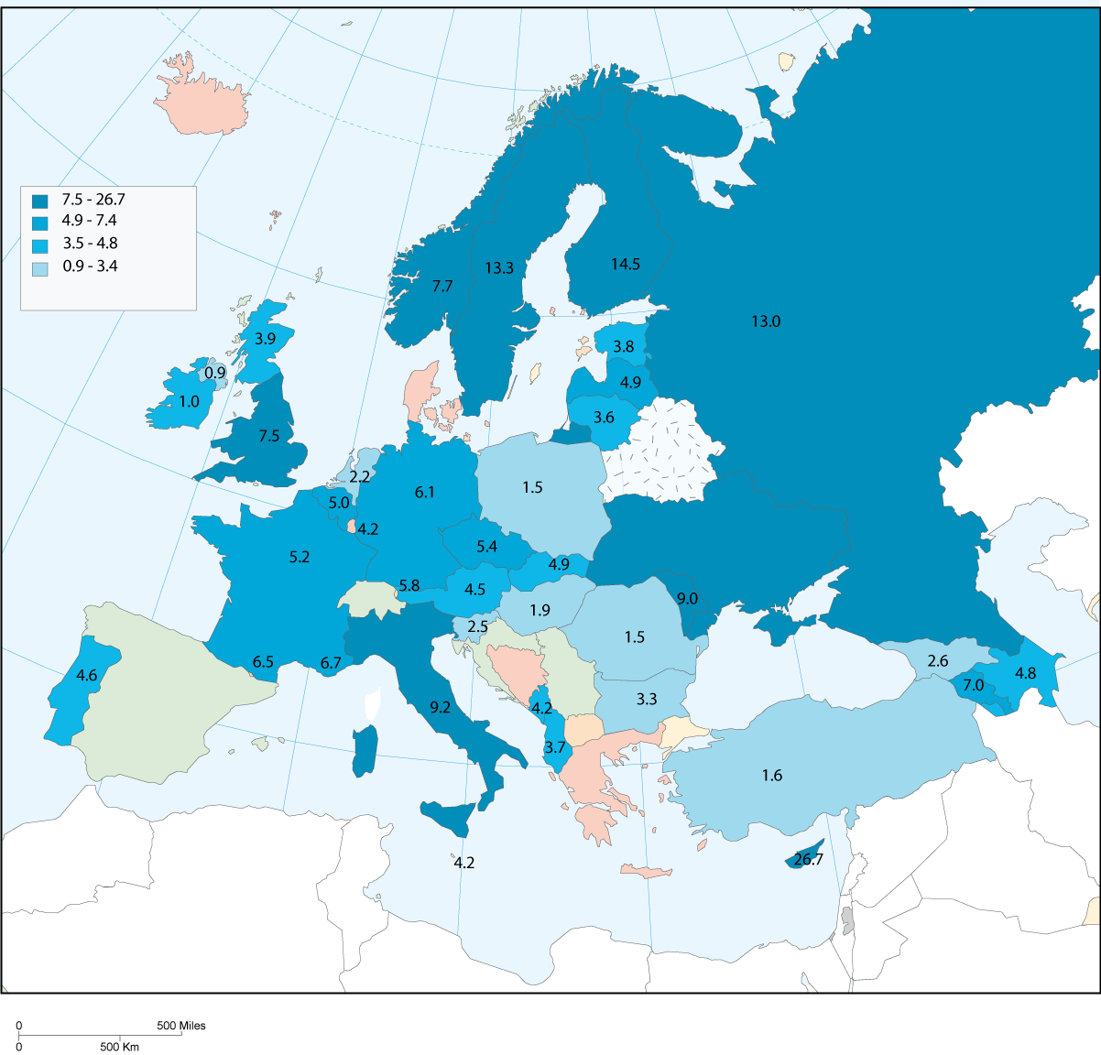

11.2.2 Organisation and training of enforcement agents

The training and the existence of a professional organisation can be seen as indicators for professional "solidarity", a sense of professional identity and also a basis for accountability of the activities exercised by enforcement agents. Indeed an initial training guarantees the homogeneity of the competences. In 32 countries there is a system of initial training or a specific examination to enter the profession. In general, there is no specific initial training in the countries where enforcement agents are judges or where they are court officers (for example in Andorra).

A professional organisation for enforcement agents (at national, regional or local level) can be found in every country, with the exception of the countries where the enforcement agents are judges. The only exception to this general conclusion concerns Denmark, where the enforcement agents are attached to a public institution.

Table 66. Initial training and professional organisation of enforcement agents (questions 107 and 108)

Country | Specific initial training or examination to enter the profession of enforcement agent | The profession of enforcement agent is organised by
Country |  | a national body | a regional body | a local body
Albania | yes |  | yes
Andorra | no
Armenia | yes | yes
Austria | yes |  | yes
Azerbaijan | no | yes | yes | yes
Belgium | yes | yes | yes | yes
Bosnia and Herzegovina | no
Bulgaria | no | yes
Croatia | no
Cyprus | yes | yes
Czech Republic | yes | yes | no | no
Denmark | no | yes
Estonia | yes | yes
Finland | yes |  |  | yes
France | yes | yes | yes | yes
Georgia | yes | yes
Germany | yes | yes | yes | yes
Greece | no | yes | no | no
Hungary | yes | yes
Iceland | yes | yes
Ireland | no | yes
Italy | yes | yes
Latvia | yes | yes
Liechtenstein
Lithuania | yes | yes
Luxembourg | yes | yes
Malta | yes | yes
Moldova | yes | yes | yes
Monaco | no | yes | no | no
Montenegro |  |  |  | yes
Netherlands | yes | yes
Norway | no |  |  | yes
Poland | yes | yes | yes | no
Portugal | yes | yes
Romania | yes | yes
Russian Federation | yes | yes | yes | yes
San Marino
Slovakia | yes | yes
Slovenia | yes | yes
Serbia | no
Spain | nap | nap | nap | nap
Sweden | yes | yes | yes
Turkey | yes | yes
Ukraine | yes | yes
UK England & Wales | yes | yes
UK Northern Ireland | yes | yes
UK Scotland | yes | yes

11.2.3 Transparency of fees and quality standards

As for lawyers, the question of fees of the agents of execution and their transparency is a key issue for the satisfaction or dissatisfaction of users. In many countries it is easy for users to receive information regarding the fees for enforcement procedures. The exceptions are: Italy, Latvia, Lithuania, Slovenia, Turkey and Ukraine.

In the majority of countries, the transparency of fees is guaranteed through public control (regulations by law). In only 3 countries (France, the Netherlands and Romania) are the fees of certain acts freely negotiable. In France a regulation enables the bailiff to negotiate some of his/her fees.

The question of the fees of enforcement agents is also connected to the quality of the services delivered by the enforcement agents. 25 countries or entities declared that they have formulated quality standards. However, most of these countries could not specify what specific quality indicators are defined to measure the quality and the services delivered by the enforcement agents (ISO quality norms or norms defined by the professionals themselves).

Quality standards may be defined by different authorities. In some countries or entities it is the Ministry of Justice or another ministry: Albania (General Department of Enforcement Services), Armenia, Finland, Hungary, Monaco, Moldova, Slovenia, Turkey, UK-England and Wales (Department for Constitutional Affairs), UK-Northern Ireland. In other countries or entities it is the professional organisation of enforcement agents: Czech Republic, the Netherlands and UK-Scotland, the courts: Austria, or the Parliament: Denmark (in combination with the court services and the local court president), Romania (in co-operation with the Ministry of Justice and the national union of bailiffs).

11.2.4 Supervision and control

With respect to the supervision and control on enforcement agents, it appears that this task may be shared in some countries by two or more different organs. This may be related to the existence of more than one kind of enforcement agents (those working in courts - public agents - and those working on a private basis). The supervision of private agents may often come under the responsibility of a professional body, whilst for the other category of enforcement agents, this task is dealt with by the Ministry of Justice, a judge (or a court) or a prosecutor.

The only countries or entities which do not have a system of supervision and control are Greece, Serbia and UK-England and Wales. But, for England and Wales, it is foreseen that a regulation for enforcement agents be drafted. (See table 67).

Table 67. Supervision and control (question 111)

Country | Body entrusted with the supervision and the control of the enforcement agents | Authority responsible for the supervision and the control of enforcement agents
Country |  | professional body | judge | ministry of justice | prosecutor | other
Albania | yes |  |  |  |  | yes
Andorra | yes |  | yes
Armenia | yes |  |  | yes
Austria | yes | yes
Azerbaijan | yes |  | yes | yes
Belgium | yes | yes | yes |  | yes
Bosnia and Herzegovina | yes |  | yes
Bulgaria | yes |  |  | yes
Croatia | yes |  | yes | yes
Cyprus | yes |  |  |  |  | yes
Czech Republic | yes | yes | yes | yes | no
Denmark | yes |  | yes
Estonia | yes |  |  | yes
Finland | yes |  |  | yes |  | yes
France | yes | yes |  | yes | yes
Georgia | yes |  |  | yes
Germany | yes |  |  | yes |  | yes
Greece | no
Hungary | yes | yes |  | yes
Iceland | yes |  |  | yes
Ireland | yes |  |  |  | yes
Italy | yes |  |  | yes
Latvia | yes | yes | yes | yes
Liechtenstein | yes |  | yes
Lithuania | yes | yes | yes | yes
Luxembourg | yes | yes | yes |  | yes
Malta | yes |  |  | yes
Moldova | yes |  | yes | yes | yes
Monaco | yes | no | yes |  | yes
Montenegro | yes |  |  | yes
Netherlands | yes |  | yes
Norway | yes |  |  | yes
Poland | yes | yes | yes | yes | no
Portugal | yes | yes | yes
Romania | yes | yes | yes | yes
Russian Federation | yes | yes | no | yes | yes
San Marino | nap
Slovakia | yes |  |  | yes
Slovenia | yes | yes | yes | yes
Serbia | no |  | yes
Spain | nap
Sweden | yes | yes |  |  | yes | yes
Turkey | yes |  | yes | yes | yes
Ukraine | yes |  |  | yes
UK England & Wales | no
UK Northern Ireland | yes |  |  |  |  | yes
UK Scotland | yes | yes

11.2.5 Disciplinary proceedings and sanctions

As for judges and prosecutors, only few countries have figures available regarding the number of disciplinary proceedings and sanctions. Only 6 countries were able to provide indications: Albania, Estonia, Finland, Hungary, Ireland and Poland.

The following table must be viewed with caution: the figures in the table must only be seen as indications.

Table 68. Disciplinary proceedings initiated against enforcement agents in 2004 (question 117)

Country | Q117 Disciplinary proceedings against enforcement agents
Country | Total number | Breach of professional ethics |  | Professional inadequacy |  | Criminal offence |  | Other
Albania | 14 | no |  | yes | 14 | no
Andorra |  | no |  | no |  | no |  | no
Armenia |  |  |  | yes |  | yes
Austria |  |  |  | yes | 2 | yes | 1
Azerbaijan |  |  |  | yes | 9
Belgium
Bosnia and Herzegovina
Bulgaria |  | no |  | no |  | no |  | yes
Croatia |  | n.a. |  | n.a. |  | n.a. |  | n.a.
Cyprus |  |  |  | yes | 3 | yes
Czech Republic |  | yes | 7 | yes | 6
Denmark |  |  |  | n.a. |  | n.a. |  | n.a.
Estonia | 11 | yes | 0 | yes | 11 | yes | 0
Finland | 3 | yes | 3 | no |  | no |  | no
France |  | yes |  | yes |  | yes |  | yes
Georgia |  | yes |  | yes |  | yes
Germany |  | yes |  | yes |  | yes |  | yes
Greece |  | yes |  |  |  | yes |  | yes
Hungary | 42 | yes | 11 | yes | 8 | yes | 2 |  | 0
Iceland |  | no |  | no |  | no
Ireland | 0
Italy |  | no |  | no |  | yes | 36 | yes | 47
Latvia |  | yes |  | yes |  |  |  | yes
Liechtenstein
Lithuania |  | yes | 6 | no |  | no |  | no
Luxembourg |  | yes | 2 | no |  | no |  | no
Malta
Moldova |  | yes | n.a. | no |  | yes | n.a.
Monaco |  |  |  | no |  | yes |  | yes
Montenegro
Netherlands
Norway |  | n.a. | n.a. | n.a. | n.a. | n.a. | n.a. | n.a. | n.a.
Poland | 193 | yes | 18 | yes | 111 | yes | 4 | yes | 60
Portugal |  | no |  | no |  | no |  | yes | 655
Romania |  | yes |  |  |  | yes
Russian Federation |  | no |  | yes | 6 | yes | 285 | no
San Marino
Serbia
Slovakia |  | yes | n.a. | yes | n.a. | yes | n.a. | yes | n.a.
Slovenia |  | yes | 3 | no |  | no |  | no
Spain
Sweden
Turkey |  | yes | 60 | yes | 1 | yes | 360 | yes | 80
Ukraine |  | yes |  | yes |  | yes
UK England & Wales
UK Northern Ireland |  | yes |  | yes |  | yes |  | yes
UK Scotland

Table 69. Sanctions imposed on enforcement agents in 2004 (question 117)

Country | Q117 Sanctions against enforcement agents
Country | Reprimand |  | Suspension |  | Dismissal |  | Fine |  | Other
Albania | yes | 20 | no |  |  |  | no
Andorra | no |  | no |  | no |  | no
Armenia | yes |  |  |  | yes
Austria |  |  |  |  | yes | 1 |  |  | yes | 2
Azerbaijan | yes | 7 |  |  | yes | 2
Belgium | n.a.
Bosnia and Herzegovina
Bulgaria | yes |  | no |  | yes |  | no
Croatia | n.a. |  | n.a. |  | n.a. |  | n.a. |  | n.a.
Cyprus |  |  |  |  | yes |  | yes
Czech Republic | yes | 3 |  |  |  |  | yes | 1
Denmark | n.a. |  | n.a. |  | n.a. |  | n.a. |  | n.a.
Estonia | yes | 3 | yes | 0 | yes | 1 | yes | 7 |  | 0
Finland | no |  | no |  | no |  | no |  | yes | 3
France | yes |  | yes |  | yes
Georgia | yes |  | yes |  | yes |  | yes
Germany | yes |  | yes |  | yes |  | yes |  | yes
Greece | yes |  | yes |  | yes |  | yes
Hungary | yes | 5 | yes | 4 | yes | 4 | yes | 7 | yes | 1
Iceland | no |  | no |  | no |  | no
Ireland
Italy | yes | 24 | yes | 4 | yes | 2 | yes | 6 | no
Latvia | yes |  | yes |  | yes
Liechtenstein
Lithuania | no |  | no |  | yes | 1 | no |  | yes | 1
Luxembourg | no |  | no |  | no |  | no
Malta | yes
Moldova | yes | 23 | yes | 2 | no |  | no
Monaco | yes |  | yes |  | yes |  | yes
Montenegro
Netherlands
Norway | n.a. | n.a. | n.a. | n.a. | n.a. | n.a. | n.a. | n.a. | n.a. | n.a.
Poland | yes | 95 | yes | 10 | yes | 12 | yes | 23 | yes | 63
Portugal | yes | 9 | yes | 1 |  |  | yes | 3
Romania |  |  | yes | 7 | yes | 1
Russian Federation | yes | 3549 | no |  | yes | 86 | no |  | no
San Marino
Serbia
Slovakia | yes | n.a. | yes | n.a. | yes | n.a. | yes | n.a.
Slovenia | yes | 1 | yes | 2 | no |  | no
Spain
Sweden
Turkey | yes | 35 | yes | 5 | yes | 3 | yes | 11 | yes | 33
Ukraine | yes |  | yes |  | yes
UK England & Wales
UK Northern Ireland | yes |  | yes |  | yes |  | yes |  | no
UK Scotland

11.2.6 The enforcement procedure: complaints

In the report of the pilot exercise, it was noted by all responding countries that legal provisions could be found to file a complaint against an enforcement agent. A more precise exploration of the reasons for these complaints shows that they are mostly related to the excessive duration of the procedures, as indicated by 34 countries or entities. The other reasons mentioned are: excessive costs, no execution at all, lack of information and unlawful practices.

Table 70. Main complaints on enforcement procedures (question 113)

no execution at all | 16
lack of information | 12
excessive length | 34
unlawful practices | 12
insufficient supervision | 5
excessive cost | 15
other complaint | 8

11.2.7 Enforcement timeframes

One important aspect of a proper functioning of judicial systems is related to an efficient and fair enforcement procedure in due time. This is also one of the reasons that in the questionnaire a specific question was included regarding timeframes of the enforcement of decisions (question 115).

23 countries or entities have a system to measure the timeframes of enforcement procedure in civil affairs; 22 countries or entities report the use of a specific method to measure timeframes in administrative law cases.

The timeframes for notification of a judicial decision concerning the recovering of a credit can be used to compare countries. The answers to question 116 of the questionnaire (which aims to check concretely, for the users, the length of an ordinary case of notification of a court decision for recovering a claim for the parties living in the city where the court seats), are as follows:

- Between 1 and 5 days: Armenia, Austria, Bosnia and Herzegovina, Estonia, Denmark (1 and 6 days), Estonia, France, Germany, Iceland., Lithuania, Luxembourg, Montenegro, Romania, UK-England and Wales and Ukraine;
- Between 6 and 10 days: Azerbaijan, Belgium, Cyprus, Finland, Latvia, Malta and Spain;
- Between 11 and 30 days: Bulgaria, Moldova, Monaco, Norway, Poland, Sweden, UK-Northern Ireland and UK-Scotland;
- More than 30 days: Czech Republic, Greece and Hungary.

This information, considered together with the status of the enforcement agents (private profession of public official), cannot lead to the conclusion that the choice of a specific status has as such an essential influence on the efficiency of the enforcement procedure, which is probably linked to the general organisation of the enforcement system, including other elements. It could be useful in the future to try to identify these elements as having a positive influence on the efficiency of the enforcement procedure.

11.3 The enforcement in criminal matters

The execution of the decision made by the judge in criminal matters can be the responsibility of different types of agents. It depends on the level of enforcement. In the following table the diversity of enforcement agents in the area of criminal matters is presented.

Table 71. The authority responsible for the execution of decisions in criminal cases (question 118)

Country | Authority in charge of the enforcement of judgments
Country | Judge | Other authority | If other authority, which one
Albania |  | yes | prosecutor
Andorra | yes | yes | judge rapporteur
Armenia | no | yes | agency of Ministry of Justice (MoJ)
Austria | yes
Azerbaijan | yes | yes | agency of MoJ
Belgium | no | yes | prosecutor and prison adm.
Bosnia and Herzegovina | yes
Bulgaria | no | yes | agency of MoJ
Croatia | yes | yes | agency of MoJ
Cyprus | no | yes | private firm under Moj
Czech Republic | yes
Denmark | no
Estonia | yes
Finland | no | yes | agency of MoJ
France | yes | yes | prosecutor
Georgia | no | yes | Agency of MoJ
Germany | yes | yes | judge and prosecutor
Greece | no
Hungary | yes
Iceland | no | yes | penitentiary administration
Country | Authority in charge of the enforcement of judgments
Country | Judge | Other authority | If other authority, which one
Ireland | no | yes | sheriffs
Italy | no | yes | prosecutor
Latvia | no | yes | MoJ
Liechtenstein | yes
Lithuania | yes | yes | prosecutor
Luxembourg | no | yes | prosecutor
Malta | no | yes | Bailiffs and court administration
Moldova | yes | yes | penitentiary administration
Monaco | yes | yes | prosecutor
Montenegro | yes
Netherlands | no | yes | prosecutor
Norway | no | yes | correctional service
Poland | yes | yes | enforcement officers
Portugal | yes
Romania | yes
Russian Federation | no | yes | federal execution agency
San Marino | yes
Slovakia | no | yes | Probation officers
Slovenia | yes
Serbia
Spain | yes
Sweden | no | yes | prison & probation service
Turkey | yes | yes | prosecutor
Ukraine | no | yes | MoJ
UK England & Wales | no | yes | bailiff & enforcement officers
UK Northern Ireland | no
UK Scotland | no | yes | sheriffs

It can also be noted that only 14 countries or entities have studies evaluating the effective rate of recovering fines (recovery rate) in criminal cases (question 119): Austria, Bulgaria, Estonia, Finland, France, Georgia, Ireland, Malta, Montenegro, the Netherlands, Norway, Poland, Sweden and UK-England & Wales.

11.4 Measures to improve the enforcement procedure

28 countries or entities have replied that measures would be implemented (or are already implemented) to increase the efficiency and effectiveness of the enforcement procedure. In the following text the most important changes per country (if provided) are summarised.

Country Measure

Albania The Ministry of Justice is working on a new enforcement law .
Austria The reform of the law enforcement (FEX-project).
Azerbaijan As part of the national action programme a new law on ‘court bailiffs and court ushers’ will be introduced.
Belgium Measures to improve the balance between the rights of the creditor and the debtor.
Bosnia Herzegovina The High Judicial and Prosecutorial Council have conducted several activities in order to change and improve situations concerning the enforcement through changes of legislation.
Bulgaria Elaboration of the Law on private bailiffs.
Croatia Amendments of the Enforcement Act, aiming at faster, cheaper and simpler enforcement procedures.
Denmark Simplified court procedures if the claim does not exceed DKK 50.000.
France In co-operation with the Public prosecution services, the National chamber of bailiffs and the Ministry of Justice, the discipline of the professional will be co-ordinated.
Germany A working group (at the Federal level and the Länder) is preparing a new law concerning the modernisation of the enforcement procedure (in order to increase efficiency).
Hungary New laws are introduced. For example concerning a swift judgement of complaints against enforcement agents.
Latvia The preparation of the establishment of an institution, responsible for the control of the recovery of claims in favour of the State. The enlargement of the State rights in the supervision on the bailiffs.
Lithuania Drafting of the amendment of the Law on Bailiffs and the new instruction of the Enforcement Procedure (e.g. review of the fees of bailiffs).
Malta New legislation under preparation.
Moldova Creation of an Enforcement department and adoption of a Code for the Enforcement. Elaboration of a draft law on the enforcement system and other various measures.
Montenegro The presidents of the courts are reorganising the work of the enforcement departments and draft programmes for solving problems in the area of enforcement.
Poland Amendments of the law on enforcement.
Portugal Introduction of a new legal system of civil enforcement (including the introduction of execution solicitors who are responsible for the enforcement of civil cases). Simplification of seizure proceedings.
Romania Regulations on organisation and professional admission procedure as bailiffs. The introduction of regulation establishing the maximum and minimum fees for bailiffs. Regulation on eliminating the condition of payment of the fee in advance.
Russian Federation Adoption of the Federal law on “law enforcement service of the Russian Federation” and inclusion of the Federal Bailiffs Service in the list of law enforcement State Agencies. Measures to improve the social protection of bailiffs. Drafting of a Code of Execution.
Slovenia Simplification of the enforcement proceeding, including cutting down expenses and fees.
Spain Certain courts have been specialised and exclusively deal with enforcement.
Ukraine Adoption of the Law of Ukraine “on State execution service” and on “Executive Procedure”.
UK-England and Wales Pending legislation to introduce new bailiffs’ laws.
UK-Northern Ireland Updating legislation The Enforcement of Judgements Order and the Judgement Enforcement Rules.
UK-Scotland Introduction of the Department Arrangement and Attachment(s) Act (2002).

12. The notaries

12.1 Introduction

A notary can be defined as a (public/private) official who is the guarantor of legal security. Woman or man of contracts and third witness, the notary is entrusted with ensuring the freedom of consent. He/she protects individuals in their activities and their goods. Furthermore, in societies with numerous and substantial legislative reforms, the notary has an important role to advise citizens on the law in force. Therefore notaries take part, to some extent, in the functioning of judicial systems. It is only under this aspect that the CEPEJ has addressed the profession, being aware that notaries can intervene in other fields, such as in the social or economic fields.

The notary has generally and inter alia the power to receive deeds, acknowledge signatures and affirmations, administer oaths, verify legal documents, and, in certain countries may also issue subpoenas in lawsuits.

12.2 The status and number of notaries

In 24 responding countries or entities, the competency and status of notaries fall within the framework of legal civil proceedings. They may provide legal advice in 28 countries or entities. The authentification of deeds is a more widely spread task, exercised in 41 countries or entities. Notaries can also fulfil other tasks and duties in 19 countries or entities.

Like the enforcement agents, the statute of notaries as well as their functions may vary greatly according to the country. There are countries where notaries have a "mixed" status (partly public, partly private) and others where notaries are operating in the public sector or in the private sector.

In table 72 the status and the number of notaries are presented. In 20 responding countries or entities, the notaries have an exclusively public status. In 3 countries, notaries are operating in a strictly private status (Bulgaria, the Netherlands and Poland). Public and private notaries can be found together in: Azerbaijan, Moldova, Monaco and Russian Federation. Others are private workers ruled by public authorities.

Table 72. Status and number of notaries in 2004 (question 120)
Country | Q 120 Status and number of notaries
Country | public |  | private |  | private worker ruled by the public authorities
Albania |  |  |  |  | yes
Andorra | yes
Armenia | yes |  |  |  | yes
Austria |  |  |  |  | yes
Azerbaijan | yes | 158 | yes
Belgium | yes | 1 333
Bosnia and Herzegovina | yes
Bulgaria |  |  | yes
Croatia |  |  |  |  | yes | 256
Cyprus |  |  |  |  | yes
Czech Republic | no |  | no |  | yes | 445
Denmark | yes
Estonia |  |  |  |  | yes
Finland | yes | 205
France |  |  |  |  | yes | 8 122
Georgia |  |  |  |  | yes
Germany | yes | 9 164 | no |  | no
Greece |  |  |  |  | yes
Hungary |  |  |  |  | yes
Iceland | yes
Ireland | yes
Italy | yes
Latvia |  |  |  |  | yes | 114
Liechtenstein
Lithuania |  |  |  |  | yes | 208
Luxembourg | yes | 36
Malta | yes
Moldova | yes | 49 | yes | 216
Monaco | yes |  | yes | 3 | yes
Montenegro
Netherlands |  |  | yes
Norway | yes
Poland | no |  | yes | 1623 | no
Country | Q 120 Status and number of notaries
Country | public |  | private |  | private worker ruled by the public authorities
Portugal | yes | 176 |  |  | yes | 227
Romania |  |  |  |  | yes | 1 299
Russian Federation | yes | 181 | yes | 6 961
San Marino | yes
Serbia
Slovakia |  |  |  |  | yes | 281
Slovenia |  |  |  |  | yes | 68
Spain | yes | 2 870
Sweden |  |  |  |  | yes | 167
Turkey |  |  |  |  | yes | 1 541
Ukraine | yes |  | yes
UK England & Wales | yes |  | no |  | no
UK Northern Ireland | yes |  | no |  | no
UK Scotland | yes

12.3 Supervision and control

Taking into account their functions and prerogatives, it is important that notaries are regularly monitored, in particular when exercising the profession under a private status. 37 countries or entities replied that they have a system of supervision and control of their activities.

Notaries are often controlled by several bodies, mixing a peer mechanism and a control by either the Ministry of Justice or/and a judicial authority.

Table 73. Supervisions and control of notaries (question 121)
Country | Is there a body entrusted with the supervision and the control of notaries? | The authority responsible is
Country |  | a professional body | the judge | the Ministry of justice | the prosecutor
Albania | yes |  |  | yes
Andorra | yes | yes | yes | yes
Armenia | yes |  |  | yes
Austria | yes | yes | yes | yes
Azerbaijan | yes |  |  | yes
Belgium | yes | yes |  |  | yes
Bosnia & Herzegovina | yes | yes |  | yes
Bulgaria | yes |  |  | yes
Croatia | yes | yes |  | yes
Cyprus | yes
Czech Republic | yes | yes | yes | yes | no
Denmark | no |  | yes
Estonia | yes | yes |  | yes
Finland | yes |  |  | yes
France | yes | yes | yes
Georgia | yes |  |  | yes
Germany | yes | yes | no | yes | no
Greece | yes |  |  |  | yes
Hungary | yes | yes | yes | yes
Iceland | no |  |  | yes
Ireland
Italy | yes | yes |  | yes
Latvia | yes | yes | yes | yes
Liechtenstein
Lithuania | yes | yes | yes | yes
Luxembourg | yes | yes |  | yes | yes
Malta | no | yes
Moldova | yes |  |  | yes
Monaco | yes | no | no |  | yes
Montenegro
Netherlands | yes | yes
Norway | yes
Poland | yes | yes | yes | yes | no
Portugal | yes | yes |  | yes
Romania | yes | yes | yes | yes
Russian Federation | yes | yes | yes | no | no
San Marino | yes | yes
Slovakia | yes |  |  | yes
Slovenia | yes | yes | yes | yes
Serbia
Spain | yes |  |  | yes
Sweden
Turkey | yes | yes |  | yes | yes
UK England & Wales | yes | yes
UK Northern Ireland | yes | yes

13. ADR (alternative dispute resolution)

13.1 Introduction

Alternative dispute resolution (ADR) can be one of the solutions to reduce the workload of the courts or to offer citizens alternatives in the area of conflict resolution, apart from the option of going to court. Member states have been invited by the Heads of States and Governments at their Third Summit (Warsaw, 16 – 17 May 2005) to develop ADR.

There are different forms of ADR, namely: arbitration, conciliation and mediation. In certain countries arbitration is often used to solve a dispute outside a court (Germany and the Netherlands are examples of countries where arbitration is one of the many options to solve a dispute). However in most recent years another form of alternative dispute resolution has been introduced: mediation. Mediation is mostly practiced in some specific areas of conflict: a dismissal case, a divorce case, certain administrative law cases and also in the area of criminal matters. The general idea of mediation is that both parties are willing to find a solution to a conflict, which is acceptable to all (instead of a decision made by a judge, which can be in favour of one party and against the (losing) other party).

The Committee of Ministers of the Council of Europe adopted several Recommendations for one specific type of ADR, namely mediation. Recommendation 98(1) concerns mediation in family matters, especially in the area of divorce matters (and custody cases of children). The aim of this Recommendation is not only to reduce the workload of courts, but also to realise a better and more acceptable solution for the parties concerned and (in case of children), for the protection of the welfare of children. Recommendation 99(19) for mediation in criminal matters aims to enhance the active participation in criminal proceedings of the victim and the offender. On the one hand, to recognise the legitimate interest of victims to have a stronger voice in dealing with the consequences of their victimisation and to communicate with the offender, and, on the other hand, to stimulate the offenders’ sense of responsibility including the offer of reintegration and rehabilitation. Mediation in civil matters is addressed in Recommendation 2002(10), where a definition is given for mediation: “a dispute resolution process whereby parties negotiate over the issues in dispute in order to reach an agreement with the assistance of one or more mediators”. This definition is used for the purpose of this Report.

In Recommendation 2001(9), other types of alternatives (conciliation, negotiated settlements and arbitration) are introduced to promote other forms of conflict resolution between administrative authorities and private parties.

In the evaluation scheme the countries were asked to provide quantitative information regarding the use of mediation, generally a more structured procedure, which can therefore be addressed more easily through statistics.

13.2 Number of mediation procedures

Despite the fact that at national and European level mediation and other forms of ADR are promoted, it is difficult to gather coherent statistical data taking into account the number and type of mediation procedures. Indeed, although judicial mediation is being developed in some member states, most of the mediation procedures are the choice of private parties and are carried out outside of the court system. Only 16 countries were able to provide more precise information. (See table 74).

Table 74. Number of mediation procedures in 2004 (question 103)

Total number of mediation procedures concerning  Country | civil cases | family cases | administrative cases | employment dismissals | criminal cases
Albania |  |  |  |  | 654
Bosnia and Herzegovina | 181 | 38 |  | 79
Bulgaria | 4 | 11 |  | 1
Croatia | 130 | 0 | 0 | 50 | 10
Czech Republic |  |  |  |  | 3 250
France |  | 1 863 |  |  | 34 865
Hungary | 433 | 254 | 0 | 34 | 0
Ireland |  |  |  |  | 95
Liechtenstein | 569
Luxembourg | 6 | 2 | 953 |  | 188
Malta |  | 1 001
Monaco | 0 | 14 | 0 |  | 0
Total number of mediation procedures concerning  Country | civil cases | family cases | administrative cases | employment dismissals | criminal cases
Netherlands | 4 414 | 9 390 | 277 | 4 215
Poland |  | 254 |  |  | 3 894
Portugal | 694 | 249
Slovenia |  |  |  |  | 2 283

Note: The figure of the penal mediations in Albania was calculated by the experts (during 2004, 2515 cases were solved through mediation. Within these 2515 cases, 26% were criminal cases and 73% were other than criminal cases).

14. Panoramic overview of judicial systems

Summary with all the key-figures in one comprehensive table (see table 75). In this table basic information is presented regarding the structure and locations of courts, judges and non-judge staff, prosecutors and staff of the prosecution services. In addition to this table a geographical overview is given with the basic information (per 100.000 inhabitants) regarding juridical services in Europe.

Table 75. Judicial personnel and services in 2004
Country | Structures and locations per 100 000 inhabitants |  |  | Judges and non-judge staff per 100 000 inhabitants |  |  |  |  | Prosecutors and non-prosecutor staff per 100 000 inhabitants |  |  | Number of non-judge staff per non-prosecutor staff | Number of judges per prosecutor
Country | 1st instance courts of general jurisdiction (Q33) | Specialised 1st instance courts (Q33) | Courts (geographic locations)  (Q34) | Professional judges (fte) (Q36) | Professional judges sitting in courts on an occasional basis (Q37) | Non-professional judges not remunerated but who can receive a defrayal (Q38) | Non-judge staff entrusted with judicial or quasi-judicial tasks (Rechtspfleger) (Q42) | Non-judge staff (fte)(Q40) | Prosecutors (fte)  (Q43) | Persons who have similar duties as public prosecutors (Q44) | Non-prosecutor staff (fte)(Q46) | Number of non-judge staff per non-prosecutor staff | Number of judges per prosecutor
Albania | 0,9 | 0,03 | 1,3 | 12,5 | - | - | - | 26,3 | 8,7 | - | 16,2 | 1,6 | 1,4
Andorra | 1,3 | - | 1,3 | 28,6 | 2,6 | - | - | 88,5 | 5,2 | - | 5,2 | 17,0 | 5,5
Armenia | 0,5 | 0,03 | 0,7 | 5,6 | - | - | 10,2 | 30,1 | 18,8 | - | 8,5 | 3,5 | 0,3
Austria | 1,9 | 0,09 | 1,8 | 20,7 | - | - | 7,0 | 52,6 | 2,6 | 1,8 | 2,1 | 25,2 | 7,9
Azerbaijan | 1,0 | 0,19 | 1,3 | 4,0 | - | - | - | 18,3 | 4,3 | - | 8,4 | 2,2 | 0,9
Belgium | 0,3 | 2,51 | 3,1 | 23,9 | - | 35,9 | - | 53,8 | 8,5 | - | 22,1 | 2,4 | 2,8
Bosnia and Herzegovina | 1,7 | - | 1,9 | 18,0 | 0,3 | 9,4 | - | 52,1 | 7,2 | - | 11,1 | 4,7 | 2,5
Bulgaria | 1,9 | - | 2,0 | - | 22,6 | - | - | - | - | - | - | - | -
Croatia | 2,8 | 2,77 | 5,7 | 42,9 | - | 141,1 | 5,0 | 145,7 | 12,6 | - | 19,9 | 7,3 | 3,4
Cyprus | 0,6 | 1,45 | 2,0 | 13,9 | - | - | - | 61,6 | 15,5 | - | 27,6 | 2,2 | 0,9
Czech Republic | 0,8 | - | 1,0 | 28,2 | - | 77,0 | 18,0 | 89,0 | 10,4 | - | 15,5 | 5,8 | 2,7
Denmark | 1,5 | 0,02 | 1,6 | 6,8 | - | - | - | 26,3 | 10,4 | - | - | - | 0,7
Estonia | 1,2 | 0,30 | 1,3 | 18,1 | - | 144,7 | 5,8 | 75,2 | 13,8 | - | 5,5 | 13,7 | 1,3
Finland | 1,2 | 0,21 | 2,5 | 16,7 | - | 70,7 | - | 49,4 | 6,3 | - | 4,0 | 12,3 | 2,7
France | 1,8 | 1,94 | 1,2 | 10,1 | 0,3 | 5,3 | - | 26,8 | 3,0 | - | 6,6 | 4,1 | 3,4
Georgia | 1,3 | - | 1,4 | 9,0 | - | - | - | 25,5 | 11,7 | - | 6,4 | 4,0 | 0,8
Germany | 1,0 | 0,32 | 1,4 | 24,7 | - | 121,2 | 14,4 | 71,4 | 6,2 | - | 14,9 | 4,8 | 4,0
Greece | 4,1 | 0,04 | 4,2 | 19,9 | - | - | - | 61,7 | 4,7 | - | - | - | 4,2
Hungary | 1,3 | 0,20 | 1,6 | 27,3 | - | 28,9 | 4,3 | 67,0 | 14,4 | - | 22,7 | 2,9 | 1,9
Iceland | 2,7 | 0,68 | 3,1 | 16,0 | - | - | - | 19,3 | 2,4 | 8,9 | 19,4 | 1,0 | 6,7
Ireland | 0,1 | 0,07 | 4,6 | 3,2 | - | - | 0,7 | 26,8 | 2,5 | 0,4 | 2,5 | 10,6 | 1,3
Italy | 1,8 | 0,26 | 1,9 | 10,4 | - | 13,8 | - | 42,7 | 3,7 | 2,6 | 18,6 | 2,3 | 2,8
Latvia | 1,5 | 0,04 | 1,8 | 16,6 | - | 175,0 | - | 59,1 | 26,0 | - | 16,0 | 3,7 | 0,6
Liechtenstein | 2,9 | 2,89 | 8,7 | 49,1 | 2,9 | 46,2 | 4,3 | 113,9 | 18,8 | - | 11,0 | 10,4 | 2,6
Lithuania | 1,6 | 0,15 | 2,0 | 20,2 | - | - | - | 68,6 | 24,8 | - | 17,1 | 4,0 | 0,8
Luxembourg | 1,1 | 1,10 | 1,8 | 35,6 | - | 27,9 | - | 52,7 | 8,6 | - | 7,9 | 6,7 | 4,2
Malta | 0,2 | 0,25 | 0,7 | 8,7 | - | - | 1,7 | 85,9 | 1,5 | 21,1 | 1,7 | 49,4 | 5,8
Moldova | 1,4 | 0,06 | 0,2 | 12,3 | - | - | - | - | 22,6 | - | 23,3 | - | 0,5
Monaco | 23,3 | 19,99 | 3,3 | 60,0 | 46,6 | 393,1 | - | 136,6 | 13,3 | - | 16,7 | 8,2 | 4,5
Montenegro | 2,7 | 0,48 | 3,5 | 39,0 | - | 87,7 | - | 133,8 | 13,4 | - | 18,7 | 7,2 | 2,9
Netherlands | 0,1 | 0,01 | 0,4 | 12,3 | 5,5 | - | - | 32,0 | 3,7 | - | 20,8 | 1,5 | 3,4
Norway | 1,7 | 0,15 | 2,0 | 10,9 | - | - | - | 20,9 | 15,3 | 13,6 | 1,1 | 18,8 | 0,7
Poland | 0,9 | 0,08 | 0,8 | 25,6 | - | 114,2 | 3,1 | 88,7 | 14,1 | - | 11,0 | 8,0 | 1,8
Portugal | 2,2 | 1,10 | 3,2 | 16,7 | - | 6,4 | - | 71,3 | 11,6 | - | 16,1 | 4,4 | 1,4
Romania | 0,9 | 0,02 | 1,2 | 18,6 | - | 0,8 | - | 41,4 | 12,8 | - | - | - | 1,4
Russian Federation | 6,4 | 0,06 | 2,0 | 20,7 | - | - | - | 45,5 | 38,3 | - | 11,8 | 3,9 | 0,5
San Marino | 3,4 | - | 3,4 | 53,9 | 13,5 | - | - | 151,7 | 3,4 | - | - | - | 16,0
Serbia | 2,3 | 0,24 | - | 32,2 | - | - | - | 242,3 | 10,7 | - | - | - | 3,0
Slovakia | 0,8 | 0,06 | 1,1 | 22,4 | - | 50,9 | 10,8 | 75,4 | 12,9 | - | 14,0 | 5,4 | 1,7
Slovenia | 2,8 | 0,25 | 3,3 | 39,0 | - | 203,5 | - | 113,0 | 8,6 | 1,1 | 8,7 | 13,0 | 4,6
Spain | 4,6 | 1,33 | 1,6 | 9,8 | 2,8 | 17,9 | 8,2 | 87,9 | 4,1 | - | 4,1 | 21,6 | 2,4
Sweden | 1,0 | 0,17 | 1,5 | 17,9 | - | 83,6 | - | 14,8 | 8,5 | - | 6,9 | 2,2 | 2,1
Turkey | 3,5 | 1,60 | - | 7,5 | - | - | - | 25,7 | 4,2 | - | - | - | 1,8
Ukraine | 1,5 | 0,11 | 1,7 | 14,8 | - | - | - | 49,3 | - | - | - | - | -
UK England & Wales | 1,3 | 0,03 | 1,3 | 2,5 | 4,5 | 52,8 | - | 43,4 | 5,3 | - | 15,1 | 2,9 | 0,5
UK Northern Ireland | 1,3 | 0,12 | 1,2 | 3,6 | - | - | - | 31,4 | 17,5 | - | 17,5 | 1,8 | 0,2
UK Scotland | 0,4 | 0,43 | - | 4,5 | 1,1 | 14,7 | - | 24,2 | 28,1 | - | 28,1 | 0,9 | 0,2

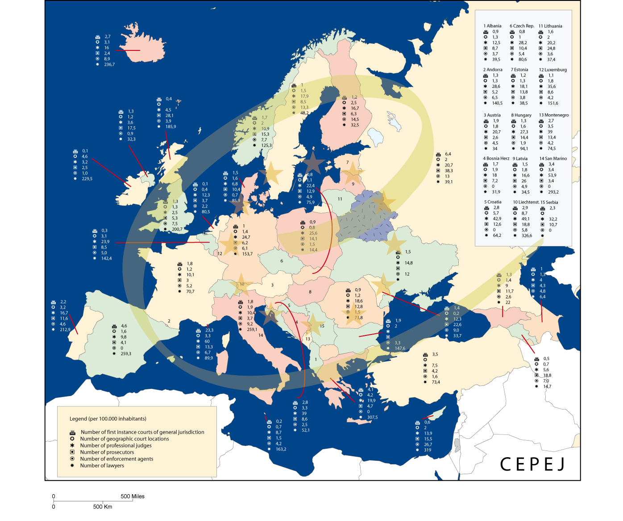

15. Appendix

In the appendix a selection of tables is presented. For more tables see the website of the CEPEJ: www.coe.int/cepej. The revised scheme for evaluating judicial systems and its explanatory note can be found in the chapter too.

Methodological issues concerning the budget of the courts and the justice budget (chapter 3)

According to the explanatory note, question 5 aimed “at specifying the total amount of the budget covering the functioning of the courts, whatever the origin of the budget is”, not having included neither the budget of the penitentiary system, neither the operational budget of the ministry for justice, nor that allocated to other institutions attached to this ministry, and also excluding the budget of the public prosecution.

Only San Marino could not provide budgetary figures relating to its legal system.

Budget of the courts and budget of the public prosecution.

The principal methodological difficulty relating to this issue is related to the fact that, in 12 countries, the courts and the public ministry are managed together and no separation can be made between the budget of the court and that of the public prosecution.

At the request of the group of experts, whatever the organisation of their judicial system is, these countries were allowed to provide the total amount of the budget (courts + public prosecution). Four of them (Andorra, Spain, France, Italy) we able to indicate the relative share of the budget devoted to the courts and the public prosecution, 8 others (Germany, Austria, Belgium, Greece, Luxembourg, Monaco, Portugal, Turkey) were not able to give an indication of the proportion of the budget allocated to the courts and the public prosecution.

All the other countries in which courts and public prosecution are economically distinguished were able to provide, without any problem, the two figures (question 5 and question 9). It is thus possible to compare similar entities of different legal systems, one gathering courts and public prosecution, the other dissociating them, after having studied each one of them: budgets devoted to the courts (table 2) and budgets devoted to the public prosecution (table 3).

The elements provided at the request of the group of experts and at the time of the meeting of the national correspondent in May 2006 in Strasbourg also made it possible to clarify other points, even if all the countries could not do it.

Centralised budgets and regional budgets

An important methodological difficulty is due to the more or less decentralised structure of certain states. Thus, for example, Spain and Germany have regional entities (autonomous communities and Länder) which have important prerogatives concerning the administration of justice, which has as an obvious consequence on the difficulty of having all information necessary and of gathering it in a satisfactory way for the questionnaire. The countries having succeeded in gathering information not easily available must be especially thanked for their accomplished work.

Legal aid

This question is studied specifically in chapter 3 of the report. It concerns the budgetary part relating to the courts in the sense that it makes it possible to measure the effort carried out by the states so that the underprivileged citizens can have access to the legal system.

All the countries could provide the total amount of legal aid (table 4). However, if the financing of this aid is passed by the budget of the ministry of justice in the majority of countries, it can also come from other sources (local authorities, social affairs) and is included or not, partly or entirely, in the budget of the jurisdictions. Thus, in 19 countries, the whole or part of the legal aid is registered in the budget devoted to courts

This specification of contribution, requested by each State, was important. It made it possible to isolate a budgetary mass expressly dissociated from the budget of the courts when it is evaluated on its own (table 2). The amount of legal aid was on the other hand added when it was a question of measuring the total financial effort made by the States at the same time to have access to the judicial system and to make it function (tables 6 and 7).

The coherence of the parameters studied

Other details required by the correspondents made it possible to remember that the coherence of the analysis required one to measure the legal activity against the means at the disposal of the courts. Thus, the penal and non-penal, civil activities in the broad sense (including labour disputes, commercial cases and administrative law cases) excluded the courts which are financially controlled by other services of the state and local authorities. In the same way, by consensus, the organisation of training sessions (national training centres for magistrates) was excluded. It seems that some countries, wrongly, did not include the budget of their Supreme courts, but the amounts in question are not really significant.

Some apparently overestimated budgetary figures

Question 6 relating to the share of staff costs (as well as new information technologies and court expenses) in the budget devoted to the courts, which 37 countries could answer, makes it possible to check, for comparable countries, which countries had taken into account other budgetary items than those strictly wanted (c.f. countries with a budgetary share devoted to the wages with 60% or less).

Overall, it appeared that, behind certain transmitted figures, states had been able to anticipate the comparative exercise and its results with regard to those of the pilot study on the 2002 figures. These national stakes, which often relate to the amount of budgets, constitute a mark of interest caused by work of the CEPEJ.

In any case, it appears that several countries, voluntarily or not, had largely increased the estimate of the sums devoted to the courts between the exercise over the year 2002 and that over the year 2004. 7 countries, in two years, thus initially declared a progression being able to go from +10% to + 45%, the increases which are not, for highest, in oneself possible or could not be specifically justified. On the basis of the remarks of the experts, some readjustments took place during the process of consultation. Some replies appearing debatable were however maintained and, in accordance with the declared and adopted working principle, they are the figures transmitted by the states after these last exchanges which are retained in the present study.

In the same way, as a partial explanation, it seemed that certain countries had integrated in their reply concerning the budget allocated to the courts the whole or a part of capital expenditure and or real investment. It was requested during the meeting of the national correspondents, to clarify this point (by sending an e-mail with clarifications to the experts). The precision were given by almost all of the countries replied, but concrete figures were only given by 14 of the 24 countries, which varied from 0,92% (Andorra) to 19,25% of the budget (Spain). But that does not mean that these budgets are overestimated in these proportions since the concept of investment also includes the purchase of computers, equipment material for the courts, which every country had included. This point can be checked by referring to the share of wages in the budgets (Q 6) and noting, for example, that Spain is situated in the average, below Italy and Belgium, and above Poland and France.

Any comparative result must integrate these elements for the countries concerned.

The methodology adopted for the budgetary part

The statistical figures make it possible in the ideal situation to only take into account the precise point, on which each correspondent provided a perfect and well documented answer to a relevant question. The differences in the legal systems, the modes of presentation of the prosecution budgets, or quite simply the understanding of the question put for each legal and cultural system could not be all smoothed out during the exchanges with the national correspondents through the bilateral contacts with the correspondents or during the meeting of the national correspondents in May 2006 in Strasbourg.

On the specific question relating to the budgets of justice, particularly politically significant, caution is even more important to any interpretation or comparison.

15.2 Additional tables

Table 76. Salaries, IT and justice expenses borne by the state in 2004 (question 6 - chapter 2)
Country | Can you isolate salaries? | If yes, amount | Salaries as % of the budget allocated to all courts (Q5) | Can you isolate IT? | If yes, amount | IT as % of the budget allocated to all courts | Can you isolate justice expenses borne by the State? | If yes, amount | Justice expenses borne by the state as % of the budget allocated to all courts
Albania | yes | 5 714 560 | 54,5% | n.r. |  |  | n.r.
Andorra | yes | 4 090 432 | 83,9% | n.r. |  |  | n.r.
Armenia | yes | 1 690 163 | 80,1% | n.r. |  |  | n.r.
Austria | yes | 294 764 000 | 55,0% | yes | 35 480 000 | 6,6% | no
Azerbaijan | n.a. |  |  | n.a. |  |  | n.a.
Belgium | yes | 530 900 000 | 76,7% | yes | 20 600 000 | 3,0% | yes | 67 310 000 | 9,7%
Bosnia & Herzegovina | yes | 48 859 892 | 80,0% | no |  |  | n.a.
Bulgaria | n.r. |  |  | n.r. |  |  | n.r.
Croatia | yes | 127 207 667 | 79,5% | yes | 2 627 381 | 1,6% | n.a.
Cyprus | yes | 7 731 809 | 43,0% | n.a. |  |  | yes | 452 054 | 2,5%
Czech Republic | yes | 119 625 532 | 49,6% | yes | 2 311 262 | 1,0% | yes | 20 067 117 | 8,3%
Denmark | yes | 121 000 000 | 76,5% | yes | 10 000 000 | 6,3% | yes | 53 000 000 | 33,5%
Estonia | yes | 16 400 000 | 79,2% | yes | 1 200 000 | 5,8% | no
Finland | yes | 164 923 000 | 77,9% | yes | 8 318 000 | 3,9% | no
France | yes | 1 375 645 000 | 54,0% | yes | 21 200 000 | 0,8% | yes | 426 400 000 | 16,7%
Georgia | yes | 5 024 320 | 69,7% | n.r. |  |  | yes | 2 132 018 | 29,6%
Germany | yes | 5 087 901 370 | 60,4% | yes | 244 554 491 | 2,9% | yes | 1 238 634 015 | 14,7%
Greece | yes | 294 900 000 | 94,9% | yes | 480 000 | 0,2% | yes | 8 395 000 | 2,7%
Hungary | yes | 162 864 000 | 58,9% | yes | 4 070 000 | 1,5% | yes | 45 730 000 | 16,5%
Iceland | yes | 7 500 000 | 79,8% | n.r. |  |  | n.r.
Ireland | yes | 43 750 000 | 44,6% | yes | 8 225 000 | 8,4% | yes | 19 370 000 | 19,8%
Italy | yes | 2 108 839 000 | 76,7% | yes | 80 794 000 | 2,9% | yes | n.r.
Latvia | yes | 11 268 472 | 53,5% | yes | 439 162 | 2,1% | yes | 267 456 | 1,3%
Liechtenstein | yes | 6 810 091 | 68,8% | yes | 59 802 | 0,6% | yes | 1 265 788 | 12,8%
Lithuania | yes | 25 310 530 | 66,5% | n.a. |  |  | n.a.
Luxembourg | yes | 38 839 301 | 79,9% | yes | 100 000 | 0,2% | yes | 160 000 | 0,3%
Malta | yes | 6 658 100 | 76,7% | no |  |  | yes | 676 700 | 7,8%
Moldova | n.a. |  |  | n.a. |  |  | n.a.
Monaco | yes | n.r. |  | n.a. |  |  | n.a.
Montenegro | yes | 5 000 000 | 73,6% | yes | 30 000 | 0,4% | yes | 1 374 429 | 20,2%
Netherlands | n.r. |  |  | n.r. |  |  | n.r.
Norway | yes | n.r. |  | yes | n.r |  | n.a.
Poland | yes | 498 337 105 | 60,0% | yes | 8 868 010 | 1,1% | yes | 123 085 068 | 14,8%
Portugal | yes | 325 846 953 | 59,0% | yes | 984 782 | 0,2% | n.a.
Romania | yes | 96 124 806 | 80,3% | n.r. |  |  | n.r.
Russian Federation | yes | 705 388 735 | 45,6% | no |  |  | no
San Marino | no |  |  | no |  |  | no
Serbia | yes | 58724678 | 83,6% | no |  |  | n.r.
Slovakia | yes | 39 827 789 | 49,0% | yes | 3 684 974 | 4,5% | yes | 584 631 | 0,7%
Slovenia | yes | 77 100 000 | 69,1% | yes | 2 900 000 | 2,6% | no
Spain | yes | 1 680 413 340 | 67,1% | yes | n.a. |  | yes | n.a.
Sweden | yes | 276 677 157 | 59,7% | no |  |  | no
Turkey | yes | 242 218 891 | 72,7% | yes | 3 015 271 | 0,9% | yes | 75 750 000 | 22,7%
Ukraine | n.r. |  |  | yes | n.r. |  | yes | n.r.
UK England & Wales | n.r. |  |  | yes | 28 000 000 | 6,5% | n.r.
UK Northern Ireland | n.r. |  |  | yes | 7 000 000 | - | n.r.
UK Scotland | yes | 31 569 184 | 33,8% | yes | 2 500 000 | 2,7% | n.r.

Table 77. Budget of judicial systems (chapter 2)
Country | Q1 Number of inhabitants | Q3 Per capita GDP | Q4 Average gross annual salary | Q5 Total annual budget allocated to all courts (as provided) | Is public prosecution included in this budget? | T2=PP Q9 Annual public budget spent on the prosecution system | Is legal aid included in the budget allocated to all courts? | T3=AL Q7 Annual public budget spent on legal aid | T1=C Total annual budget allocated to all courts without prosecution nor legal aid | T4=C+MP Total annual budget allocated to all courts and prosecution (without legal aid) | T5=C+PP+AL Total budget allocated to the judiciary system (courts, public prosecution and legal aid) | T6 C+AL Total annual budget allocated to all courts and legal aid (without prosecution) | Are capital expenditures-investments included in this budget? | If yes, amount
Albania | 3 069 275 | 1 920 € | 2 440 € | 10 486 065 € | n.r.(no) | 8 498 900 € | n.r.(no) | 130 550 € | 10 486 065 € | 18 984 965,00 € | 19 115 515,00 € | 10 616 615,00 € | n.r. | -
Andorra | 76 875 | 22 347 € | 14 846 € | 4 874 162 € | yes* | 426 969 € | no | 230 668 € | 4 447 193 € | 4 874 161,65 € | 5 104 829,49 € | 4 677 860,77 € | yes | 45 404 €
Armenia | 3 210 000 | 850 € | 756 € | 2 109 239 € | yes | n.a. | no | 14 500 € | - | 2 109 239,00 € | 2 123 739,00 € | - | yes | n.a.
Austria | 8 206 500 | 29 000 € | 38 640 € | 536 265 392 € | yes | n.a. | yes * | 24 100 000 € | - | 512 165 392,33 € | 536 265 392,33 € | - | yes | n.a.
Azerbaijan | 8 347 000 | 852 € | 994 € | 6 915 057 € | no | 10 916 740 € | no | 28 500 € | 6 915 057 € | 17 831 796,68 € | 17 860 296,68 € | 6 943 556,50 € | no | -
Belgium | 10 446 000 | 27 579 € | 31 992 € | 692 600 000 € | yes | n.a. | yes | 30 750 000 € | - | 661 850 000,00 € | 692 600 000,00 € | - | no | -
Bosnia & Herzegovina | 3 832 000 | 1 732 € | 4 634 € | 61 040 303 € | no | 16 591 370 € | yes * | 1 777 399 € | 59 262 904 € | 75 854 274,00 € | 77 631 673,00 € | 61 040 303,00 € | yes | 2 492 911 €
Bulgaria | 7 761 049 | n.r. | 2 417 € | 48 900 313 € | n.r.(no) | 22 826 626 € | n.r.(no) | 1 571 358 € | 48 900 313 € | 71 726 939,00 € | 73 298 297,00 € | 50 471 671,00 € | n.r. | -
Croatia | 4 443 900 | 6 200 € | 9 582 € | 159 988 552 € | no | 28 967 501 € | no | - | 159 988 552 € | 188 956 052,53 € | - | - | no | -
Cyprus | 689 565 | 7 216 € | 11 700 € | 17 997 698 € | no | n.a. | yes | n.a. | 17 997 698 € | - | - | 17 997 698,00 € | yes | n.a.
Czech Republic | 10 220 577 | 8 446 € | 6 783 € | 241 292 690 € | no | 55 924 241 € | no | 12 273 022 € | 241 292 690 € | 297 216 931,00 € | 309 489 953,00 € | 253 565 712,00 € | yes | 16 747 179 €
Denmark | 5 397 640 | n.a. | n.a. | 158 200 000 € | n.r.(no) | n.a. | yes | 3 200 000 € | 155 000 000 € | 155 000 000,00 € | - | 158 200 000,00 € | n.r. | -
Estonia | 1 351 069 | 6 644 € | 5 588 € | 20 700 000 € | no | 3 500 000 € | no | 1 700 000 € | 20 700 000 € | 24 200 000,00 € | 25 900 000,00 € | 22 400 000,00 € | yes | n.a.
Finland | 5 236 611 | 28 646 € | 33 000 € | 211 636 000 € | no | 33 022 000 € | no | 52 129 000 € | 211 636 000 € | 244 658 000,00 € | 296 787 000,00 € | 263 765 000,00 € | yes | n.a.
France | 62 177 400 | 26 511 € | 38 921 € | 2 549 181 000 € | no | 646 771 000 € | yes | 291 200 000 € | 2 549 181 000 € | 2 904 752 000,00 € | 3 195 952 000,00 € | 2 549 181 000,00 € | no | -
Georgia | 4 535 200 | 923 € | 992 € | 7 206 338 € | no | 7 498 585 € | no | 69 760 € | 7 206 338 € | 14 704 923,00 € | 14 774 683,00 € | 7 276 098,00 € | yes | n.a.
Germany | 82 500 000 | 26 754 € | 39 815 € | 8 417 000 000 € | yes | n.a. | yes * | 468 400 000 € | - | 7 948 600 000,00 € | 8 417 000 000,00 € | - | yes | n.a.
Greece | 11 056 800 | 15 119 € | 16 776 € | 310 700 000 € | yes | n.a. | yes | 724 187 € | - | 309 975 812,52 € | 310 700 000,00 € | - | no | -
Hungary | 10 097 549 | 8 025 € | 6 984 € | 276 564 000 € | no | 108 000 000 € | yes (100 000€) | 851 333 € | 276 563 900 € | 384 464 000,00 € | 385 315 333,00 € | 277 315 333,00 € | yes | 32 700 000 €
Iceland | 293 577 | 34 700 € | 38 700 € | 9 400 000 € | no | 3 100 000 € | no | 1 200 000 € | 9 400 000 € | 12 500 000,00 € | 13 700 000,00 € | 10 600 000,00 € | no | 135 100 €
Ireland | 4 040 000 | 36 737 € | 27 780 € | 97 991 000 € | n.r.(no) | 28 661 000 € | no | 47 649 000 € | 97 991 000 € | 126 652 000,00 € | 174 301 000,00 € | 145 640 000,00 € | yes | 18 866 000 €
Italy | 58 462 375 | 23 115 € | 22 254 € | 2 749 944 000 € | no | 1 167 510 000 € | no | 66 030 256 € | 2 749 944 000 € | 3 917 454 000,00 € | 3 983 484 256,35 € | 2 815 974 256,35 € | no | -
Latvia | 2 319 200 | 4 777 € | 3 600 € | 21 074 355 € | no | 12 018 365 € | no | 653 490 € | 21 074 355 € | 33 092 720,01 € | 33 746 209,76 € | 21 727 844,76 € | yes | 1 946 587 €
Liechtenstein | 34 600 | 106 000 € | 74 592 € | 9 903 150 € | no | 1 302 339 € | yes | 1 292 008 € | 8 611 142 € | 9 913 481,00 € | 11 205 489,00 € | 9 903 150,00 € | no | -
Lithuania | 3 425 300 | 5 264 € | 4 024 € | 38 045 065 € | no | 24 375 087 € | no | 1 636 208 € | 38 045 065 € | 62 420 152,00 € | 64 056 360,00 € | 39 681 273,00 € | no | 6 382 646 €
Luxembourg | 455 000 | 56 488 € | 39 587 € | 48 593 995 € | yes | n.a. | yes | 2 574 828 € | - | 46 019 167,34 € | 48 593 995,00 € | - | yes | 168 000 €
Malta | 402 668 | 9 647 € | 11 644 € | 8 679 000 € | no | 1 023 260 € | no | 16 720 € | 8 679 000 € | 9 702 260,00 € | 9 718 980,00 € | 8 695 720,00 € | no | 512 000 €
Moldova | 3 386 000 | 572 € | 853 € | 26 015 100 € | no | 18 623 700 € | no | 124 100 € | 26 015 100 € | 44 638 800,00 € | 44 762 900,00 € | 26 139 200,00 € | yes | n.a.
Monaco | 30 020 | n.a. | n.a. | 3 903 700 € | yes* | 780 740 € | yes | 102 950 € | 3 020 010 € | 3 800 750,00 € | 3 903 700,00 € | 3 122 960,00 € | no | -
Montenegro | 620 533 | 2 113 € | 3 636 € | 6 791 731 € | no | 1 197 047 € | no | - | 6 791 731 € | 7 988 778,26 € | - | - | no | -
Netherlands | 16 292 000 | 29 993 € | 30 642 € | 762 607 000 € | no | 335 300 000 € | no | 378 358 000 € | 762 607 000 € | 1 097 907 000,00 € | 1 476 265 000,00 € | 1 140 965 000,00 € | n.r. | -
Norway | 4 606 363 | 43 818 € | 41 219 € | 164 000 000 € | no | 10 737 € | no | 137 528 000 € | 164 000 000 € | 164 010 737,00 € | 301 538 737,00 € | 301 528 000,00 € | no | -
Poland | 38 174 000 | 5 246 € | 6 218 € | 830 504 751 € | no | 226 591 855 € | yes | 16 775 566 € | 813 729 185 € | 1 040 321 040,00 € | 1 057 096 606,00 € | 830 504 751,00 € | yes | 59 334 913 €
Portugal | 10 529 255 | 13 550 € | 13 492 € | 552 462 601 € | yes | n.a. | yes | 27 632 424 € | - | 524 830 177,00 € | 552 462 601,00 € | - | yes | n.a.
Romania | 21 673 328 | 2 718 € | 2 423 € | 119 771 995 € | no | 70 989 086 € | yes | 1 810 732 € | 117 961 263 € | 188 950 349,00 € | 190 761 081,00 € | 119 771 995,00 € | n.r. | -
Russian Federation | 143 474 143 | 3 478 € | 2 379 € | 1 545 651 802 € | no | 926 827 355 € | no | n.a. | 1 545 651 802 € | 2 472 479 157,00 € | - | - | yes | n.a.
San Marino | 29 673 | 26 350 € | 23 609 € | n.a. | n.r.(no) | n.a. | n.a. | - | - | - | - | - | n.r. | -
Serbia | 7 498 001 | 2 255 € | 3 420 € | 70 207 781 € | no | 12 108 235 € | n.a. | - | 70 207 781 € | 82 316 016,00 € | - | - | no | -
Slovakia | 5 400 000 | 6 200 € | 4 997 € | 81 306 053 € | no | 26 289 474 € | yes | 1 967 026 € | 79 339 027 € | 105 628 501,00 € | 107 595 527,00 € | 81 306 053,00 € | yes | 10 599 684 €
Slovenia | 1 997 590 | 13 103 € | 13 565 € | 111 500 000 € | no | 15 600 000 € | yes | n.a. | 111 500 000 € | 127 100 000,00 € | 127 100 000,00 € | 111 500 000,00 € | yes, in part | 407 798 €
Spain | 42 935 001 | 19 502 € | 25 060 € | 2 503 746 020 € | yes* | 153 158 726 € | yes | 119 055 984 € | 2 231 531 310 € | 2 384 690 036,00 € | 2 503 746 020,00 € | 2 350 587 294,30 € | yes | 232 968 500 €
Sweden | 9 034 837 | 28 832 € | 31 906 € | 463 687 163 € | no | 89 000 000 € | no | 95 455 900 € | 463 687 163 € | 552 687 163,00 € | 648 143 063,00 € | 559 143 063,00 € | no | -
Turkey | 71 152 000 | 3 359 € | 7 783 € | 333 217 760 € | yes | n.a. | yes | 13 626 853 € | - | 319 590 906,63 € | 333 217 760,00 € | - | yes | n.a.
Ukraine | 47 280 800 | 1 141 € | 1 105 € | 107 696 300 € | no | 41 307 900 € | n.r. | - | - | 149 004 200,00 € | - | - | n.r. | n.a.
UK England & Wales | 53 046 300 | 24 579 € | 36 900 € | 429 000 000 € | no | 770 000 000 € | no | 3 070 000 000 € | 429 000 000 € | 1 199 000 000,00 € | 4 269 000 000,00 € | 3 499 000 000,00 € | yes | n.a.
UK Northern Ireland | 1 710 300 | 25 343 € | 31 061 € | n.r. | no | 35 370 000 € | no | 93 630 000 € | - | - | - | - | n.r. | n.a.
UK Scotland | 5 078 400 | 24 600 € | 33 500 € | 93 301 917 € | no | 131 300 000 € | no | 216 000 000 € | 93 301 917 € | 224 601 916,80 € | 440 601 916,80 € | 309 301 916,80 € | n.r. | n.a.

Table 78. Matter and type of legal aid (question 11- chapter 3)
country | Q11 Legal aid for criminal cases |  |  | Q11 Legal aid for other than criminal cases
country | Representation in court | Legal advice | Other | Representation in court | Legal advice | Other
Albania | yes | yes
Andorra | yes | yes |  | yes | yes
Armenia |  |  |  |  | yes
Austria | yes | yes | yes | yes | yes | yes
Azerbaijan | yes | no |  | no | no
Belgium | yes | yes |  | yes | yes
Bosnia and Herzegovina | yes | yes |  | no | no
Bulgaria | yes | yes |  | yes | yes
Croatia | yes | yes | no | yes | yes | no
Cyprus | yes | yes |  | yes | yes
Czech Republic | yes | yes | no | yes | yes | no
Denmark | no | no | no | yes | yes | no
Estonia | yes | yes | yes | yes | yes | yes
Finland | yes | yes |  | yes | yes
France | yes | yes | yes | yes | yes | yes
Georgia | yes | yes | yes
Germany | yes | yes | yes | yes | yes | yes
Greece | yes | yes | yes | yes
Hungary | yes | yes |  | yes | yes
Iceland | no | yes | no | yes | yes
Ireland | yes | yes |  | yes | yes
Italy | yes | no | yes | yes | no | no
Latvia | yes | yes | yes | no | no | yes
Liechtenstein | yes | yes |  | yes | yes
Lithuania | yes | yes |  | yes | yes
Luxembourg | yes | yes | no | yes | yes | no
Malta | yes | yes |  | yes | yes
Moldova | yes |  |  | no
Monaco | yes | no |  | yes | no | yes
Montenegro | yes | yes |  |  |  | yes
Netherlands | yes | yes | no | yes | yes | yes
Norway | yes | yes |  | yes | yes | yes
Poland | yes | no | yes | yes | no | yes
Portugal | yes | yes | yes | yes | yes | yes
Romania | yes | yes | yes | yes | yes | yes
Russian Federation | yes | yes | yes | yes | yes | yes
San Marino | yes | no |  | yes | no
Slovakia | yes | yes |  | no | yes
Slovenia | yes | yes | yes | yes | yes | yes
Serbia | yes | yes |  | yes | yes
Spain | yes | yes | yes | yes | yes | yes
Sweden | yes | no | yes | yes | yes | yes
Turkey | yes | no | no | yes | no | yes
UK England & Wales | yes | yes |  | yes | yes
UK Northern Ireland | yes | yes |  | yes | yes
UK Scotland | yes | yes |  | yes | yes
Ukraine | yes | yes | no | yes | yes | no

Table 79. Annual public budget spent on legal aid for criminal and other than criminal matter and number of cases (questions 8 and 12)
Country | Q1 Number of inhabitants | Q7 Annual public budget spent on legal aid | Q8 Annual public budget spent on legal aid in criminal cases | Q8 Annual public budget spent on legal aid in other court cases | Q12 Total number of legal aid cases | Q12 Number of legal aid in criminal cases | Q12 Number of legal aid in non criminal cases
Albania | 3 069 275 | 130 550 € | 62 620 138 € | n.a. | - | n.r. | n.r.
Andorra | 76 875 | 230 668 € | 653 490 € | n.r. | 437 | n.r. | n.r.
Armenia | 3 210 000 | 14 500 € | 523 962 € | n.r. | - | n.r. | n.r.
Austria * | 8 206 500 | 24 100 000 € | n.a. | n.r. | 24 650 | n.r. | n.r.
Azerbaijan | 8 347 000 | 28 500 € | n.a. | n.a. | n.a. | n.r. | n.r.
Belgium | 10 446 000 | 30 750 000 € | n.r. | n.a. | 99 468 | n.a. | n.a.
Bosnia & Herzegovina * | 3 832 000 | 1 777 399 € | 124 100 € | n.a. | - | n.r. | n.r.
Bulgaria | 7 761 049 | 1 571 358 € | n.a. | n.r. | - | n.r. | n.r.
Croatia | 4 443 900 | n.a. | n.r. | n.a. | 410 | n.a. | n.a.
Cyprus | 689 565 | n.a. | 144 688 000 € | n.a. | 1 161 | 820 | 341
Czech Republic | 10 220 577 | 12 273 022 € | 62 144 000 € | 656 579 € | n.a. | n.r. | n.r.
Denmark * | 5 397 640 | 3 200 000 € | n.a.p. | 3 200 000 € | 17 316 | n.a.p. | 17 316
Estonia | 1 351 069 | 1 700 000 € | n.a. | 118 152 € | - | n.r. | n.r.
Finland | 5 236 611 | 52 129 000 € | n.r. | n.a. | 79 494 | 27 410 | 52 084
France | 62 177 400 | 291 200 000 € | n.a. | 167 400 000 € | 831 754 | 353 393 | 478 361
Georgia | 4 535 200 | 69 760 € | n.r. | n.r. | 114 | 114 | n.r.
Germany * | 82 500 000 | 468 400 000 € | n.a. | 380 400 000 € | n.a. | n.a. | 578 835
Greece | 11 056 800 | 724 187 € | 1 967 026 € | n.r. | - | n.r. | n.r.
Hungary * | 10 097 549 | 851 333 € | n.a. | n.a. | 52 928 | 14 926 | 38 002
Iceland | 293 577 | 1 200 000 € | n.a. | n.a. | 392 | n.a. | n.a.
Ireland | 4 040 000 | 47 649 000 € | 79 492 100 € | 13 510 000 € | 39 965 | 31 820 | 8 145
Italy | 58 462 375 | 66 030 256 € | 11 274 145 € | 3 410 118 € | 97 845 | 72 879 | 24 966
Latvia | 2 319 200 | 653 490 € | 1 750 000 000 € | n.a. | - | n.r. | n.r.
Liechtenstein | 34 600 | 1 292 008 € | 36 960 000 € | 694 785 € | - | n.r. | n.r.
Lithuania | 3 425 300 | 1 636 208 € | 151 150 000 € | n.a. | n.a. | n.a. | n.a.
Luxembourg | 455 000 | 2 574 828 € | n.r. | n.a. | 3 602 | 901 | 2 702
Malta | 402 668 | 16 720 € | 62 620 138 € | n.r. | - | n.r. | n.r.
Moldova | 3 386 000 | 124 100 € | 653 490 € | n.a. | n.a. | n.r. | n.r.
Monaco | 30 020 | 102 950 € | 523 962 € | n.a. | 656 | 95 | 561
Montenegro | 620 533 | n.r. | n.a. | n.r. | - | n.r. | n.r.
Netherlands | 16 292 000 | 378 358 000 € | n.a. | 233 666 000 € | 343 473 | 129 404 | 214 069
Norway | 4 606 363 | 137 528 000 € | n.r. | 75 384 000 € | n.a. | n.a. | 5 600
Poland | 38 174 000 | 16 775 566 € | 124 100 € | n.a. | n.a. | n.a. | n.a.
Portugal | 10 529 255 | 27 632 424 € | n.a. | n.a. | 130 095 | n.a. | n.a.
Romania | 21 673 328 | 1 810 732 € | n.r. | n.r. | 287 698 | n.r. | n.r.
Russian Federation | 143 474 143 | n.a. | 144 688 000 € | n.a. | - | n.r. | n.r.
San Marino | 29 673 | n.a. | 62 144 000 € | n.r. | n.a. | n.a. | n.a.
Serbia | 7 498 001 | n.a. | n.a. | n.a. | n.a. | n.r. | n.r.
Slovakia | 5 400 000 | 1 967 026 € | n.a. | n.a. | n.a. | n.r. | n.r.
Slovenia * | 1 997 590 | n.a. | n.r. | 900 000 € | - | n.r. | 18 664
Spain | 42 935 001 | 119 055 984 € | n.a. | n.a. | n.a. | n.a. | n.a.
Sweden | 9 034 837 | 95 455 900 € | n.r. | 15 963 800 € | n.a. | n.a. | n.a.
Turkey | 71 152 000 | 13 626 853 € | n.a. | 2 352 708 € | 107 349 | 102 920 | 4 429
UK England & Wales | 53 046 300 | 3 070 000 000 € | 1 967 026 € | 1 320 000 000 € | 2 436 000 | 1 580 000 | 856 000
UK Northern Ireland | 1 710 300 | 93 630 000 € | n.a. | 55 670 000 € | 96 058 | 26 220 | 69 838
UK Scotland | 5 078 400 | 216 000 000 € | n.a. | 64 780 000 € | 407 156 | 246 988 | 160 168
Ukraine | 47 280 800 | n.r. | 79 492 100 € | n.r. | 219 462 | 4 462 | 215 000
* estimation or approximation
Special arrangements for vulnerable persons (chapter 4)

Table 80. Special arrangements for victims of rape (question 23)
Victims of rape  Country | Information mechanism | Hearing modalities | Procedural rights | Other
Albania
Andorra |  | yes
Armenia |  | yes
Austria | yes | yes | yes
Azerbaijan | yes | yes | yes
Belgium | yes | yes | yes
Bosnia and Herzegovina | no | yes | yes
Bulgaria | yes | yes | yes
Croatia | yes | no | no | no
Cyprus | yes | yes | yes
Czech Republic | no | no | no | no
Denmark | yes | yes | yes
Estonia | no | yes | no
Finland | yes | yes | yes
France | no | no | yes | yes
Georgia
Germany | yes | yes | yes
Greece
Hungary |  | yes
Iceland | yes | yes | yes | yes
Ireland | yes | yes
Italy | no | yes | no | no
Latvia
Liechtenstein | yes | yes | yes
Lithuania | no | no | no | no
Luxembourg | no | no | yes | no
Malta | no | yes | yes
Moldova |  | yes | yes
Monaco | no | no | no
Montenegro | no | yes | yes
Netherlands | yes | yes | yes | no
Norway | yes |  | yes | yes
Poland | yes | yes | no | yes
Portugal | no | yes | yes | yes
Romania | yes | yes | yes | yes
Russian Federation | yes | yes | yes | no
San Marino | no | yes | yes
Slovakia | no | no | no | no
Slovenia | no | yes | no | no
Serbia | no | yes | no
Spain | yes | yes | yes
Sweden | no | yes | yes
Turkey | no | no | no
Ukraine | yes | yes | yes | yes
UK England & Wales | yes | yes | yes
UK Northern Ireland | yes | yes | yes | yes
UK Scotland | yes | yes | yes | yes

Table 81. Special arrangements for victims of terrorism (question 23)
Victims of terrorism  Country | Information mechanism | Hearing modalities | Procedural rights | Other
Albania
Andorra
Armenia |  | yes
Austria | yes | yes | yes
Azerbaijan | yes | yes | yes
Belgium | no | no | no | no
Bosnia and Herzegovina | no | yes | yes
Bulgaria | no | no | no
Croatia | yes | no | no | no
Cyprus | yes | yes | yes
Czech Republic | no | no | no | no
Denmark | no | no | no
Estonia | no | yes | no
Finland | no | no | no
France | no | no | no | yes
Georgia
Germany | yes | yes | yes
Greece
Hungary
Iceland | yes | yes | yes
Ireland | no | no | no
Italy | no | yes | no | no
Latvia
Liechtenstein | yes | yes | yes
Lithuania | no | no | no | no
Luxembourg | no | no | no | no
Malta | no | no | no
Moldova
Monaco | no | no | no
Montenegro
Netherlands | yes | yes | yes | no
Norway | yes |  | yes | yes
Poland | no | no | no | no
Portugal | no | yes | yes | yes
Romania | yes | yes | yes | yes
Russian Federation | yes | yes | yes | no
San Marino | no | no | no
Slovakia | no | no | no | no
Slovenia | no | yes | no | no
Serbia | no | yes | no
Spain | yes | yes | yes
Sweden | no | yes | yes
Turkey | no | no | no
Ukraine | no | no | no
UK England &Wales | yes | yes | yes
UK Northern Ireland | yes | yes | yes | yes
UK Scotland | yes | yes | yes | yes

Table 82. Special arrangements for children witness/victim (question 23)
Child witness/victim  Country | Information mechanism | Hearing modalities | Procedural rights | Other
Albania
Andorra | yes | yes | yes
Armenia |  | yes
Austria | yes | yes | yes
Azerbaijan | yes | yes | yes | yes
Belgium | yes | yes | yes | yes
Bosnia and Herzegovina | no | yes | yes | yes
Bulgaria | yes | yes | yes
Croatia | yes | yes | yes | no
Cyprus | yes | yes | yes
Czech Republic | yes | yes | yes
Denmark | yes | yes | yes
Estonia | no | yes | no
Finland | yes | yes | yes
France | no | yes | yes | yes
Georgia
Germany | yes | yes | yes
Greece
Hungary |  | yes | yes
Iceland | yes | yes | yes | yes
Ireland | yes | yes | no
Italy | no | yes | no | no
Latvia
Liechtenstein | yes | yes | yes
Lithuania | no | yes | yes | no
Luxembourg | no | yes | yes | no
Malta | no | yes | yes
Moldova |  | yes | yes
Monaco | no | yes
Montenegro | yes | yes | yes
Netherlands | yes | yes | yes | no
Norway | yes | yes | yes | yes
Poland | yes | yes | yes | yes
Portugal | no | yes | yes | yes
Romania | yes | yes | yes | yes
Russian Federation | yes | yes | yes | no
San Marino | no | yes | yes
Slovakia | yes | yes | yes | yes
Slovenia | yes | yes | yes
Serbia | no | yes | yes
Spain | yes | yes | yes
Sweden | no | yes | yes
Turkey | no | yes | yes
Ukraine | yes | no | yes | yes
UK England &Wales | yes | yes | yes
UK Northern Ireland | yes | yes | yes | yes
UK Scotland | yes | yes | yes | yes

Table 83. Special arrangements for victims of domestic violence (question 23)
Victims of domestic violence  Country | Information mechanism | Hearing modalities | Procedural rights | Other
Albania
Andorra |  | yes
Armenia |  | yes | yes
Austria | yes | yes | yes
Azerbaijan | yes | yes | yes
Belgium | yes | no | yes | no
Bosnia and Herzegovina | no | yes | yes | yes
Bulgaria | yes | yes | yes
Croatia | yes | no | no | yes
Cyprus | yes | yes | yes
Czech Republic | no | no | no | no
Denmark | yes | yes | yes
Estonia | no | yes | no
Finland | yes | yes | yes
France | no | no | no | yes
Georgia
Germany | yes | yes | yes
Greece
Hungary
Iceland | yes | yes | yes
Ireland | yes | no | no
Italy | no | no | no | no
Latvia
Liechtenstein | yes | yes | yes
Lithuania | no | no | no | no
Luxembourg | no | no | yes | yes
Malta | no | yes | yes
Moldova
Monaco | no
Montenegro | yes | yes | yes
Netherlands | yes | yes | yes | no
Norway | yes |  | yes | yes
Poland | yes | no | no | yes
Portugal | no | yes | yes | yes
Romania | yes | yes | yes | yes
Russian Federation | yes | yes | yes | no
San Marino | no | yes | yes
Slovakia | no | no | no | no
Slovenia | no | yes | no | no
Serbia | no | yes | no
Spain | yes | yes | yes | yes
Sweden | no | yes | yes
Turkey | no | no | no | yes
Ukraine | no | no | no
UK England &Wales | yes | yes | yes
UK Northern Ireland | yes | yes | yes | yes
UK Scotland | yes | yes | yes | yes

Table 84. Special arrangements for ethnic minorities (question 23)
Ethnic minorities  Country | Information mechanism | Hearing modalities | Procedural rights | Other
Albania
Andorra
Armenia |  | yes
Austria | yes | yes | yes
Azerbaijan | yes | yes | yes
Belgium | yes | yes | yes | no
Bosnia and Herzegovina | no | no | no
Bulgaria | no | no | no
Croatia | yes | no | no | no
Cyprus | yes | yes | yes
Czech Republic | no | no | no | no
Denmark | no | no | no
Estonia | no | yes | no
Finland | yes | yes | yes
France | no | no | no | yes
Georgia
Germany |  |  | yes
Greece
Hungary |  |  |  | yes
Iceland | yes | yes | yes
Ireland | yes | yes | no
Italy | no | no | no | no
Latvia
Liechtenstein | yes | yes | yes
Lithuania | no | no | no | no
Luxembourg | no | no | no | no
Malta
Moldova
Monaco | no | no | no
Montenegro | yes | yes | yes
Netherlands | no | yes | no
Norway | yes |  | yes
Poland | no | no | no | no
Portugal | no | no | no | no
Romania | yes | yes | yes | yes
Russian Federation | yes | yes | yes | no
San Marino | no | no | no
Slovakia | no | no | no | no
Slovenia | no | no | no | no
Serbia | no | yes | yes
Spain
Sweden | no | yes | yes
Ukraine | no | no | no
Turkey | no | no | no
UK England &Wales | yes | yes | yes
UK Northern Ireland | yes | yes | yes | yes
UK Scotland | yes | yes | yes | yes

Table 85. Special arrangements for disabled persons (question 23)
Disabled persons  Country | Information mechanism | Hearing modalities | Procedural rights | Other
Albania
Andorra | yes
Armenia |  | yes
Austria | yes | yes | yes
Azerbaijan | yes | yes | yes
Belgium | yes | yes | yes | no
Bosnia and Herzegovina | no | yes | yes
Bulgaria | yes | yes | yes
Croatia | yes | no | no | no
Cyprus | yes | yes | yes
Czech Republic | no | no | no | no
Denmark | no | no | no | yes
Estonia | no | yes | no
Finland | yes | yes | yes
France | no | yes | no | yes
Georgia
Germany |  | yes | yes
Greece
Hungary
Iceland | yes | yes | yes
Ireland | yes | yes | no
Italy | no | yes | no | no
Latvia
Liechtenstein | yes | yes | yes
Lithuania | no | no | yes | no
Luxembourg | no | yes | yes | yes
Malta | no | no | no | yes
Moldova |  | yes | yes
Monaco | no | yes
Montenegro | yes | yes | yes
Netherlands | no | no | no | no
Norway | yes | yes | yes
Poland | no | yes | no | no
Portugal | no | yes | yes | yes
Romania | yes | yes | yes | yes
Russian Federation | yes | yes | yes | no
San Marino | no | yes | yes
Slovakia | no | no | no | no
Slovenia | no | yes | no | no
Serbia | no | yes | yes
Spain |  | yes
Sweden | no | yes | yes
Turkey | no | yes | yes
Ukraine | no | no | yes | yes
UK England &Wales | yes | yes | yes
UK Northern Ireland | yes | yes | yes | yes
UK Scotland | yes | yes | yes | yes

Table 86. Special arrangements for juvenile offenders (question 23)
Juvenile offenders  Country | Information mechanism | Hearing modalities | Procedural rights | Other
Albania |  | yes | yes
Andorra | yes | yes | yes
Armenia |  | yes
Austria | yes | yes | yes
Azerbaijan | yes | yes | yes
Belgium | yes | yes | yes | no
Bosnia and Herzegovina | no | yes | yes | yes
Bulgaria | yes | yes | yes
Croatia | yes | no | yes | no
Cyprus | yes | yes | yes
Czech Republic | yes | yes | yes
Denmark | yes | yes | yes
Estonia | no | yes | yes
Finland | no | no | yes
France | yes | yes | yes
Georgia
Germany | yes | yes | yes | yes
Greece
Hungary | yes | yes | yes
Iceland | yes | yes | yes | yes
Ireland | yes | yes | no
Italy | no | no | yes | no
Latvia
Liechtenstein | yes | yes | yes
Lithuania | no | yes | yes | yes
Luxembourg | no | yes | yes | no
Malta | no | no | yes | yes
Moldova |  | yes | yes
Monaco | no | yes | yes
Montenegro | yes | yes | yes
Netherlands | no | yes | yes | no
Norway | yes |  | yes
Poland | no | no | yes | no
Portugal | no | yes | yes | yes
Romania | yes | yes | yes | yes
Russian Federation | yes | yes | yes | no
San Marino | no | yes | yes
Slovakia | yes | yes | yes | no
Slovenia | no | yes | yes
Serbia | no | yes | no
Spain |  | yes | yes
Sweden | no | yes | yes
Turkey | no | yes | yes
Ukraine | yes | yes | yes | yes
UK England &Wales | yes | yes | yes
UK Northern Ireland | yes | yes | yes | yes
UK Scotland | yes | yes | yes | yes

Table 87. Special arrangements for other vulnerable persons (question 23)
Other vulnerable persons  Country | Information mechanism | Hearing modalities | Procedural rights | Other
Albania
Andorra
Armenia |  | yes
Austria | yes | yes | yes | yes
Azerbaijan
Belgium
Bosnia and Herzegovina |  |  | yes | yes
Bulgaria
Croatia
Cyprus
Czech Republic | no | no | no | no
Denmark
Estonia
Finland
France
Georgia
Germany
Greece
Hungary
Iceland
Ireland
Italy
Latvia
Liechtenstein
Lithuania | no | no | yes | no
Luxembourg | no | no | no | no
Malta
Moldova
Monaco | no | no | no
Montenegro
Netherlands | no | no | no | no
Norway
Poland
Portugal | no | yes | yes | yes
Romania | yes | yes | yes | yes
Russian Federation | yes | yes | yes | no
San Marino
Slovakia
Slovenia
Serbia
Spain
Sweden | no | yes | yes
Turkey |  |  |  | yes
Ukraine | no | yes | yes
UK England & Wales
UK Northern Ireland
UK Scotland

Table 88. Consideration of the positive answers vis-à-vis the date of accession to the Council of Europe
Categories of vulnerable persons | Date of accession to the CoE vis-à-vis 1989 | Number of states having given positive answers to specific hearing modalities | Number of states having given positive answers as regards procedural rights
Victim of rape | Before | 17 | 18
Victim of rape | After | 14 | 7
Victims of terrorism | Before | 11 | 11
Victims of terrorism | After | 7 | 3
Children witnesses/victims | Before | 21 | 19
Children witnesses/victims | After | 18 | 16
Victims of domestic violence | Before | 14 | 17
Victims of domestic violence | After | 10 | 6
Ethnic minorities | Before | 10 | 10
Ethnic minorities | After | 6 | 4
Disables persons | Before | 18 | 14
Disables persons | After | 12 | 9
Juvenile offenders | Before | 17 | 20
Juvenile offenders | After | 18 | 18
Other vulnerable categories | Before | 1 | 1
Other vulnerable categories | After | 3 | 4

Chapter 5: the courts

Table 89. Answers on the definition of a small claim (question 35)
Country | Definition of a small claim
Albania | It does not exist any definition for small claims because there is not any distinction between small and big claims. All district courts can handle a dismissal and a robbery case in Albania.
Andorra | Small claims procedure is between 1.201 and 12.000€
Armenia | There is not any note on such claims in the legislation.
Austria | up to € 10.000
Belgium | The judges of the peace are responsible for all claims which not exceeds the financial amount of 1.860 €.(See: Art. 590 Code judiciaire)
Bosnia and Herzegovina | Small claim disputes are those where the monetary claim does not exceed 1.500 Euro. Small claim disputes also include disputes which are not of pecuniary nature but for which the plaintiff has stated in the complaint that s/he will accept certain monetary sum that does not exceed the amount. Small claim disputes also include those disputes in which the main subject matter is not of pecuniary nature but the transfer of a moveable asset with value, as stated in the complaint by the plaintiff that does not exceed the amount.
Croatia | According to the Civil Procedure Act the amount in dispute for small claims in Municipal Court is up to 5.000,00 kn (672 €). // In Commercial Courts the amount in dispute is 200.000,00 kn (26.845 €).
Cyprus | A claim up to £50,000
Czech Republic | Small claims are monetary claims not exceeding the amount of CZK 2.000 (approx. € 63).
Denmark | Any claims are equally dealt with but law procedure differs if the claim is less than DKK 50.000
Estonia | No such distinction
Finland | Small claims do not exist as a legal term in Finland. Undisputed civil matters can be dealt with in a summary proceeding.
France | Claims up to the amount of 4.000€.
Germany | under 600€
Greece | small claims refer to: if the content of the dispute is referred to the Magistrates’ Court and it’s related to claims as well as rights on mobiles or their ownership right and their value is not beyond 880 €.
Hungary | Disputed amount is under 5 million HUF (800 €)
Iceland | There is no distinction
Ireland | Claims not exceeding €1,269.70 (2004 limit) brought by an individual who has purchased goods or services for private use from someone selling them in the course of a business.
Italy | Actions which do not amount to more than 15,493.71 €
Liechtenstein | A Claim is defined a small claim if the value of the dispute (monetary claim or a claim of equivalent value) does not surpass 645 €. A simplified proceeding applies.
Lithuania | Small claims cover all monetary claims up to 290 €.
Luxembourg | Claims up to the amount of 10.000 €. It is the competence of the judge of the peace.
Malta | Small claims are all case that in their value does not exceed the amount of 3488€
Moldova | A material debt (patrimonial) of an individual or a legal person.
Monaco | Claims up to the amount of 1.800 Euros.
Montenegro | claim less than 500 € before the courts of general jurisdiction, claim less than 5000 € before the commercial courts
Netherlands | Less than 5,000 €
Norway | In civil cases, claims below a value of 20000 NOK (2500 €) follow simplified procedures, but are handled by the first instance courts of general jurisdiction. Many cases concerning debt collection for small claims are solved in the Conciliation Boards.
Poland | Small civil claims: – property claims based on contracts and breach of contracts relations, with total value not exceeding 10. 000 PLN (2.262 €.). - rent payment disputes in a housing matters, - court’s deposits
Portugal | In 2004, a small claim was a claim under 3 740,98 €
Romania | In civil matters, all the Courts of First Instance have the competence to solve patrimonial litigations regarding a value up to 5 billions ROL (approx. 126.975€) and the Tribunals have competence for claims regarding amounts over 5 bn. ROL, according to their territorial competence. In commercial matters, all the Courts of First Instance have the competence to solve patrimonial litigations regarding a value up to 1 billion ROL (approx. 25.395€), and the Tribunals have competence for claims regarding amounts over 1 bn. ROL, according to their territorial competence. In the Romanian legislation there is no specific procedure regarding the small claims, but the jurisprudence has showed that the procedure on the payment order, stipulated in a Government Ordinance in 2001, is applied many times for small claim cases (...).
Russian Federation | Under jurisdiction of justices of peace. Suit on a small claim is one which value is not more than 50.000 roubles (approximately 1470 €).
Slovakia | There is no official distinguishing of small claims. All district (first instance) courts are competent for mentioned types of cases.
Slovenia | 845 EUR in civil cases, 2.112 € in commercial cases
Spain | Small claims are civil claims of less than 3000 €
Sweden | A claim that concerns less then 2 074 €.
Turkey | The amount should be less than 2828 € while we use the average foreign exchange rate of 2004 (1.768.000 TL.). Petty robbery offences up to 282€, Small robbery offences between 282€ - 565€, Normal robbery offences from 565€ to 1131€, High Robbery offences- over 1131€
UK England & Wales | 220 County Courts. Small claims are specified as all claims under £ 5,000 (=7297.09 €) with exception of personal injury and housing disrepair, in which cases the threshold is £ 1,000 (=1459.85 €)
UK Scotland | Small claims actions are civil actions for the recovery of sums up to £750 (Summary cause actions are civil actions for the recovery of sums between £750 and £1,500. Any sums exceeding £1,500 are dealt with by Ordinary cause.)

Table 90. Computer facilities used within the courts (question 49 - chapter 5)
Country | Direct Assistance to the judge / court clerk |  |  |  |  | Administration and management: |  |  | Communication between the court and the parties
Country | Word processing | Electronic data base of jurisprudence | Electronic files | E-mail | Internet connection | Case registration system | Court management information system | Financial information system | Electronic forms | Special Website | Other electronic communication facilities
Albania | 100% | 100% | 100% | 100% | 100% | < 50% | < 50% | < 50% | < 10% | < 10% | < 10%
Andorra | 100% | 100% |  | 100% | 100% | 100% | < 10% | < 10% | < 10% | < 10% | 100%
Armenia | > 50% | > 50% | > 50% | <50% | <50% | <50% | <50% | < 10% | < 10% | < 10% | < 10%
Austria | 100% | 100% | > 50% | 100% | 100% | 100% | 100% | 100% | 100% | 100% | 100%
Azerbaijan | 100% | < 50% | < 50% | > 50% | > 50% | < 50% | < 10% | < 10% | < 10% | < 50% | < 10%
Belgium | 100% | > 50% | > 50% | 100% | 100% | > 50% | > 50% | > 50% | < 10% | < 10% | < 10%
Bosnia & Herzegovina | > 50% | < 10% | < 10% | < 50% | < 50% | < 10% | < 10% | < 10% | < 10% | < 50% | < 50%
Bulgaria | 100% | 100% | 100% | 100% | 100% | > 50% | > 50% | 100% | < 50% | > 50%
Croatia | > 50% | > 50% | < 10% | > 50% | > 50% | < 10% | < 10% | > 50% | < 10% | < 50% | < 10%
Cyprus | 100% | > 50% | < 10% | > 50% | > 50% | < 10% | > 50% | > 50% | < 10% | < 10% | < 10%
Czech Republic | 100% | 100% | < 10% | 100% | 100% | > 50% | > 50% | > 50% | 100% | 100% | > 50%
Denmark | 100% | 100% | 100% | 100% | 100% | 100% | 100% | < 50% | 100% | 100%
Estonia | 100% | 100% | 100% | 100% | 100% | 100% | 100% | 100% | 100%
Finland | 100% | 100% | 100% | 100% | 100% | 100% | 100% | 100% | 100% | 100% | 100%
France | 100% | 100% | 100% | 100% | 100% | 100% | 100% | < 10% | < 10% | < 10% | < 10%
Georgia | 100% | > 50% | < 10% | < 10% | < 10% | 100% | > 50% | 100% | < 10% | < 10%
Germany | 100% | 100% | < 10% | > 50% | 100% | > 50% | > 50% | 100% | < 10% | > 50% | > 50%
Greece | > 50% | 100% | > 50% | > 50% | > 50% | > 50% | > 50% | 100% | < 10% | < 10% | < 10%
Hungary | 100% | 100% | 100% | 100% | 100% | > 50% | < 50% | 100% | 9% | > 50%
Iceland | 100% | 100% | 100% | 100% | 100% | 100% |  | 100% |  | 100% | 100%
Ireland | 100% | 100% | 100% | 100% | 100% | > 50% | > 50% | 100% | < 50% | 100%
Italy | 100% | 100% | > 50% | > 50% | 100% | > 50% | > 50% | > 50% | > 50% | > 50% | > 50%
Latvia | 100% | 100% | 100% | 100% | 100% | 100% | 100% | 100% | 100% | 100% | 100%
Liechtenstein | 100% |  | 100% | 100% | 100% | 100%
Lithuania | 100% | 100% | 100% | 100% | 100% | 100% | > 50% | > 50% | < 50% | < 50%
Luxembourg | 100% | 100% | 100% | 100% | 100% | 100% | 100% |  | 100% | < 50% | 100%
Malta | 100% | 100% | 100% | 100% | 100% | 100% | 100% | 100% | 100% | 100% | 100%
Moldova
Monaco | 100% |  |  | 100% |  | 100% |  |  |  | 100%
Montenegro | > 50% |  |  | < 10% | < 10% |  |  |  |  | < 10%
Netherlands | 100% | 100% | < 10% | 100% | 100% | 100% | 100% | 100% | < 10% | < 10% | 100%
Norway | 100% | 100% | 100% | 100% | 100% | 100% | 100% | 100% | 100% | > 50%
Poland | 100% | 100% | < 10% | < 50% | > 50% | < 10% | < 10% | 100% | < 10% | < 10% | < 10%
Portugal | 100% | 100% | < 10% | 100% | 100% | 100% | > 50% | 100% | < 50% | 100% | > 50%
Romania | 100% | 100% | < 10% | < 50% | < 50% | < 10% | < 10% | < 10% |  | 100%
Russian Federation | 100% | < 10% |  | > 50% | < 50% | < 50% | < 10% | 100% |  | < 50% | < 10%
San Marino | 100% |  |  |  | 100% |  |  | 100%
Slovakia | 100% | 100% | < 10% | 100% | 100% | 100% | 100% | < 10% | < 10% | < 10% | < 10%
Slovenia | 100% | 100% | < 10% | 100% | 100% | > 50% | > 50% | 100% | < 10% | 100% | < 10%
Serbia | <10% | <10% | <10% | <50% | <10% | <10% | <10% | <10% | <10% | <10% | <10%
Spain | 100% | 100% | 100% | 100% | 100% | 100% | 100% | 100% | < 10% | 100%
Sweden | 100% | 100% | < 10% | 100% | 100% | 100% | 100% | 100% | < 10% | 100% | < 10%
Turkey | 100% | 100% | 100% | 100% | 100% | 100% | < 50% | < 50% | < 10% | < 50%
Ukraine | 100% | 100% | 100% | 100% | 100% | 100% | 100% | 100% | 100% | 100% | 100%
UK England & Wales | 100% | 100% | > 50% | 100% | 100% | 100% | 100% | > 50% | 100% | 100% | 100%
UK Northern Ireland | 100% | 100% | 100% | 100% | 100% | 100% | 100% |  | 100% | 100% | 100%
UK Scotland | 100% | 100% | 100% | 100% | 100% | 100% | 100% | 100% | 100% | 100% | 100%

Chapter 7: fair trial within a reasonable time

Article 6 ECHR

Table 91. Number of applications/cases indicated by 16 member states related to Article 6 of the European Convention on Human Rights
 |  | Cases communicated by the Court |  | Cases declared inadmissible by the Court |  | Friendly settlements |  | Judgements establishing a violation |  | Judgements establishing a non violation
 |  | 2003 | 2004 | 2003 | 2004 | 2003 | 2004 | 2003 | 2004 | 2003 | 2004
Criminal proceedings | Article 6§1 (equity) | 44 | 35 | 25 | 27 | 7 | 4 | 64 | 34 | 7 | 21
Criminal proceedings | Article 6§1 (duration) | 11 698 | 11 422 | 8329 | 11732 | 10 | 7 | 94 | 39 | 6 | 12
Criminal proceedings | Article 6§2 | 8 | 6 | 8 | 9 | 2 | 2 | 1 | 1 | 2 | 4
Criminal proceedings | Article 6§3a | 6 | 2 | 6 | 6 | 0 | 0 | 0 | 2 | 7 | 5
Criminal proceedings | Article 6§3b | 4 | 7 | 7 | 7 | 1 | 2 | 0 | 3 | 0 | 2
Criminal proceedings | Article 6§3c | 6 | 7 | 3 | 6 | 1 | 1 | 2 | 7 | 17 | 2
Criminal proceedings | Article 6§3d | 11 | 5 | 11 | 5 | 1 | 1 | 2 | 1 | 0 | 4
Criminal proceedings | Article 6§3e | 1 | 0 | 0 | 1 | 1 | 0 | 0 | 0 | 0 | 0
Civil proceedings | Article 6§1 (equity) | 120 | 85 | 28 | 58 | 2 | 3 | 26 | 25 | 7 | 7
Civil proceedings | Article 6§1 (duration) | 271 | 324 | 338 | 364 | 59 | 100 | 124 | 130 | 4 | 1
Civil proceedings | Article 6§1 (non execution only) | 91 | 34 | 2 | 8 | 6 | 6 | 3 | 13 | 0 | 0

Table 92. First instance incoming cases of administrative law, divorce and employment dismissals (question 69)
Country | Q1 Number of inhabitants | Q69 Administrative (1st instance) incoming cases | per 100 000 inhabitants | Q69 Divorce (1st instance) incoming cases | per 100 000 inhabitants | Q69 Employment dismissal (1st instance) incoming cases | per 100 000 inhabitants
Albania | 3 069 275 | 2 603 | 85 | 3 670 | 120 | 809 | 26
Andorra | 76 875 | 185 | 241 | 89 | 116 | 108 | 140
Armenia | 3 210 000 | 41 117 | 1 281 | 2 143 | 67 | 463 | 14
Austria | 8 206 500 | - | - | 7 358 | 90 | - | -
Azerbaijan | 8 347 000 | 12 547 | 150 | 8 748 | 105 | 608 | 7
Belgium | 10 446 000 | - | - | 33 241 | 318 | - | -
Bulgaria | 7 761 049 | 15 267 | 197 | 13 426 | 173 | 5 121 | 66
Croatia | 4 443 900 | 11 179 | 252 | 6 408 | 144 | 1 749 | 39
Cyprus | 689 565 | 1 409 | 204 | 4 941 | 717 | 1 179 | 171
Czech Republic | 10 220 577 | 4 984 | 49 | 37 934 | 371 | - | -
Denmark | 5 397 640 | - | - | 6 813 | 126 | - | -
Estonia | 1 351 069 | 3 257 | 241 | 1 338 | 99 | 556 | 41
Finland | 5 236 611 | 21 157 | 404 | 17 663 | 337 | - | -
France | 62 177 400 | 149 000 | 240 | 106 433 | 171 | 126 147 | 203
Germany | 82 500 000 | 571 505 | 693 | - | - | - | -
Greece | 11 056 800 | 42 973 | 389 | - | - | - | -
Hungary | 10 097 549 | 25 308 | 251 | 36 409 | 361 | 5 175 | 51
Ireland | 4 040 000 | 1 205 | 30 | 3 914 | 97 | - | -
Italy | 58 462 375 | - | - | 18 517 | 32 | 161 108 | 276
Latvia | 2 319 200 | 2 658 | 115 | 6 762 | 292 | 314 | 14
Lithuania | 3 425 300 | 61 517 | 1 796 | 7 275 | 212 | - | -
Luxembourg | 455 000 | 1 203 | 264 | 116 | 25 | - | -
Moldova | 3 386 000 | 3 987 | 118 | 13 649 | 403 | 336 | 10
Monaco | 30 020 | - | - | - | - | 132 | 440
Montenegro | 620 533 | - | - | 1 536 | 248 | 7 532 | 1 214
Netherlands | 16 292 000 | 123 540 | 758 | 33 280 | 204 | 72 010 | 442
Poland | 38 174 000 | 58 815 | 154 | 134 898 | 353 | 31 931 | 84
Portugal | 10 529 255 | - | - | 10 119 | 96 | - | -
Romania | 21 673 328 | 194 101 | 896 | 79 619 | 367 | 53 755 | 248
Russian Federation | 143 474 143 | - | - | 549 000 | 383 | 33 000 | 23
Serbia | 7 498 001 | 5160 | 69 | n.a. | - | n.a. | -
Slovakia | 5 400 000 | 9 909 | 184 | 14 759 | 273 | - | -
Slovenia | 1 997 590 | 3 618 | 181 | 3 134 | 157 | 1 185 | 59
Spain | 42 935 001 | 115 921 | 270 | 21 022 | 49 | 64 571 | 150
Sweden | 9 034 837 | - | - | 5 537 | 61 | - | -
Turkey | 71 152 000 | 237 591 | 334 | 156 450 | 220 | - | -
Ukraine | 47 280 800 | - | - | 188935 | 400 | - | -
UK England & Wales | 53 046 300 | 582 185 | 1 098 | 167 193 | 315 | 84 675 | 160
UK Northern Ireland | 1 710 300 | - | - | 2 808 | 164 | - | -

It is to be noted that several countries have provided detailed information out of which the average has been calculated.

Table 93. Average length of first a second instance decisions for litigious divorce and employment dismissal cases in 2004 (in days)
Country | Q69 Divorce average length 1st instance decisions | Q69 Divorce average length 2nd instance decisions | Q69 Employment dismissals average length 1st instance decisions | Q69 Employment dismissals average length 2nd instance decisions
Albania | 120 |  | 150
Armenia | 55 | 40 | 40 | 35
Azerbaijan | 175 | 60 | 30 | 60
Cyprus | 365 | 365 | 300 | 365
Czech Republic | 228 | 55 | 490 | 138
Denmark | 100
Finland | 240 |  | 264 | 380
France | 423 | 441 | 342 | 537
Germany | 302
Italy | 582 | 502 | 696 | 790
Montenegro | 98 | 165 | 150 | 182
Netherlands | 117 | 237 | 19
Poland | 204
Portugal | 308 | 106 | 244 | 167
Romania | 189 | 183 | 183 | 183
Russian Federation | 30 | 30 | 30 | 30
Slovenia | 173 |  | 304
Spain | 251 |  | 80 | 217

Table 94. Robbery and intentional homicide cases (total and per 100.000 cases) in 2004 (question 73)
Country | 73b1 Robbery incoming cases | Robbery incoming cases per 100 000 inhabitants | 73c1 Homicide incoming cases | Homicide incoming cases per 100 000 inhabitants
Albania | 39 | 1,3 | - | -
Andorra | 28 | 36,4 | 1 | 1,3
Armenia | 1016 | 31,7 | 143 | 4,5
Austria | 1184 | 14,4 | 390 | 4,8
Azerbaijan | 87 | 1,0 | 304 | 3,6
Belgium | 1 994 | 19,1 | 69 | 0,7
Bulgaria | 1954 | 25,2 | 201 | 2,6
Croatia | 35 | 0,8 | 228 | 5,1
Cyprus | 18 | 2,6 | 2 | 0,3
Finland | 512 | 9,8 | 90 | 1,7
Iceland | 23 | 7,8 | 5 | 1,7
Ireland | - | - | 28 | 0,7
Italy | 55 040 | 94,1 | 1 599 | 2,7
Latvia | 596 | 25,7 | 165 | 7,1
Luxembourg | 389 | 85,5 | 1 | 0,2
Moldova | 700 | 20,7 | 288 | 8,5
Monaco | 1 | 3,3 | - | -
Montenegro | 662 | 106,7 | 61 | 9,8
Romania | 2 432 | 11,2 | 748 | 3,5
Russian Federation | 308 000 | 214,7 | 26 700 | 18,6
Serbia | 492 | 6,6 | - | -
Turkey | 209 557 | 294,5 | 22 717 | 31,9
UK England & Wales | 12 404 | 23,4 | 759 | 1,4

Chapter 11: Enforcement of court decisions

Table 95. Main complaints of users regarding enforcement procedures in civil matters (question 113)
Country | no execution at all | lack of information | excessive length | unlawful practices | insufficient supervision | excessive cost | other
Albania | yes |  | yes
Andorra |  |  | yes
Armenia
Austria |  |  | yes | yes
Azerbaijan | yes | yes | yes
Belgium | yes | yes | yes | yes | yes | yes
Bosnia & Herzegovina |  |  | yes
Bulgaria |  |  | yes
Croatia |  |  | yes
Cyprus | yes | yes | yes |  |  | yes
Czech Republic |  |  | yes | yes |  | yes
Denmark |  |  | yes |  |  | yes
Estonia |  |  | yes |  |  | yes
Finland |  |  |  | yes
France
Georgia | yes
Germany | yes | yes | yes
Greece |  |  | yes |  |  | yes
Hungary |  |  | yes |  |  |  | yes
Iceland |  |  | yes
Ireland | yes | yes | yes |  |  |  | yes
Italy |  |  | yes
Latvia | yes | yes | yes | yes | yes | yes
Liechtenstein
Lithuania |  | yes | yes | yes |  | yes
Luxembourg
Malta |  |  | yes | yes | yes | yes
Moldova | yes |  | yes |  |  |  | yes
Monaco
Montenegro |  |  | yes
Netherlands
Norway
Poland | yes | yes | yes | yes | yes | yes
Portugal |  | yes | yes |  |  | yes
Romania |  |  | yes | yes
Russian Federation | yes |  | yes
San Marino
Slovakia | yes | yes | yes | yes |  | yes
Slovenia | yes |  | yes | yes |  | yes
Spain
Sweden |  | yes | yes |  |  |  | yes
Turkey |  |  | yes |  |  |  | yes
UK England & Wales | yes | yes | yes | yes | yes | yes | yes
UK Northern Ireland |  | yes | yes
UK Scotland

It should be noted that France and Luxembourg did not provide information concerning this topic due to the fact that they do not have a statistical system making it possible to know what the precise reasons for filing a complaint are.



EUROPEAN COMMISSION FOR THE EFFICIENCY OF JUSTICE
(CEPEJ)

REVISED SCHEME FOR EVALUATING JUDICIAL SYSTEMS

adopted by the CEPEJ at its 5th Plenary Meeting (Strasbourg, 15 – 17 June 2005) and
approved by the Committee of Ministers on 7 September 2005
(936th meeting of the Ministers’ Deputies)

15.3 Revised scheme for evaluating judicial systems

I. Demographic and economic data

I. A. General information

- Number of inhabitants

- Total of annual State public expenditure / where appropriate, public expenditure at regional or federal entity level

- Per capita GDP

- Average gross annual salary

I. B. Budgetary data concerning judicial system

- Total annual budget allocated to all courts
Please specify:

- Within this budget, can you isolate the following budgets and specify, if appropriate, their amount:
- Salaries?
- IT?
- Justice expenses borne
by the State?

- Annual public budget spent on legal aid

- If possible, please specify:
- the annual public budget spent
on legal aid in criminal cases
- the annual public budget spent
on legal aid in other court cases

- Annual public budget spent on prosecution system

- Bodies formally responsible for budgets allocated to the courts:

 | Preparation of the budget  (Yes/No) | Adoption of the budget  (Yes/No) | Management and allocation of the budget among courts  (Yes/No) | Evaluation of the use of the budget  (Yes/No)
Ministry of Justice
Other ministry. Please specify
Parliament

Supreme Court

Judicial Council

Courts
Inspection body. Please specify.
Other. Please specify

***
You can indicate below:
- any useful comments for interpreting the data mentioned above
- the characteristics of your budgetary system

II. Access to Justice and to all courts

II. A. Legal aid

- Does legal aid concern:

 | Criminal cases | Other than criminal cases
Representation in court (Yes/No)
Legal advice
(Yes/No)

Other (Yes/No).
Please specify

- Number of legal aid cases:
- total
- criminal cases
- other than criminal cases

- In a criminal case, can any individual who does not have sufficient financial means be assisted by a free of charge (or financed by public budget) lawyer?

- Does your country have an income and asset test for granting legal aid:
- for criminal cases?
- for other than criminal cases?

- In other than criminal cases, is it possible to refuse legal aid for lack of merit of the case (for example for frivolous action)?

- If yes, is the decision taken by:
- the court?
- a body external to the court?
- a mixed decision-making body (court and external)?

- In general are litigants required to pay a court tax or fee to start a proceeding at a court of general jurisdiction:

- for criminal cases?
- for other than criminal cases?
If yes, are there exceptions? Please specify:

- Is there a private system of legal expense insurance for individuals in order to finance legal proceedings to court?
Please specify:

- Do judicial decisions have an impact on who bears the legal costs which are paid by the parties during the procedure in:
- criminal cases?
- other than criminal cases?

***
You can indicate below:
- any useful comments for interpreting the data mentioned above
- the characteristics of your legal aid system

II. B. Users of the courts and victims
II. B. 1. Rights of the users and victims

- Are there official internet sites/portals (e.g. Ministry of Justice, etc.) for the following, which the general public may have free of charge access to:
- legal texts (e.g. codes, laws, regulations, etc.)?
Internet address(es):
- case-law of the higher court/s?
Internet address(es):
- other documents (for examples legal forms)?
Internet address(es):

- Is there an obligation to provide information to the parties concerning the foreseeable timeframe of the proceeding?
If yes, please specify:

- Is there a public and free-of-charge specific information system to inform and to help victims of crimes?

- Are there special arrangements to be applied, during judicial proceedings, to the following categories of vulnerable persons:

 | Information mechanism  (Yes/No) | Hearing modalities  (Yes/No) | Procedural rights  (Yes/No) | Other (Yes/No). Please specify
Victims of rape
Victims of terrorism
Child/Witness/
Victim
Victims of domestic violence
Ethnic minorities
Disabled persons
Juvenile offenders
Other

- Does your country have compensation procedure for victims of crimes?

- If yes, does this compensation procedure consist in:
- a public fund?
- a court order?
- private fund?

- If yes, which kind of cases does this procedure concern?

- For victims, are there studies to evaluate the recovery rate of the compensation awarded by courts?
Please specify:

II. B.2. Confidence of citizens in their justice system

- Is there a system for compensating users in the following circumstances:
- excessive length of proceedings?
- wrongful arrest?
- wrongful condemnation?
If yes, please specify (fund, daily tariff):

- Does your country have surveys on users or legal professionals (judges, lawyers, officials, etc.) to measure public trust and satisfaction with the services delivered by the judiciary system?
If possible, please specify their titles, how to find these surveys, etc:

- If yes, please specify:

 | Trough systematic surveys (Yes/No) | Through ad hoc surveys (Yes/No)
Surveys at national level
Surveys at court level

- Is there a national or local procedure for making complaints about the performance of the judicial system?

- If yes, please specify:

 | Time limit to respond (Yes/No) | Time limit for dealing with the complaint (Yes/No)
Court concerned
Higher court
Ministry of Justice
High Council of Justice
Other external organisations (e.g. Ombudsman)

Can you give information elements concerning the efficiency of this complaint procedure?

III. Organisation of the court system
III. A. Functioning

- Total number of courts (administrative structure):
- first instance courts of general jurisdiction
- specialised first instance courts
Please specify the different areas of specialisation (and, if possible, the number of courts concerned):

- Total number of courts (geographic locations)

- Number of first instance courts competent for a case concerning:
- a debt collection for small claims
Please specify what is meant by small claims in your country:
- a dismissal
- a robbery

- Number of professional judges sitting in courts
(present the information in full time equivalent and for permanent posts)

- Number of professional judges sitting in courts on an occasional basis and who are paid as such:
- gross figure
- if possible, in full time equivalent
Please specify:

- Number of non-professional judges (including lay judges) who are not remunerated but who can possibly receive a simple defrayal of costs
Please specify:

- Does your judicial system include trial by jury with the participation of citizens?
For which type of case(s)?
If possible, number of citizens who were involved in such juries for the year 2004?

- Number of non-judge staff who are working in courts
(present the information in full time equivalent and for permanent posts)
Source

- If possible, could you distribute this staff according to the 3 following categories:
- non-judge staff whose task is to assist the judges (case file preparation, assistance during the hearing, keeping the minutes of the meetings, helping to prepare the decisions) such as registrars:
- staff in charge of different administrative tasks as well as of the management of the courts (human resources management, material and equipment management, including computer systems, financial and budgetary management, training management):
- technical staff:

- In courts, do you have non-judge staff entrusted with judicial or quasi-judicial tasks having autonomous competence and whose decisions could be subject to appeal (such as German and Austrian Rechtspfleger):

- Number of public prosecutors
(present the information in full time equivalent and for permanent posts)

- Do you have persons who have similar duties as public prosecutors?
Please specify:

- Is the status of prosecutors:
- independent within the judiciary?
- independent from the judiciary ?
- under the authority of the Ministry of Justice?

- Number of staff (non prosecutors) attached to the public prosecution service
(present the information in full time equivalent and for permanent posts)

- Who is entrusted with the individual court budget?

 | Preparation of the budget  (Yes/No) | Arbitration and allocation  (Yes/No) | Day to day management of the budget (Yes/No) | Evaluation and control of the use of the budget  (Yes/No)
Management Board
Court President
Court administrative director
Head of the court clerk office
Other.
Please specify

- In general, do the courts in your country have computer facilities?

- What are the computer facilities used within the courts?

Functions | Facilities | 100% of courts | +50% of courts | -50% of courts | - 10 % of courts
Direct assistance to the judge/court clerk | Word processing
Direct assistance to the judge/court clerk | Electronic data base of jurisprudence
Direct assistance to the judge/court clerk | Electronic files
Direct assistance to the judge/court clerk | E-mail
Direct assistance to the judge/court clerk | Internet connection
Administration and management | Case registration system
Administration and management | Court management information system
Administration and management | Financial information system
Communication between the court and the parties | Electronic forms
Communication between the court and the parties | Special Website
Communication between the court and the parties | Other electronic communication facilities

- Is there a centralised institution which is responsible for collecting statistical data regarding the functioning of the courts and judiciary?
Please specify the name and the address of this institution:

***
You can indicate below:
- any useful comments for interpreting the data mentioned above
- the characteristics of your judicial system

III. B. Monitoring and evaluation

- Are the courts required to prepare an annual activity report?

- Do you have a regular monitoring system of court activities concerning the:
- number of incoming cases?
- number of decisions?
- number of postponed cases?
- length of proceedings?
- other?
Please specify:

- Do you have a regular evaluation system of the performance of the court?
Please specify:

- Concerning court activities, have you defined:
- performance indicators?
- Please specify the 4 main indicators for a proper functioning of justice:
- targets?
Please specify who is responsible for setting the targets:
- executive power?
- legislative power?
- judicial power?
- other? Please specify:

Please specify the main objectives applied:

- Which authority is responsible for the evaluation of the performances of the courts:
- the High Council of judiciary?
- the Ministry of justice?
- an Inspection body?
- the Supreme Court?
- an external audit body?
- other? Please specify:

- Does the evaluation system include quality standards concerning judicial decisions?
Please specify:

- Is there a system enabling to measure the backlogs and to detect the cases which are not processed within an acceptable timeframe for:
- civil cases?
- criminal cases?
- administrative cases?

- Do you have a way of analysing queuing time during court procedures?
Please specify:

- Do you monitor and evaluate the performance of the prosecution services?
Please specify:

***
You can indicate below:
  - any useful comments for interpreting the data mentioned above
  - the characteristics of your court monitoring and evaluation system

IV. Fair trial
IV. A. Fundamental principles

- Is there in your judicial system:
- a right for an interpreter for all those within your jurisdiction who cannot understand or speak the language used in court?
- the right to have reasons given for all prisons sentences?
- for all cases, an effective remedy to a superior jurisdiction?

- Which is the percentage of judgements in first instance criminal cases in which the suspect is not actually present or represented?

- Is there a procedure to effectively challenge a judge if a party consider he/she is not impartial?
If possible, number of successful challenges (in a year):

- Please give the following data 2003 and 2004 concerning the number of cases regarding the violation of Article 6 of the European Convention of Human Rights:

 |  | Cases communicated by the Court |  | Cases declared inadmissible by the Court |  | Friendly settlements |  | Judgements establishing a violation |  | Judgements establishing a non violation
 |  | 2003 | 2004 | 2003 | 2004 | 2003 | 2004 | 2003 | 2004 | 2003 | 2004
Criminal proceedings | Article 6§1 (equity)
Criminal proceedings | Article 6§1 (duration)
Criminal proceedings | Article 6§2
Criminal proceedings | Article 6§3a
Criminal proceedings | Article 6§3b
Criminal proceedings | Article 6§3c
Criminal proceedings | Article 6§3d
Criminal proceedings | Article 6§3e
Civil proceedings | Article 6§1 (equity)
Civil proceedings | Article 6§1 (duration)
Civil proceedings | Article 6§1 (non execution only)

IV.B. Timeframes of proceedings
IV. B. 1. General

- Are there specific procedures for urgent matters in:
- civil cases?
- criminal cases?
- administrative cases?

- Are there simplified procedures for:
- civil cases (small claims)?
- criminal cases (petty offences)?
- administrative cases?

- Is it possible for a second instance court to send back a case to a first instance court for a new examination?

- Do courts and lawyers have the possibility to conclude agreements on modalities for processing cases (presentation of files, binding timeframes for lawyers to submit their conclusions and dates of hearings)?
Please specify:

IV. B. 2. Civil and administrative cases

- Total number of civil cases in courts (litigious and not litigious):
Please specify the main types of cases:

- Litigious administrative and civil cases in courts – please complete this table concerning the number of cases/length of proceedings/pending cases and specify definitions of incoming cases, starting and ending point of length and pending cases:

 |  | Civil cases | Administrative cases | Divorce | Employment dismissal
Total number  (1st instance) | Incoming cases
Total number  (1st instance) | Decisions on the merits
Total number  (1st instance) | Percentage of decisions subject to appeal in a higher court
Total number  (1st instance) | Pending cases by 1 January 2005
Total number  (1st instance) | Percentage of pending cases of more than 3 years
Average length (from date of lodging of court proceedings*) | 1st instance decisions
Average length (from date of lodging of court proceedings*) | 2nd instance decisions
Average length (from date of lodging of court proceedings*) | Total procedure
* If you cannot calculate the average length from the date of lodging of court proceedings, how do you calculate length of proceedings?

Where appropriate, please specify the specific procedure as regards divorce:

IV. B. 3. Criminal cases

- Please describe the role and powers of the prosecutor in the criminal procedure:
- to conduct or supervise police investigation?
- to conduct investigation?
- when necessary, to demand investigation
measures from the judge?
- to charge?
- to present the case in the court?
- to propose a sentence to the judge?
- to appeal?
- to supervise enforcement procedure?
- to end the case by dropping it without the
need for a judicial decision?
- to end the case by imposing or negotiating
a penalty without a judicial decision?
- other significant powers?
Please specify:

- Does the prosecutor also have a role in civil and/or administrative cases?
Please specify:

- Functions of the public prosecutor in relation to criminal cases – please complete this table:

 |  | Total number of 1st instance criminal cases
Received by the public prosecutor
Discontinued by the public prosecutor | In general
Discontinued by the public prosecutor | Because the offender could not be identified
Discontinued by the public prosecutor | Due to the lack of an established offence or a specific legal situation
Concluded by a penalty, imposed or negotiated by the public prosecutor
Charged by the public prosecutor before the courts

- Criminal cases in courts – please complete this table concerning the number of cases/length of proceedings/pending cases and specify definitions of incoming cases, starting and ending point of length and pending cases:

 |  | Criminal cases | Robbery cases | Intentional homicides
Total number (1st instance) | Incoming cases
Total number (1st instance) | Judicial decisions
Total number (1st instance) | Convicted persons
Total number (1st instance) | Acquitted persons
Total number (1st instance) | Percentage of decisions subject to appeal in a higher court
Total number (1st instance) | Pending cases by 1 January 2005
Total number (1st instance) | Percentage of pending cases of more than 3 years
Average length*(from the date of official charging) | 1st instance decision
Average length*(from the date of official charging) | 2nd instance decision
Average length*(from the date of official charging) | Total procedure
* If you cannot calculate the average length from the date of official charging, how do you calculate length of proceedings?

***
You can indicate below:
  - any useful comments for interpreting the data mentioned above
  - the characteristics of your system concerning timeframes of proceedings

V. Career of judges and prosecutors
V. A. Appointment and training

- Are judges initially/at the beginning of their carrier recruited and nominated by:
- a body composed of members of the judiciary?
- a body composed of members external to the judiciary?
- a body composed of members of the judiciary and
external to the judiciary?

- Are prosecutors initially/at the beginning of their carrier recruited and nominated by:
- a body composed of members of the prosecution system?
- a body composed of members external to the prosecution
system?
- a body composed of members of the prosecution system
and external to the prosecution system?

- Is the mandate given for an undetermined period for:
- judges?
- prosecutors?
Are there exceptions ? Please specify:
If no, what is the length of the mandate:
- of judges?
- of prosecutors?
Is it renewable?
***
You can indicate below:
  - any useful comments for interpreting the data mentioned above
  - the characteristics of the selection and nomination procedure of judges and prosecutors

- Nature of the training of judges:

 | Compulsion (Yes/No) |  | Frequency (Yes/No)
Initial training | Compulsory
Initial training | Highly recommended
Initial training | Optional
General in-service training | Compulsory |  | Annual
General in-service training | Highly recommended |  | Regular
General in-service training | Optional |  | Occasional
In-service training for specialised functions (e.g. judge for economic or administrative issues) | Compulsory |  | Annual
 | Highly recommended |  | Regular
 | Optional |  | Occasional
In-service training for specific functions (e.g. head of court) | Compulsory |  | Annual
 | Highly recommended |  | Regular
 | Optional |  | Occasional

- Nature of the training of prosecutors:

 | Compulsion (Yes/No) |  | Frequency (Yes/No)
Initial training | Compulsory
Initial training | Highly recommended
Initial training | Optional
General in-service training | Compulsory |  | Annual
General in-service training | Highly recommended |  | Regular
General in-service training | Optional |  | Occasional
Specialised in-service training | Compulsory |  | Annual
Specialised in-service training | Highly recommended |  | Regular
Specialised in-service training | Optional |  | Occasional

***
You can indicate below:
  - any useful comments for interpreting the data mentioned above
  - the characteristics of of your training system for judges and prosecutors

V. B. Practice of the profession

- Gross annual salary of a first instance professional judge at the beginning of his/her career

- Gross annual salary of a judge of the Supreme Court or of the highest appellate court

- Gross annual salary of a public prosecutor at the beginning of his/her career

- Gross annual salary of a public prosecutor of the Supreme Court or of the highest appellate court

- Do judges and public prosecutors have additional benefits?

 | Judges (Yes/No) | Public prosecutors (Yes/No)
Reduced taxation
Special pension
Housing
Other financial benefit
(If yes, please specify)

- Can judges or prosecutors combine their work with any of the following other professions?

 | Judges |  |  | Prosecutors
 | Yes with remuneration | Yes without remuneration | No | Yes with remuneration | Yes without remuneration | No
Teaching
Research and publication
Arbitrator
Consultant
Cultural function
Other
function
to specify

- Do judges receive bonus based on the fulfilment of quantitative objectives relating to the delivering of judgments?
Please specify:

V. C. Disciplinary procedures

- Types of disciplinary proceedings and sanctions against judges and prosecutors:

 |  | Judges | Prosecutors
Reasons for disciplinary procedures | Total number
Reasons for disciplinary procedures | Breach of professional ethics  (Yes/No)  If yes, please specify the number
Reasons for disciplinary procedures | Professional inadequacy (Yes/No)  If yes, please specify the number
Reasons for disciplinary procedures | Criminal offence  (Yes/No)  If yes, please specify the number
Reasons for disciplinary procedures | Other (Yes/No)  If yes, please specify
Types of sanctions | Total number
Types of sanctions | Reprimand (Yes/No)  If yes, please specify the number
Types of sanctions | Suspension (Yes/No)  If yes, please specify the number
Types of sanctions | Dismissal (Yes/No)  If yes, please specify the number
Types of sanctions | Fine (Yes/No)  If yes, please specify the number
Types of sanctions | Other (Yes/No)  If yes, please specify

***
You can indicate below:
  - any useful comments for interpreting the data mentioned above
  - the characteristics of your system concerning disciplinary procedures for judges and prosecutors

VI. Lawyers

- Number of lawyers practising in your country

- Does this figure include legal advisors (solicitors or in-house counsellor) who cannot represent their clients in court?

- Do lawyers have a monopoly of representation:

 | Monopoly (Yes/No) |  | If no, possible representation by (Yes/No)
Civil cases* |  |  | Member of family
Civil cases* |  |  | Trade Union
Civil cases* |  |  | NGO
Civil cases* |  |  | Other
Criminal cases* | Defendant |  | Member of family
Criminal cases* | Defendant |  | Trade Union
Criminal cases* | Defendant |  | NGO
Criminal cases* | Defendant |  | Other
Criminal cases* | Victim |  | Member of family
Criminal cases* | Victim |  | Trade Union
Criminal cases* | Victim |  | NGO
Criminal cases* | Victim |  | Other
Administrative cases* |  |  | Member of family
Administrative cases* |  |  | Trade Union
Administrative cases* |  |  | NGO
Administrative cases* |  |  | Other
* If appropriate, please specify if it concerns first instance and appeal.

- Is the lawyer profession organised through?
- a national bar?
- a regional bar?
- a local bar?
Please specify:

- Is there a specific initial training or examination to enter the profession of lawyer?

- Is there a mandatory general system for lawyers requiring continuing professional development?

- Is the specialisation in some legal fields tied with a specific level of training/ qualification/ specific diploma or specific authorisations?
Please specify:

- Can users establish easily what the lawyers’ fees will be?

- Are lawyers fees:
- regulated by law?
- regulated by Bar association?
- freely negotiated?

- Have quality standards been formulated for lawyers?

- If yes, who is responsible for formulating these quality standards:
- the bar association?
- the legislature?
- other? Please specify:

- Is it possible to complain about :
- the performance of lawyers? Please specify:
- the amount of fees?

- Disciplinary proceedings and sanctions against lawyers:

Yes /No
(If yes, please specify the annual number)
Reasons for disciplinary proceedings | Breach of professional ethics
Reasons for disciplinary proceedings | Professional inadequacy
Reasons for disciplinary proceedings | Criminal offence
Reasons for disciplinary proceedings | Other
Type of sanctions | Reprimand
Type of sanctions | Suspension
Type of sanctions | Removal
Type of sanctions | Fine
Type of sanctions | Other

- Who is the authority responsible for the disciplinary procedures:
- a professional body? Please specify:
- the judge?
- the Ministry of justice?
- other? Please specify:

***
You can indicate below:
  - any useful comments for interpreting the data mentioned above
  - the characteristics of your system concerning the organisation of the Bar

VII. Alternative Dispute Resolution

- If appropriate, please specify, by type of cases, the organisation of the judicial mediation:

 | Compulsion (Yes/No) |  | Body providing mediation  (Yes/No)
Civil cases | Compulsory stage prior to court proceedings |  | Private mediator
Civil cases | Compulsory stage prior to court proceedings |  | Public or authorised by court body
Civil cases | Compulsory stage prior to court proceedings |  | Court
Civil cases | Compulsory stage in court proceedings |  | Judge
Civil cases | Ordered by judge in certain cases |  | Prosecutor
Family cases | Compulsory stage prior to court proceedings |  | Private mediator
Family cases | Compulsory stage prior to court proceedings |  | Public or authorised by court body
Family cases | Compulsory stage prior to court proceedings |  | Court
Family cases | Compulsory stage in court proceedings |  | Judge
Family cases | Ordered by judge in certain cases |  | Prosecutor

Administrative cases | Compulsory stage prior to court proceedings |  | Private mediator
Administrative cases | Compulsory stage prior to court proceedings |  | Public or authorised by court body
Administrative cases | Compulsory stage prior to court proceedings |  | Court
Administrative cases | Compulsory stage in court proceedings |  | Judge
Administrative cases | Ordered by judge in certain cases |  | Prosecutor
Employment dismissals | Compulsory stage prior to court proceedings |  | Private mediator
Employment dismissals | Compulsory stage prior to court proceedings |  | Public or authorised by court body
Employment dismissals | Compulsory stage prior to court proceedings |  | Court
Employment dismissals | Compulsory stage in court proceedings |  | Judge
Employment dismissals | Ordered by judge in certain cases |  | Prosecutor
Criminal cases | Compulsory stage prior to court proceedings |  | Private mediator
Criminal cases | Compulsory stage prior to court proceedings |  | Public or authorised by court body
Criminal cases | Compulsory stage prior to court proceedings |  | Court
Criminal cases | Compulsory stage in court proceedings |  | Judge
Criminal cases | Ordered by judge in certain cases |  | Prosecutor

- Can you provide information about accredited mediators?

- Can you provide information about the total number of mediation procedure concerning:
- civil cases?
- family cases?
- administrative cases?
- employment dismissals?
- criminal cases?

- Can you give information concerning other alternative dispute resolution (e.g. Arbitration)? Please specify:

***
You can indicate below:
  - any useful comments for interpreting the data mentioned above
  - the characteristics of your system concerning ADR

VIII. Enforcement of court decisions
VIII. A. Execution of decisions in civil matters

- Are enforcement agents:
- judges?
- bailiff practising as private profession ruled by
public authorities?
- bailiff working in a public institution?
- other enforcement agents?
Please specify their status:

- Number of enforcement agents

- Is there a specific initial training or examination to enter the profession of enforcement agent?

- Is the profession of enforcement agent organised by?
- a national body?
- a regional body?
- a local body?

- Can users establish easily what the fees of the enforcement agents will be?

- Are enforcement fees:
- regulated by law?
- freely negotiated?

- Is there a body entrusted with the supervision and the control of the enforcement agents?
Which authority is responsible for the supervision and the control of enforcement agents:
- a professional body?
- the judge?
- the Ministry of justice?
- the prosecutor?
- other?
Please specify:

- Have quality standards been formulated for enforcement agents?
Who is responsible for formulating these quality standards?

- What are the main complaints of users concerning the enforcement procedure:
- no execution at all?
- lack of information?
- excessive length?
- unlawful practices?
- insufficient supervision?
- excessive cost?
- other?

- Does your country prepared or has established concrete measures to change the situation concerning the enforcement of court decisions?
Please specify:

- Is there a system measuring the timeframes of the enforcement of decisions :
- for civil cases?
- for administrative cases?

- As regards a decision on debts collection, can you estimate the average timeframe to notify the decision to the parties which live in the city where the court seats:
- between 1 and 5 days
- between 6 and 10 days
- between 11 and 30 days
- more: please specify

- Disciplinary proceedings and sanctions against enforcement agents:

Yes /No
(If yes, please specify the total number)
Disciplinary proceedings | Breach of professional ethics
Disciplinary proceedings | Professional inadequacy
Disciplinary proceedings | Criminal offence
Disciplinary proceedings | Other
Sanctions | Reprimand
Sanctions | Suspension
Sanctions | Dismissal
Sanctions | Fine
Sanctions | Other

***

You can indicate below:
  - any useful comments for interpreting the data mentioned above
  - the characteristics of your enforcement system of decisions in civil matters

VIII. B. Enforcement of decisions in criminal matters

- Is there a judge who has in charge the enforcement of judgments?
If yes, please specify his/her functions and activities (e.g. Initiative or control functions):
If no, please specify which authority is entrusted with the enforcement of judgements (e.g prosecutor):

- As regards fines decided by a criminal court, are there studies to evaluate the effective recovery rate?
Please specify:

***
You can indicate below:
  - any useful comments for interpreting the data mentioned above
  - the characteristics of your enforcement system of decisions in criminal matters

IX. Notaries

- Is the status of notaries:
- a private one?
- a status of private worker ruled by the public authorities?
- a public one?
- other?
Please specify:

- Do notaries have duties:
- within the framework of civil procedure?
- in the field of legal advice?
- to authenticate legal deeds?
- other?
If yes, please specify:

- Is there a body entrusted with the supervision and the control of the notaries?
Which authority is responsible for the supervision and the control of the notaries:
- a professional body?
- the judge?
- the Ministry of justice?
- the prosecutor?
- other? Please specify:

***
You can indicate below:
  - any useful comments for interpreting the data mentioned above
  - the characteristics of your system of notaries

******

- Please indicate main orientations for reform and concrete measures which could improve the quality and the efficiency of your judicial system:

EUROPEAN COMMISSION FOR THE EFFICIENCY OF JUSTICE
(CEPEJ)

EXPLANATORY NOTE
TO THE REVISED SCHEME FOR EVALUATING JUDICIAL SYSTEMS

15.4 Explanatory note

- Introduction

Background

In conformity with its terms of reference, the European Commission for the Efficiency of Justice (CEPEJ) adopted in December 2003 a Pilot Scheme for evaluating judicial systems, which was approved by the Committee of Ministers in February 2004.

The main aim of this Pilot Scheme, containing both qualitative and quantitative indicators, was to enable member States to compare the functioning of their judicial systems.

The Pilot Scheme was sent in May 2004 to all members States of the Council of Europe. The data for the year 2002 were thus collected and processed by the Dutch Research Institute of the Ministry of Justice (WODC) and the Working Group CEPEJ-GT-2004. The Report “European Judicial Systems 2002” was then adopted by the CEPEJ at its 4th plenary meeting (December 2004), presented to the Committee of Ministers in January 2005 and published. A Conference on “Evaluating European judicial systems” was organised in The Hague (the Netherlands) on 2 and 3 May 2005; the results of this pilot exercise were presented to the public on this occasion.

This work was achieved with the support of the national correspondents designated in each member States to reply to the questionnaire. The CEPEJ is expecting that these national correspondents will constitute a genuine network working in a long-term perspective with the CEPEJ.

Although 45 member States replied by May 2005, the Report presents the results of those 40 members States of the Council of Europe which replied in due time so that their answers could be processed.

The Report contains precise and substantiated information, with detailed figures, where the reader can find comparative tables concerning essential items of the functioning of judicial systems.
As the conclusion of a pilot exercise, it obviously contains limits and shortcomings because of its experimental character. Although the wording of the questions was agreed by the member States, this exercise highlighted the fact that some questions did not received satisfactory replies either because of differing interpretation or because there were not always relevant.

However it proves that this evaluation exercise is both possible and useful.

At their 3rd Summit, organised in Warsaw on 16 and 17 May 2005, the Heads of State and government of the Member States of the Council of Europe "[decided] to develop the evaluation and assistance functions of the European Commission for the Efficiency of Justice (CEPEJ)”.

This experimental exercise conducted through the Pilot Scheme for evaluating judicial systems constitutes to that extent a solid basis in order to develop this essential task.

The CEPEJ is convinced that, by using the methodology developed in the framework of this pilot exercise and with the help of the national correspondents, it is possible to obtain a general evaluation of the judicial systems containing recent data. This will enable policy makers to act on the basis of that information. Therefore the CEPEJ wishes to pursue the evaluation on a regular basis.

In 2005, in order to set up a questionnaire which can be used in a systematic way for regular evaluation exercises, the CEPEJ entrusted the Working Group on evaluating judicial systems (CEPEJ-GT-EVAL) to collect all the comments submitted by CEPEJ members, observers, members of CEPEJ-GT-2004 and national correspondents during the pilot evaluation exercise and to take them into account for the preparation of a revised Scheme.

The revised Scheme was adopted by the CEPEJ at its 5th plenary meeting (15 – 17 June 2005) [and was approved by the Committee of Ministers at the 936th meeting of the Deputies (7 September 2006.]

General recommendations

The aim of this exercise is to compare the functioning of judicial systems in their various aspects, to have a better knowledge of the trends of the judicial organisation and to propose reforms aiming at improving the efficiency of justice. The evaluation scheme and the analysis of the conclusions which can result from it should become a genuine tool in favour of public policies on justice and for the sake the European citizens.

Because of the diversity of the judicial systems in the member states concerned, each state will probably not be able to reply to all questions. The objective of the Scheme is then also to stimulate the collection of data by the States in those fields where such data are still not available.

It must also be noted that the Scheme neither aims to include an exhaustive list of indicators nor aims to be an academic or scientific study. It contains indicators which have been considered relevant to assess the situation of the judicial systems and to enable the CEPEJ to work more in depth in promising fields as regards the improvement of the quality and the efficiency of justice. At the same time, the data collected will enable the CEPEJ to continue to work in depth in new essential fields for improving the quality and efficiency of justice.

- Comments concerning the questions of the Scheme

This note aims to assist the national correspondents and other persons entrusted with replying to the questions of the revised Scheme.

a. General remarks

The year of reference for this Scheme is 2004. If 2004 data are not available, please use the most recent figures. In this case, please indicate the year of reference used under the relevant question.

Please indicate the sources of your data if possible. The “source" concerns the institution which has given the information to answer a question (e.g. the National Institute of the Statistics of the Ministry of Justice) in order to check the credibility of the data.

All financial amounts should be given, if possible, in Euros.

You are invited to send by e-mail the WORD-file Scheme duly completed to the following address: mailto:CEPEJ@coe.int

Before sending back your reply, please change the name of the file to the name of your country and the year of reference (2004). For instance: "albania2004.doc".

When the choice between ‘yes’ or ‘no’ is offered, please tick the appropriate box. It may, however, not always be possible to choose between these answers. Please feel free to give a more elaborated answer of your choice. If certain information is not available or not relevant, please use “N.A” (not applicable).

As the document has been prepared under WORD format, you can always add extra lines under the questions or within the frames to complete your answer.

Complementary comments on the answers

In general, if certain questions cannot be answered or if you need to give details in particular due to the specificity of your judicial system, please comment on it.

A specific area has been left at the end of each chapter to briefly give, on the one hand, any useful comments for interpreting the data given in the chapter, and, on the other hand, the main characteristics or even a qualitative description of your system if your State has chosen specific system to cope with a specific situation.

You are not required to fill systematically this area. On the contrary, please feel free to add comments on certain questions where you deem it useful, even if no specific area for “comments” has been foreseen. Your comments will be useful for the analysis of your replies and the data processing.

If data indicated for 2004 differ significantly from the same data given for 2002 (within the framework of the pilot exercise), please give the explanation for this difference after your answer.

Help desk

Should you have any question as regards this Scheme and the way to answer it, please send an e-mail to Stéphane Leyenberger (stephane.leyenberger@coe.int) or Muriel Décot (muriel.decot@coe.int).

b. Comments question by question

I. Demographic and economic data

For the data requested in this Chapter, please use if possible those available at the OECD to ensure a homogenous calculation of the ratios between member States. If the data concerning your country are not available at the OECD, please use another source and specify this source.

Question 1

The number of inhabitants should be given, if possible, as of 1 January 2005. If this is not possible, please indicate which date has been used.

Question 2

The new version of the Scheme requires an indication of the amount of public expenditure (all expenses made by the State or public bodies, including public deficits) instead of the amount of the “budget” which is deemed not to be precise enough and would not include certain “extra expenditure” which does not fall within the budget. The expression territorial authorities has been added in order to include federal States or States where power is shared between the central authorities and the territorial authorities. The reply to this question will enable ratios to be calculated which would measure the total real investment of member States in the operation of justice.

Question 3

Please indicate the Gross Domestic Product (GDP) of your country in 2004. This data will be useful to calculate several ratios enabling a comparative analysis.

Question 4

Please indicate the average gross annual salary and not the disposable salary. The gross salary is calculated before any social expenses and taxes have been paid; it is the amount that the employer has actually to pay out per employee.

Please use the same definition of “gross annual salary” in questions 79 to 82.

The annual gross average salary is an important piece of information in order to calculate ratios which would measure and compare the salaries of the principal “players” involved in the judicial system, in particular judges and prosecutors.

Question 5

Question 5 aims to establish the total amount of the budget covering the operation of the courts, whatever the source of this budget is.
This amount does not include:
- the budget for the prison system;
- the budget for the operation of the Ministry of Justice (and/or any other institution which deals with the administration of justice);
- the budget for the operation of other organs (other than courts) attached to the Ministry of Justice;
- the budget of the prosecution system.

Where appropriate, this amount should include both the budget at national level and at the level of territorial entities.

Question 6

The budgets to be addressed for the purpose of this question concern only those used for the operation of the courts (salaries, justice expenses, IT).

Salaries are those of all judicial and non-judicial staff working within courts, with the exception, where appropriate, of the prosecution system.

IT (Information Technologies) includes all the expenses for the installation, use and maintenance of computer systems, including the expenses paid out for the technical staff.

Justice expenses borne by the State refers to the amounts that the courts should pay out such as expenses paid for expert opinions. Any expenses paid to the courts by the parties should not be indicated here.

Questions 7 and 8

Annual public budget allocated to legal aid refers to the amount of the public budget allocated by the Ministry of Justice or the institution dealing with the administration of justice and/or the territorial authorities to legal aid in its widest sense. This includes both aid given for representation before the courts and legal advice. Further information can be given in question 11. The total should include only the sums directly paid to those benefiting from legal aid or their lawyers (and not include administrative costs).

Please indicate separately the sums allocated to criminal cases and to all other cases.

Question 9

Public Prosecutor is to be understood in the sense of the definition contained in Recommendation Rec(2000)19 of the Committee of Ministers of the Council of Europe on the role of public prosecution in the criminal justice system: "(…) authorities who, on behalf of society and in the public interest, ensure the application of the law where the breach of the law carries a criminal sanction, taking into account both the rights of the individual and the necessary effectiveness of the criminal justice system".

If there is a single budget for judges and prosecutors please indicate, if possible, the proportion of this budget intended for prosecutors. If part of the Public Prosecution’s budget is allocated to the police budget, or to any other budget, please indicate it.

Question 10

The aim of this question is to know the institutions involved in the various phases of the process regarding the global budget allocated to the courts. This question does not concern the management of the budget at court level, to be addressed under question 47.

- Access to justice and to all courts

As the European Convention on Human Rights guarantees legal aid in criminal matters, the questionnaire specifies legal aid in criminal cases from legal aid in other than criminal cases.

For the purposes of this Scheme, legal aid is defined as aid given by the State to persons who do not have sufficient financial means to defend themselves before a court. For the characteristics of legal aid, please refer to Resolution Res(78)8 of the Committee of Ministers of the Council of Europe on Legal Aid and Advice.

Question 12

This question concerns the annual number of decisions granting legal aid to persons involved in cases going to court. It does not concern legal advice regarding questions that are not addressed by the court.

Question 14

If the reply to the question is “yes”, you can indicate in your comments the maximum annual income (if possible for a single person) for which legal aid can be awarded.

Questions 15 and 16

These questions require from the States an indication whether it is possible, according to the law, to refuse legal aid in other than criminal matters for reasons such as frivolous or vexation actions.

Question 17

A general rule can exist in States according to which a person is required to pay a court tax or fee to start a proceeding at a general jurisdiction court. This general rule can have exceptions - please indicate these exceptions. This tax does not concern fees of lawyers. Please also indicate if this court tax applies in criminal cases only or also to other case.

For the purposes of this question, courts of general jurisdiction means those courts which deal with all those issues which are not attributed to specialised courts according to the nature of the case.

Question 18

This question does not refer to insurances offered to companies. For the purposes of this question, “legal expenses insurance” covers the costs of legal proceedings, including lawyers' fees and other services relating to settlement of the claim. If possible, please give some indications about the development of such insurances in your country. Please also specify whether this is a growing phenomenon.

Question 19

For this question, please indicate whether the judicial decision given by the judge has an impact on the repartition of judicial costs. In other words, States should indicate whether, for instance in a civil case, the losing party has to bear the costs of the winning party. In the affirmative case, States should indicate whether this concerns criminal cases or other cases.

Judicial costs include all costs of legal proceedings and other services relating to the case paid by the parties during the proceedings (taxes, legal advice, representation, travel expenses, etc).

Question 20

The web sites mentioned could appear in particular on the internet web site of the CEPEJ.

Question 21

This question can apply to all types of cases.

A mandatory provision of information to individuals on the foreseeable timeframe of the case in which they are parties is a concept to be developed to improve judicial efficiency. It can be simple information to the parties or for instance a procedure requiring the relevant court and the opposing parties to agree on a jointly determined time-limit, to which both sides would commit themselves through various provisions. Where appropriate, please give details on the existing specific procedures.

Question 22

The question aims to specify if the State has established structures which are known to the public, easily accessible and free of charge, for victims of criminal offences.

Question 23

This question aims to learn how States protect those groups of population which are particularly vulnerable in judicial proceedings. It does not concern the police investigation phase of the procedure.

Specific information mechanism might include, for instance, a public, free of charge and personalised information mechanism, operated by the police or the justice system, which enables the victims of criminal offences to get information on the follow up to the complaints they have launched

Specific hearing modalities might include, for instance, the possibility for a child to have his/her first declaration recorded so that he/she does not have to repeat it in further steps of the proceedings.

Specific procedural rights might include, for instance, in camera hearing for the victims of rape or the obligation to inform beforehand the victim of rape, in case of the release of the offender.

Please specify if other specific modalities are provided for by judicial procedures to protect these vulnerable groups (for instance, the right for a woman who is a victim of family violence to enjoy the use of the common house).

This question does not concern compensation mechanisms for the victims of criminal offences, which are addressed under questions 24 to 27.

Questions 24 to 27

These questions aim to provide precise information on the existing compensation mechanisms for the victims of criminal offences. These details concern the nature of the compensation mechanisms, the type of offences for which compensations can be claimed and the quality of the recovery of damages awarded by the court.

Question 28

This question concerns every user of justice and the compensation for a damage suffered because of dysfunctions of the justice system. Where appropriate, please give details on the compensation procedure and the possible existing scales for calculating the compensation (e.g. the amount per day of unjustified detention or condemnation).

Questions 29 and 30

These questions concern the surveys carried on with the persons who had a direct contact with a court and are directly involved in proceedings (for instance the parties). It does not concern opinion surveys.

You can give here concrete examples in indicating the titles of these surveys, the web sites where they can be consulted, etc.

Questions 31 and 32

These questions refer to the existence of a procedure enabling every user of the justice system to complain with regard to a fact that he/she thinks to be contrary to the good functioning of the judicial system. If such a procedure exists, please specify in the table under question 32 the modalities for managing these complaints. It must be specified what is the competent body to address the complaint and, where appropriate, if this body must, on the one hand, answer to this complaint in a given timeframe (to acknowledge receipt of the complaint, to provide information on the follow up to be given to the complaint, etc.) and, on the other hand, to address the complaint in a given timeframe.

If possible, please give details on the efficiency of these procedures, indicating for instance the timeframes or the number of complaints filed.

III. Organisation of the court system

A court can be considered either as a legal entity or a geographical location. Therefore it is required to number the courts according to both concepts, which enable in particular to give information on the accessibility to courts for the citizens.

Question 33

For the purposes of this question, a court means a body established by the law appointed to adjudicate on specific type(s) of judicial disputes within a specified administrative structure where one or several judge(s) is/are sitting, on a temporary or permanent basis.

For the purpose of this question, a first instance court of general jurisdiction means those courts which deal with all those issues which are not attributed to specialised courts owing to the nature of the case.

Please give the list of specialised courts and, if possible, their number.

Should your system require it, you could indicate the criteria used to number these courts.

Question 34

For the purposes of this question, please indicate the total number of geographical locations (premises) where judicial hearings are taking place, numbering both the courts of first instance of general jurisdiction and the specialised courts of first instance. Please do not count simple annexes to a court within a same city.

Should your system require it, you could indicate the criteria used to number these courts.

Question 35

This question aims to compare the number of courts (geographical locations) with jurisdiction for specific and standard cases. It should enable a comparison between member States in spite of the differences in the judicial organisation.

Small claims are not specified to take into account the differences in the living conditions of the European States. Please specify the maximum amount to define a "small claim" in your country, which is generally used as criteria of procedural jurisdiction.

Should your system require it, you could indicate the criteria which are used to number these courts.

Questions 36 to 39

These questions aim to count all persons entrusted with the task to deliver or to participate in a judicial decision.

For the purposes of this Scheme, judge must be understood according to the case law of the European Court of Human Rights. In particular, the judge decides, according to the law and following an organised proceeding, on any issue within his/her jurisdiction. He/she is independent from the executive power.

Therefore judges deciding in administrative or financial matters (for instance) must be counted if they are included in the above mentioned definition.

Question 36

For the purposes of the question, professional judges means those who have been trained and who are paid as such. Please indicate the number of actually filled posts at the date of reference and not the theoretical budgetary posts. The information should be presented in full time equivalent and for permanent posts.

Question 37

This question concerns professional judges but who do not perform their duty on a permanent basis.

In a first phase, in order to measure to what extent part time judges participate in the judicial system, the gross data could be indicated.

In a second phase, in order to compare the situation between, member States, the same indication could be given, if possible, in full time equivalent.

Question 38

For the purposes of this question, non-professional judges means those who sit in courts (as defined in question 33) and whose decisions are binding but who do not belong to the categories mentioned in questions 36 and 37 above. This category includes lay judges and juges consulaires.

If possible, please indicate, for each category of non-professional judges, the average number of working days per month. Neither arbitrators, nor those persons who have been sitting in a jury (see question 39) are subject to this question.

Question 39

This category concerns for instance the citizens who have been drawn to take part in a jury entrusted with the task of judging serious criminal offences.

Question 40

The whole judicial (administrative or technical) non-judge staff working in all courts must be counted here, in full time equivalent for permanents posts. This includes court clerks, secretaries, technical staff, etc. Precisions according to the various categories of non-judge staff can be given under questions 41 and 42.

Questions 41 and 42

This question aims to specify the various functions of administrative staff working within the courts.

Technical staff means staff in charge of execution tasks or assuming technical and other maintenance functions such as cleaning staff or electricians.

Question 42 concerns specifically the Rechtspfleger, for those States which experience this quasi judicial function.

Question 43

For the purposes of this question, prosecutors are defined according to the Recommendation R(2000)19 of the Committee of Ministers on the role of public prosecution in the criminal justice system, as public authorities who, on behalf of society and in the public interest, ensure the application of the law where the breach of the law carries a criminal sanction, taking into account both the rights of the individual and the necessary effectiveness of the criminal justice system.

Question 44

In some States, some persons (private workers or police officers) are specifically entrusted with duties similar to those exercised by public prosecutors. Please specify whether these persons are included in the data concerning the number of public prosecutors. Please give also information on these categories (statute, number, functions). This excludes lawyers who are bringing an accusation in a criminal hearing. This excludes also victims who can go directly to the judge without intervention of the public prosecutor.

Question 45

This question aims to situate the prosecutorial system in the organisation of the judicial system in your country. Please specify if it is an independent body or if it is placed under the authority of the Ministry of justice; if it is an independent body, please indicate if it is a hierarchy apart from the judicial power or if it belongs however to the judicial power.

Question 46

For the purposes of this question, please number the non-prosecutor staff working for the prosecution system, even when this staff appear in the budget of the court.

Question 47

Contrary to question 10 which concerns the elaboration of the budget before it is actually allocated between the courts, this question concerns those persons within the courts who enjoy specific powers as regards the budget.

Questions 48 and 49

These questions aim to evaluate the quality of the computerised support to judges and court clerks in their various judicial and administrative tasks.

Please tick the boxes according to the rate of courts which are equipped with the computer facilities indicated in the table. For instance, if it is not possible in your State to introduce a judicial case by electronic form, tick the case “-10% of courts” in the row “electronic form”.

Question 51

The annual report of the court includes e.g. data on the number of cases processed or pending cases, the number of judges and administrative staff. It might also include targets and an assessment of the activity.

Questions 52 to 55

Various court activities (including judges and administrative court staff) are nowadays subject, in numerous countries, to monitoring and evaluation procedures.

The monitoring procedure aims to assess the day-to-day activity of the courts, and in particular what the courts produce.

The evaluation procedure refers to the performance of the court systems with prospective concerns, using indicators and targets.

In question 52, please indicate the main items which are regularly assessed by the monitoring procedure. The list which is mentioned is not exhaustive and can be completed.

In question 54, it might be interesting to compare among States what are the most important issues to be considered in view of improving their system and to know if the States define specific targets to the courts.

Question 56

The aim of this question is to know if there are standards as regards for instance the formal drafting of a judicial decision (wording used, motivation) or the timeframe between the hearing and the issuing of the decision.

Question 57

Backlogs are composed of filled cases which have not yet been decided. Please give details concerning your system to measure backlogs.

For the purposes of this Scheme, "civil cases" refer in general to all those cases involving private parties, including namely family law cases, commercial cases, employment cases.

Question 58

Queuing time means time in which nothing happens during a procedure (for instance because the judge is waiting for the report of an expert). It is not the general length of procedure.

Question 59

This question concerns the same types of monitoring or evaluation procedures as those under questions 52 to 54, but applied to the prosecution system.

IV. Fair trial

Question 60

This question aims to know to what extent procedural rights guaranteed under Articles 6 and 13 of the European Convention of Human Rights are protected by the law.

Question 61

This question refers to situations in which a judgement is taken without actual defence. This may occur – in some judicial systems – when a suspect is at large or does not show up for trial. The aim of this question is to know if the right to an adversarial trial is respected, in particular in criminal cases in first instance. The right to an adversarial trial means the opportunity for the parties to have knowledge of and comment on the observations filed or evidence adduced by the other party (see amongst others Ruiz-Mateos vs. Spain, judgment of the ECHR of 23 June 1993, Series A no. 262, p.25, para. 63).

Question 62

This questions aims to provide information on procedures which enable to guarantee to the user of justice the respect of the principle of impartiality, in line with Article 6 of the European Convention on Human Rights.

Question 63

This table concerns the number of cases regarding the violation of Article 6 of the European Convention on Human Rights for 2003 and 2004, specifying civil and criminal cases. In the first column, please indicate the number of cases communicated by the Court to your government, which is the beginning of the adversarial procedure.

Data requested for your country in this question are available at the European Court of Human Rights.

European Convention on Human Rights - Article 6 – Right to a fair trial

1 In the determination of his civil rights and obligations or of any criminal charge against him, everyone is entitled to a fair and public hearing within a reasonable time by an independent and impartial tribunal established by law. Judgment shall be pronounced publicly but the press and public may be excluded from all or part of the trial in the interests of morals, public order or national security in a democratic society, where the interests of juveniles or the protection of the private life of the parties so require, or to the extent strictly necessary in the opinion of the court in special circumstances where publicity would prejudice the interests of justice.

2 Everyone charged with a criminal offence shall be presumed innocent until proved guilty according to law.

3 Everyone charged with a criminal offence has the following minimum rights:

a to be informed promptly, in a language which he understands and in detail, of the nature and cause of the accusation against him;

b to have adequate time and facilities for the preparation of his defence;

c to defend himself in person or through legal assistance of his own choosing or, if he has not sufficient means to pay for legal assistance, to be given it free when the interests of justice so require;

d to examine or have examined witnesses against him and to obtain the attendance and examination of witnesses on his behalf under the same conditions as witnesses against him;

e to have the free assistance of an interpreter if he cannot understand or speak the language used in court.

Question 64

Such a procedure of urgency can be used so that the judge can take a provisional decision (e.g. decision on the right to control and care of a child) or when it is necessary to preserve elements of proof or when there is a risk of imminent or hardly repairable damage (for instance emergency interim proceedings).

Question 65

Such a simplified procedure can be used in civil matters for instance when it concerns the enforcement of a simple obligation (e.g. payment order).

For criminal matters, the question aims to know whether petty offences (for instance minor traffic offences or shoplifting) can be processed through administrative or simplified procedures. These offences are considered as incurring sanctions of criminal nature by the European Court of Human Rights and shall therefore be processed in the respect of the subsequent procedural rights.

Question 67

This question refers to agreements between lawyers and the courts which can be concluded in order to facilitate the dialogue between main actors of the proceeding and in particular to improve timeframes of proceedings. Such agreements can concern the submission of files, the setting up of deadlines for submissions of elements, dates for hearings, etc.

Question 68

States should indicate in this question the total number of civil cases received by first instance courts, including non-litigious cases (e.g. change of civil status or measures to preserve rights).

Question 69

This question, which appears as a table, aims to gather data regarding the total number of litigious incoming cases (filed in the current year) and the length of proceedings (in number of days), first in civil and administrative matters in general, second as regards divorce without mutual consent (see below) and employment dismissal. The number of cases concerns first instance proceedings.

In the row decisions on the merits, States are required to count the total number of decisions on the substance which end the dispute at the level of first instance (provisional decisions or decisions regarding the proceeding should not be counted here). The average length of proceedings concerns the first and second instance proceedings. Only litigious cases are addressed here.

Pending cases by 1st January 2005 means cases which have not been completed in 2004.

If the average length of proceedings is not calculated from lodging of court proceedings, please specify the starting point for the calculation. Please calculate the timeframe until the judicial decision is given, without taking into account the execution procedure.

An administrative case means a case which is considered as such according to domestic legislation. It concerns generally a dispute between a private person and the State or one of its organs.

Data regarding divorce concern only adversarial divorce lodged to a court (in which the judge totally or partly settle the dispute). They do not concern divorce in which an agreement between parties concerning the separation of the spouses and all its consequences (procedure of mutual consent, even if they are processed by the court) or ruled through an administrative procedure. If your country has a totally non-judicial procedure as regards divorce or if you can not isolate data concerning adversarial divorces, please specify it and give the subsequent explanations. Furthermore, if there are in your country, as regards divorce, compulsory mediation procedures or reflecting times, or if the conciliation phase is excluded from the judicial proceeding, please specify it and give the subsequent explanations.

Data regarding employment dismissal concern only dismissals within the private sector and not dismissals of public officials following a disciplinary procedure, for instance. Dismissal means the end of the working relationships at the initiative of the employer.

Questions 70 to 72

The role of the prosecutor varies significantly among member States. Therefore it was difficult to get useful information from the questions of the Pilot Scheme. Another approach has been used this time: a non exhaustive list of his/her functions has been established, to be answered by yes or no. You can give further details about such functions.

In civil matters (question 71), the prosecutor can, in some member States, be entrusted for instance with safeguarding the interest of children or persons under guardianship. In administrative matters, he/she can, for instance, represent the interest of children vis-à-vis the State or one of its organs.

Question 72 aims to provide information about the number of criminal cases to be addressed by the prosecutor in first instance. As traffic cases represent a large volume of cases, please specify whether the data indicated includes or not such cases.

Discontinued criminal cases mean cases received by the prosecutor, not brought before the court without any sanction or other measure had been taken. If information on the number of cases is not available, it can be given in number of persons concerned (a same case may concern several persons). Please indicate the number of cases discontinued because the case could not be processed, either (i) because no suspect was identified or (ii) due to the lack of an established offence or (iii) a specific legal situation (e.g. amnesty).

Question 73

This question, which appears as a table, aims to gather the number of cases (filed during the current year) and the lengths of proceedings (in number of days), first in criminal matters in general, second as regards robbery cases and intentional homicides. The number of cases concerns only first instance proceedings for a criminal offence and excludes all decisions that the judge can take as regards the application of the sentence (e.g. pre-trial detention, release on parole).

Pending cases by 1st January 2005 refers to those cases which have not been completed in 2004.

The average length of proceedings concerns first and second instance proceedings.

If the average length of proceedings is not calculated from lodging of court proceedings, please specify the starting point for the calculation. The average length of proceedings excludes the police investigation period. Please calculate the timeframe until the judicial decision is given, without taking into account the execution procedure.

Robberies means stealing from a person with force or threat of force. If possible, these figures include: muggings (bag-snatching) and theft immediately followed by violence (cf. European Sourcebook of crime and criminal justice statistics). This notion does not include attempts.

Intentional homicides means intentional killing of a person (cf. European Sourcebook of crime and criminal justice statistics). This notion does not include attempts.

V. Career of judges and prosecutors

Questions 74 to 76

Question 74 concerns only judges and question 75 concerns only prosecutors. If judges and prosecutors are designated according to the same procedure, please indicate it.

Recruited and nominated refers to the whole procedure resulting in the nomination of a judge/prosecutor and not only the formal and official act to nominate the person as judge/prosecutor.

Question 76 on the mandate of judges and prosecutors specify two existing situations: mandate for an undetermined period or mandate for a determined period. If, in your country, judges or prosecutors generally belong to the first category, please specify if there are however exceptions to this "life term nomination” (e.g. for certain categories of elected judges). If, in your country, judges or prosecutors belong to the second category, please specify if the mandate is renewable.

Question 77

There are substantial differences among European States with respect to the initial training of judges. Some countries offer lengthy formal training in specialised establishments, followed by intensive in-service training. Others provide for a sort of traineeship under the supervision of an experienced judge, who imparts knowledge and professional advice on the basis of concrete cases.

Considering the complexity of cases, judges' specialisation in very specific fields (economy, financial cases, health law, sport law, etc.) has been made necessary. This training, which might result in specialised functions, is different from the general in-service training that judges shall or can follow during their career and which namely enables them to remain up to date as regards legislative or case law reforms.

To these two types of training can be added the training for specific functions (e.g. court president) which require from judges, in addition to their judicial functions, to have e.g. administrative, management or financial skills, for which they have not necessarily been trained within the framework of their initial or continuous training

Question 78

This question, which repeats the content of the question above, concerns the training of prosecutors and is accurate in particular for those judicial systems where the training of prosecutors is different from the training of judges. However this question does not specify, as regards prosecutors, specialised or specific functions, contrary to the question above. Should such a distinction appear to be relevant in your country, please specify it.

Questions 79 to 82

Please use the same definition of salary as the definition used in question 4.

Question 79

The question concerns the annual gross salary of a full time first instance professional judge at the beginning of his/her career. If a bonus given to judges increases significantly their income, please specify it and, if possible, indicate the annual amount of such bonus or the proportion that the bonus takes in the judge's income. This bonus does not include the bonus mentioned under question 85 (productivity bonus).

The gross salary is calculated before any social expenses and taxes have been paid.

Question 80

This question concerns the annual gross salary of a full time Supreme Court or last instance judge.

If a bonus given to judges increases significantly their income please specify it and, if possible, indicate the annual amount of such bonus or the proportion that the bonus takes in the judge's income.

The gross salary is calculated before any social expenses and taxes have been paid.

If it is not possible to provide for a determined amount, please indicate the minimum and maximum annual gross salary.

Question 81

The question concerns the annual gross salary of a full time prosecutor at the beginning of his/her career.

If bonus given to prosecutors increase significantly his/her income, please specify it and, if possible, indicate the annual amount of such bonus or the proportion that the bonus takes in the prosecutor's income.

The gross salary is calculated before any social expenses and taxes have been paid.

Question 82

This question concerns the annual gross salary of a full time prosecutor to the Supreme Court or the last instance court.

If bonus given to prosecutors increase significantly his/her income, please specify it and, if possible, indicate the annual amount of such bonus or the proportion that the bonus takes in the judge's income.

The gross salary is calculated before any social expenses and taxes have been paid.

If it is not possible to provide for a determined amount, please indicate the minimum and maximum annual gross salary.

Question 83

This question aims to provide information on financial advantages that judges and prosecutors might be given because of their functions.

Question 84

Teaching means for instance exercising as University professor, participation in conferences, in pedagogical activities in schools, etc.

Research and publication means for instance publication of articles in newspapers, participation in the drafting of legal norms.

Cultural function means for instance performances in concerts, in theatre plays, selling of his/her own paintings, etc.

If rules in this field exist in your country, which require in particular an authorisation to perform the whole or a part of these activities, please specify it.

Question 85

This question refers to the productivity bonus that judges could be granted, for instance based on the number of judgements delivered in a given period of time.

Question 86

This question, which appears as a table, specifies the number of disciplinary proceedings against judges or prosecutors and the sanctions actually decided against judges or prosecutors. If a significant difference between those two figures exists in your country, and if you know why, please specify it.

In the second column, breach of professional ethics (e.g. rude behaviours vis-à-vis a lawyer or another judge), professional inadequacy (e.g. systematic slowness in delivering decisions), criminal offence (offence committed in the private or professional framework and open to sanction) refer to some mistakes noticed from judges or prosecutors which might justify disciplinary proceedings against them. Please complete the list where appropriate. The same applies as regards the type of possible sanctions (reprimand, suspension, dismissal, fine).

If the disciplinary proceeding is undertaken because of several mistakes, please count the proceeding only once and for the main mistake.

VI. Lawyers

Questions 87 and 88

For the purposes of this chapter, lawyers refer to the definition of the Recommendation Rec(2000)21 of the Committee of Ministers of the Council of Europe on the freedom of exercise of the profession of lawyer: a person qualified and authorised according to national law to plead and act on behalf of his or her clients, to engage in the practice of law, to appear before the courts or advise and represent his or her clients in legal matters.

As some countries had experienced difficulties to count precisely the number of lawyers according to this definition without taking into account the solicitors (lawyers who have not the competence to represent users in courts), please give a global figure, and specify whether this figure includes solicitors. If you have figures for both categories, please specify them. If possible, please indicate also whether this figure includes trainees.

Question 89

This question aims to get information concerning persons entitled, according to the type of cases, to represent their clients before courts and/or at measuring the scope of the "monopoly of lawyers".

The answer to this question might vary whether first or second instances are considered. If appropriate, please specify it.

Question 90

This question aims to know at which level is organised the profession of lawyer (for instance registration of lawyers, disciplinary procedures, representation of the profession vis-à-vis the executive power). It can be organised both at national and regional/local levels. Where appropriate, please indicate the number of regional or local bars.

Question 91

If a specific training or exam is not required, please indicate however if there are specific requirements as regards diploma or university graduation.

Question 93

Specialisation in some legal fields refers to the possibility for a lawyer to use officially and publicly this specificity, such as "lawyer specialised in real estate law".

Questions 94 and 95

As the systems for defining lawyers' fees vary significantly and taking into account the principle of freedom for defining fees in numerous countries, the pilot evaluation exercise has shown the quasi-impossibility to get detailed information on the amount of lawyers' fees.

Therefore these questions aim only to provide information on the way fees are determined and on the possibility for the users to have easily access to prior information on the foreseeable level of amount of fees (the fees that the lawyer estimates that he/she must request when he/she opens the file).

Question 98

The question refers to complaints which might be introduced by the users who are not satisfied with the performance of the lawyer responsible for their case. This complaint can concern for instance slowness of proceedings, the omission of a deadline, the violation of professional secrecy. Where appropriate, please specify.

Please specify also, where appropriate, the body entrusted with receiving and addressing the complaint.

Question 99

The question refers to disciplinary proceedings which are generally introduced, for instance by other lawyers or judges. This question, which appears as a table, specifies the number of disciplinary proceedings against lawyers from the sanctions actually decided against lawyers. If a significant difference between those two figures exists in your country, and if you know why, please specify it.

Where appropriate, please complete or modify the list of reasons for disciplinary proceedings and the type of sanctions mentioned in the second column.

If the disciplinary proceeding is undertaken because of several mistakes, please count the proceeding only once and for the main mistake.

VII. Alternative Disputes Resolutions

The pilot exercise of evaluation demonstrated that the drafting of a common definition of mediation is very difficult and that States are currently at various stages concerning the development of mediation.

Recommendation Rec(2002)10 of the Committee of Ministers of the Council of Europe gives a definition of the mediation in civil matters: it is a dispute resolution process whereby parties negotiate over the issues in dispute in order to reach an agreement with the assistance of one or more mediators.

Recommendation Rec(1999)19 of the Committee of Ministers of the Council of Europe gives a definition of the mediation in penal matters: it is any process whereby the victim and the offender are enabled, if they freely consent, to participate actively in the resolution of matters arising from the crime through the help of an impartial third party (mediator).

Generally, for the purposes of this Chapter, mediation is to be considered as a judicial process, or a process developed within a judicial context (e.g. required by a judge) in which a third party, who has no immediate interest in the matters in dispute, facilitates discussion between the parties in order to help them to resolve their difficulties and reach agreements.

Question 101

This question, which appears as a table, aims to indicate, for each type of cases, the degree of implementation and compulsion of the mediation in the framework of judicial proceedings and which are the persons authorized to act as mediator.

For the purposes of this specific question, "civil cases" exclude family cases and employment cases, to be addressed in the specific rows below in the table.

Question 102

For this question, presented deliberately open, please indicate, if possible, the number of accredited mediators, the modalities of their designation, their specific attributions, etc.

Question 103

This question is mainly directed to those States in which precise figures concerning mediation procedures by type of cases are available. If figures available do not enable you to reply completely to the question or, for example, if these figures cover partially the civil cases (divorce), please indicate it.

The interest of this question is to understand in which fields mediation is more used and considered as a successful procedure.

For the purposes of this specific question, "civil cases" exclude family cases and employment cases, to be addressed specifically below .

Question 104

While questions 101 to 103 concern judicial mediation, this question refers to all other types of alternative dispute resolution and in particular for cases which, being non litigious, are bringing out of the jurisdiction of the courts.

This question aims inter alia to identify the type of cases which can be, in some member States, addressed by non judicial bodies (for instance divorce cases addressed by Conciliation Boards in some Scandinavian countries).

Please specify the cases concerned by such ADR.

IX. Enforcement of court decisions

In accordance with the definition contained in Recommendation Rec(2003)17 of the Committee of Ministers of the Council of Europe on enforcement of court decisions: the enforcement agent is a person authorised by the state to carry out the enforcement process irrespective of whether that person is employed by the state or not.

Please note that questions 105 to 117 concern only the enforcement of decisions in civil matters (which include commercial matters or family law issues for the purpose of this Scheme).

Question 105

Some countries have court employed execution officers, some are in public service outside the courts and, in some countries, they work as private professionals (entrusted with public duties).

Question 108

This question aims to know at which level is organised the profession of enforcement agent (for instance registration, disciplinary procedures, representation of the profession). It can be organised both at national and regional/local levels.

Questions 109 and 110

These questions aim to provide information on the way enforcement fees are determined and on the possibility for the users to have easily access to prior information on the foreseeable level of amount of fees in order for an enforcement agent to execute the judicial decision.

Question 111

Enforcement agents are entrusted with public duties. It is therefore important to know who supervises them, even if their status can be very different.

Question 113

The pilot exercise of evaluation demonstrated that all countries that answered the questionnaire provide in their legislation for complaints which can be filed by users against enforcement agents. The answers should give deeper knowledge about the reasons of such complaints.

Question 114

Please indicate, where appropriate, which are the items that your country wishes to improve, which are the foreseen or the adopted measures undertaken to improve the situation and, where appropriate, which are the difficulties in this field. In other terms, please evaluate the situation in the State concerning the enforcement procedures.

Question 115

This question refers to the setting up of a statistical system, which can also be used for measuring the length of judicial proceedings, enabling to indicate, in number of days for example, the length of the enforcement procedure as such, from the service of the decision to the parties. One of the reasons of the difficulty to have statistics in this field can be that, in civil matters, the execution of the decision depends on the wish of the winning party.

Question 116

The aim of this question, which appears as a specific case, is to compare the situation between countries concerning the notification of the judicial decision enabling the beginning of the enforcement procedure.

Question 117

This question, which appears as a table, specifies the number of disciplinary proceedings against enforcement agents from the sanctions actually decided against them. If a significant difference between those two figures exists in your country, and if you know why, please specify it.

If appropriate, please complete or modify the list of reasons for disciplinary proceedings and the type of sanctions mentioned in the second column.

If the disciplinary proceeding is undertaken because of several mistakes, please count the proceeding only once and for the main mistake.

VIII. Notaries

Questions 120 to 122

Functions and status of notaries are very different in member States. These questions aim to define only the status, the judicial functions exercised by the notaries (e.g. drawing up friendly settlements) as well as the nature of the supervision when exercising these functions.

***

Question 123

As a general conclusion, this open question offers the possibility to indicate general or more specific remarks concerning the situation in the replying State and the necessary reforms to be undertaken to improve the quality and the efficiency of justice.

Though it is not compulsory to reply to this question, concrete suggestions from national experts would be very useful for the future work of the CEPEJ.

Thank you very much for your valuable co-operation!

15.5 National Correspondents entrusted with the coordination of the answers to the Scheme for evaluating judicial systems

ALBANIA/ALBANIE
Victor GUMI, Director General of codification, Directory of Foreign Affairs and Public Relations, Ministry of Justice, Tirana

ANDORRA/ANDORRE
Carme OBIOLS, Secretary General, High Council of Justice, Andorre la Vieille

ARMENIA/ARMENIE
Armen SANOYAN, Chief Specialist, Department of international Legal Affairs, Ministry of Justice, Yerevan

AUSTRIA/AUTRICHE
Georg STAWA, Judge assigned to the Ministry of Justice, Federal Ministry of Justice, Vienna

AZERBAIJAN/AZERBAIDJAN
Ramin GURBANOV, Senior Adviser, Department of Organisation and Analysis, Ministry of Justice, Baku

BELGIUM/BELGIQUE
Dietger GEERAERT, Attaché, SPF Justice, Ministry of Justice, Brussels

BOSNIA AND HERZEGOVINA/BOSNIE-HERZEGOVINE
Adis HODZIC, Head of the Budget and Statistics Department, Secretariat of High Judicial and prosecutorial Council of Bosnia and Herzegovina, Sarajevo

BULGARIA/BULGARIE
Kremena LAZAROVA, Senior expert, Ministry of Justice, Sofia

CROATIA/CROATIE
MARIO VUKELIC, Judge to the High Commercial Court, High Commercial Court, Zagreb

CYPRUS/CHYPRE
Savvas Raspopoulos, Chief Registrar, Supreme Court of Cyprus, Nicosia

CZECH REPUBLIC/REPUBLIQUE TCHEQUE
Ivana BORZOVÁ, Head, Department of Civil Supervision, Ministry of Justice, Prague

DENMARK/DANEMARK
Mette Fjord kristensen, Head of Section, Ministry of Justice, Copenhagen

ESTONIA/ESTONIE
Timo Ligi, Head of the Court Administration Division, Ministry of Justice, Tallinn

FINLAND/FINLANDE
Piritta KOIVUKOSKI, Project worker, Department of Judicial Administration, Ministry of Justice, Helsinki

FRANCE
Hélène DAVO, Special adviser, Ministry of Justice, SAEI, Paris

GEORGIA/GEORGIE
Rusudan TUSHURI, Head of the International Legal Relations Department, Ministry of Justice, Tbilisi

GERMANY/ALLEMAGNE
Matthias HEGER, Head of the International civil procedure Department, Federal Ministry of Justice, Berlin

GREECE/GRECE
Athanasia VASILOPOULOU, Expert, Department of special legal affairs of the EU’s and International Organisations, Ministry of Justice, Athens

HUNGARY/HONGRIE
Gabor SZEPLAKI-NAGY, Auxiliary judge at the Supreme Court of Hungary, Director of the Human Rights Office at the Supreme Court of Hungary, Budapest

ICELAND/ISLANDE
Anna Sigriđur ARNARDÓTTIR, Legal Expert, Ministry of Justice and Ecclesiastical Affairs, Reykjavik

IRELAND/IRLANDE
Denis BYRNE, Assistant Principal Officer, Courts Policy Division, Department of Justice Equality and Law Reform, Dublin

ITALY/ITALIE
Fausto DE SANTIS, Director General at the Judicial organisation office, Ministry of Justice, Rome

LATVIA/LETTONIE
Agnija KARLSONE, Head of Public Relation Division, Court Administration, Riga

LIECHTENSTEIN
Hubert WACHTER, Lawyer, Government of the Liechtenstein Principality, Vaduz

LITHUANIA/LITUANIE
Ilona VIJEIKIENĖ, Senior Specialist, Legal institution’s Department, Ministry of Justice, Vilnius

LUXEMBOURG
Yves HUBERTY, Governmental Officer, Ministry of justice, Luxembourg-Kirchberg

MALTA/MALTE
Marco CACHIA, Head of Secretariat, Parliamentary Secretariat, Ministry for Justice and Home Affairs, Valetta

MOLDOVA
Lilia GRIMALSCHI, Deputy Head, International relations and European integration, Ministry of Justice, Chisinau

MONACO
Jean CURRAU, Auxiliary judge at the Court of Appeal, honorary Councillor of Court of Appeal, Law- courts, Monaco

MONTENEGRO/MONTÉNÉGRO
Nevenka MUGOSA, Senior Adviser, Ministry of Justice, Podgorica

NETHERLANDS/PAYS-BAS
Paul SMIT, WODC, Research and Documentation Centre, Ministry of Justice, The Hague
NORWAY/NORVEGE
Karl Otto THORHEIM, Legal Adviser, Ministry of Justice, Oslo

POLAND/POLOGNE
Cezary Dziurkowski, Judge, Counsellor to the Minister of Justice, Department of International Cooperation and Judicial Assitance, Ministry of Justice, Warsaw

PORTUGAL
João ARSENIO DE OLIVEIRA, Legal adviser, Office of the legislative policy and planning, Ministry of Justice, Lisbon

ROMANIA/ROUMANIE
Vasilica-Cristi DANILET, Judge, Councillor to the Minister of justice, Ministry of Justice, Bucharest

THE RUSSISAN FEDERATION/FEDERATION DE RUSSIE
Mikhail VINOGRADOV, Lawyer, State Legal Directorate of the President of the Russian Federation (GGPU), Moscow

SAN-MARINO/SAINT MARIN
Stefano PALMUCCI, Civil servant at the Secretariat of State for Justice, San Marino Citta

SERBIA /SERBIE
Majda KRŠIKAPA, Advisor to the Court on European Integration and Harmonisation of Legislation, Supreme Court, Belgrade

SLOVAK REPUBLIC/REPUBLIQUE SLOVAQUE
Igor BELKO, Judge, Supreme Court, Bratislava

SLOVENIA/SLOVENIE
Janko MARINKO, Judge, Secretary General of the Supreme Court, Ljubljana

SPAIN/ESPAGNE
Elsa GARCIA-MALTRAS DE BLAS, Public prosecutor, Councillor at the General Direction of International legal co-operation, Ministry of Justice, Madrid

SWEDEN/SUEDE
Catarina BARKATORP, Judge, Consultant, The Swedish National Court Administration, Ministry of Justice, Stockholm
Johan SANGBORN, Deputy Director, Division for Procedural and Court Issues, Ministry of Justice, Stockholm

TURKEY/TURQUIE
Selda SAYGI, Investigative Judge, Ministry of Justice, Ankara

UKRAINE
Olena YAKOVENKO, Head of Division, International Cooperation Department, Ministry of Justice, Kyiv

UNITED KINGDOM/ROYAUME-UNI
Deirdre BOYLAN, Policy Officer, European and International Policy Division, Department for Constitutional Affairs, London

Composed of: - Pim ALBERS Senior Policy Advisor, Strategy Department for the Administration of Justice, Ministry of Justice, The Netherlands (Chair 2005), - Jean-Paul JEAN, Prosecutor, Court of Appeal of Paris, Associated Professor at the University of Poitiers, France (Chair 2006), - Fausto DE SANTIS, Director General, Office of Judicial organisation, Ministry of Justice, Italy, - Elsa GARCIA-MALTRAS DE BLAS, Prosecutor, Legal Advisor, Directorate General of the international judicial cooperation, Ministry of Justice, Spain, - Hazel GENN, Professor of Socio-Legal Studies, Faculty of Laws, University College London, United Kingdom, - Beata Z. GRUSZCZYŃSKA, Institute of Justice, Ministry of Justice, Chair of Criminology and Criminal Policy at the Warsaw University, Poland, - Mikhail VINOGRADOV, Lawyer, State Legal Directorate of the President of the Russian Federation (GGPU), The Russian Federation, - Katarzyna GRZYBOWSKA, Administrator, JLS.C-3 Citizenship and Fundamental Rights, Directorate General Justice Freedom and Security, European Commission (Observer). The group also benefited from the valuable contribution of Mr Jean HUBER, junior judge of the French Ecole Nationale de la Magistrature, and Mr Julien LHUILLIER, Researcher at the Law Faculty of Nancy 2 (France).
See part 15.3 in appendix.
Ms FALCONI was scientifically supported in this task by the Centre Maurice Halbwachs, attached to the French Centre National pour la Recherche Scientifique (CNRS), the Ecole des Hautes Etudes en Sciences Sociales, the Ecole Normale Supérieure and the University of Caen.
The Ministry of Justice of the Netherlands has seconded to the Secretariat of the CEPEJ, as from 1 March 2006, Pim ALBERS to work within the Secretariat as Special Advisor.
Figures of Serbia exclude the region under the administration of the United Nations Mission in Kosovo (UNMIK).
The results for the United Kingdom are presented separately for England and Wales, Scotland and Northern Ireland, as the three judicial systems are organised on different basis and operate independently form each other.
Though Montenegro is a non-member state at the date of adoption of this report, it has fully participated in the evaluation exercise when it was part of the Union of States of Serbia and Montenegro.
The reply of "the former Yugoslav Republic of Macedonia" to the Scheme had not been received in due time to be processed in this report. However, it appears on the website of the CEPEJ: www.coe.int/cepej
However in Germany much legal advice is provided by the lawyers («Beratungshilfe»).
There are exceptions: if the litigant is granted legal aid, he/she is not required to pay a court tax and court fee to start a proceeding at a court of general jurisdiction. According to articles of the Law of Charges no. 492 and specific laws in the following situations parties to not have to pay a court fee: cases which are brought by the public prosecutors in civil courts, the cases which are brought by the Social Security Organisation for Artisans and the Self-Employed and the cases which are brought by soldiers, corporals and sergeants.
Andorra specifies that a website giving access to the case law of the Supreme Court and other documents is under construction.
See the CEPEJ Framework Programme "A new objective for judicial systems: the processing of each case within an optimum and foreseeable timeframe" (CEPEJ (2004) 19 Rev).
After Law 27/2003 on the Protection Order for domestic violence victims, Organic Law 1/2004 28th December on Integral Protection Measures against Domestic Violence aims at a comprehensive protection of these victims taking into account institutional, social, educational, preventive and legal aspects. Accordingly specific measures are provided as to for example public health, social services, legal aid, financial support to victims and the set up of specialised courts and prosecutors. The protection order allows the judge to take a very broad range of preventive measures, of both civil and criminal law (ie. the defendant can be forced to leave the family house, paternal authority can be suspended, etc).
The small countries whose number of inhabitants < 100.000 (San Marino, Monaco and Liechtenstein) are not been taken into account of the graph.
No specific question was drafted concerning the type of courts or judges responsible for the treatment of small claims.
In Romania there are simpified procedures, but which do not depend on the amount of the litigation.
Data of the year 2005.
The performance of a court must be seen in the light of what a court produces in terms of judicial decisions, the (judicial quality) or other outcomes in relation to the influx of cases and the personnel and material resources.
In certain countries there exist no regular system (monthly, quarterly or annual) of evaluation, but the courts are evaluated on an ad hoc basis. This is for example the case for Bosnia and Herzegovina. Performance is defined as «any recognized accomplishment».
Turkey has answered in a negative way. However, there is an effective remedy to a superior jurisdiction for most of the cases: the right to the effective remedy to a superior jurisdiction is therefore ensured to a great extent. Although this is the general rule, there are some exceptions to this rule specified in various codes. In some certain circumstances for example in civil cases which are determined by the Civil Court of Peace (a first instance court) and where the claim is petty , that is to say if the monetary value of subject matter of the dispute was under the threshold of 226,24 € in 2004, then the judgment could not be appealed. For the cases brought before the Civil Courts of First Instance this amount was 565,61 €. Secondly, Civil Courts of Peace (first instance courts) are entrusted with trying cases concerning guardianship matters. Although the parties can appeal to the judgments of these courts before the Civil Courts of First Instance, they cannot appeal to the Court of Cassation which acts as a superior jurisdiction for civil, commercial and criminal matters. Since, pursuant to the Civil Code of Turkey, the judgments of Civil Court of First Instance are final regarding certain guardianship matters and thus cannot be appealed to the superior courts. This was the same as regards the criminal cases for judgments that were held solely for petty fines. Therefore, judgments for petty fines could not be appealed in 2004.
In certain countries this is not allowed. For example Germany. In this country it is admissible in exceptional cases only, the most relevant being less severe cases where the sanction is very low (low fine).
In addition to those declared inadmissibles by committees.
See document CEPEJ (2004) 19 Rev
See document CEPEJ (2005) 12 Rev
See the European Sourcebook of Crime and Criminal Justice Statistics - 2003, Second edition, Boom Juridische uitgevers, WODC, 2003. http://www.wodc.nl/onderzoeken/onderzoek_212.asp?loc=/onderwerp
The CEPEJ Task Force on judicial timeframes is wirking on the definition and measuring of judicial timeframes. The results of these works will be useful in the future for analysing these essential issues more in depth.
Prosecutors receive a comparable premium too.
In June 2006 the law on Enforcement has been changed. As a part of this change two types of enforcement agents are operating: the State enforcement agents (civil servants) and the Private enforcement agents.
The figures of France are presented for the date October 2005.
In Spain judges are not enforcement agents, but in the Spanish Constitution judges are attributed with the function of "judging and enforcing judgements".
This information only concerns execution solicitors and does not include court officials who may also have some duties towards the enforcement of cases. The Solicitors’ Chamber Statute foresees that whenever a solicitor is dismissed (disassociated), a disciplinary proceeding must be initiated in order to verify the existence of illicit behaviour on the part of the execution solicitor. Often, to not deliver a report is a cause for dismissal, as foreseen by article of the Civil Procedure Code, which is in itself a point of disagreement, bringing about discussions on whether its presentation is compulsory or if, on the contrary, it is the right of the creditor not to demand it; not presenting it, may, however, and as a consequence, bring about the application of fines. A great number of cases are filed either because there is no proof of disciplinary illegalities or because the execution solicitor has already been sanctioned with a fine.
The CEPEJ shall fulfill its tasks (…) by identifying and developing indicators, collecting and analysing quantitative and qualitative data, and defining measures and means of evaluation (Resolution (2002) 12 establishing the CEPEJ).

